

|  |
| --- |
|  |

|  |
| --- |
|  |
| PLC and HMI  Training |
|  |

Integrity Integration Resources

Rev 08_2016

**Table of Contents**

1 Allen Bradley PLC Hardware (Review this section for possible appendix) 14

1.1 AB PLC Family 14

1.2 MicroLogix 16

1.2.1 1000 Controllers 17

1.2.2 1100 Controllers 17

1.2.3 1200 Controllers 17

1.2.4 1400 Controllers 17

1.2.5 1500 Controllers 17

1.2.6 Expansion I/O Modules 18

1.2.7 Compact I/O Modules 18

1.2.8 Communication Interfaces 18

1.3 CompactLogix 19

1.3.1 Controllers 19

1.3.2 Communication Modules 20

1.3.3 Compact I/O Modules 20

1.3.4 Motion Modules 20

1.3.5 Power Supplies 20

1.4 PLC5 21

1.4.1 Overview 21

1.4.2 Power Supplies 22

1.4.3 Rack or Chassis Setup 23

1.4.4 Processors 26

1.4.5 Remote Input and Output Racks (RIO) and Configuration 27

1.4.6 PLC 5 Rack Addressing 37

2 *Rockwell Software* Communication Software 45

2.1 RSLinx Overview 45

2.1.1 Driver Configuration in RSLinx 48

2.1.2 Configure an RS-232 DF1 driver 48

2.1.3 Configure an Ethernet driver 50

3 LAB - RSLinx 52

3.1 RS-232 Exercise 52

3.2 Ethernet Exercise 55

4 Ethernet Networks 59

4.1 Plant Level Network View 59

4.1.1 Process Line Level Network View 60

4.1.2 Ethernet Network Troubleshooting 60

4.1.3 IPCONFIG Command 61

4.1.4 PING Command 62

4.1.5 TRACERT Command 62

4.1.6 Ethernet Connection Troubleshooting 63

5 Bit/Word Relationships & PLC 5 Data Storage Types 65

5.1 Data Relationships & Data Storage Overview 65

5.2 Data Relationships 65

5.3 Data Storage 66

6 *Rockwell Software* Programming Software 68

6.1 RSLogix 5 / PLC 5 Basic Instructions 68

6.2 Additional PLC 5 Instructions (Counters, Timers) 70

6.3 Introduction to RSLogix 5 71

6.4 Background Topic: How a PLC Processes Logic 71

6.5 A Brief Tour of RSLogix 5 72

6.5.1 Creating a New Project in RSLogix 5 74

7 Lab - RS Logix 5 – System Communication, Configuration, Downloading / Uploading Programs to / from a PLC-5 75

7.1 System Communication, Configuration, and Downloading a Program to a PLC-5 75

7.2 Uploading a Program from a PLC-5 80

7.3 Going Online with a PLC-5 and merging the loaded program with the current program on your computer 81

7.4 Online Editing with RSLogix 5 82

7.4.1 Online Editing in REMOTE PROGRAM Mode 83

7.4.2 Online Editing in RUN Mode 84

8 Understanding Remote I/O (RIO) Networks, PLC 5 Channel Configuration & PLC Scan List 86

8.1 Setting Up the Communication Channels for Remote I/O Scanning 86

8.2 Troubleshooting Remote I/O Communication Problems 87

8.2.1 Recognizing Remote I/O Communication Problems 87

8.2.2 RSLogix5 Minor Errors 88

8.2.3 Diagnostics 89

8.3 LAB - RS Logix 5 – Troubleshooting Remote I/O (RIO) Racks 90

9 Digital I/O Address Mapping & Searching 91

9.1 Example of typical device / motor starter wiring 91

9.2 Typical device and motor starter PLC code structure 94

9.2.1 The RUN command rung 94

9.2.2 The Fault Timer rung 95

9.2.3 The Hand Switch Disconnect rung (unlatches manual run command) 96

9.2.4 The Auto Run command rung that unlatches the manual run command 96

9.3 Searching for device addresses in PLC code 97

10 Introduction to Wonderware 98

10.1 Wonderware Runtime & Development 98

10.1.1 Wonderware Runtime 98

10.1.2 Wonderware Development 98

10.1.3 Switching Between Wonderware Runtime & Development 98

10.2 Wonderware Tags 99

10.2.1 I/O Tags 99

10.2.1.1 I/O Discrete 99

10.2.1.2 I/O Integer 99

10.2.1.3 I/O Real 99

10.2.1.4 I/O Message 99

10.2.2 Memory Tags 99

10.2.2.1 Memory Discrete 100

10.2.2.2 Memory Integer 100

10.2.2.3 Memory Real 100

10.2.2.4 Memory Message 100

10.2.3 Indirect Tags 100

10.2.3.1 Indirect Discrete 100

10.2.3.2 Indirect Analog 101

10.2.3.3 Indirect Message 101

10.3 Intouch Application Manager 101

10.3.1 Importing WW Applications 102

10.4 Tagname Dictionary 103

10.4.1 I/O Tags and PLC Addresses 106

10.4.2 Scaling 107

10.4.3 Referencing Tag Fields 108

10.4.4 Referencing Bits within an I/O Integer Tag 109

10.5 LAB - Wonderware – Finding digital and analog I/O in the PLC from a Wonderware tag 110

10.5.1 Exercise #1 110

10.5.2 Exercise #2 111

10.6 InTouch Scripts 113

10.6.1 Application Scripts 113

10.6.2 Condition Scripts 114

10.6.3 Window Scripts 117

10.6.4 Data Change Scripts 120

10.6.5 Key Scripts 121

10.6.6 Special Cases 122

10.7 Wonderware Data Base (DB) 124

10.7.1 DB Dump 124

10.7.2 DB Load 125

10.7.3 Modifying an Alarm Comment Using DB Dump and DB Load Utilities 125

10.8 Wonderware Lab: Modifying an Alarm 134

10.9 Troubleshooting a Database Dump and Database Load Failure 135

10.10 Using the Cross Reference Utility to Locate PLC Addresses in InTouch 139

10.11 LAB - Wonderware - Locate a Tag in InTouch based on PLC Address 152

10.12 DA Servers 153

10.12.1 DASABTCP Server 153

10.12.2 DASABCIP Server 153

10.13 Configuring DAServers 154

10.14 LAB - Wonderware - Configuring the DASABTCP Server 159

10.15 Verifying Communication between the PLC and InTouch 160

10.16 LAB - Wonderware - Verifying Good Communication and the Diagnostics Component 162

11 LogixPro 500 PLC Simulator 163

11.1 LogixPro I/O Simulator 164

11.2 LAB - LogixPro Garage Door 165

11.2.1 Exercise #1 165

12 RSLogix 5000 and ControlLogix Processors 167

12.1 A Brief Tour of RSLogix 5000 (ControlLogix) 167

12.2 Creating a New Project in RSLogix 5000 169

12.3 LAB - RS Logix 5000 - Downloading / Uploading Programs to / from a Control Logix Processor 171

12.3.1 Downloading a Program to a Control Logix Processor 171

12.3.2 Uploading a Program from a Control Logix Processor 174

12.4 Online Editing with RSLogix 5000 176

12.4.1 Online Editing in REMOTE PROGRAM Mode 177

12.4.2 Online Editing in RUN Mode 178

13 Sample PLC 5 Device Rungs Begin Intermediate 180

13.1.1 Adding a new Valve to RSLogix 5 and Wonderware 183

13.2 LAB - RSLogix 5 & Wonderware - Adding a New Solenoid Valve 193

13.3 Sample PLC 5 Motor Rungs 194

13.3.1 Adding a New Constant Speed Motor to RSLogix 5 / Wonderware 200

13.4 LAB - RSLogix 5 & Wonderware - Adding a New Motor 207

14 Signal Filtering, Scaling and De-scaling Subroutines 208

14.1 Signal Filtering Subroutine 208

14.2 Scaling and De-scaling Subroutines 208

14.2.1 Scaling Subroutine 209

14.2.2 De-scaling Subroutine 209

14.3 Sample PLC 5 VFD Rungs 210

14.3.1 Adding a New Motor/ VFD to RSLogix 5 and Wonderware 210

14.3.2 Jump to Subroutine Instructions 213

14.3.3 Analog Out Scaling Subroutine 215

14.4 LAB - RSLogix 5 & Wonderware - Adding VFD Speed Control 221

15 Rules for Crossing Versions of ControlLogix 222

15.1 Using the Control FLASH Utility with ControlLogix Cards 223

15.2 Troubleshooting Tools in RSLogix 5000 223

15.3 Sample ControlLogix Programming Standards 225

15.3.1 User Defined Data Types 225

15.3.2 Control Words 226

16 CLX Rungs and Adding Devices to RSLogix 5000 and Wonderware 230

16.1 Sample CLX Device Rungs 230

16.1.1 Adding a New Valve to RSLogix 5000 and Wonderware 230

16.2 LAB - RSLogix 5000 & Wonderware - Adding a new Solenoid Valve. 236

16.3 Sample CLX Motor Rungs 237

16.3.1 Adding a New Constant Speed Motor to RSLogix 5000/ Wonderware 237

16.4 LAB - RSLogix 5000 & Wonderware - Adding a New Motor. 243

16.5 Sample CLX VFD Rungs 243

16.5.1 Adding a new Motor/ VFD to RSLogix 5000 and Wonderware 243

16.6 LAB - RSLogix 5000 & Wonderware - Adding a New VFD. 246

17 PID Basics 247

17.1 What a PID Does 247

17.1.1 PID Related Terms 248

17.2 Elements of a PID and How They Relate 249

17.2.1 Proportional Gain 249

17.2.2 Integral 249

17.2.3 Derivative 249

17.2.4 Direct Acting and Reverse Acting PIDs 250

17.2.5 Direct Acting PID 250

17.2.6 Reverse Acting PID 250

17.3 The PID Instruction in RSLogix 5 251

17.3.1 Status Tab for the PID Instruction 251

17.3.2 Configure Tab for the PID Instruction 252

17.4 PID Subprogram and Wonderware PID Faceplate 253

17.4.1 PID Subprogram 254

17.4.1.1 Moving External Values into the PID Subroutine 254

17.4.1.2 Inside the PID Subroutine 255

17.4.1.3 PID De-scaling 256

17.4.1.4 The PID Control Block 257

17.4.1.5 The PID Output 258

17.4.1.6 The PID Control Word 259

17.4.1.7 The PID Status Word 259

17.4.2 Typical Wonderware PID Faceplate 259

17.5 Cascaded PID Structure 260

17.5.1 Cascaded PID Subprogram and Wonderware PID Faceplates 262

17.5.2 Cascaded PID Subprogram 262

17.5.3 Cascaded PID Wonderware Faceplates 263

17.5.4 Adding a PID to a Program 266

17.6 LAB - PID - Adding a PID to a Program 270

17.7 The PID Instruction in RSLogix 5000 271

17.7.1 Tuning Tab for the PID Instruction in RSLogix 5000 272

17.7.2 Configuration Tab for the PID Instruction in RSLogix 5000 273

17.7.3 Alarms Tab for the PID Instruction in RSLogix 5000 274

17.7.4 Scaling Tab for the PID Instruction in RSLogix 5000 275

17.7.5 Tag Tab for the PID Instruction in RSLogix 5000 276

17.8 Typical PID Subprogram and Wonderware PID Faceplate 277

17.8.1 Typical PID Subprogram in RSLogix 5000 277

17.8.1.1 Moving External Values into the PID Subroutine in RSLogix 5000 277

17.8.1.2 Inside the PID Subroutine in RSLogix 5000 279

17.8.1.2.1 PID Descaling – Not Needed in RSLogix 5000 279

17.8.1.2.2 The PID Control Block in RSLogix 5000 279

17.8.1.2.3 The PID Output in RSLogix 5000 280

17.8.2 Typical Wonderware PID Faceplate for Use with RSLogix 5000 281

17.9 Cascaded PID Structure 282

17.10 Typical Cascaded PID in RSLogix 5000 and WW PID Faceplates 284

17.10.1 Typical Cascaded PID Subprogram in RSLogix 5000 284

17.10.1.1 Cascaded PID Setup in RSLogix 5000 284

17.10.2 Typical Cascaded PID Wonderware Faceplates for Use with RSLogix 5000 286

17.11 Adding a PID Subprogram in RSLogix 5000 288

17.11.1 Steps to Add a PID Subroutine in RSLogix 5000 288

17.11.2 LAB - Add a PID in an existing RSLogix 5000 Project 289

18 RSTune Basics 290

18.1 Starting RSTune 290

18.2 Using the AutoTune Feature in RSTune 291

18.3 A Simple Method for PID Tuning 292

18.4 User PID Tuning in RSTune Using a Simulation Loop 293

18.5 Using RSTune with RSLogix 5 294

18.5.1 Setting Up a Topic in RSLinx 294

18.5.2 Checking PID Configuration in RSLogix 5 298

18.5.3 Setting Up a New Tuning File in RSTune 299

18.5.4 User PID Tuning in RSTune Using a Real PID Loop 300

18.6 LAB - Tuning a Simulation PID Using RSTune 301

19 PLC-5 to PLC-5, SLC and ControlLogix Communications 302

19.1 PLC-5 to PLC-5 Communications 302

19.2 LAB - PLC-5 to PLC-5 Communications 304

19.3 PLC-5 to SLC Communications 306

19.4 ControlLogix to PLC-5 Communications 307

19.5 LAB - CLX and PLC-5 Communications 311

20 Understanding First In First Out and Bit Shift Instructions 313

20.1 FIFO Basics 313

20.1.1 FIFO Definition 313

20.1.2 Stack Definition 313

20.1.3 Stack Usage Example 313

20.1.4 FIFO Instructions: FIFO Load and FIFO Unload 314

20.1.5 FIFO Application Example 315

20.2 LAB - FIFO 316

20.3 Bit Shift Instructions: BSL and BSR 317

20.4 LAB - BSL 317

21 I/O Networks (Inputs and Outputs) 319

21.1 Configuring Remote I/O for ControlLogix 319

21.1.1 Software Configuration for the DHRIO card in RSLogix 5000 319

21.1.2 Hardware Configuration for the DHRIO card 321

21.1.3 Configuring 1771 Series Remote I/O with ControlLogix 321

21.1.4 Software Configuration for 1771 Remote ASB in RSLogix 5000 322

21.1.5 Software Configuration for 1771 Remote I/O cards in RSLogix 5000 323

21.1.6 Hardware Configuration for the Remote I/O Adapter (1771-ASB) 324

21.2 Configuring Flex I/O for ControlLogix 328

21.2.1 Software Configuration for 1794 Flex I/O ASB in RSLogix 5000 328

21.2.2 Hardware Configuration for the Flex I/O Remote Adapter (1794-ASB) 329

21.3 LAB- ControlLogix Configuring 1771 and Flex I/O Remote ASBs 333

21.4 DeviceNet Network Structure 334

21.4.1 DeviceNet Network Cabling 335

21.4.2 DeviceNet Network Basics for PLC-5 337

21.4.3 Configuring the 1771-SDN DeviceNet Scanner 338

21.4.4 DeviceNet Network Basics for ControlLogix 340

21.4.5 Configuring the 1756-DNB DeviceNet Scanner in RSLogix 5000 340

21.4.6 RSNetWorx for DeviceNet Overview 342

21.4.7 Configuring Devices on the Network with RSNetWorx 343

21.4.8 Configuring the DeviceNet Scanner card in RSNetWorx 345

21.5 LAB - DeviceNet Configure a DeviceNet Scanner 349

21.5.1 Adding a 1756-DNB DeviceNet Scanner card to RSLogix 5000 349

21.5.2 Creating a DeviceNet network in RSNetWorx 349

21.5.3 Verifying Communications with devices in RSLogix 5000 349

21.6 ControlNet Network I/O (Coax) 350

21.6.1 ControlNet Basics 352

21.6.2 ControlNet Network Structure 352

21.6.3 ControlNet Network Cabling 353

21.6.4 ControlNet Network Terms 354

21.6.5 ControlNet and ControlLogix 356

21.6.6 Configure a 1756-CNB ControlNet Scanner in CLX 5000 359

21.6.7 Hardware Configure a 1756-CNB ControlNet Scanner 361

21.6.8 Configure a 1794-ACN15 Flex I/O ControlNet Module 363

21.6.9 Configuration a 1794-ACN15 Flex I/O ControlNet Adapter 365

21.6.10 Configure a 1794 Flex I/O Discrete Module 367

21.6.11 Configure a 1794 Flex I/O Analog Module 369

21.6.12 RSNetWorx for ControlNet Overview 371

21.6.12.1 Configure / Schedule the Network with RSNetWorx in Offline Mode 372

21.6.12.2 Configure / Schedule the Network with RSNetWorx in Online Mode 373

21.7 LAB - Adding a New Device to an Existing ControlNet Network with RSNetWorx 375

21.8 LAB - ControlNet 376

21.8.1 Exercise #1: Wiring a ControlNet Network 376

21.8.2 Exercise #2: Configure a ControlNet Network 376

21.8.3 Exercise #3: Schedule a ControlNet Network Offliine 377

21.8.4 Exercise #4: Schedule a ControlNet Network Onliine 377

21.8.5 Exercise #5: Add a node to an existing ControlNet network in RSNetWorx 378

21.9 Ethernet Network 378

21.9.1 EtherNet Network I/O (Cat 5) 379

21.9.2 EtherNet and ControlLogix 379

21.9.3 BooTP for Ethernet Devices 380

21.9.4 RSNetWorx for EtherNet Overview 385

21.10 LAB - Ethernet I/O 386

22 Panelview and FactoryTalk View Studio 387

22.1 FactoryTalk View Studio 389

22.1.1 Menu Bar 389

22.1.2 Tool Bar 390

22.1.3 Explorer Window 391

22.1.4 The Workspace 392

22.1.5 Diagnostics List 393

22.1.6 Status Bar 393

22.1.7 Workbook Tabs 394

22.1.8 Project Settings 395

22.1.9 Runtime Security 396

22.1.10 Diagnostics List Setup 397

22.1.11 Global Connections 398

22.1.12 Startup Editor 399

22.1.13 Tags 400

22.1.14 Alarm Setup 401

22.1.15 Information Setup 402

22.1.16 Logic and Control (Macros) 403

22.1.17 Data Log Models 404

22.1.18 Recipe Plus 405

22.1.19 Display Objects for Recipe 405

22.1.20 Communications 406

22.2 LAB - FactoryTalk View 407

22.2.1 Creating an Application 408

22.2.2 Adding Communication 429

22.3 LAB – FT View Studio 432

22.3.1.1 Exercise #1 432

22.3.1.2 Exercise #2 433

22.3.2 Users and Groups 434

22.3.2.1 Runtime Security 435

22.3.2.2 Users 436

22.3.3 RecipePlus 437

22.4 Communication Setup 439

22.5 Runtime file: 440

22.6 Transfer Utility: 441

**Technical Training**

Training Overview

This document contains detailed and technical information for Allen Bradley Programmable Logic Controllers (PLC’s), Rockwell PLC programming software, Wonderware HMI software, Allen Bradley Panelviews and FactoryTalk View HMI software. It also contains exercises and hands-on procedures to better explain the lessons.

# Allen Bradley PLC Hardware (Review this section for possible appendix)

## AB PLC Family

Below are a few examples of the AB family of Controllers

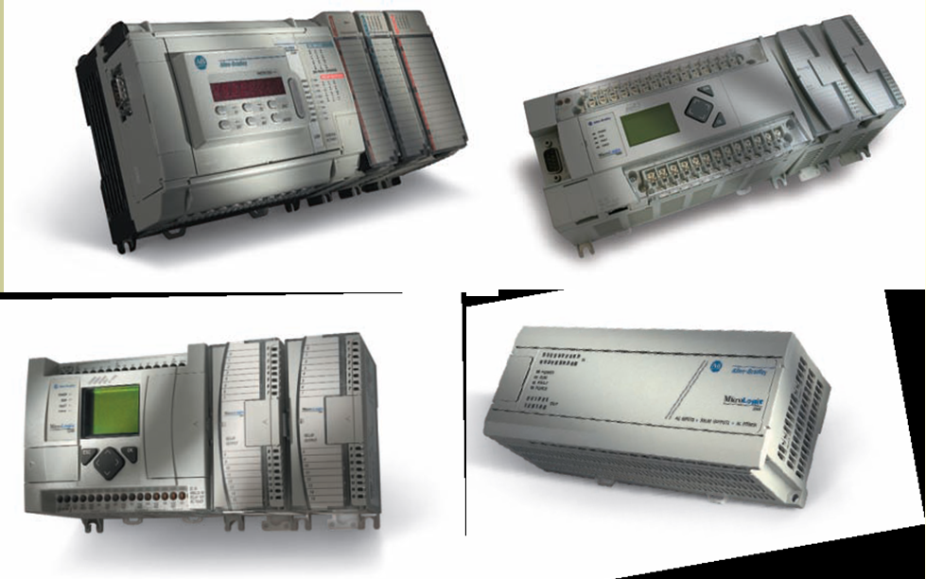

Figure MicroLogix PLC

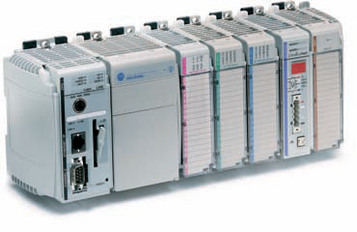

Figure CompactLogix PLC

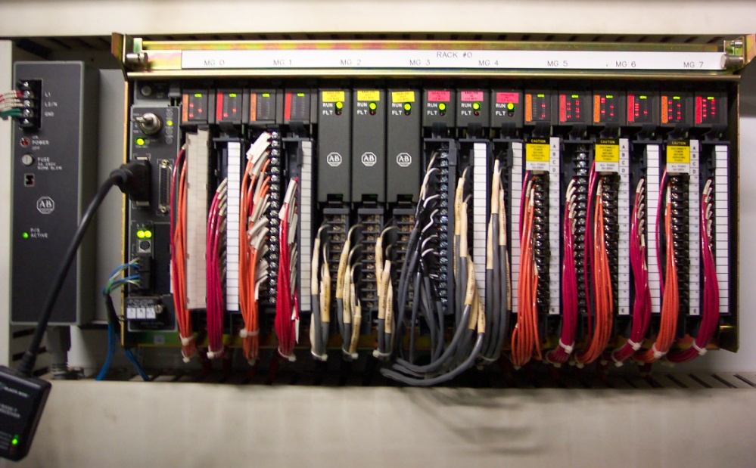

Figure PLC 5

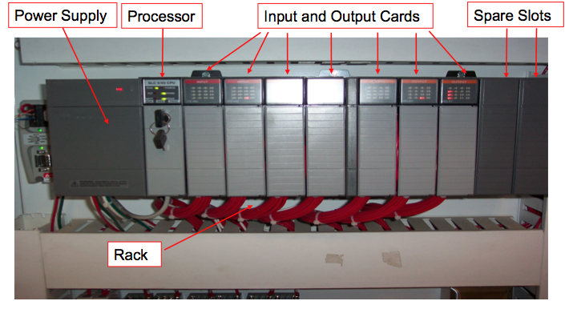

Figure SLC 5/05

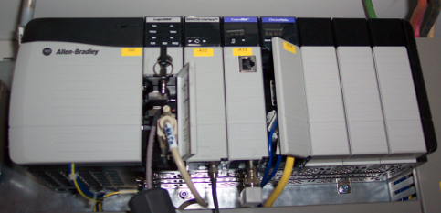

Figure ControlLogix

## PLC5

### **1.2.1 Overview**

**The PLC5 below consists of a power supply, chassis, processor, input and output cards.**

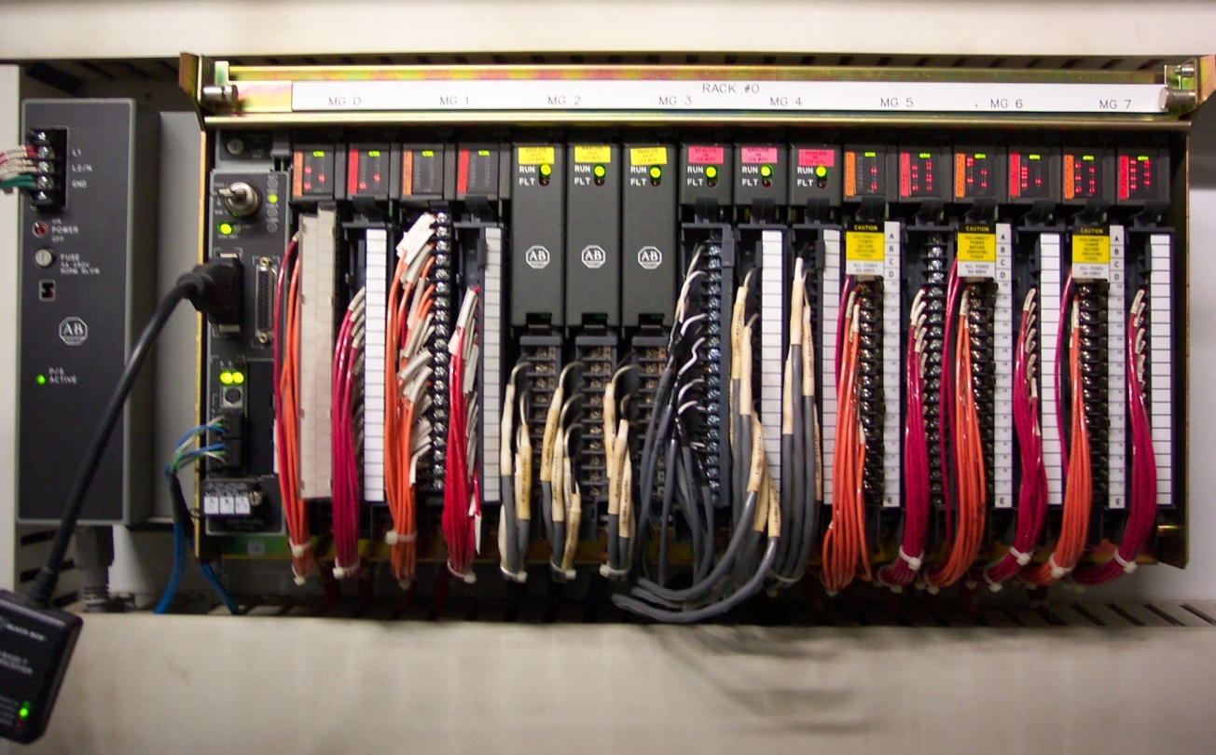

Figure PLC 5 Overview

### Power Supplies

**External**

An external power supply is located to the outside left of the Rack or Chassis

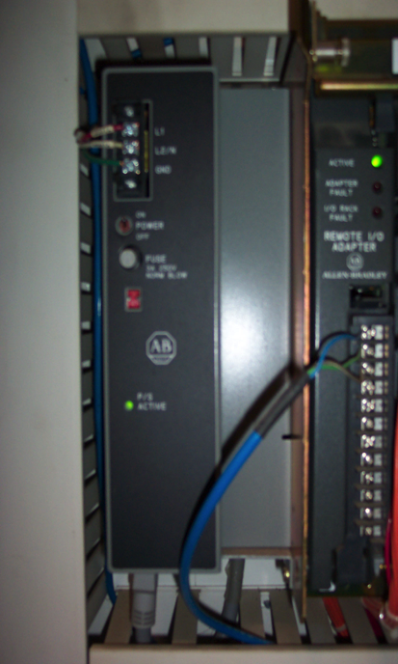

Figure PLC 5 External Power Supply

**Internal**

An internal power supply reside inside the Rack or Chassis

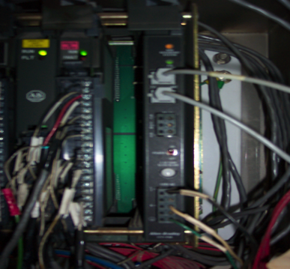

Figure PLC 5 Internal Power Supply

### 1.2.3 Back or Chassis Setup

A Rack or Chassis is where the processor, input cards and output cards are located

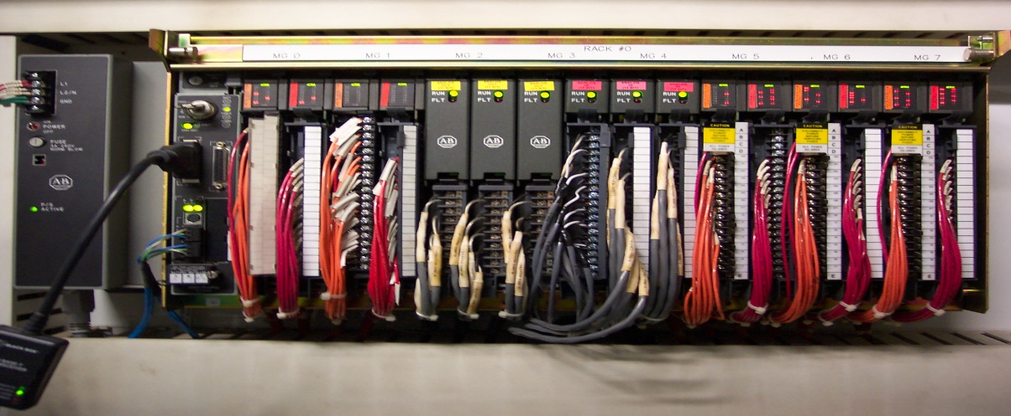

Figure PLC 5 Main Rack

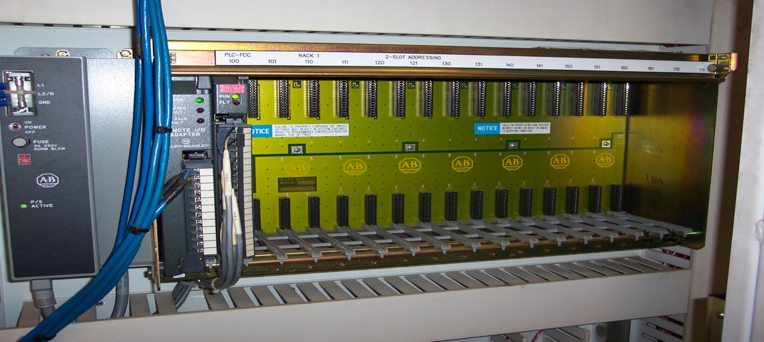

Figure PLC 5 Remote Rack

1. Set the DIP switches on the PLC as shown in Figure 14. DIP switches 6,5,4,3,2, and 1 set the DH+ address for this PLC. The addressing is in the octal numbering system, so switches 6, 5, and 4 set the MSB (most significant bit or digit) and switches 3, 2, and 1 set the LSB (least significant bit or digit). These three-switch groups make up both numbers for the DH+ address. Example: The DH+ address is 21 in octal (25 in decimal). Set switches 6, 5, and 4 to make up the “2” (the MSB) and set switches 3, 2, and 1 to make up the “1” (the LSB). Since the switches are set according to the octal numbering system, switch 5 is in the “Off” position and switch 1 is in the “Off” position. All other switches are in the “On” position. DIP switch 7 is used to set the BAUD rate for the DH+ connection. This switch is in the “On” position for 57.6 kbps, and is in the “Off” position for 230.4 kbps.

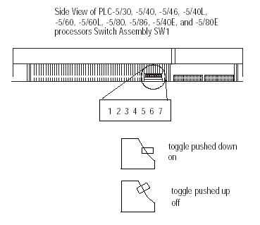

Figure : SW1 Settings for DH+ Address and BAUD Rate for PLC 5. [1]

Locate the communication connections on the PLC as pictured in .

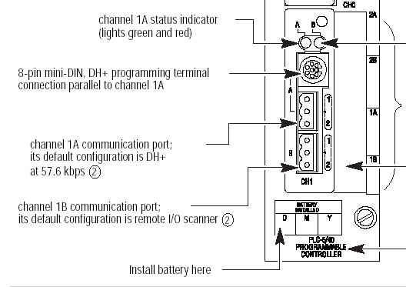

Figure : Communication Connection Location on the PLC 5/40 Processor.[2]

1. Set the DIP switches on the rack backplane as diagrammed in and Figure 17.

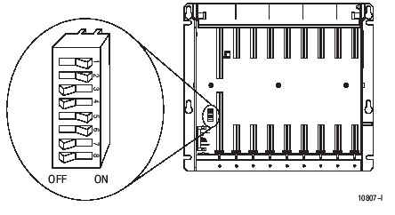

Figure : Rack DIP switches for 1771-A4B.[3]

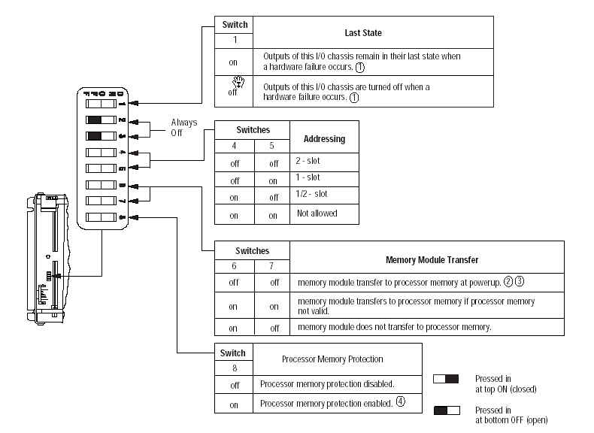

Figure : Rack DIP switches for 1771-A4B.[4]

### 1.2.4 Processors

The processor is the brain of the controls system. It evaluates all the information and then reacts in accordance to how it is programmed.

**Enhanced Processor**

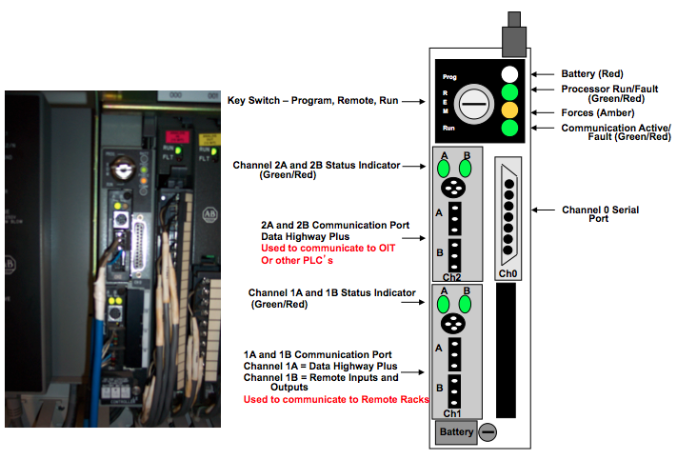

**Ethernet Processor**

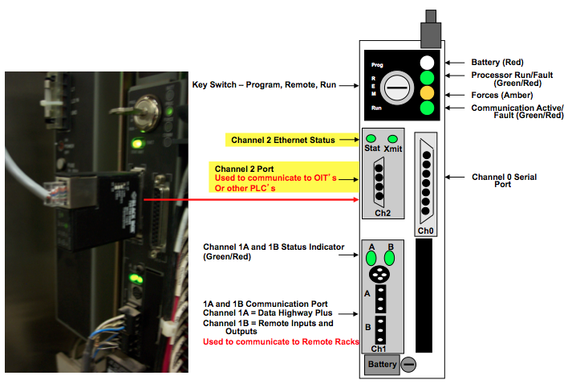

### Remote Input and Output Racks (RIO) and Configuration

A remote rack does not have a processor located in the rack or chassis.

It has a Remote ASB Adaptor, which communicates directly to the main processor through Channel 1 or Channel 2. 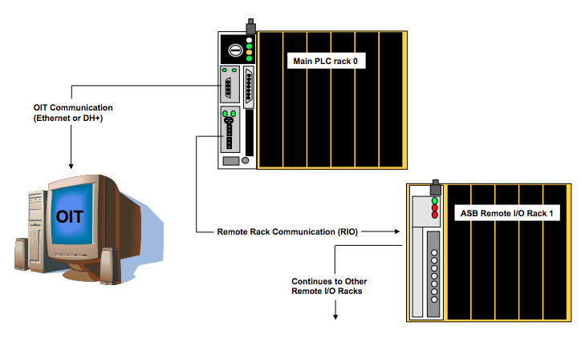

Figure 18 Remote Rack Configuration

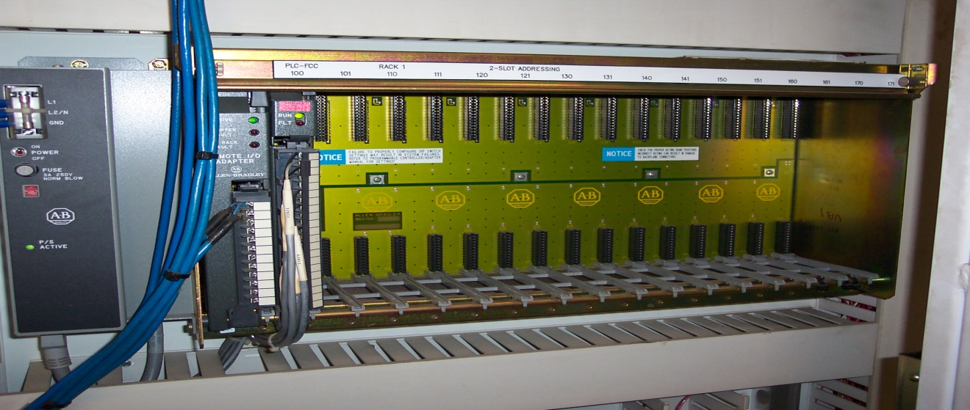

Figure PLC 5 Remote Rack

**1771-ASB Hardware Configuration**

The remote I/O adapter module serves as an interface between remote I/O modules in a remote chassis and the PLC. There are two switch assemblies (S1 and S2) and one set of configuration jumpers that need to be set in order to properly configure the remote I/O adapter. The 1771-ASB module must be mounted in the leftmost slot of the chassis.

When connecting to a PLC5 processor, module switch assembly S1 is used to set the first I/O group number and the I/O rack number. Module switch assembly S2 is used to set the Baud rate and Scan parameters (to scan all slots or all but the last four slots).

In Figure 20, address switch assembly S1 is used to select the first I/O group number, the I/O rack number and whether the I/O scanner communicates with or without complementary I/O. Address switch assembly S2 is used to select baud rate, whether the processor will scan all slots in the chassis or all but the last four slots in the chassis and the link response.

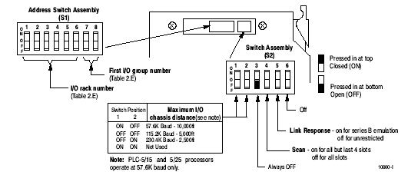

Figure : S1 and S2 Assembly switch locations.[5]

shows how to set S1 in order to select the desired remote rack number, as shown below.

Table : I/O Rack Selection for PLC5 Family Processors without Complimentary I/O.5

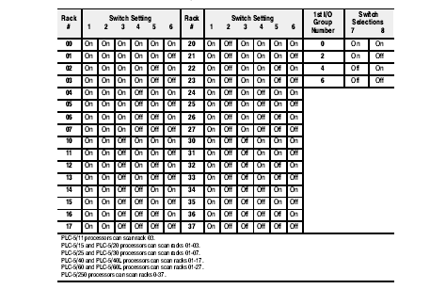

The Module configuration plug is set in order to use 32-point I/O modules. Since 32-point cards are not normally used, the plugs should be set in the right position which will allow use of 1771-IX or 1771-IY modules and any type of addressing method as shown in Figure 21.

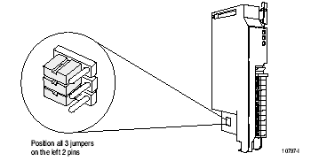

Figure : Module Configuration Plug Needs to be Set in Order to Use 32-point I/O Modules.[6]

Figure 22 shows how to set the chassis DIP switches when using the remote adapter in the remote chassis.

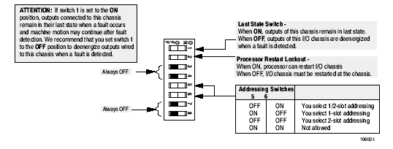

Figure : I/O Chassis Switch Assembly Settings for Remote Adapter Module in PLC5 Family Processor System in Remote Configuration.6

Use the configuration of the plug in the assembly shown in Figure 23 to identify the type of power supply being used with the remote chassis. Use the top setting for power supplies that slide into a slot in the chassis, and use the bottom setting for a power supply that is external to the chassis.

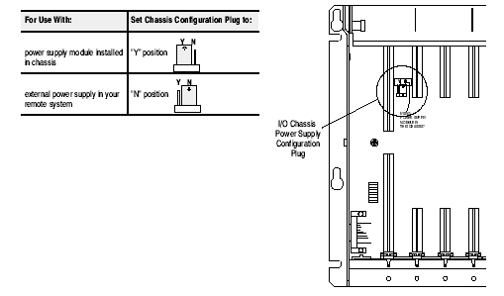

Figure : 1771 Series B I/O chassis power supply configuration plug settings. 6

**Flex I/O RIO Adapter (1794-ASB) Hardware Configuration**

The Flex I/O remote I/O adapter module consists of diagnostic indicators, reset push button, RIO wiring connections, 24 VDC power wiring connection, and address/group switch assemblies. The Flex I/O RIO adapter is shown in .

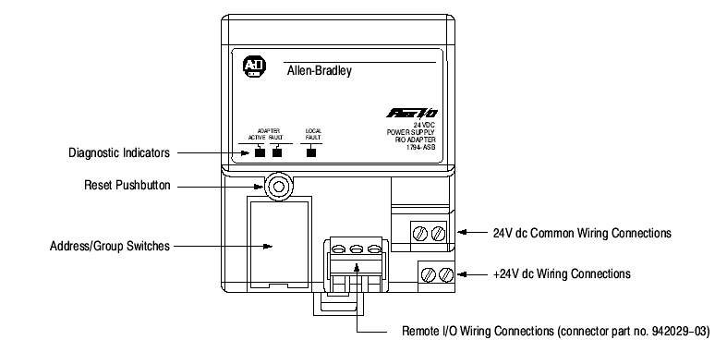

Figure : 1794-ASB RIO adapter.[7]

The RIO adapter has two 8-position switch assemblies which are set for starting I/O group, I/O rack number, hold inputs, last chassis, reply delay (always on), communication rate, processor restart lockout and hold last state (outputs). The S1 DIP switch set is used to set the starting I/O group and the I/O rack number. Detailed settings for the S1 switch are shown in Figure 25.

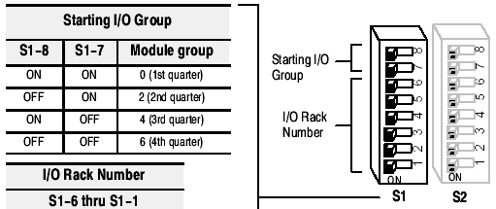

Figure : Flex IO Adapter S1 DIP Switch Settings.[8]

The S2 DIP switch group is used to set the following:

* Hold the last state of outputs.
* Processor restart lockout.
* Communications rate.
* Replay delay.
* Last chassis.
* Hold inputs.

Detailed settings for the S2 switch are shown in .

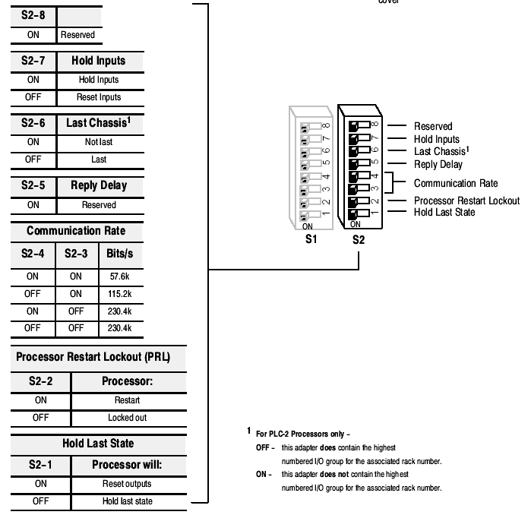

Figure : Flex I/O Adapter S2 Settings.9

**Example of Remote I/O network**

The Remote I/O network shown in Figure 27 is configured with a PLC-5/40 as the master processor. It has two slave devices: a 1771-ASB remote adapter card and a PLC-5/20 processor in adapter mode. The cabling is connected in a daisy-chain configuration (not shown are the resistors that should be connected at the PLC-5/40 and the PLC-5/20).

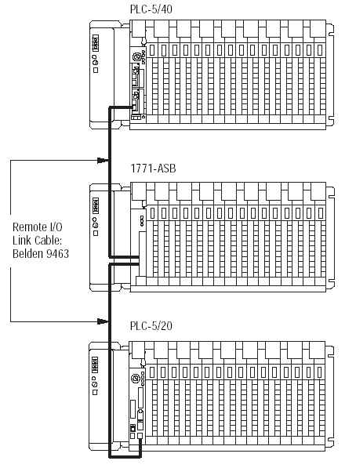

Figure : PLC5/40 Processor Connected to Two Remote I/O Racks.[9]

**Remote I/O Communication Module (1771-ASB)**

There are 3 LED indicators on the front of the Remote I/O Communication Module that provide information concerning the status of the remote rack. From top to bottom, the indicators are as follows:

O – Active

O – Adapter Fault

O – I/O Rack Fault

The state of the ASB module is determined from these LED’s as follows in Table 2:

Table : 1771-ASB Module Status Indicators.[10]

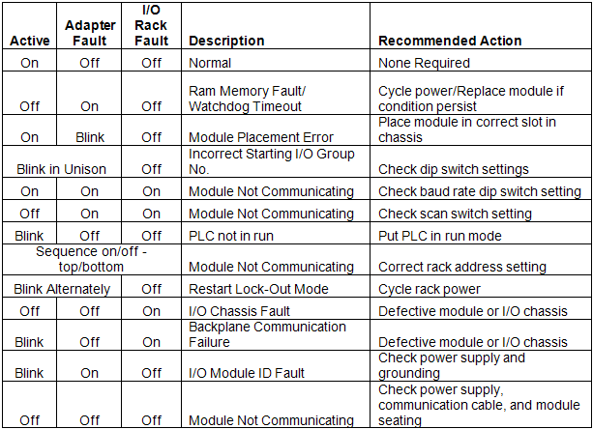

### PLC 5 Rack Addressing

**Remote Rack Addressing**

I/O modules, processor modules and power supplies are mounted in physical chassis. A chassis can have 1, 2, 4, 8, 12 or 16 slots. An I/O logical addressing group includes one input word and one output word (16 bits each). A rack consists of 8 groups (0-7), which correspond to 8 input image table words and 8 output image table words. A rack is a logical entity, not a physical entity like the chassis. A physical slot is a location on the chassis where a module is installed. The number of physical slots per group determines the addressing mode. One slot per group indicates 1-slot addressing. Two slots per group indicates 2-Slot addressing. A logical slot applies to 2-slot addressing. The logical slot is the slot number within the group (as opposed to the physical slot number). In 2-slot addressing, each group contains two logical slots, slot 0 and slot 1. In 1-slot addressing mode, the logical slot is always zero.

The group number is represented by a “g” in the addressing format I:rrg/xx. Eight groups = 1 full rack, six groups = ¾ rack, four groups = ½ rack and two groups = ¼ rack. The rack number is represented by the “rr” in the addressing format I:rrg/xx. Figure 28 shows different combinations of I/O modules and how the data table bits are used in each configuration.

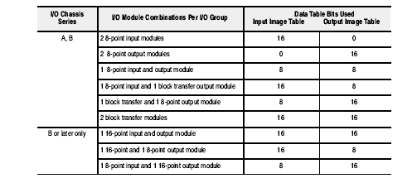

Figure : I/O Module combinations using 2-slot addressing (Series B chassis is most common).[11]

The PLC5 processor addresses two physical slots as one I/O group when using 2-Slot addressing. Each physical slot in the chassis, beginning with slot 0, is sequentially mapped to one byte (8 bits) of the I/O data table. 2-Slot addressing is designed to accommodate I/O modules whose image size is one byte (8 bits) or less. An example of two-slot addressing is shown in Figure 29.

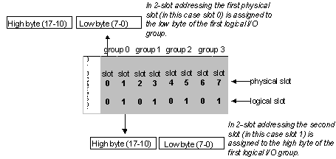

Figure : An Example of 2-Slot Addressing.

The PLC5 processor addresses one physical slot as one I/O group when using 1-Slot addressing. Each physical slot in the chassis, beginning with slot 0, is sequentially mapped to one word (16 bits) of the I/O data table. 1-Slot addressing is most straightforward with 16-point modules (16 bits). An example of one-slot addressing is shown in Figure 30.

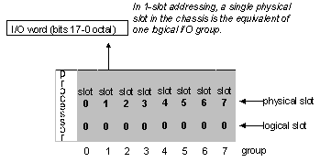

Figure : An Example of 1-slot Addressing.

The rack shown in Figure 31 illustrates an example of both a 1-slot I/O group

and a 2-slot I/O group. In this example, if the rack shown is rack 5, group 3 and configured for 2-slot addressing, the input module address will start with I:053/00 and the output module address will start with O:053/00. The starting address for the 16 input module with rack 5, group 3 and 1 slot addressing will be I:053/00. If an output module is installed in rack 5, group 4 and 1 slot addressing, the starting address will be O:054/00.

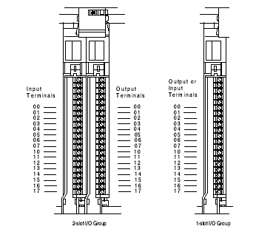

Figure : An Example of One I/O group with Up to 16 Input Terminals and 16 Output Terminals.[12]

Figure 32 shows the I/O group numbering scheme for remote I/O racks using 2-slot addressing, 1-slot addressing, and even 1/2-slot addressing.

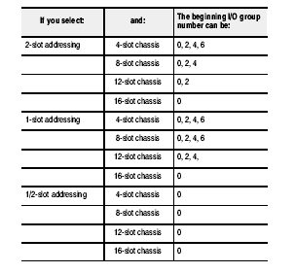

Figure : I/O Group Numbering Scheme for Remote I/O Chassis.

**Single-Slot Addressing**

Each Logical Group uses a word of space in the scanner image (one bit for each of 16 inputs or outputs) if using single-slot addressing (ex: Rack 1, Group 0 for the first card in the rack). Figure 33 shows that there are eight cards in the rack. These cards can be any mix of input and output cards when using Single-Slot addressing.

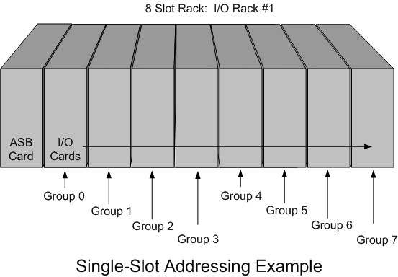

Figure : I/O Rack with Single-Slot Addressing.

Finding the correct input or output point is often the most important task when dealing with single-slot and two-slot addressing. Figure 34 gives an example of how the input and output addresses are constructed.

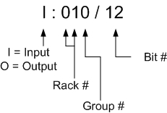

Figure : PLC-5 Address Construction.

When using Single-Slot addressing, the Group number will always be unique to one card. This means that there is only one card assigned per group. This makes Single-Slot addressing simple to understand and makes finding the desired input or output address easy.

**Two-Slot Addressing**

Each Logical Group uses two words of space in the scanner image if using two-slot addressing (ex: Rack 0, Group 0, Slot 0 and Slot 1 for the first input/output card pair).

**Note: You must pair an input card and an output card together in a Logical Group when using two-slot addressing. You cannot use two input cards or two output cards together.**

When using Two-Slot addressing, the Group number will always be shared by an input card and an output card, as shown below.

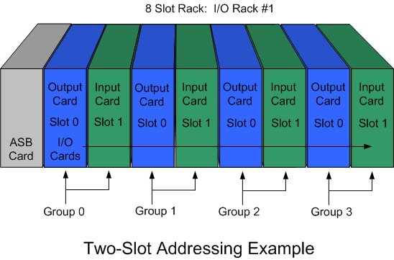

Figure : I/O Rack with Two-Slot Addressing.

The other designation used in Two-Slot addressing is the Slot Number. The Slot Number defines the position of the card in the Group. The Slot Number can be 0 or 1 for Slot 0 and Slot 1 (where Slot 0 is the left slot in the group and Slot 1 is the right slot).

The physical addresses for an input point on one card and the corresponding output point on the other card will be identical. For example, input I: 021/8 is the input address for an input in rack 02, group 1, bit 8. The corresponding output in the same group would have the address O: 021/8.

# *Rockwell Software* Communication Software

## RSLinx Overview

RSLinx is a Windows based application which links Allen-Bradley networks and devices to windows based applications such as RSLogix 5 (ladder logic programming environment) and Wonderware (the graphical package used for process control by an operator). RSLinx allows the user to easily view in a graphical format all available configured networks to which it is connected. Figure 36 shows a typical communications layout and shows different communications schemes.

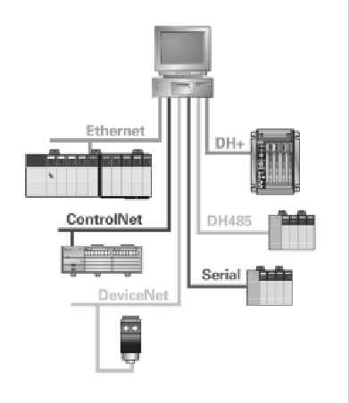

Figure : Typical communications layout.[13]

From the communications menu in RSLinx, the user can select “RSWho” and “Configure Drivers” command as show in Figure 37. RSWho is a software function in RSLinx that supplies a graphical representation of the configured drivers.

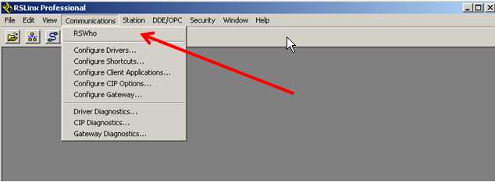

Figure : RSLinx Communications Application for Allen-Bradley Devices.

When “RSWho” is selected from the Communications menu, the RSWho browse window appears as shown in Figure 38.

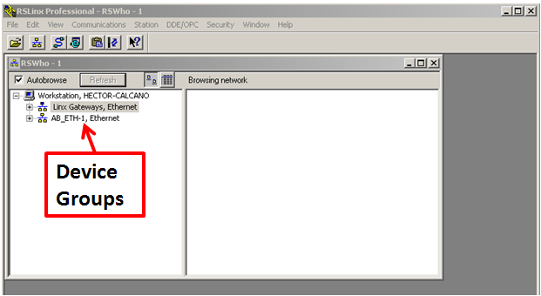

Figure : RSLinx “RSWho” Configured Drivers.

RSWho is RSLinx's network browser interface. RSWho allows the user to view all of the active network connections from a single screen. The left side shows types of networks and associated devices. The right side shows all member devices of a network. A device that appears with a red “X” indicates that RSWho previously recognized this device but that the device is no longer available on the network (meaning that RS Linx can no longer communicate with this device). The red “X” indicates a communication status error, such as a situation where a previously recognized device has been unplugged. The device can be removed from the right side by right-clicking on it and choosing “Remove.” The next time RSLinx sees that it is connected or working properly, an icon for that device will reappear in the right-hand window.

When the “Autobrowse” checkbox is selected, RSWho continuously browses the selected network. If Autobrowse is cleared, the Refresh button is active (the Refresh button is grayed out or unavailable when Autobrowse is selected). Clicking Refresh instructs RSWho to perform one browse cycle of the selected device. Since Refresh only performs a single browse cycle, clicking Refresh multiple times may be necessary to discover everything on the network. Using Autobrowse is the preferred method for network browsing.

### Driver Configuration in RSLinx

RSLinx uses Ethernet device drivers, Data Highway Plus device drivers (such as the 1784-KT), and others to communicate to different device types on the network. The following sections will discuss how to add and configure a driver in RSLinx.

### Configure an RS-232 DF1 driver

In order to add a new driver to RSLinx, select “Configure Drivers” from the Communications menu in the main toolbar as shown in Figure 39.

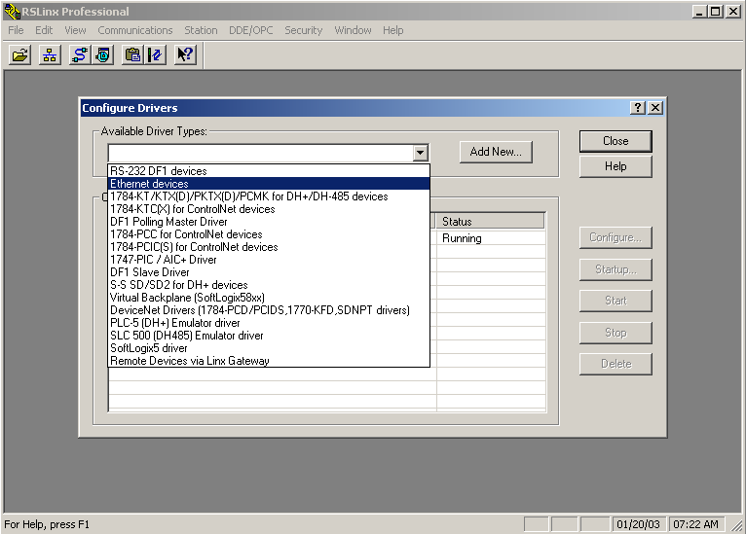

Figure : Driver Configuration Screen.

The drop-down list contains the available drivers that can be configured through RSLinx. To connect the PC with a device over the serial port, select the RS-232 DF1 devices driver. To connect to Ethernet devices through the network interface card on the PC, select and configure the Ethernet devices driver. To connect to I/O over DH+ through a 1784-KT interface card on a PC or 1784-PCMK card on a laptop, select and configure 1784-KT/KTX(D)/PKTX(D)/PCMK for DH+/DH-485 devices driver.

Once a driver is selected from the list, a configuration pop-up for that driver will be displayed, as shown in Figure 40. Figure 40 shows the RS-232 serial communications driver setup box.

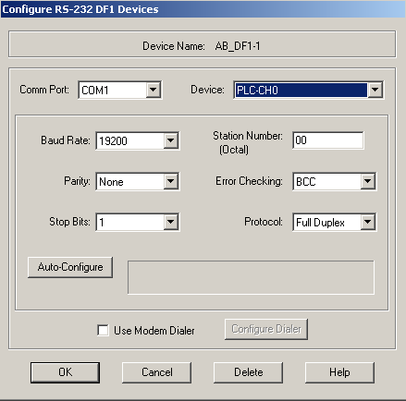

Figure : RS-232 Serial Communications Driver Setup.

Follow the steps below to configure an RS-232 driver:

1. Click Auto-Configure to automatically detect the settings of the 1770-KF2B, 1770-KF3, 1747-KE, 1770-KFC, 1785-KE, or Channel Zero device connected to the specified Comm port and set the values in this dialog box appropriately. Before using Auto-Configure, ensure that the Device Type, Station Number, and Comm Port are correct.
2. Select a port from the drop-down list of all Comm Ports available on the PC (This driver transmits data to a device connected to the computer's serial (Comm) port).
3. Choose the DF1 Device Type to which the computer is connected. Channel 0 is used when connecting to the front port of a New Platform PLC5 or SLC 5/03 and SLC 5/04 processors.
4. This driver transmits data to the device at a specific Baud Rate. Match the setting of the device to which it is connected. A drop-down list shows all Baud rates.
5. In the Parity control, match the error checking method of the DF1 driver (None, Odd, or Even) to which it is connected.
6. In the Stop Bits control, select the amount of time (1, 1.5, and 2) between data transmissions. Basic DF1 protocol generally uses 1 as the unit of time.
7. Enter the Station Number for this driver. All packets sent to this station address will be forwarded to RSLinx.
8. Match the Error Checking setting (BCC or CRC) of the DF1 device connection.
9. Select the Protocol (Full Duplex or Half Duplex) of the DF1 driver.
10. If the user wishes to use the DF1 modem dialer, enable Use Modem Dialer and click Configure Dialer.

### Configure an Ethernet driver

To configure an Ethernet driver in RSLinx, select “Configure Drivers” from the Communications menu in the main toolbar. Select “Ethernet devices” from the list of available driver types to configure and click on the “Add New” button. This will show “AB_ETH-1 AB Ethernet Running” under configured drivers. Click on the AB_ETH-1 selection under the configured drivers box, and then click on the “Configure” button at the right of the box. This will bring up the popup shown in below. From the popup shown in , the user can set up communication parameters for the desired Ethernet devices using available IP addresses and the network interface card installed in the PC.

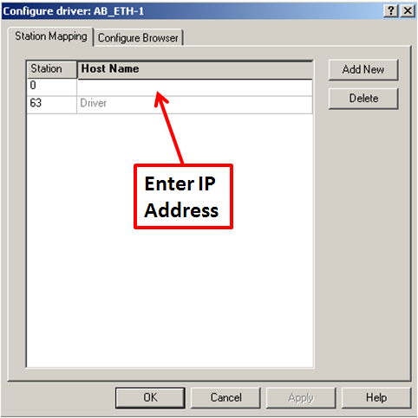

Figure : Ethernet Communications Driver Setup.

Enter the IP address in the column labeled Host Name for each device with which RSLinx will be communicating. If more than one device needs to be added, click on the “Add New” button to add additional stations to the list. Once the changes have been made, click on the “Apply” button to save these changes. Click on “OK” to close the Ethernet configuration popup, and click on “Close” to close the driver configuration popup.

# LAB - RSLinx

## RS-232 Exercise

In this exercise you want to connect to the serial port on a PLC5-40E in order to modify the PLC program. The computer in this case uses COM1 and the PLC5-40E uses PLC-CH0 for serial communications. Upon successful configuration, the PLC5-40E will be detected and it will appear as an active icon in the RSWho browse screen under the AB_DF-1, Data Highway Plus section.

1. Connect one end of the proper serial cable to the serial communications port on the PC. Connect the other end to the serial port on the device with which we wish to communicate. Verify that the correct cable is being used to communicate with the field devices, as these will vary with different pin-out configurations.
2. Open RSLinx and select  to bring up the Configure Driver popup screen, as shown in Figure 42.



Figure : RSLinx Configure Driver Setup.

1. From the available driver types drop-down list, select RS232 DF1 devices. Click the Add New button. This will bring up a popup showing the name of the driver pictured in Figure 43. Click on OK if name is acceptable. This will bring up the “Configure RS-232 DF1 Devices” popup screen.

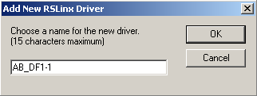

Figure : RSLinx Configure Driver Name Setup.

1. Select COM1 from the drop down Comm Port list. Select PLC-CH0 from the Device drop down list. Enter the Station Number, 0-77(octal). If you already know the desired settings, then select the baud rate, parity, stops bits, error checking and protocol. The recommended method is to use the Auto-Configure button. By clicking it, the driver checks for the baud rate, parity, stops bits, error checking and protocol. It is recommended you use the Auto-Configure after setting the Comm Port, Device and Station Number. Once it is configured successfully, select OK as shown in Figure 44.



Figure : RSLinx Configure RS-232 DF1 Device Setup.

1. Bring up the RSWho screen by using the communications menu or selecting the tool bar icon. When connected properly, you can see the PLC icon by selecting AB_DF1-1, Data Highway Plus from the tree menu on the left side of the screen. An icon representing the type of PLC (in our case a PLC5) shows up next to the workstation on the right side.

## 3.2 Ethernet Exercise

Using RSLinx, connect to a PLC5 configured with an Ethernet interface module using IP address 130.130.130.1 and a PC with an IP address 130.130.130.85. Upon successful completion, you will see the PLC in the RSWho screen under the AB_ETH-1 Ethernet tree. Follow these steps to complete this exercise:

1. Open RSLinx on your computer.
2. Select  to bring up the Configure Drivers popup screen, as shown in Figure 45 below.



Figure : RSLinx Driver Configuration Screen.

1. From the available driver type’s drop-down list, select Ethernet devices. Click the Add New button. This will bring up a popup showing the name of the driver, as shown in Figure 46. Click on OK if name is acceptable. This will bring up the Configure driver: AB_ETH-1 popup screen.

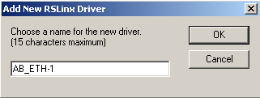

Figure : RSLinx Add New RSLinx Driver Popup Screen.

1. Enter the IP address of the PLC with which you want to communicate in the “Host name” column. In this exercise, you only have one PLC on the network with IP address 130.130.130.1 as shown in Figure 47. Enter this IP address in the first available empty row under Host Name. Click on the Apply button. This saves the new entry and adds another empty station row. After clicking the OK button in the Configure driver: AB_ETH-1 popup, the driver is configured and running.

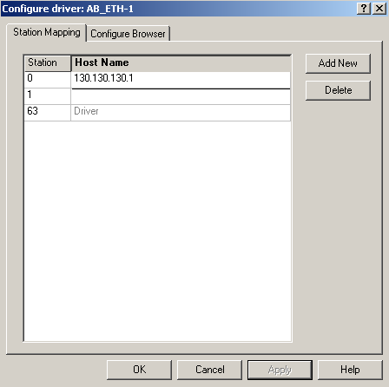

Figure : RSLinx Driver Configuration Screen for Ethernet Driver.

1. Click on the Close button as shown in Figure 48.

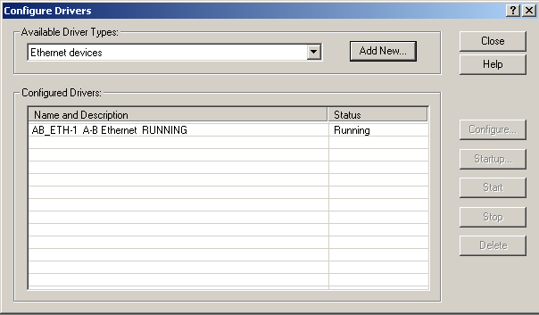

Figure : RSLinx Driver Configuration Screen (showing status for Ethernet driver).

1. Open the RSWho screen from the communications menu or by selecting the tool bar icon . When connected properly, you can see the PLC with the configured IP address by selecting AB_ETH-1 from the tree menu on the left side of the screen. An icon representing the type of PLC (in our case a PLC5) would show up with the IP address beneath it, as pictured in Figure 49.

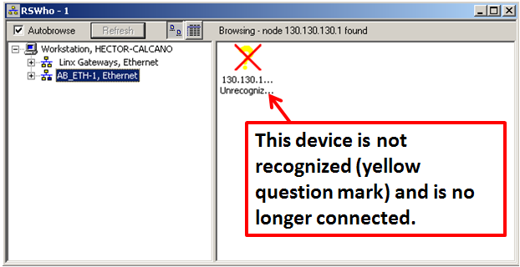

Figure : Ethernet Driver Configured to Link to PLC with IP Address 130.130.130.1.

**Note: A yellow question mark appears an Ethernet driver is configured to communicate to an IP address with no physical device (the device is not connected). In this case, RSWho displays the Device Name as Unrecognized Device. A red X in RSWho indicates that an error currently exists with a previously recognized node. The red X indicates a communication status error, such as unplugging a recognized device.**

1. Now that the driver is linked to the specified PLC, RSLogix can be used to program or monitor the PLC while online (connected to PLC in run mode).

# Ethernet Networks

The Ethernet network is becoming more and more prevalent in some plants, both as a supervisory level network (networking Office PCs together) and as a plant floor level network (networking PLCs and OITs together). The Controls Specialist should have a good understanding of the basic Ethernet network structure and how the Ethernet network operates.

## Plant Level Network View

The plant floor network can be divided into two sections – the Plant level structure and the Process Line level structure. While they are interconnected as one complete network, it is easier to examine the network as two parts. The two parts of the network are connected together via Fiber Optic cable. This high speed media allows for longer distances between the plant level network (Plant Admin Switch) and the Process Line Level switches. An example of a customer’s standard Ethernet network at the Plant level is shown below. Notice each process line has a switch connected via Fiber Optic cable to the Plant Admin switch. This means the Process Line switches can be located in an MCC room adjoining the process line and still have a high-speed connection back to the main switch (Plant Admin switch).

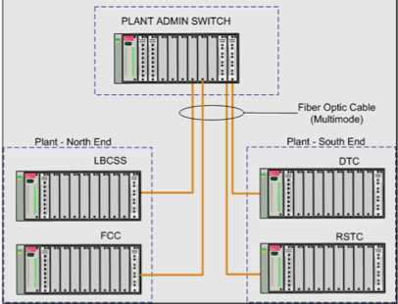

Figure Typical Switch Network

### Process Line Level Network View

The Process Line level network encompasses all network connections that are part of a particular process line. This includes Ethernet processors (either PLC-5 processors with Ethernet side cards or PLC-5 Ethernet processors), OITs and local maintenance computers (computers located in a lab or maintenance area adjacent to the particular process line). These local connections are all CAT5 (Category 5) cable connections. This is the standard cable used for hardwire connections in an Ethernet network.

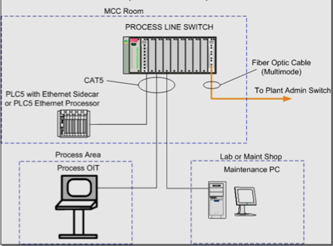

Figure : Ethernet Network (Process Line Level).

### Ethernet Network Troubleshooting

The Ethernet network uses TCP/IP as its communication protocol. Each node on the network is assigned a unique number, called an IP number. Within the plant, these numbers can be any combination of four octets (each ranging from 1 to 254). This is because it is a local network and these computers are not utilizing the Internet. IP addresses for use on the Internet must be registered and purchased. Some useful tools for Ethernet network troubleshooting are: PING, IPCONFIG, and TRACERT. These three are all commands that can be used from within a DOS box (otherwise known as a command prompt). The DOS box (or command prompt) can be accessed on a Windows PC by opening the start menu and selecting “RUN,” then typing “cmd” in the RUN prompt screen. This will bring up a DOS box (which has a black background and is command based, meaning the commands have to be typed in for the computer to execute). Once the DOS box has been opened, any of these three commands can be entered.

### IPCONFIG Command

The **IPCONFIG** command can be typed in by itself and will give the user information about the network connections on the local PC. This is information about what network card is attached to the machine, what IP address is assigned to that NIC (network interface card), and what subnet mask is being used. An example of the **IPCONFIG** is displayed in Figure 52.

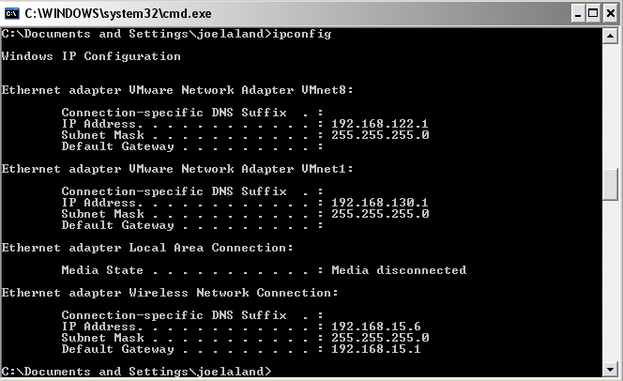

Figure : Ipconfig Command.

### PING Command

The **PING** command must be used with either an IP address (like 10.131.19.20) or a server address (like [www.google.com](http://www.google.com)) as displayed in Figure 53. This will give the user information about the network link between the local PC and the remote PC or Server the user is “pinging.” This information tells whether the two machines have a connection over the network and how fast the connection allows the PING replies to go to the remote machine and back to the local (originating) machine.

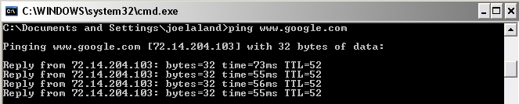

Figure : Ping Command.

### TRACERT Command

The **TRACERT** command is not used as much as the other two commands but gives more detailed information about the connection between a local and remote machine. It is generally used more on the Internet than on a LAN or small WAN but can still be helpful in a smaller network. TRACERT will show all connections that the messages from the local machine traverse (called “hops”) en route to the remote machine and tells how long the messages take to traverse each hop. An example of the command is pictured in Figure 54.

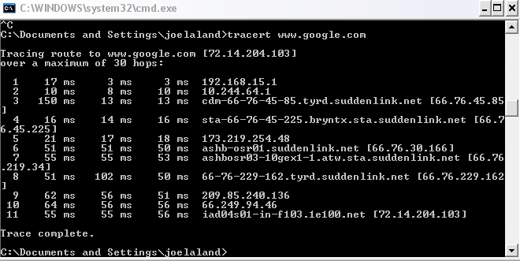

Figure : Tracert Command.

### Ethernet Connection Troubleshooting

The Ethernet network was designed with robustness and simplicity in mind. There are, however, some possible trouble spots to look for when dealing with an Ethernet network. Here is a list of possible problems that may arise on the Ethernet network, along with their probable causes and solutions:

* + 1. **Scenario:** When plugged in for the first time, a network connection does not show as being connected (the link light on the switch and the link light on the PC’s NIC do not turn on).

**Possible Cause 1:** The network cable may have broken conductors, or may be pinched (causing crosstalk between the conductors).

**Solution 1:** Try a different or new network cable.

**Possible Cause 2:** The NIC card in the PC may not be properly configured (including an incorrect IP address), or may not have all of the required drivers installed.

**Solution 2:** Check the configuration of the network card, and reinstall the drivers, if necessary.

**Possible Cause 3:** The network cable may be plugged into the “UPLINK” port on the network switch.

**Solution 3:** Find another open port on the switch and plug into the switch using this new port.

**\*\*NOTE: The UPLINK port should only be used to connect a switch to another switch (or hub or router).**

* + 1. **Scenario:** When power is lost on the main PLC chassis (and the battery on the processor is dead), the other computers on the network (including the OIT) lose communication with the PLC.

**Possible Cause 1:** The PLC’s Ethernet channel (either on an Ethernet processor or on an Ethernet sidecar) has lost its IP address.

**Solution 1:** Connect to the PLC via the DH+ default channel (Channel 1A) and re-assign the IP address on the Ethernet channel (accessed by double-clicking on the “Channel Configuration” selection in the Project window in RSLogix 5).

**Solution 2:** Connect to the PLC via the RS-232 (Serial) port and re-assign the IP address on the Ethernet channel (accessed by double-clicking on the “Channel Configuration” selection in the Project window in RSLogix 5).

* + 1. **Scenario:** When the main PLC chassis is powered down and then turned back on, the other computers on the network (including the OIT) lose communication with the PLC.

**Possible Cause 1:** The PLC’s Ethernet channel (either on an Ethernet processor or on an Ethernet sidecar) has lost its IP address due to the fact that the BOOTP selection has been checked in the Ethernet channel configuration.

**Solution 1:** Connect to the PLC via the DH+ default channel (Channel 1A) and re-assign the IP address on the Ethernet channel (accessed by double-clicking on the “Channel Configuration” selection in the Project window in RSLogix 5). Ensure the BOOTP selection on the Ethernet channel configuration is UNCHECKED.

**\*\*NOTE: When the PLC is powered back up, the BOOTP selection tells the PLC to look for a BOOTP server (which should assign the PLC an IP Address). If your plant does not use a BOOTP server, then the PLC does not have an IP address to use (the one used before powering down is lost).**

# Bit/Word Relationships & PLC 5 Data Storage Types

Reference Items in folder – “Section 5 To 9 and 12.5 To 13.4 - PLC5 Reference and Adding Devices” for examples and additional information

## Data Relationships & Data Storage Overview

The understanding of data relationships at a low level is of great importance in determining what activities are occurring in a PLC while it is running. Finding out if a motor starter has pulled in and is closing its running contact can be seen by using the low-level data contained in a PLC’s data table.

Understanding how a PLC stores data is also important when trying to determine what is happening in a PLC. Improper data storage can cause problems for the unsuspecting user. The proper use of data storage can be helpful to the careful user and allow for greater efficiency in troubleshooting PLC problems.

## Data Relationships

Data relationships begin at the simplest possible level: machine language (bit level), which is composed of 1s and 0s. A string of 16 bits make up a word of data for certain data types in PLC data (Binary, Integer). This relationship between bits and words is of utmost importance when viewing the PLC data table, since both bits and words can represent collections of data.

## 5.3 Data Storage

Data storage in the PLC 5 is separated into several types. The following are the most common:

* Binary (B).
* Counter (C).
* Float (F).
* Input (I).
* Integer (N).
* Output (O).
* Timer (T).

Binary, Input, Integer, and Output all share the same common form of the bit / word relationship as described in section 3.2. Counter and Timer files are used to store information about these devices (such as status bits and accumulated time registers). Float data is stored in word format in the PLC data table.

Data in the PLC data table is accessed by using the address structure of data type, file number, word number, and bit number (if applicable). For example, the address B22:1/0 follows this format where B is the data type (Binary), 22 is the file number, 1 is the word number, and 0 is the bit number.

Here is a real-world example: The “motor running” signal coming from a motor contactor aux contact is a single bit of data in the PLC data table (1 or 0). In this example, we will call this motor the “Outfeed Conveyor.” The motor signals for the Outfeed Conveyor’s motor are assigned together in the same word address in the PLC data table. This allows for easy viewing of the status of the conveyor motor in a binary (bit) format by looking at the whole word of data. For example, the motor control word assigned to the Outfeed Conveyor motor is N26:100. This is an integer data type (N), and is in file #26, and is word #100 in this file. The status bits for the Outfeed Conveyor are defined at the bit level. The “Motor Running” signal is assigned to N26:100/1, or bit #1 of the Outfeed Conveyor motor control word. Similarly, the “Run Command” signal is assigned to N26:100/0, or bit #0 of the Outfeed Conveyor motor control word. This word is highlighted in blue in the data table shown in Figure 55.

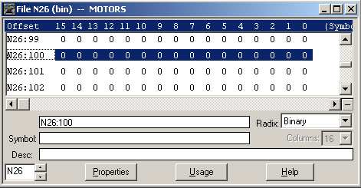

Figure : PLC 5 Data Table Entry.

# 6 *Rockwell Software* Programming Software

Reference Items in folder – “Section 5 To 9 and 12.5 To 13.4 - PLC5 Reference and Adding Devices” for examples and additional information



## RSLogix 5 / PLC 5 Basic Instructions

RSLogix 5 has several basic instructions that are used in most applications for the PLC-5:

* XIC (Examine if Closed).
* XIO (Examine if Open).
* OTE (Output Energize).
* OTL (Output Latch).
* OTU (Output Unlatch).

The first instruction, the XIC, is used to denote a situation where we are evaluating a bit for a “True” or “1” state. The XIO is the opposite and is evaluated at the bit level for a “False” or “0” state. The OTE is normally set in a “True” or “1” state when the permissives on the rung are met. A permissive is a condition that must be met in order for the rung to become “true”.

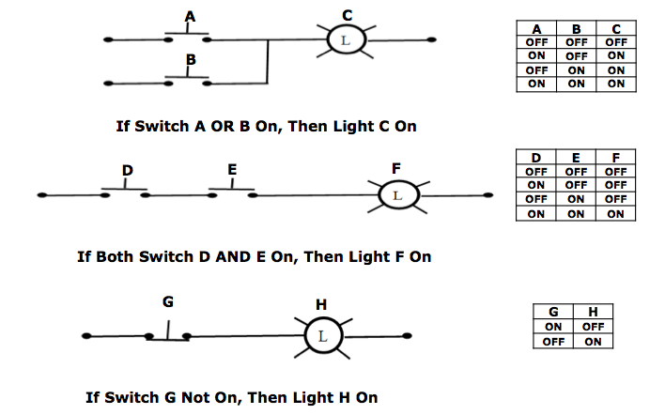

The permissives for a rung to be true are usually the instructions appearing to the left of an OTE, OTL, or OTU instruction. Figure 56 shows an XIC as the rung permissive and an OTU as the rung output.

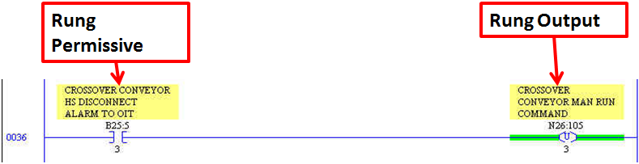

Figure : Typical RSLogix 5 Ladder rung.

## Additional PLC 5 Instructions (Counters, Timers)

RSLogix 5 uses Counter and Timer instructions to keep track of events that occur in the PLC logic. The Counter instructions are used to count occurrences of a particular state within the PLC, such as the number of times a slide gate has opened. Timers are used for time-based events, such as motor faults. When the command is given to start a motor, the motor starter auxiliary contact should send a “motor running” signal back to the PLC. If the PLC program has not received the running status signal by the next PLC scan, then the timer begins timing for a preset amount of time (ex: 5 seconds) and sets its DN (or “done”) bit to tell the PLC program it has finished timing. This function allows PLC to alert the operator that the motor has faulted or has some problem.

Figure 57 illustrates several different instruction types and is typical of a motor fault rung in a customer’s applications.

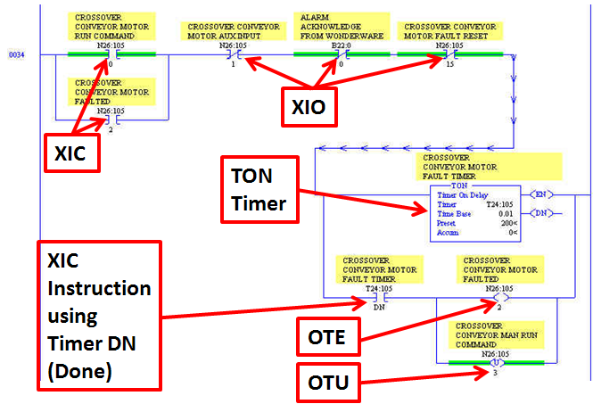

Figure : Basic RSLogix 5 Instructions.

## Introduction to RSLogix 5

The RSLogix 5 programming software is a powerful and useful tool that can be used in many ways. From creating new programs to updating existing programs (while running – called “online editing”) to simply checking the status of devices and motors, RSLogix 5 allows you to update and monitor processes in the PLC-5.

## Background Topic: How a PLC Processes Logic

Before beginning to program, you should understand the basic processing of logic that occurs in the PLC. This allows for a better grasp on what is happening when a program is running and can help identify and troubleshoot problems. When the PLC is placed in “Run” mode, it goes through a simple process over and over again. The process is composed of three basic steps:

1. Evaluates Inputs – The PLC checks the status of all of the inputs that are assigned in the program.
2. Scans Program - The PLC then scans all of the program rungs (that are either in Program File #2 or are called either directly or indirectly from File #2).
3. Sets Outputs – After scanning the program rungs, the PLC then sets the outputs assigned in the program according to the ladder logic.

## 6.5 A Brief Tour of RSLogix 5

RSLogix 5 has two basic areas for evaluating a program: The project window, which shows the project “tree”, and the program file window, which opens when a program file shown in the project tree is double-clicked (Ladder 2 opens as the default when opening an existing project). These two areas are shown in Figure 58.

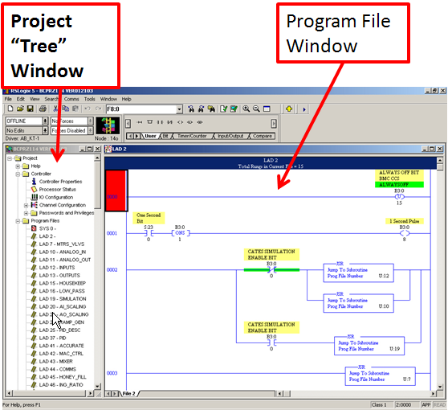

Figure : RSLogix 5 Main Screen.

The top section of the RSLogix 5 program contains the PLC status toolbars (used to change PLC from Program Mode to Run Mode, for example), the search window, and the instruction palette. These are all commonly-used features of RSLogix 5. The instruction palette shows all of the available instructions in RSLogix 5 in an easy-access format. The Address Find Tool can be used to search for a particular address in the PLC (or can be used to find PID loops – by typing “PID,” among other things). The top toolbar area is shown in Figure 59.

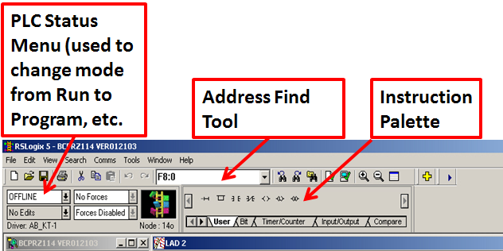

Figure : RSLogix 5 Top Toolbar.



### 6.5.1 Creating a New Project in RSLogix 5

Creating a new project in RSLogix 5 is fairly simple and straightforward:

1. Open RSLogix 5 programming software.
2. Select the “New” icon in the top toolbar (or go to the File menu and select “New”) to open the window show in Figure 60.
3. You will see the “Select Processor Type” popup appear, as shown in the figure on the following page. Enter a Processor Name for this project.
4. Select the PLC Platform that you will use for this project (Ethernet, ControlNet, Enhanced). Specify the PLC type you will be using with this program.
5. Select the processor used with the project (ex: PLC5/40).
6. Select the processor series (shown on the label on the side of the processor).
7. Specify the memory capacity for the processor (this will usually contain a default value for the processor chosen).
8. The communication settings can be selected at this point, but it is not necessary since this is usually done from RSLinx.

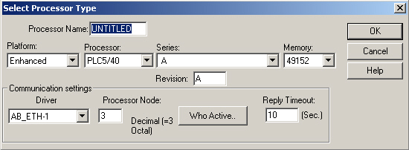

Figure : RSLogix 5 Select Processor Type Popup Box.

# 7 Lab - RS Logix 5 – System Communication, Configuration, Downloading / Uploading Programs to / from a PLC-5

Reference Items in folder – “Section 5 To 9 and 12.5 To 13.4 - PLC5 Reference and Adding Devices” for examples and additional information

This lab will allow you to practice setting up communications between your computer and a PLC-5. During this lab you will have the task of setting up the computer to communicate with the proper PLC and then downloading a program to this PLC. Once the program has been downloaded, you will go online with the PLC. You will also practice uploading the program from the PLC to your computer.



## System Communication, Configuration, and Downloading a Program to a PLC-5

1. Open RSLogix 5.
2. Create a new program file on the computer. (Select the same Processor type as the hardware Processor you’re going to download to)
3. Select “Comms” from the main toolbar and choose “System Comms…” to view devices that are active on the network as seen in Figure 61.

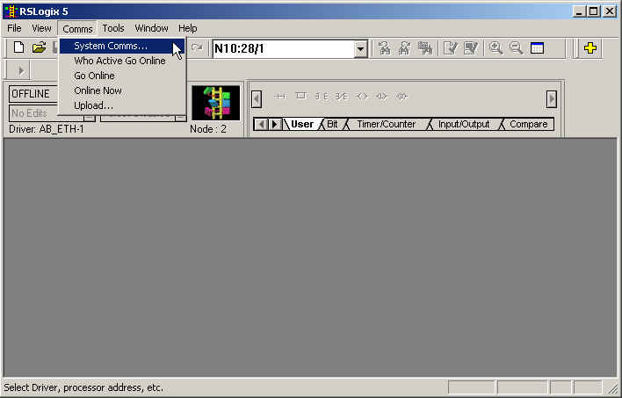

Figure : RSLogix 5 Comms Menu.

1. Look at the System Comms popup like the one in Figure 62 to see what devices are currently online. Notice that this communications browser looks almost exactly the same as the browser in RSLinx, with the exception of the action buttons on the right of the popup screen.

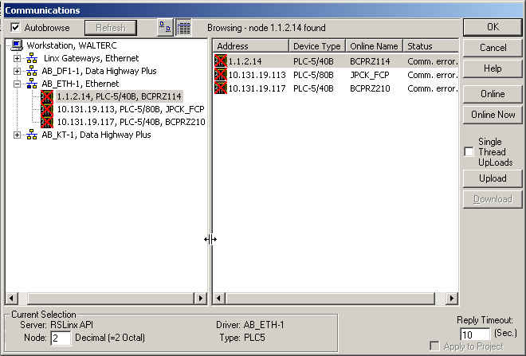

Figure : RSLogix 5 System Comms Browser Window.

1. Select the PLC to which you want to download your program in the right-hand side of the communications browser as pictured in . Click on the “Download” button on the right-hand side of the screen to begin the process of downloading the program to the PLC. Keep in mind that the program you will be downloading is the program that you currently have open in RSLogix 5.

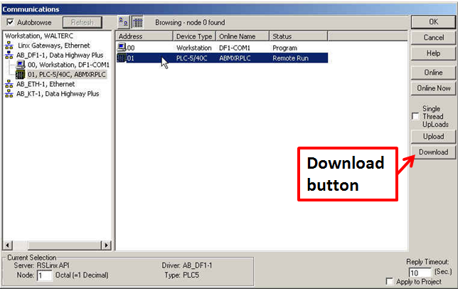

Figure : RSLogix 5 System Communications Browser Window.

1. When you click on the “Download” button, the popup screen shown in may appear. Since our processor setup in RSLogix does not match the PLC to which we want to download, we must click “Yes” to enable the download process.

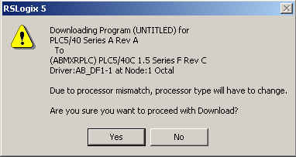

Figure : RSLogix 5 Download Confirmation Window.

1. You may then see a popup showing current communication settings for both the PLC and the current program you are attempting to download as pictured in Figure 65. You will need to click “Yes” to continue the download process.

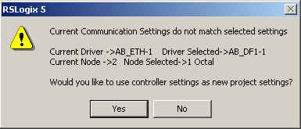

Figure : RSLogix 5 Download Confirmation Window Showing Communication Settings Mismatch.

1. You will then see a popup confirming that you want to change the processor type for the project (program) you are downloading as show in Figure 66. You need to evaluate the Conversion Options check boxes carefully before proceeding. These selections will depend on your specific application. You will need to click “OK” to continue the download process.

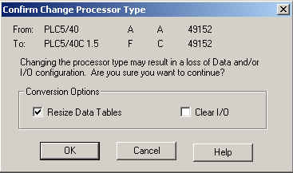

Figure : RSLogix 5 Download Confirmation Window Showing Processor Change Selections and Conversion Options.

1. You will then see the download status box, as shown in Figure 67, which shows the progress of the download to the PLC.

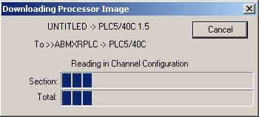

Figure : RSLogix 5 Download Progress Window.

1. The popup pictured in Figure 68 will then appear and ask if you would like to switch the processor from RUN mode to PROG (program) mode. Click “Yes” to go online with the processor.

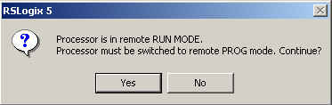

Figure : RSLogix 5 Online Mode Switch Window.

## 7.2 Uploading a Program from a PLC-5

1. Open RSLogix 5 on your computer.
2. Select “Comms” from the main toolbar and choose “System Comms” to view devices that are active on the network.
3. Select the PLC from which you want to upload the program in the right-hand side of the communications browser and click “Upload” as shown in .

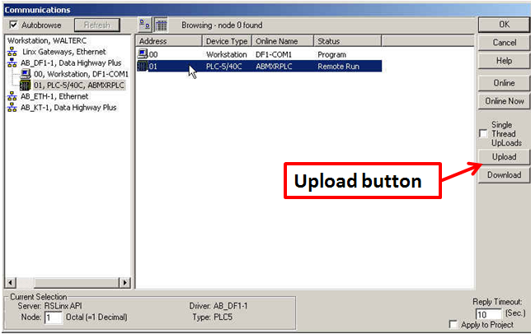

Figure : RSLogix 5 Communications Window Showing Upload Button.

1. You will then see the upload status window, as shown in Figure 70.

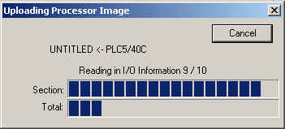

Figure : RSLogix 5 Upload Status Window.

## Going Online with a PLC-5 and merging the loaded program with the current program on your computer

1. Open RSLogix 5 on your computer.
2. Open your current version of the PLC program on your computer. This is the version with which you want to merge the current PLC program (that is loaded in the PLC).
3. Select “Comms” from the main toolbar and choose “System Comms” to view devices that are active on the network.
4. Select the PLC from which you want to upload the program in the right-hand side of the communications browser.
5. Click on the “Online” button to go online with the PLC. You will then see the popup screen shown in Figure 71, which shows that your current program does not match the current loaded program on the PLC. If you are certain that you have the most current program on your computer, then you can click on the “Upload Logic, Merge with Existing File’s Comment/Symbol DB”. This will merge the PLC’s loaded program with the current program on your computer. This means that you will retain all of the comments for the rung commands that you have stored in your program’s database. If you are not sure that the two programs are the same, you can choose the “Create New File” button. This will create a whole new file for the uploaded program, but you may lose rung command comments.

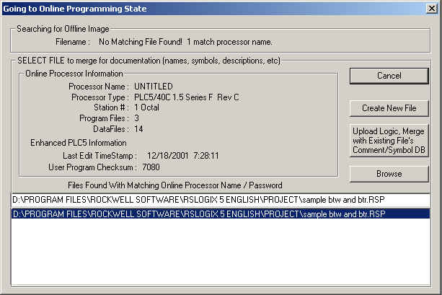

Figure : RSLogix 5 Online State Window.

## Online Editing with RSLogix 5

This part of the lab is included purely for familiarization with online programming tools. You will need to be able to identify the state of your connection to the PLC-5 and how to edit program rungs online. If you are online with the processor, you will be in either RUN mode, or in REMOTE PROGRAM mode. This makes a difference in what you can do and what steps you must go through to edit the PLC program. Figure 72 and show some example screens showing the RUN and REMOTE PROGRAM modes:

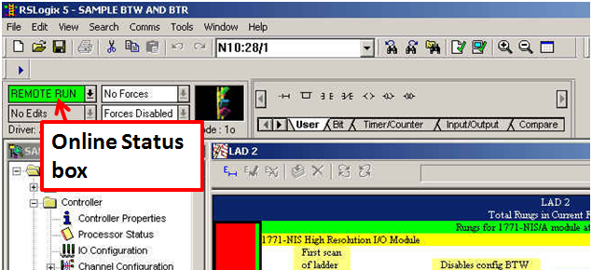

Figure : RSLogix 5 in Online RUN Mode.

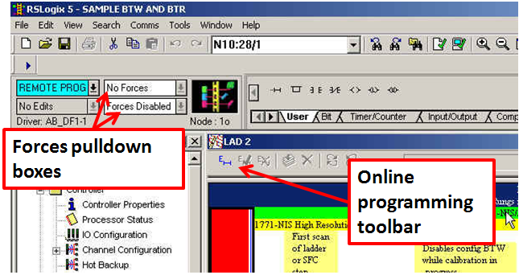

Figure : RSLogix 5 in Online in REMOTE PROGRAM Mode.

### Online Editing in REMOTE PROGRAM Mode

To edit a rung in REMOTE PROGRAM mode, follow these steps:

1. Click on the left end (or margin) of the rung that you wish to edit. The end (or margin) should then show a series of vertical “e” characters, which shows that the rung is in the “edit” state. You will also see another rung below the original rung that has a series of vertical “r” characters, which shows that the rung is in the “run” state. RSLogix 5 has basically made a copy of the rung that the PLC is executing (the “run” rung) for you to do your editing. This is shown in Figure 74.
2. When finished editing, click on the green check mark at the top of the program window.
3. To cancel an edit, click on the red X at the top of the program window.

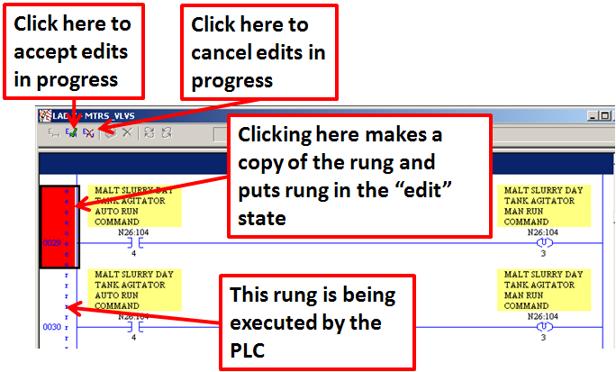

Figure : RSLogix 5 in Online in REMOTE PROGRAM Mode.

### 7.3.2 Online Editing in RUN Mode

To edit a rung in RUN mode, follow these steps:

1. Click on the left end (or margin) of the rung that you wish to edit and proceed as in REMOTE PROGRAM mode.
2. When finished editing, click on the green check mark at the top of the program window.
3. To cancel an edit, click on the red X at the top of the program window.
4. Next you will see a round shape with arrows in the toolbar. This is the “test edits” button as shown in Figure 75. Use this to test the edits you have made – this will cause the PLC to execute the rung you have edited. If you want to cancel the edits once tested, simply press the other button with the round shape, the “untest edits” button. This will cause the PLC to stop executing the edited rung.

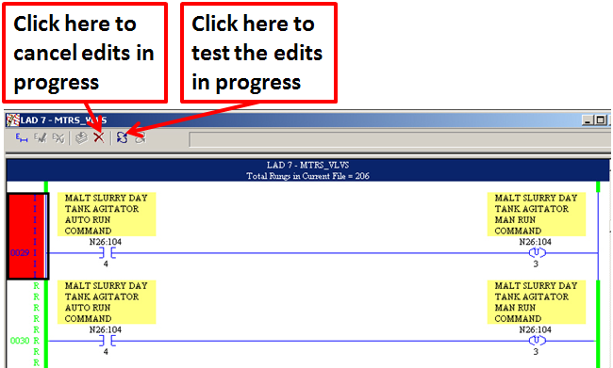

Figure : Testing Edits with RSLogix 5 in Online in RUN Mode

1. Once you have tested your edits and are satisfied with their stability while being executed, you are ready to assemble the edits. Press the “assemble edits” button (looks like a stack of paper) in the online toolbar as shown in Figure 76. You have now completed the online edit process for this rung.

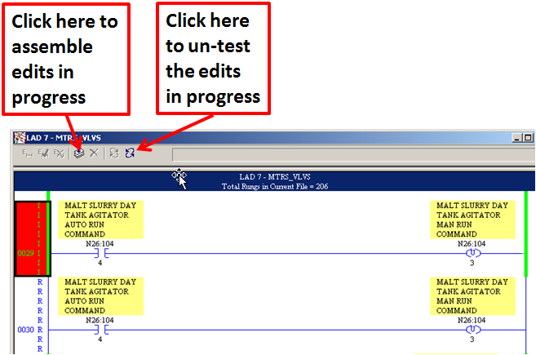

Figure : Assembling Edits with RSLogix 5 in Online in RUN Mode.

# Understanding Remote I/O (RIO) Networks, PLC 5 Channel Configuration & PLC Scan List

Reference Items in folder – “Section 5 To 9 and 12.5 To 13.4 - PLC5 Reference and Adding Devices” for examples and additional information

## Setting Up the Communication Channels for Remote I/O Scanning

While the I/O Configuration tool is useful to the user in keeping track of the logical racks and physical chassis that are configured on the Remote I/O network, the PLC only “sees” the logical racks that are listed in the PLC Scan List. To find the PLC Scan List, open the “Channel Configuration” box (located just below the IO Configuration box in the Project Tree). The PLC’s Scan List is contained in the I/O Channel tab that is set for “Remote I/O Scanner.” This Scan List shows the logical racks with which the PLC can communicate. The Scan List can have entries added to it manually, or you can use the “Auto Configure” feature that polls the network for existing logical racks.

To set up the Scan List manually, follow these steps:

1. Select “Remote I/O Scanner” in the I/O Channel Mode box as shown in Figure 77.

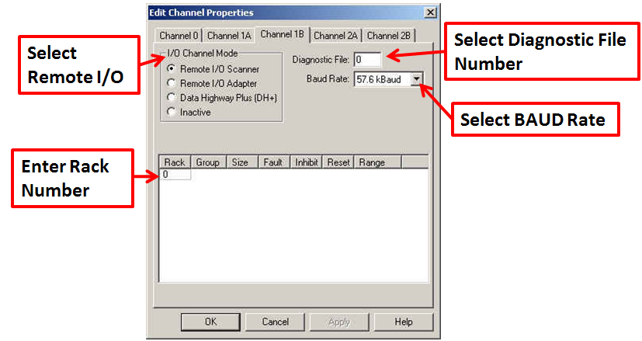

Figure : The Channel Configuration Box.

1. Select the BAUD rate for this channel.

Note: The BAUD rate must be the same for all devices on the Remote

I/O network.

1. Enter the PLC file number to be used for diagnostics in the Diagnostic file box (This PLC file number should already be set up – you can find this number by looking at the Processor status box. The file number is located in the “I/O status” box on the Main tab). Enter the rack information for the rack you want to configure: the rack number (in octal), group number, and rack size

## Troubleshooting Remote I/O Communication Problems

Most remote I/O communication problems are due to incorrect installation of the remote I/O highway or improper setup of new hardware. Remote I/O communication problems due to hardware failure are rare. The first consideration when a problem occurs should be whether there have been any changes or additions to the system.

### Recognizing Remote I/O Communication Problems

The first indication that a remote I/O communication problem has occurred is when equipment cannot be operated or status indication on the Operator Interface Terminal (OIT) does not change as it should. The first step to resolve this type of problem is to connect to the processor using RSLogix5.

### RSLogix5 Minor Errors

A minor error will be reported in RSLogix5 when a remote I/O communication problem occurs. The following example in Figure 78 shows the Processor Status window. The “Rack” tab shows the current status of all racks. Fault bit 3 is set to 1, which indicates that rack #3 is currently faulted.

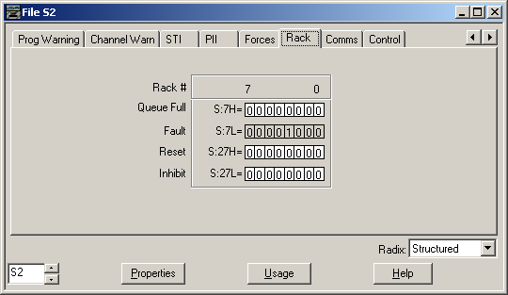

Figure : Processor Rack Status Window.

### Diagnostics

The following example in Figure 79 shows the Channel Status window. The number of retries for rack #3 has accumulated a value of 23702. This is an indication that the PLC processor is having trouble communicating with remote rack #3. The Clear button can be used to zero this value.

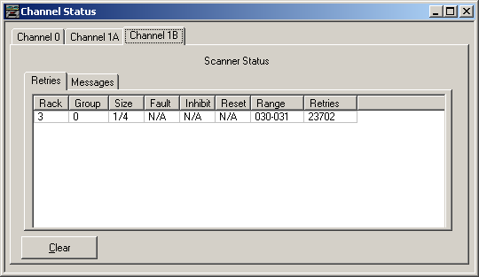

Figure : Channel Status Window.

## LAB - RS Logix 5 – Troubleshooting Remote I/O (RIO) Racks

Reference Items in folder – “Section 8.3 - PLC Hardware & Cards” for examples and additional information

This lab will allow you to practice setting up and troubleshooting Remote I/O networks.

1. Instructor - Set up the PLC / ASB for remote I/O scanning and verify all racks are communicating.
2. Instructor - Change some hardware and software settings so that the PLC is no longer communicating with the remote rack.
3. Student - Troubleshoot the problem and restore communications to the remote racks.

# Digital I/O Address Mapping & Searching

Reference Items in folder – “Section 5 To 9 and 12.5 To 13.4 - PLC5 Reference and Adding Devices” for examples and additional information

## Example of typical device / motor starter wiring

Refer to Figure 80 and Figure 81for typical motor starter wiring.

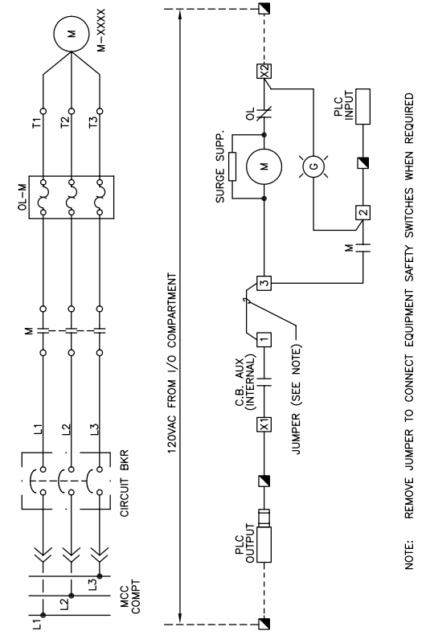

Figure Full Voltage Non-Reversing Drawing

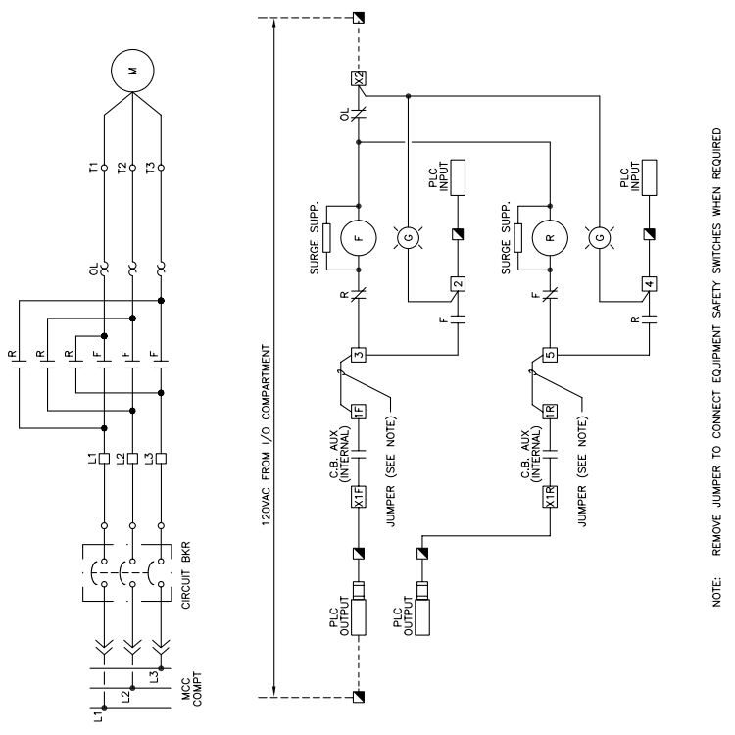

Figure 81 Full Voltage Forward Reversing Drawing

## Typical device and motor starter PLC code structure

A typical device or motor has several rungs associated with it. These are all required to properly control the device.

### The RUN command rung

The Auto Run command is used when an auto system will turn on this device. The Manual Run command is used when the operator turns on the device from the OIT screen using the manual device run button. All other instructions on the left side of the output are permissives. When one of the run commands is enabled and all of the permissives in line with that run command are met, then the output of the rung (the OTE, in this case) is turned on. The different elements that make up the RUN command rung can be seen in Figure 82.

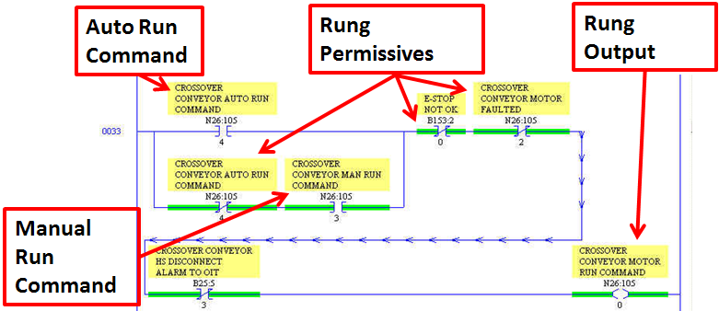

Figure : The RUN Command Rung.

### The Fault Timer rung

The purpose of the Fault timer rung is to start a timer when the RUN command is given and ensure that the feedback signal from the device or the contactor for the device is received. On the rung shown in Figure 83, the timer is set for two seconds. If the motor run command is given and the auxiliary contact input is not received within two seconds, then the outputs of the fault timer rung are turned on (as long as the other permissives are met). The rung stays true until the operator presses the Alarm Acknowledge button on the OIT, which causes the rung to be false.

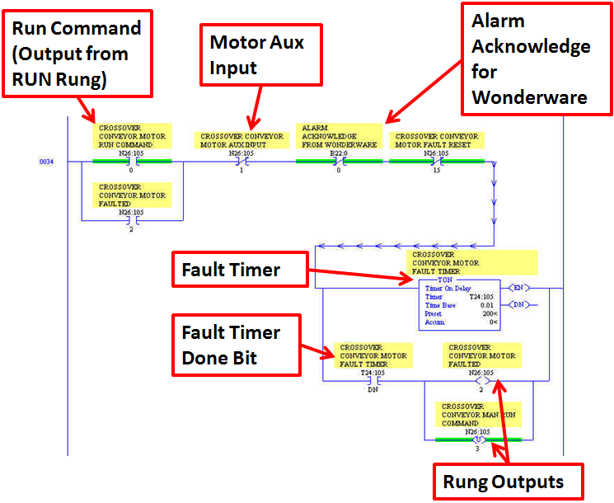

Figure : The Fault Timer Rung.

### The Hand Switch Disconnect rung (unlatches manual run command)

The Hand Switch Disconnect rung unlatches the manual run command as shown in Figure 84. The rung is true when the HS Disconnect alarm has been enabled. This occurs if the HS Disconnect input is turned off (meaning that the disconnect is in the OFF position). This prevents the operator from trying to manually operate the device.

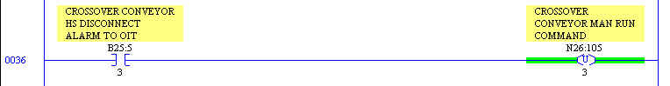

Figure : The Hand Switch Disconnect Rung.

### The Auto Run command rung that unlatches the manual run command

The rung in keeps the operator from turning on the Manual Run command while the Auto Run command is enabled. This rung is somewhat redundant with the RUN command rung, since the Auto Run command must NOT be on in order to enable the Manual Run command. It is, however, a good safety measure to have this rung in the code. This rung also addresses the case where a device is being run in manual mode and the auto system that controls this device is enabled. This means that the Manual Run command is already enabled, and so the Auto Run command must turn off the Manual Run command to avoid erroneous operation.

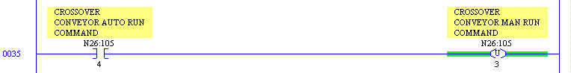

Figure : The Auto Run Command Rung.

Searching for device addresses in PLC code

Finding device addresses in the PLC is simple and straightforward if you have some basic information about where to start:

1. Determine the input or output address you want to find.
2. In RSLogix 5, select “Search” from the toolbar and choose “Find” in the list of selections under search as shown in .

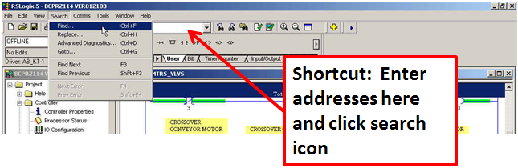

Figure : Accessing the Find Command in RSLogix 5.

**Shortcut: Use the CTRL+F keyboard shortcut or use the address box in the lower toolbar**

1. Enter the input or output that you want to find into the “Find What” field shown in .

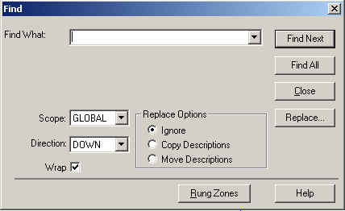

Figure : Find Box.

# Introduction to Wonderware

Most of you are familiar with Wonderware, but we will provide this brief introduction for the benefit of those who are not familiar with it.

## Wonderware Runtime & Development

Wonderware Runtime and Development are two applications that are tied together for the purpose of creating and running graphical interface screens that the user can utilize to interact with a PLC.

### Wonderware Runtime

“Wonderware Runtime” refers to the “Window Viewer” application that can be started either from a desktop shortcut icon, or from the FactorySuite folder in the Programs menu. Wonderware Runtime allows the user to view graphical screens while the IO Server application communicates with the PLC for information such as status (ex: Is the motor running?) and quantitative (ex: How much flour is on the scale?) information. Runtime also allows the user to send commands to the PLC (ex: Run the Outfeed Conveyor Motor).

### Wonderware Development

“Wonderware Development” refers to the “Window Maker” application that can be started either from a desktop shortcut icon, or from the FactorySuite folder in the Programs menu. Wonderware Development allows the screen developer to create and/or modify graphical screens to be used by the Window Viewer application. The Development program allows the user to define screen items such as buttons, shapes, text boxes, and other graphics, which can then be interfaced to the PLC (via the IO Server) by creating a Wonderware Tag (to be described in the next section). These screen items can be animated (change colors, display numbers) based on the information that is received from the PLC.

### Switching Between Wonderware Runtime & Development

To switch to Wonderware Development when in the Runtime application, simply press the “Development” button located in the upper-right-hand corner of the Runtime application screen. If this button is not visible (the toolbar may be hidden), then simply press “Alt”, “Shift” and “1” at the same time. Using this three-key combination, you can easily switch between the two applications.

## Wonderware Tags

A Tag is the mechanism used to identify a location in Wonderware where data is stored, much in the same way that an address is used in a PLC. The tag types that interface to the PLC have the PLC address included as part of their properties when the tag is set up in Wonderware. Tags that are internal to Wonderware have no PLC addresses associated with them. Let’s begin by defining the different tag types available in Wonderware.

### I/O Tags

All tagnames that read or write their values to or from another Windows program are I/O type tagnames. This includes all inputs and outputs from programmable controllers, process computers and data from network nodes. I/O tagnames are accessed either through the Microsoft Dynamic Data Exchange (DDE) or Wonderware SuiteLink communication protocols.

#### I/O Discrete

Discrete input/output tagname with a value of either 0 (False, Off) or 1 (True, On).

#### I/O Integer

A 32-bit signed integer value between -2,147,483,648 and 2,147,483,647.

#### I/O Real

Floating (decimal) point tagname. The floating point value may be between -3.4e38 and 3.4e38 . All floating point calculations are performed with 64-bit resolution, but the result is stored in 32-bit.

#### I/O Message

Text string input/output tagname that can be up to 131 characters long.

### Memory Tags

Memory tagname types exist internally within your InTouch application. You use them to create system constants and simulations. You can also use them to create calculated variables that are accessed by other Windows programs. For example, you can define a memory tagname with the initial value of 3.1416 or, you could store recipes in groups of memory tagnames. In simulations, you can use memory tagnames to control the actions of a background QuickScript. For example, you could define a memory tagname "COUNT" what is changed in an action QuickScript to cause various animation effects to occur for the current STEP of a process.

#### Memory Discrete

Internal discrete tagname with a value of either 0 (False, Off) or 1 (True, On).

#### Memory Integer

A 32-bit signed integer value between -2,147,483,648 and 2,147,483,647.

#### Memory Real

Floating (decimal) point memory tagname. The floating point value may be between -3.4e38 and 3.4e38. All floating point calculations are performed with 64-bit resolution, but the result is stored in 32-bit.

#### Memory Message

A text string’s tagname that can be up to 131 characters long.

### Indirect Tags

Indirect type tagnames allow you to create one window and reassign the tagnames in that window to multiple sources. For example, let’s say you have fifty identical pumps that you want an operator to monitor for alarm conditions. Instead of creating fifty different windows (one for each pump) you can use indirect tagnames in one window that will call the source tagnames associated with individual pumps based on a QuickScript that points the indirect tagnames to the source tagnames of a pump that has entered an alarm state. You could also use a Touch Pushbutton QuickScript that allows the operator to manually select which pump to display. This method reduces both development time and application size.

#### Indirect Discrete

Discrete tagname with a value of either 0 (False, Off) or 1 (True, On). The source tag must be either an I/O discrete or memory discrete tag.

#### Indirect Analog

Variable data tag. The source tag must be an I/O integer, an I/O real, a memory integer, or a memory real tag.

#### Indirect Message

Text string tagname that can be up to 131 characters long. The source tag must be either an I/O message or memory message tag.

## Intouch Application Manager

Application manager contains a list of the installed Wonderware applications on the local hard drive or remotely mapped locations. See Figure 88.

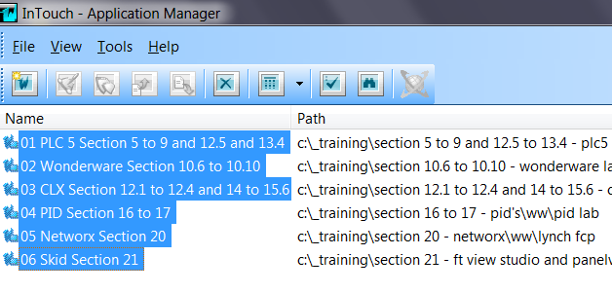

Figure Intouch Application Manager

### Importing WW Applications

Follow the steps below to import WW applications into Application Manager.

1. Select “Tools” and “Find Applications”

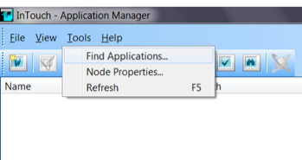

Figure Find Applications

1. Navigate to the WW application folder(s).

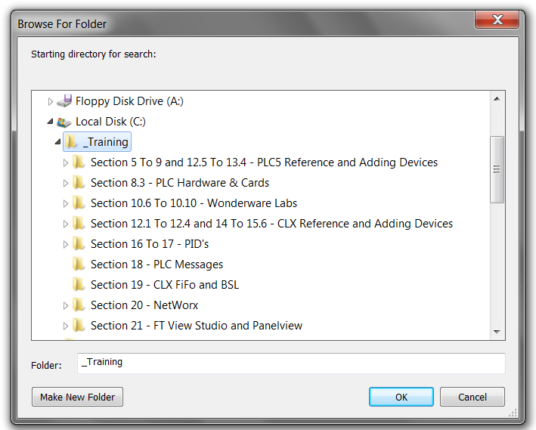

Figure 90 WW Application Folder Path

1. Then select “OK” to import all WW application located in the selected folder.



Figure Imported WW Applications

1. Select an application and then the WindowMaker icon to open WindowMaker (Development).

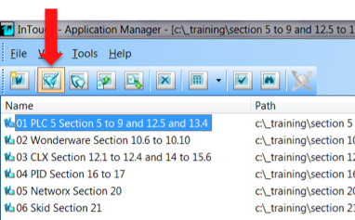

Figure Selecting the WindowMaker Icon

## Tagname Dictionary

The Tagname Dictionary in Wonderware Development (Window Maker) is basically a list of the Tags that have been created and saved in alphabetical order by tagname. It can be used to look up any existing tagname and view its properties and assignments. These properties can also be accessed by clicking “Ctrl” and “E” when selecting an object in Window Maker. To access the Tagname Dictionary, go to the “Special” selection in the top toolbar in Window Maker and select “Tagname Dictionary” from the menu as shown in Figure 93. This will bring up the window shown in Figure 94.

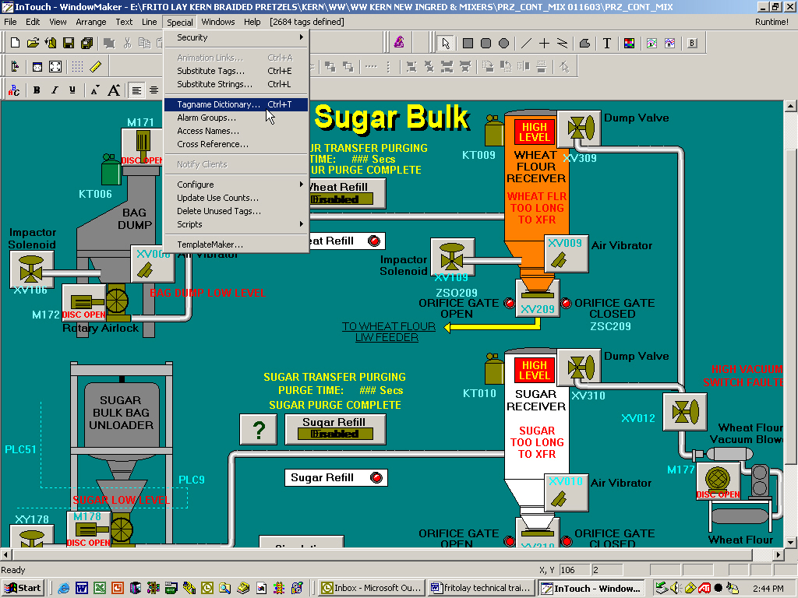

Figure : Accessing the Tagname Dictionary.

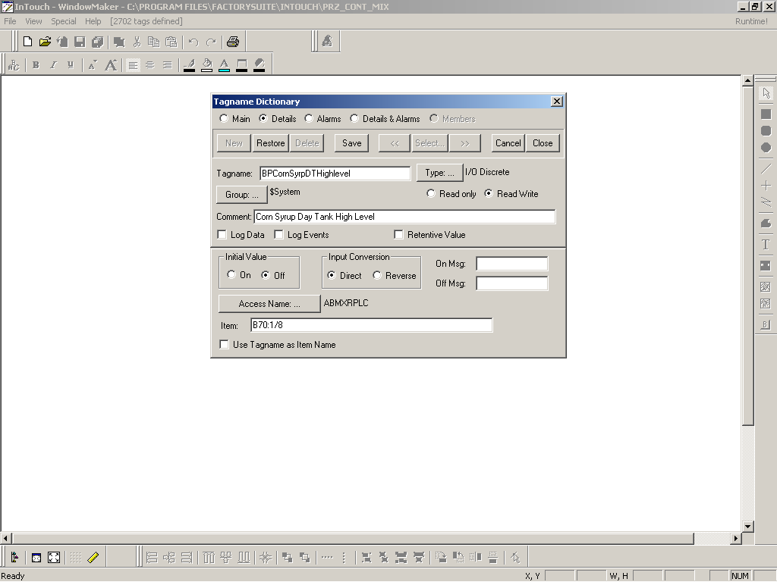

Figure : Tagname Dictionary – I/O Discrete Tag.

To access the list of Tags available in the Tagname Dictionary, click on the “Select” button in the upper right area of the Tagname Dictionary window. This will bring up the window shown in Figure 95.

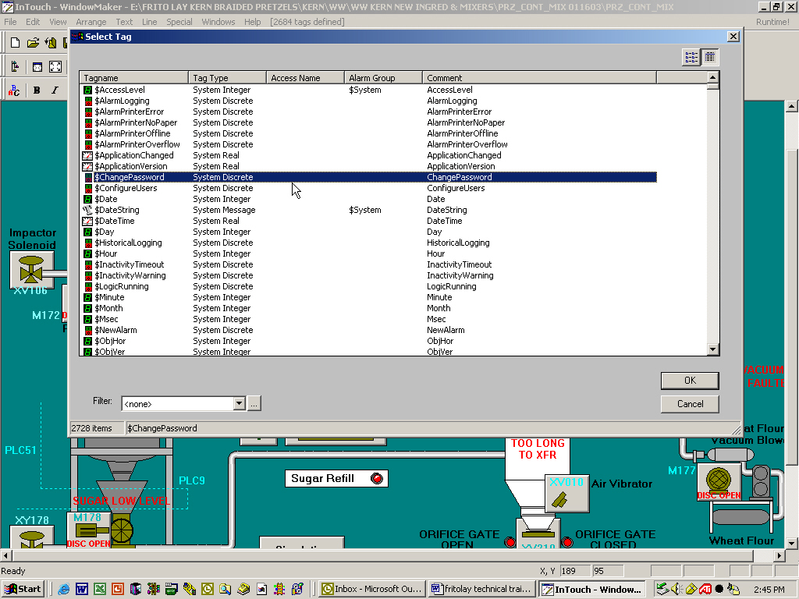

Figure : Tagname Dictionary – Tag List.

### I/O Tags and PLC Addresses

I/O Tags are used to read and write to addresses in a PLC. The Access Name identifies which PLC is referenced and the item name identifies which address is referenced as pictured in Figure 96.



Figure : Tagname Dictionary – I/O Discrete Tag Shown in Window.

### Scaling

I/O Integer and I/O Real tags can be scaled using the Min EU, Max EU, Min Raw, and Max Raw fields. The Min Raw and Max Raw fields identify the range represented in the PLC register which is referenced. The Min EU and Max EU represent the range displayed in Wonderware. The Raw range and EU (Engineering Unit) range should be set to the same values so no scaling is performed in Wonderware.

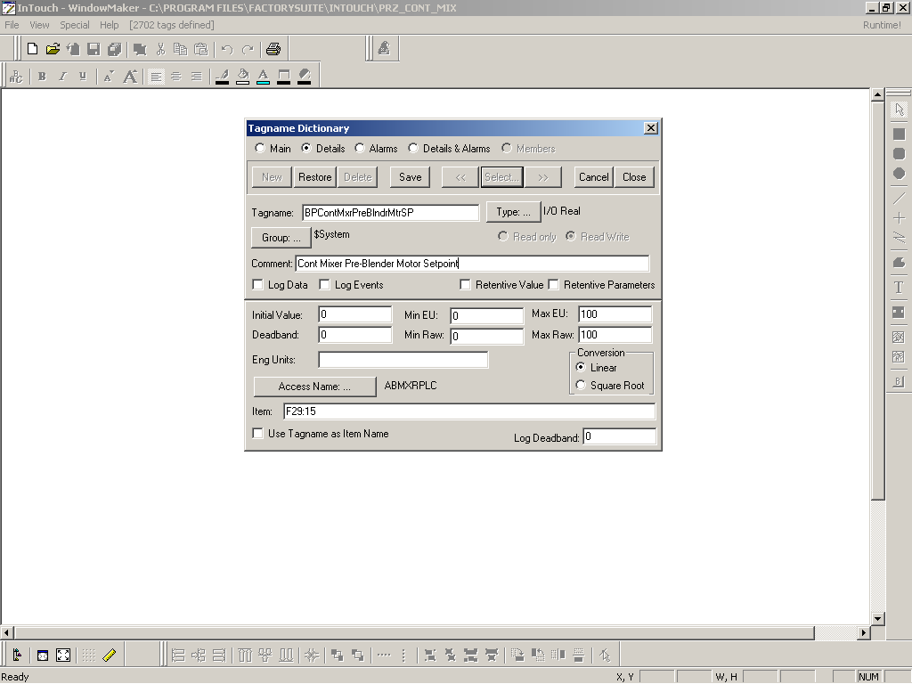

Figure 87. Tagname Dictionary – I/O Real Tag.

### Referencing Tag Fields

Tagnames have certain “attributes” which can be referenced. For example, if an analog, alarmed tagname is created called "Analog_Tagname," it will have "attributes" associated with it such as its name, HiHi alarm setpoint, and so on. Some of these "attributes" are accessible within InTouch through scripts, expressions and user inputs and are known as dot fields. The syntax required to access these data fields associated with a tagname is Tagnamedot field.

For example, to allow runtime changes to the HiHi alarm limit on tagname "Analog_Tagname," you could create an Analog - User Input touch link and apply it to a button that is defined with the expression Analog_Tagname.HiHiLimit. In Runtime, the operator would simply click the button and type in a new value for the HiHi alarm limit being used for "Analog_Tagname. Figure 97 shows the Field Name Select Window. These are the tag attributes available for use.

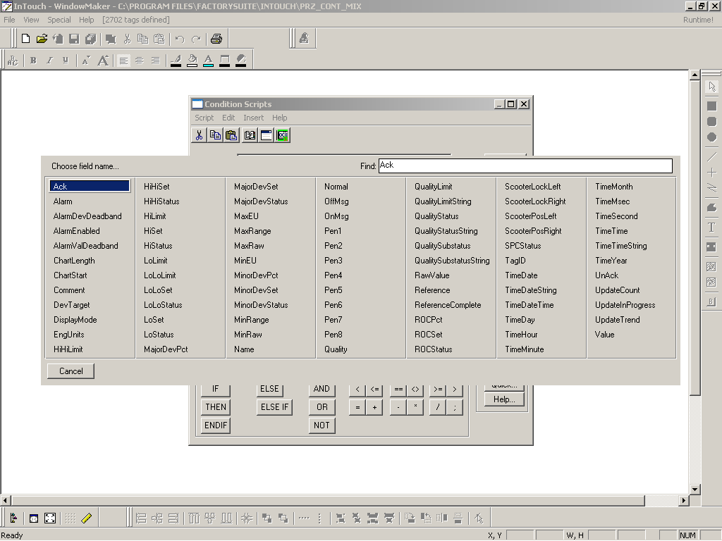

Figure : Field Name Select Window.

### Referencing Bits within an I/O Integer Tag

In the same way in which Tag Fields can be referenced, individual bits in an I/O Integer Tag can be referenced. This is how a single I/O Integer Tag is utilized for motor and device control per a customer standard. Individual bits are referenced in the control pop-up to accomplish discrete functions as shown in .

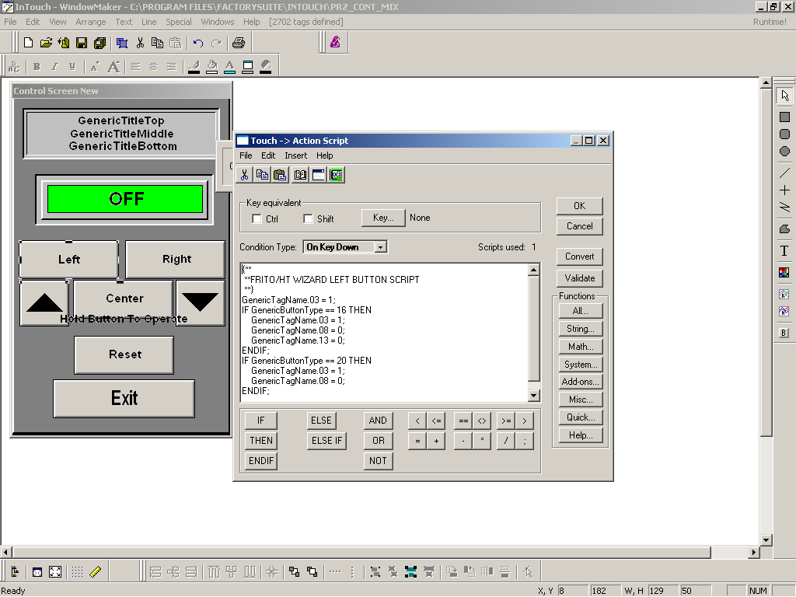

Figure : Standard Customer Device Control Popup – Action Script.

In the example in , bit 3 is set to a value of 1 when the left button is depressed. Bit 3 is the “Motor Forward Manual On Command” per a customer’s programming standard. Bit 8 is the “Motor Reverse Manual On Command” and bit 13 is “Motor Process Fault”.

## 10.5 LAB - Wonderware – Finding digital and analog I/O in the PLC from a Wonderware tag

This lab will provide practice in determining which I/O point on a PLC is associated with a particular Wonderware Tag. The lab is designed for you to work with a partner so that you can each take a turn at tracing a Wonderware tag all the way through to a PLC I/O point. In the first exercise, one partner will perform each task while the other observes and fills in the requested blanks on this hand out. In the second exercise, each partner will switch roles.



### Exercise #1

1. With Window Viewer running, hold down the <ALT> <SHIFT> and <1> key. This will start Window Maker if it is not already running and open the currently displayed screen.
2. Hold down the <SHIFT> key and drag a box using your mouse to select a numeric display. Once the desired display field is selected, double-click on it. The “Substitute Tagnames” window will be displayed showing the tag name connected to the selected field. Record this tag name in the field below.

Tag Name: ______________________________________________________

1. Double-Click on the tag name using the mouse. The “Tagname Dictionary” is displayed which shows all of the information defined for the selected tag. Record the Access Name and Item in the field below.

Access Name: ____________________________________________________

Item: ___________________________________________________________

1. Start RSLogix 5 if it is not already running and connect to the on-line processor.
2. Select “Search”, then “Find” from the Menu bar at the top of the screen. In the “Find What:” field, enter the Item name recorded in step 3 and select “Find All”. Click on each result in the “Output Window” and search the logic to determine from which register the data originates. Continue searching as needed until the PLC I/O point can be determined. Record each instruction and PLC address below to chart the flow of data.

Instruction (MOV, MUL, ADD, etc.) Register Address

______________________________ ______________

______________________________ ______________

______________________________ ______________

______________________________ ______________

______________________________ ______________

### Exercise #2

1. Return to Window Viewer and, with it running, hold down the <ALT> <SHIFT> and <1> keys. This will open the currently displayed screen.
2. Hold down the <SHIFT> key and drag a box using your mouse to select a numeric setpoint button. Once the desired setpoint field is selected, hold down the <CTRL> and <E> keys. The “Substitute Tagnames” window will be displayed showing the tag name connected to the selected setpoint field. Record this tag name in the field below.

Tag Name: ______________________________________________________

1. Double-Click on the tag name using the mouse. The “Tagname Dictionary” is displayed which shows all of the information defined for the selected tag. Record the Access Name and Item in the field below.

Access Name: ____________________________________________________

Item: ___________________________________________________________

1. Start RSLogix 5 if it is not already running and connect to the on-line processor.
2. Select “Search”, then “Find” from the Menu bar at the top of the screen. In the “Find What:” field, enter the Item name recorded in step 3 and select “Find All”. Click on each result in the “Output Window” and search the logic to determine to which register the data is mapped. Continue searching as needed until the PLC I/O point can be determined. Record each instruction and PLC address below to chart the flow of data.

Instruction (MOV, MUL, ADD, etc.) Register Address

______________________________ ______________

______________________________ ______________

______________________________ ______________

______________________________ ______________

______________________________ ______________

## InTouch Scripts

### Application Scripts

Application scripts are linked to the entire InTouch application. Since all scripts are event driven, application scripts are application specific in order of processing events, such as executing data change scripts, condition scripts, etc. Application scripts can also be used to start other applications, create process simulations, calculate variables, handle recipe information and many other cases.

The On Startup script executes one time when the application is initially started up and before any window opens or any runtime initialization occurs. I/O communications are also initialized after the On Startup script is executed. ActiveX methods, properties or events cannot be referenced in an On Startup script nor can I/O type tagnames or remote tagname references. An example of the On Startup script is pictured in Figure 99.

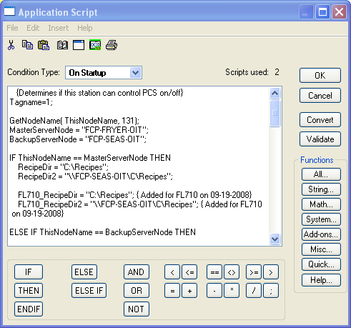

Figure : Application On Startup Script.

The While Running script executes continuously at the specified frequency while the application is running. Once selected, the Every Milliseconds box becomes active and the Controls Specialist can type the number of milliseconds to elapse before the script executes. An example of the While Running script is shown in Figure 100.

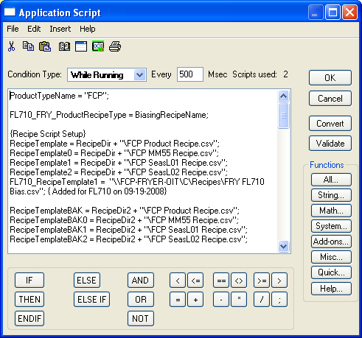

Figure : Application While-Running Script.

The On Shutdown script executes one time when the application is exited. I/O type tagnames and remote tagname references will not update in an On Shutdown script. Also, an On Shutdown script cannot be used to startup other applications in InTouch.

### Condition Scripts

Unlike application scripts, condition scripts are linked to a discrete tagname or expression that equates to true or false. Discrete expressions that contain analog tagnames can also be used.

The On True script executes one time when the condition transitions to true. In other words, the value for this condition must equal to one before the script will execute. For example, if the initial value when WindowViewer starts is true, the value must become false and then true again for an On True script to execute. Examples of the On True script can be seen in

Figure 101 through .

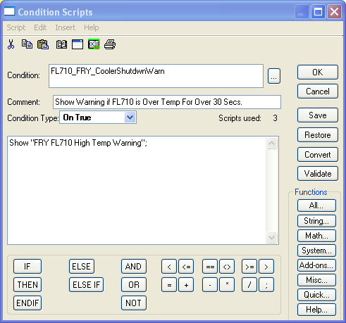

Figure : On True Condition Script.

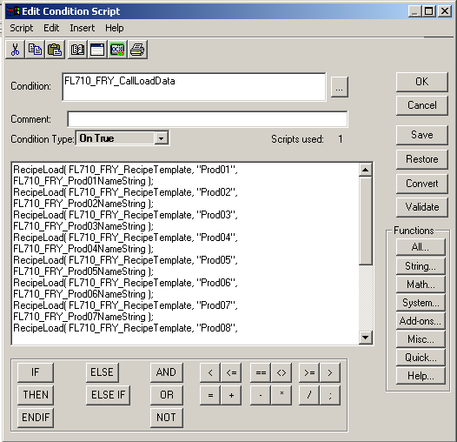

Figure : Call Load Data Condition “On True” Script.

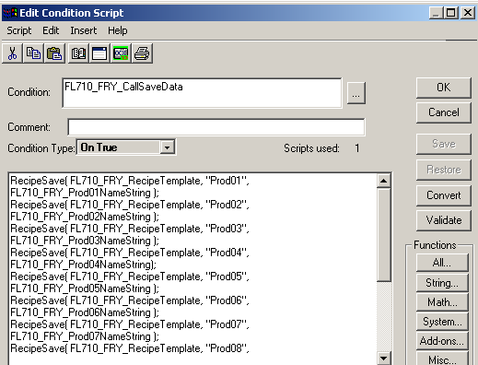

Figure : Call Save Data Condition “On True” Script.

The On False script executes one time when the condition transitions to false. In other words, the value for this condition must equal to zero before the script will execute. For example, if the initial value when WindowViewer starts is false, the value must become true and then false again for an On True script to execute. An example of the On False script is shown in Figure 104.

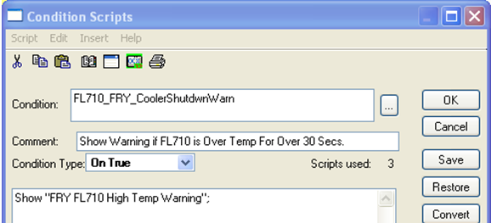

Figure : On False Condition Script.

The While True script executes continuously while the condition remains true and will begin executing after 1000 milliseconds have elapsed. An example of the On False script is shown in Figure 105.

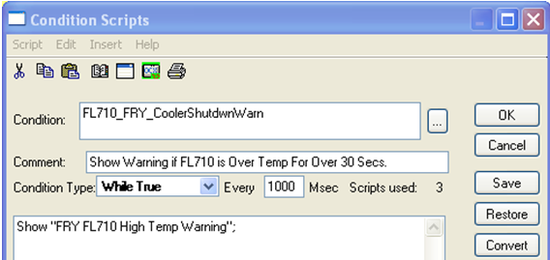

Figure : While True Condition Script.

The While False script executes continuously while the condition remains false and will begin executing after 1000 milliseconds have elapsed.

### Window Scripts

Window scripts are script tied to specific windows. There are three types of Window scripts.

1. **On Show**
2. **While Showing**
3. **On Hide**

The On Show script executes one time when the window is initially shown. Examples of the On Show script are shown in Figure 106 and Figure 107.

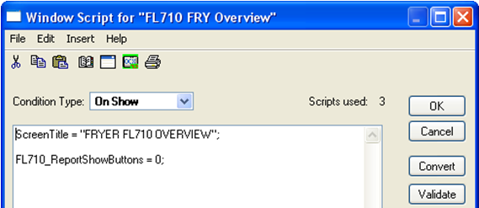

Figure : On Show Window Script.

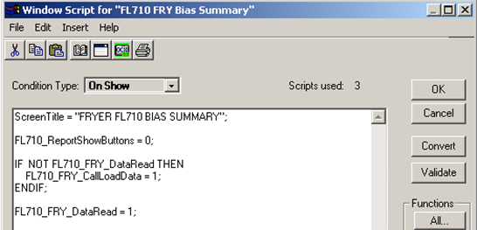

Figure : On Show Window Script

The While Showing script executes continuously at the specified frequency while the window is showing. Examples of the While Showing script are shown in and Figure 109.

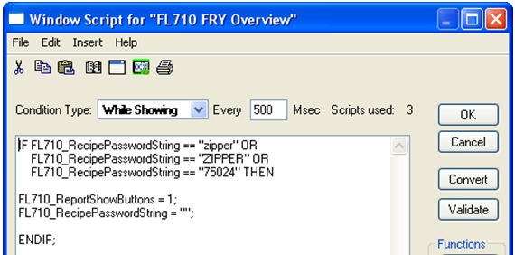

Figure : While Showing Window Script.

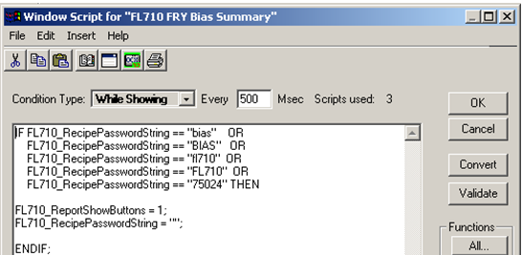

Figure : While Showing Window Script.

The On Hide script executes one time when the window is hidden. Examples of the On Hide script are shown in and Figure 111.

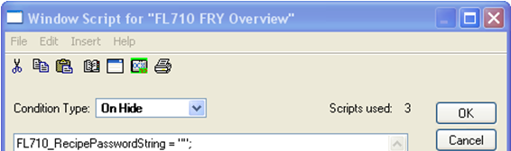

Figure : On Hide Window Script.

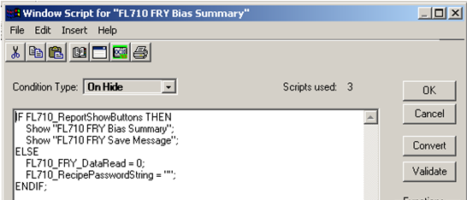

Figure : On Hide Window Script.

### Data Change Scripts

Data Change scripts are tagname and/or tagname dotfield specific and execute one time when the value of the tagname or tagname.field changes by a value greater than the deadband defined for the tagname in the Tagname Dictionary. They are executed when a data value changes and require a specific tagname or tagname.field in the Tagname[.field] box. A Data Change Script can be seen in Figure 112.

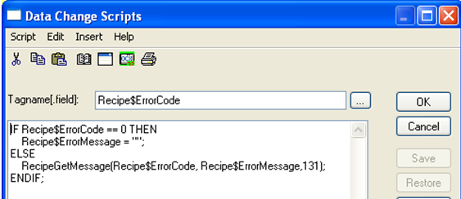

Figure : Data Change Script.

### Key Scripts

Key scripts are linked to a certain key or combination of keys on the keyboard and can be used to create global keys for an application. An example of the On Key Down script is shown in Figure 113.

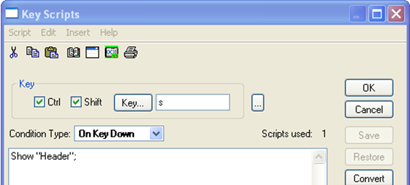

Figure : “On Key Down” Script.

The While Down script executes continuously at the specified frequency while the key is held down and the On Key Up script executes one time when the key is released.

### Special Cases

Scripts may also be used in InTouch to accomplish other goals not achieved through use of the PLC code, such as alarming. Scripts have been added to some applications to acknowledge all alarms in one area of a line. An example of this script is shown in through and .

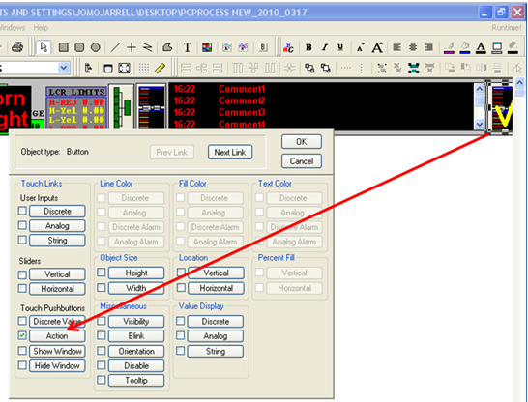

Figure : Touch Pushbutton Action Animation Link.

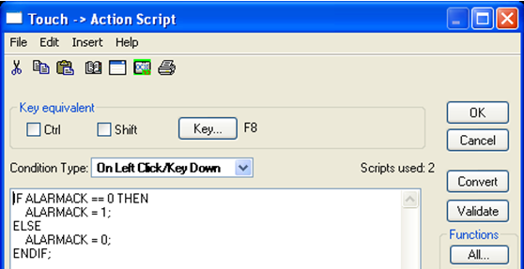

Figure : Alarm Acknowledgement Action Script (On Left Click/Key Down).

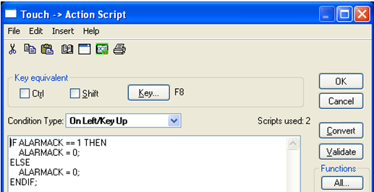

Figure : Acknowledgement Action Script (On Left Click/Key Up).

Another instance would be to create an Application On-Startup script to set off a bit within the PLC to turn on an alarm horn and light. An example of this script is pictured in Figure 117.

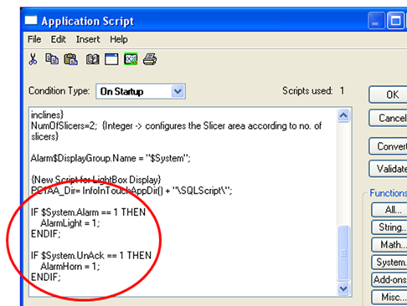

Figure : Alarm Horn and Light Script.

## Wonderware Data Base (DB)

Reference Items in folder – “Section 10.6 To 10.10 - Wonderware Labs” for examples and additional information

### DB Dump

DB Dump is a Tagname Dictionary utility and is used to export an InTouch application Tagname Dictionary as a text file that can be viewed or edited in another program such as Microsoft Excel. Once the database is exported in the text file, it can be copied, modified or developed in separate portions and is very useful when cross-referencing tags and PLC addresses. To access the DB Dump utility, double-click on the InTouch Icon, then click on the DB Dump icon in the Application Manager or select File from the Menu Bar of the Application Manager and select DB Dump from the drop down menu.

### DB Load

DB Load is also a Tagname Dictionary utility which allows a properly formatted Tagname Dictionary file (created in another program such as Excel or a DB Dump file from another InTouch application) to be loaded into an existing InTouch application. It can also be used as an alternative to the InTouch TemplateMaker to create SuperTag instances. To access the DB Load utility, double-click on the InTouch Icon, then click on the DB Load icon in the Application Manager or select File from the Menu Bar of the Application Manager and select DB Load from the drop down menu.

### Modifying an Alarm Comment Using DB Dump and DB Load Utilities

This exercise will prepare the Controls Specialist on how to utilize the DB Dump and DB Load tools to modify an alarm comment of an existing tag in InTouch. Therefore, the changes can be applied by following the steps listed below. These steps may also be applied when adding tags to an InTouch application.

* + 1. To modify an existing tag in an existing CSV file, open InTouch and click on the DB Dump icon in the Application Manager as shown in Figure 118.



Figure : DB Dump Icon.

* + 1. Once selected, the Controls Specialist will be prompted to name the CSV file as well as choose the directory where the database will be stored as shown in Figure 119.

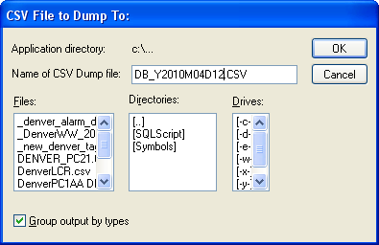

Figure : DB Dump Display.

* + 1. Name or choose a file to be dumped from the Files menu on the left-hand side of the DB Dump display, select the drive and directory of the file to be stored and then click OK. A dump successful display should appear as shown in Figure 120.

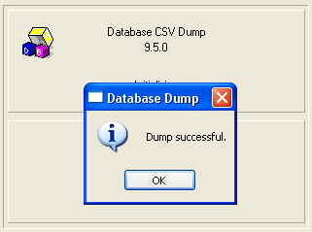

Figure : DB Dump Successful Display.

* + 1. Next, open the WW folder and search for the dumped CSV file and open it as shown in Figure 121.

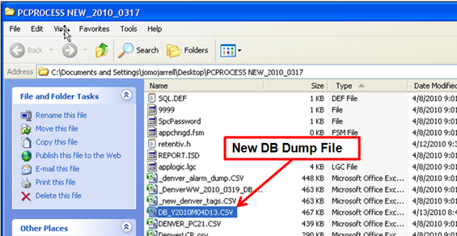

Figure : New DB Dump File.

* + 1. After opening the new DB Dump file, locate where the tag(s) need to be added, deleted, and/or modified. The next example will cover how to modify an alarm comment of an existing tag within the DB Dump file. Notice in Figure 122, column R, line 133, the alarm comment is in all capital letters, but only the first letter of each word needs to be capitalized. Therefore, the Controls Specialist would select the alarm comment in line 133 and modify as shown in Figure 123.

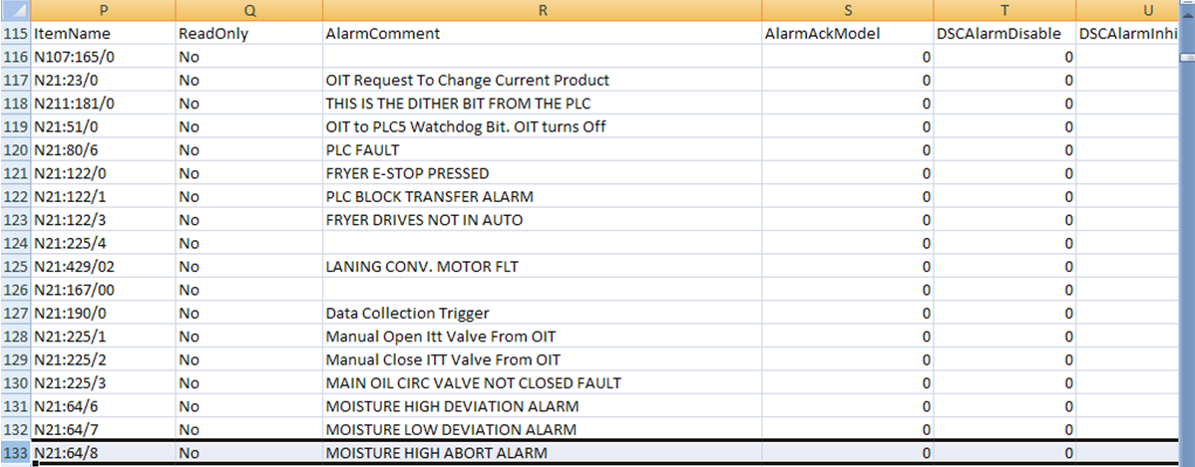

Figure : Capitalized Alarm Comment.

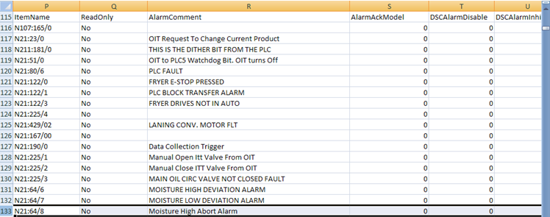

Figure : Modified Alarm Comment.

* + 1. Once the alarm comment is modified, save the dumped file with today’s date and the current time. Then use the DB Load utility to import the modified dumped file into the WW application. Open InTouch and click on the DB Load icon in the Application Manager as shown in Figure 124.



Figure : DB Load Icon.

* + 1. The Controls Specialist will be prompted to backup the existing application. See Figure 125.

**\*\*Note: Be sure to make a backup copy of all applications before making modifications.)**

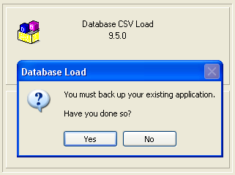

Figure : DB Load Backup Application Display.

* + 1. Click on yes and a second display will appear similar to the display that appeared in the DB Dump. See Figure 126.

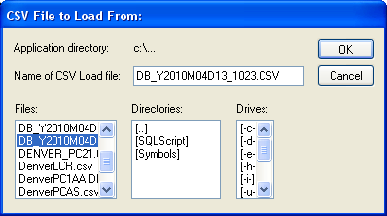

Figure : DB Load Display.

* + 1. Select the new CSV file to be loaded from the Files menu on the left-hand side of the DB Load display, select the drive and directory of the file to be stored and then click OK. A load successful display should appear as seen in Figure 127.

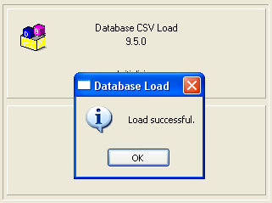

Figure : DB Load Successful Display.

* + 1. Next, open the WW application by double-clicking on the InTouch icon, selecting the correct application from the Application Manager as shown in Figure 128.

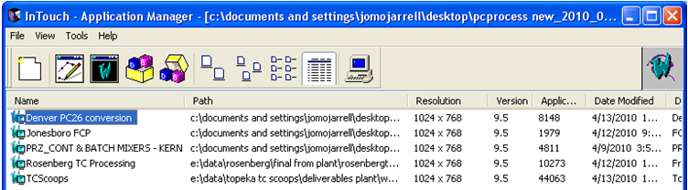

Figure : InTouch Application Manager.

* + 1. Double-click on the application or click on the WindowMaker Icon to open and a select “Windows to Open” display will appear as shown in Figure 129.

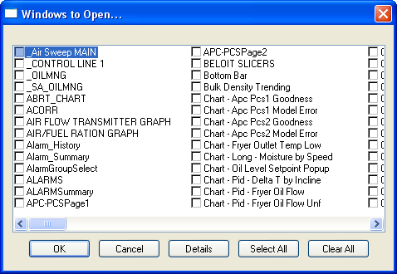

Figure : “Windows to Open” Display.

* + 1. Click on Cancel and access the Tagname Dictionary. To access the Tagname Dictionary, select Special from the Menu Bar and scroll down to Tagname Dictionary or press the Ctrl + T keys simultaneously or press the Alt + S keys, then press the N key and the Tagname Dictionary display will appear as shown in Figure 130.

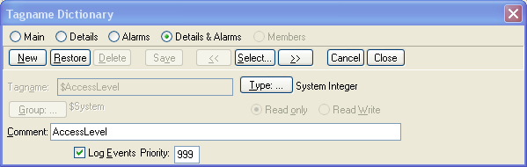

Figure : Tagname Dictionary Display.

* + 1. Select Details & Alarms at the top of the display, then press the Select button and the complete Tagname Dictionary list will appear as shown in Figure 131.

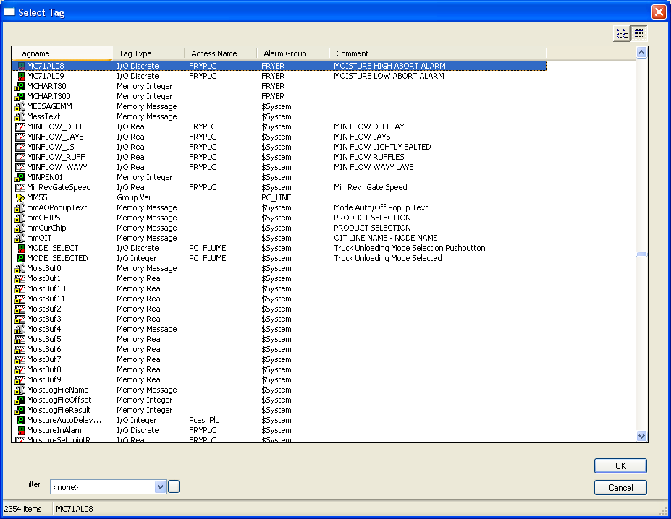

Figure : Tagname Dictionary List.

* + 1. Search for the modified tag in the Tagname Dictionary and verify that the alarm comment has been changed as shown in Figure 132.

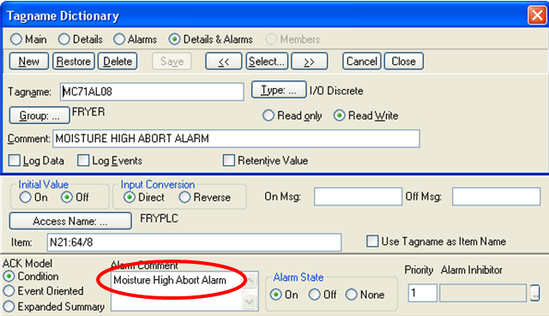

Figure : Modified Alarm Comment.

## 10.8 Wonderware Lab: Modifying an Alarm

Modifying the alarm comment of an existing tag in Wonderware using the DB dump and DB load utilities

In this exercise, modify the alarm comment of an existing tag in the InTouch application. Utilize the DB Dump tool to export the tags within the application, modify the alarm comment from all capital to both upper and lower case letters, and use the DB Load utility to import the tags back into the application. Then, open the InTouch application to verify the alarm comment has changed. Use the Denver PC26 Conversion application in the InTouch Application Manager. Here are some of the details needed:

1. Open the Denver PC26 Conversion application in the InTouch Application Manager.
2. Use the DB Dump Utility to export the tags contained within the application.
3. Name the CSV file with today’s date. BE SURE to dump the file inside of the PCPROCESS NEW_2010_0317 folder.
4. Open the PCPROCESS NEW_2010_0317 folder, locate and open the CSV file.
5. Find a tag that has an alarm comment in all capital letters associated with it.
6. Modify the alarm comment using both upper and lower case letters, and Save As today’s date and current time.
7. Use the DB Load utility to import the CSV file into the application.
8. Open the Tagname Dictionary, search for the modified tag and verify the alarm comment has changed.

## 10.9 Troubleshooting a Database Dump and Database Load Failure

When an unsuccessful Database Dump or Database (DB) Load occurs, the ArchestrA Log Viewer is useful for troubleshooting errors. The ArchestrA Log Viewer is a utility within the ArchestrA System Management Console (SMC). SMC supports:

* Generic DAServer error messages.
* ABCIP-DAServer error messages.
* ABTCP-DAServer error messages.
* Controller-specific error messages.

These error messages are sent to the Log Viewer. The Log Flag data tool can be used to customize the type of messages logged to the Log Viewer and see the Log Viewer documentation for more information about using log flags.

* + 1. To access the Log Viewer, double-click on the System Management Console Icon shown in .

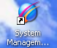

Figure : System Management Console Icon.

* + 1. Expand the Log Viewer menu as shown in .

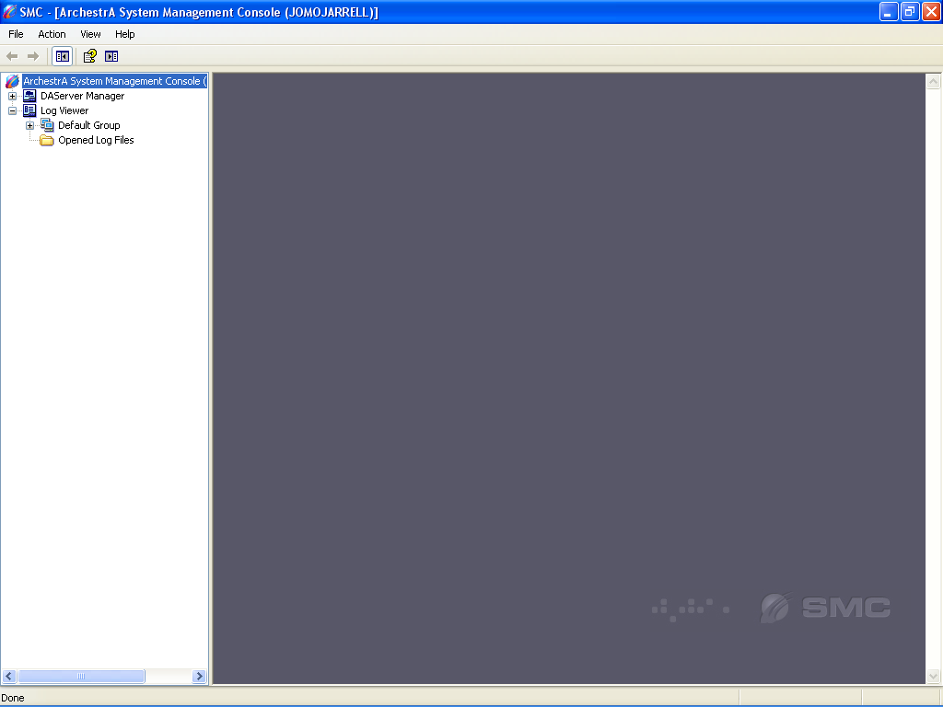

Figure : Log Viewer Menu Expanded.

* + 1. Expand the Default Group menu as shown in .

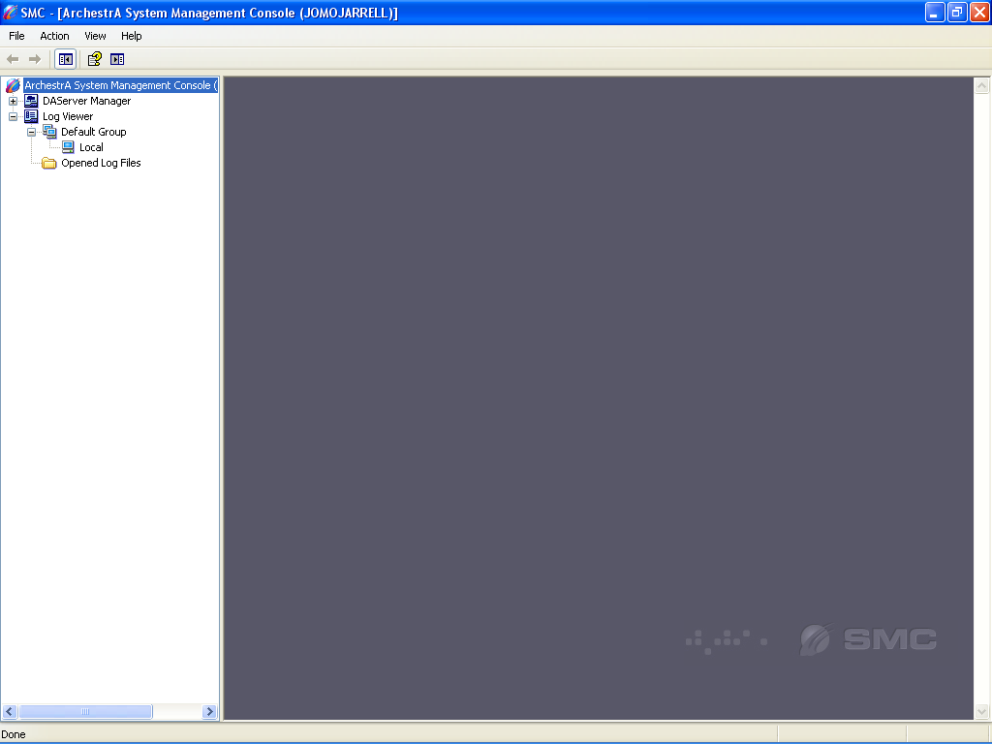

Figure : Default Group Menu Expanded.

* + 1. Click on Local and scroll down the Message List to locate the error as shown in .

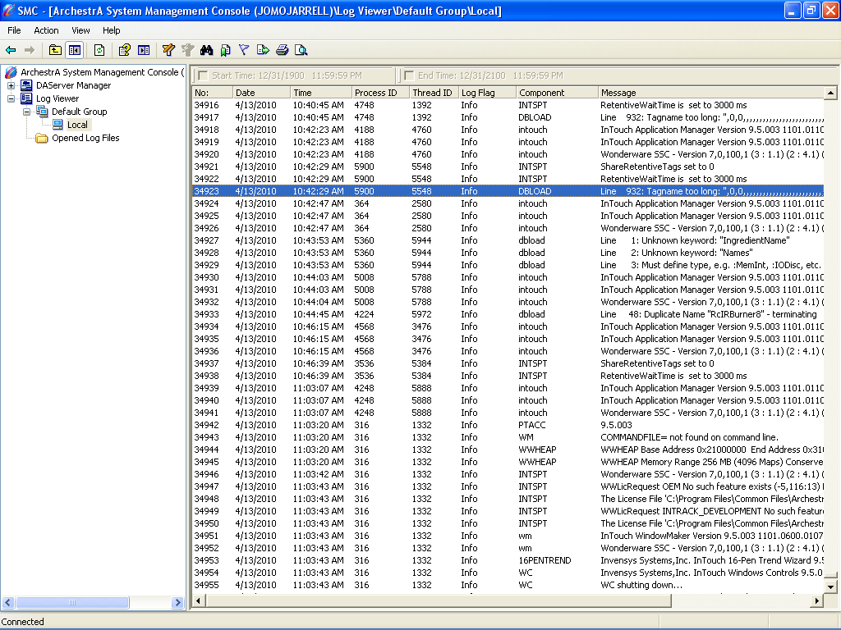

Figure : Log Viewer Error Message.

## 10.10 Using the Cross Reference Utility to Locate PLC Addresses in InTouch

The Cross Reference utility is useful when searching for PLC addresses in InTouch while troubleshooting. It helps to locate a tag in the Tagname Dictionary based on the PLC address. The controls specialist can use the Cross Reference utility to locate areas (windows, scripts, animation links, etc…) where tags are used. The following steps will walk the controls specialist on how to utilize the Cross Reference tool to locate a tag in InTouch based on a PLC address.

1. Open the PLC program and locate the desired bit as shown in Figure 137. This example focuses on an alarm bit from an RSLogix 5 program.

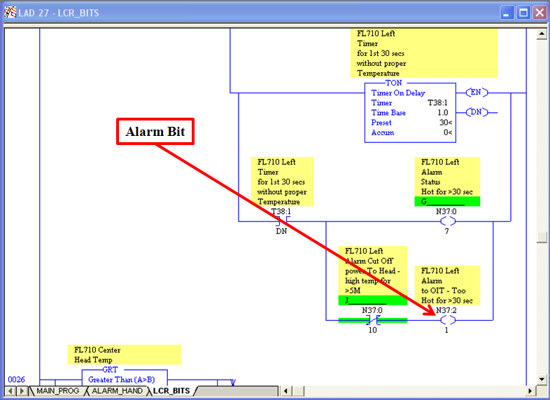

Figure : PLC Alarm Bit.

1. Double-click on the alarm bit to highlight the address as shown in Figure 138.

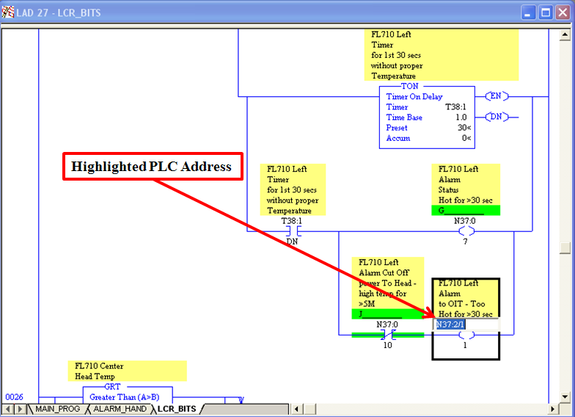

Figure : Highlighted PLC Address.

1. Copy the PLC address, open the DB Dump file associated with the RSLogix 5 program and highlight the entire CSV file by clicking on the icon located next to column A of the spreadsheet as seen in Figure 139.

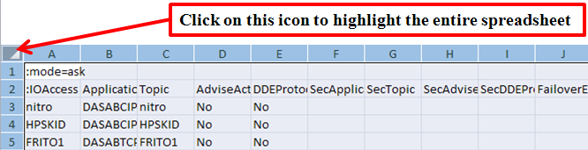

Figure : Highlighted CSV File.

1. Double-click between columns A and B to maximize the column sizes as pictured in Figure 140.

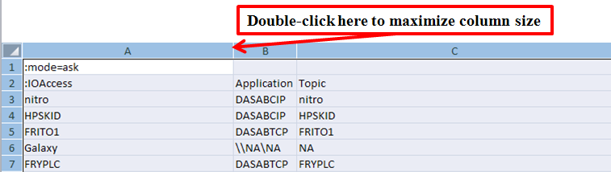

Figure : Maximized Column Size.

1. Click on the Find & Select icon located on the upper right-hand side of the spreadsheet, scroll down to Find, left click on the mouse and paste the PLC address into the slot labeled “Find What” as displayed in Figure 141.

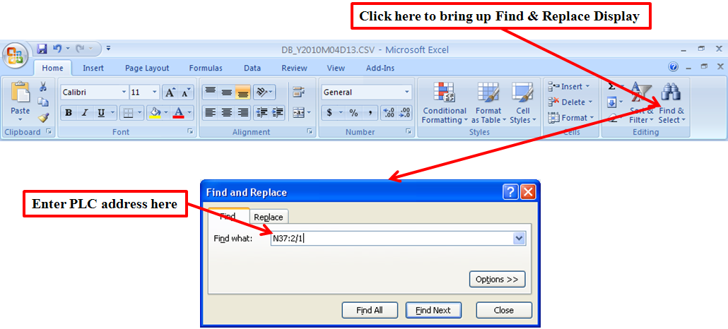

Figure : Find and Replace Display.

1. Click on the Find All button on the display and all tags which have the PLC address will appear as pictured in Figure 142.

**\*\*NOTE: The PLC address may need to be modified if it is NOT recognized in Excel. (i.e. N37:2/1 in the PLC code is equivalent to N37:002/01 in Excel).**

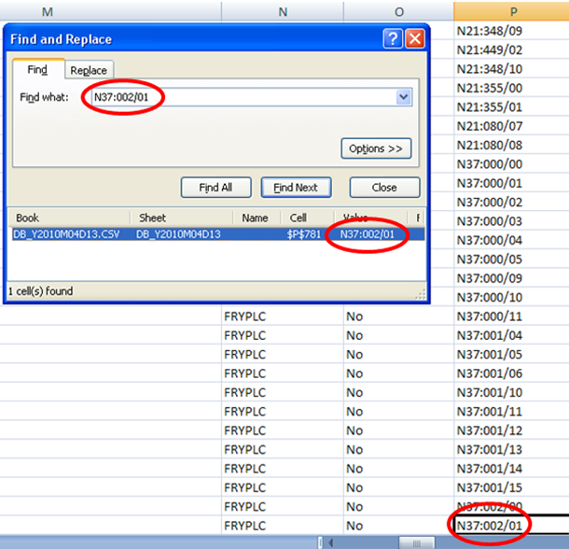

Figure : PLC Addresses Found in CSV File.

1. Scroll to the left-most column for the tagname associated with the address as shown in Figure 143.

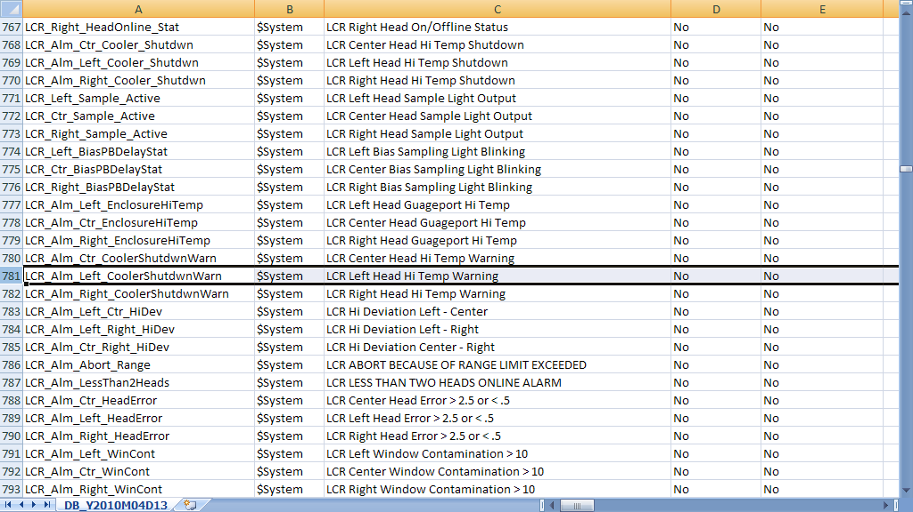

Figure : Tagname Associated with PLC Address.

1. Copy the tagname (in this case it would be “LCR_Alm_Left_CoolerShutdwnWarn”), open InTouch and access the Cross Reference utility by selecting Special from the Menu Bar, scroll down the menu and select Cross Reference, or press the Alt + S keys, then press the F key as shown in Figure 144.

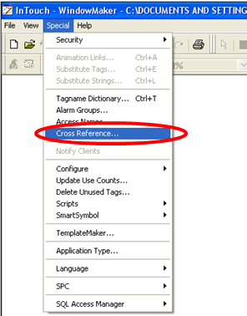

Figure : Accessing the Cross Reference Utility.

1. Paste the copied tagname in the Filter slot of the display, choose whether to search for all or specified occurrences and click the Search button at the bottom of the display can be viewed in Figure 145.

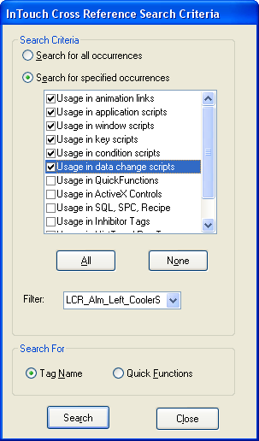

Figure : Cross Reference Utility Display.

1. Once the Cross Reference utility has completed its search, another display containing the occurrences will appear. This display allows the user to locate exactly where the tag is used as shown in Figure 146.

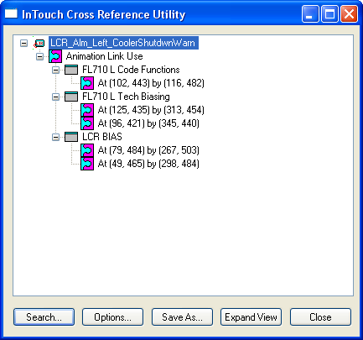

Figure : Links to Where the Tagname is Used.

1. Notice that the tagname is used in three animation links on three windows. The Controls Specialist can open any or all of the three windows and use the coordinates to locate the animation link that uses the tagname as displayed in Figure 147.

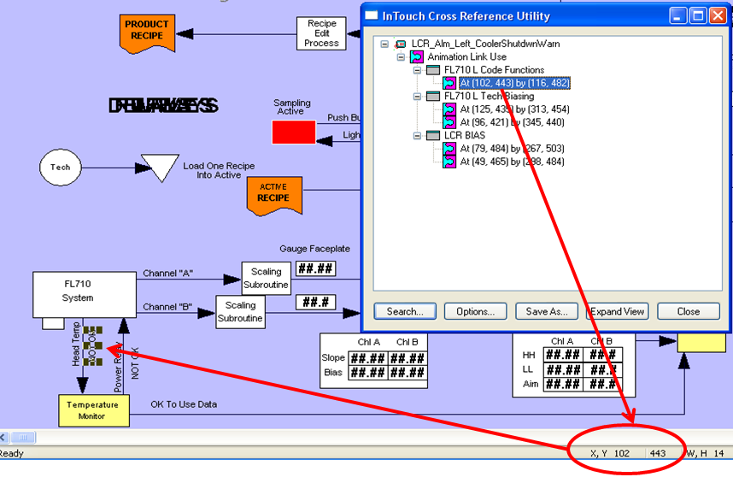

Figure : Animation Link Coordinates.

1. To access the Animation Link attributes, double-click on the NOT OK Animation Link, or highlight the Animation Link and press the Ctrl + A keys or press the Alt + S keys, then press the A key or scroll down the menu and select Animation Links. The Animation Link display will appear as shown in Figure 148.

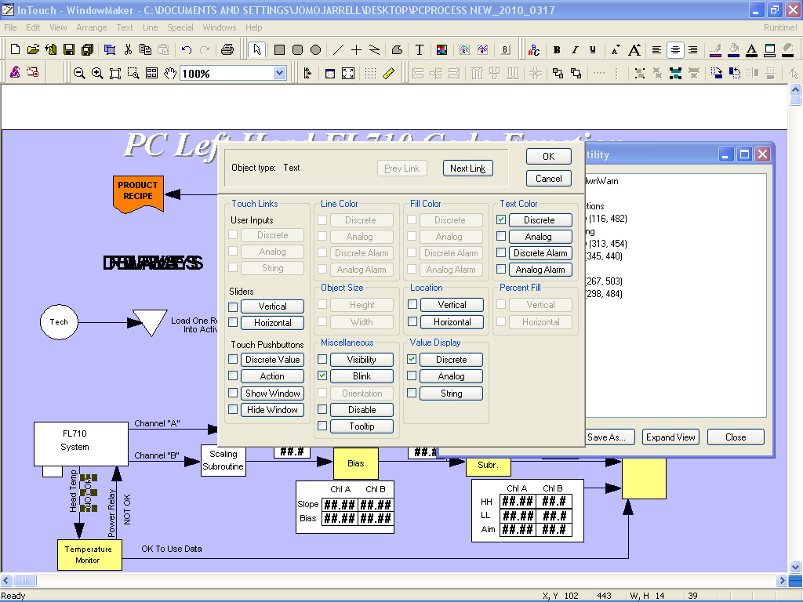

Figure : Animation Link Display.

There are three attributes used for the animation link:

* Blink.
* Discrete Text Value Display.
* Discrete Text Color.

1. Click on the Blink attribute. Notice that there are two tags associated with this display, including the tagname “LCR_Alm_Left_CoolerShutdwnWarn” as shown in Figure 149. When the alarm state is high for either of the two tags, the “NOT OK” animation link will begin to blink.

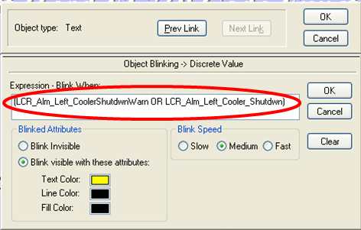

Figure : Blink Attribute.

1. Now, click on the Discrete Text Value Display attribute. The same two tags are included in this attribute, including the tagname “CR_Alm_Left_CoolerShutdwnWarn” as shown in Figure 150. When either of these two tags are in an alarm state, NOT OK will display on the screen. Otherwise, OK will display on the screen.

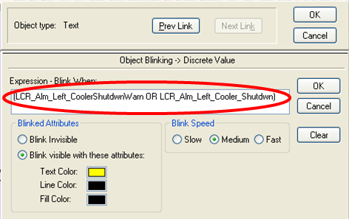

Figure : Discrete Text Value Display Attribute.

1. Next, click on the Discrete Text Color Display attribute. Again, the two tags are included in this attribute, including the tagname “LCR_Alm_Left_CoolerShutdwnWarn” as shown in Figure 151. When the alarm state is high for either of the two tags, the text color displayed would be red. Conversely, the text color displayed would be green when the alarm state is low for either of the two tags.

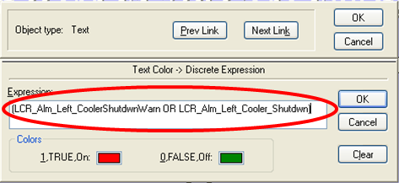

Figure : Discrete Text Color Display Attribute.

## 10.11 LAB - Wonderware - Locate a Tag in InTouch based on PLC Address

Reference Items in folder – “Section 10.6 To 10.10 - Wonderware Labs” for examples and additional information

In this exercise, locate an address in RSLogix 5, utilize the DB Dump utility to export the tags to a CSV file, reference the tagname used in the InTouch application using the PLC address, and use the Cross Reference utility to reference where and how the tagname is used throughout the application. Use the DENVER_PC.RSP application in RSLogix 5 and Denver PC26 Conversion application in InTouch. All additional instructions will be provided by the instructor.

## 10.12 DA Servers

Wonderware DA Servers leverage industry standards-based ArchestrA technology, Wonderware’s SuiteLink protocol, OPC technology and DDE to connect Wonderware software with third-party products and OPC-compliant devices and applications.  They also support simultaneous connectivity to multiple client nodes, enabling users to easily expand their existing supervisory HMI, SCADA and production and performance management applications.

Wonderware DA Servers incorporate advanced functionality through a user interface, facilitating local, remote, on-the-fly and hot configuration changes.  Users can add new devices and nodes to the network without taking the DA Server offline.  With these capabilities and support for runtime changes and robust server diagnostics, the DA Server simplifies system maintenance and administration.  Migration to enhanced DA Servers is designed to be a simple and seamless process. The DA Server does not require any Rockwell Software RSLinx package.

### DASABTCP Server

The Wonderware DASABTCP Server allows InTouch to access data in Allen-Bradley PLC’s such as SLC-500 series and PLC-5 over the Ethernet network. This server can be used as a DDE, SuiteLink, or OPC server to communicate with Wonderware InTouch applications or Windows programs capable of being a DDE, FastDDE, Suitelink, or OPC client.

### DASABCIP Server

**The Wonderware DASABCIP Server allows** client applications direct and indirect access to Allen-Bradley families of ControlLogix, GuardLogix, FlexLogix, CompactLogix, SoftLogix 5800 controllers.

## Configuring DAServers

This exercise will prepare the controls specialist on how to configure the DAServers. The DAServers play an important role in communication between InTouch and Allen-Bradley PLCs. Although only the DASABTCP Server is configured in this exercise, the DASABCIP Server is configured the same way

1. Double-click on the System Management Console icon as shown in Figure 152.



Figure : System Management Console Icon.

1. Expand DAServer Manager / Default Group / Local / ArchestrA.DASABTCP.1 / Configuration as shown in .

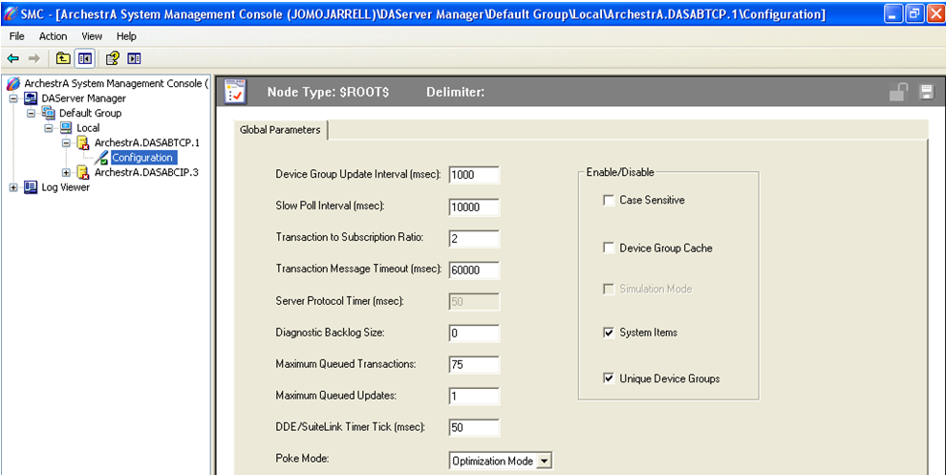Figure : ABTCP DAServer expanded menu.

1. Right-Click Configuration and select Add Port_TCPIP Object as shown in
2. Figure 154. A default name New_PORT_TCPIP_000 is assigned to the Ethernet port as shown in .

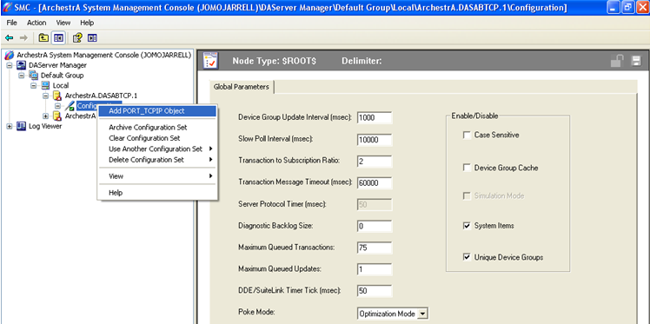

Figure : Adding New TCPIP Object.

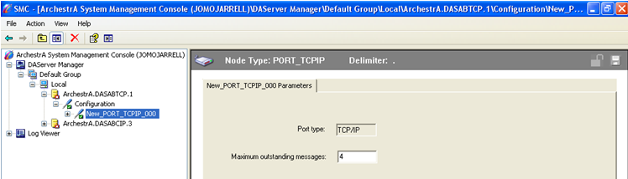

Figure : New TCPIP Object Parameters Configuration.

From this branch of the hierarchy, the PLC5_TCPIP (PLC5/20E through PLC5/80E), SLC500_TCPIP (SLC5/05 PLC), and PYRAMID_EI (Pyramid Integrator network) objects can be created.

1. Right-click on the New_PORT_TCPIP_000 branch and select AddPLC5_TCPIP Object as shown below in **Error! Reference source not found.**.

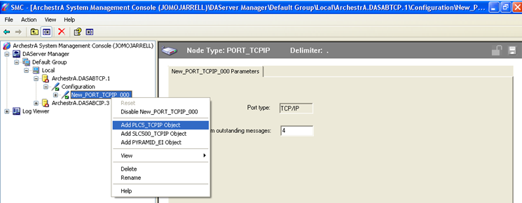

Figure Add a PLC5 TCPIP Object

1. On the New_PLC5_TCPIP_000 Parameters configuration view, enter either the PLC's host name OR IP address. Click the Apply button to implement the changes. After all modifications are made, save the changes to the configuration set. See Figure 157.

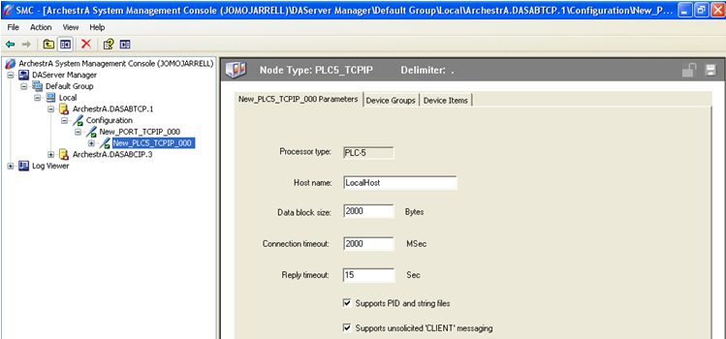

Figure : New PLC5_TCPIP Parameters.

1. **Host Name** is The Host Name OR IP Address of the PLC. The host name is defined in the host file which is used to resolve the PLC's host name and IP address.
2. **Data block Size** is the number of date bytes can be sent in a message.   
   Valid range for PLC5 and the pyramid are from 2 to 2000. For SLC500 PLC is from 2 to 510.
3. **Connection Timeout** is the time (in milliseconds) allowed to establish the connection to the PLC. Valid range is 1000 - 20000 msec.
4. **Reply Timeout** is the time (in seconds) the ABTCP DAServer is to wait for the acknowledgement after sending out a message. The DAServer will resend the message when the timeout is done. Valid range is 1 to 300 seconds.
5. Click on the Device Groups tab to create and configure device group definitions (also known as topic definitions). Right-Click in the Device Group area and use the context menu to add a new device group as shown in Figure 158.

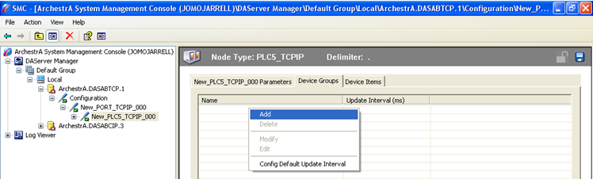

Figure : Device Groups Tab.

1. A default name (Topic_0) will be given to the new device group and it can be changed by clicking on the name (Topic_0) and enter a name (maximum 32-characters long). Click on the Save icon in the right-hand corner of the screen to implement the changes as shown in Figure 159.

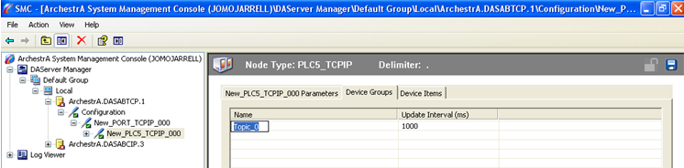

Figure : Changing the Topic Name.

**\*\*NOTE: The Update Interval can be changed (in milliseconds) by double-clicking on the number and modifying it. The update interval can be changed to help reduce the traffic in the network when there are multiple device groups in the list. Configure the group for unsolicited messages by setting the update interval to zero (0) millisecond.**

1. In the hierarchy tree on the left pane, right-click on ArchestrA.DASABTCP.1 and select Activate Server in the context menu to start the DAServer. The icon next to ArchestrA.DASABTCP.1 will change from red to green as shown in Figure 160.

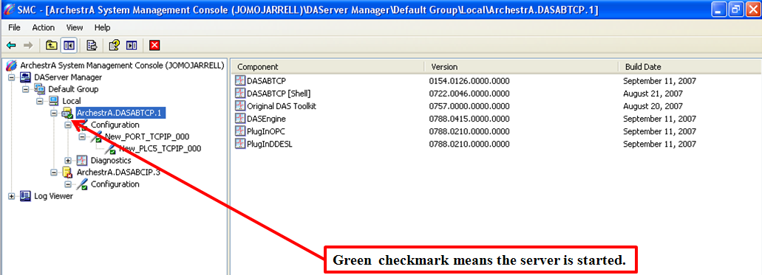

Figure : ABTCP Server Started.

## 10.14 LAB - Wonderware - Configuring the DASABTCP Server

In this exercise, configure the DASABTCP Server in the System Management Console. Use IP Address 192.168.1.150 as the Host Name and FRYPLC as the new Topic Name and leave the remaining parameters as default settings. All additional details will be provided by the instructor.

It is important to verify communication exists between the PLC and InTouch after configuring the DAServers. This ensures both are able to send and receive information to/ from one another. The controls specialist can check to see if communication exists between the two applications using the Diagnostics component within the System Management Console. The Diagnostics component contains six roots: Client Groups, Structure, Transactions, Statistics, Messages, and Device Groups. When the individual diagnostic roots or items contained in one are selected, the Details pane displays data for that root or item. Descriptive icons accompany each data element and indicate the quality of the information presented. The icon descriptions are as followed:

* Clock: Indicates that the data displayed on that line was not updated during the last update interval and the data item has just been scrolled into view. It is displayed until the next update interval, at which time it changes to one of the icons below.
* White: Initializing.
* Red: Error active.
* Yellow: Warning active.
* Green: Normal active.
* Red Marked: Bad Inactive.
* Yellow Marked: Warning Inactive.
* Green Marked: Normal Inactive.

## 10.15 Verifying Communication between the PLC and InTouch

This exercise will prepare the Controls Specialist on verifying communication exists between the PLC and InTouch using the System Management Console (SMC). This section will cover:

* Going online with the PLC application.
* Configuring the DASABTCP Server in the System Management Console.
* Check the communication status of the PLC and InTouch using the Diagnostics component within the System Management Console.
  + 1. Open the System Management Console and configure the DASABTCP Server using the IP Address 192.168.1.150 as the Host Name as shown in Figure 161.

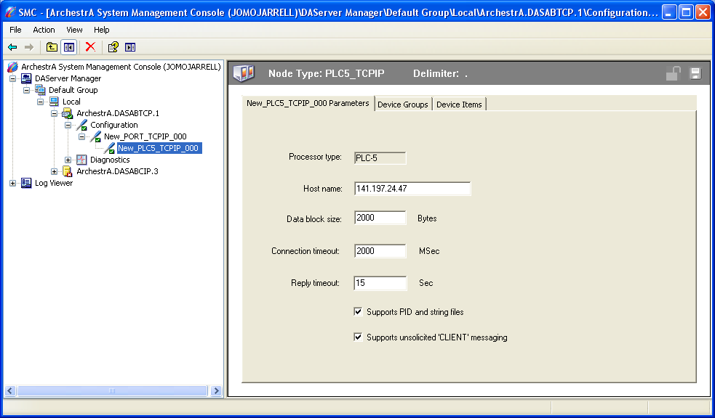

Figure : Configured ABTCP DAServer.

1. Click on the Device Groups tab and use FRYPLC as the Topic Name as shown in Figure 162. Save the configuration.

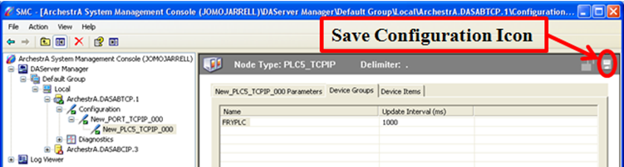

Figure : New Topic Name.

1. Expand the Diagnostics component and scroll down to Device Groups. Expand the Device Groups root and click on FRYPLC as shown in .

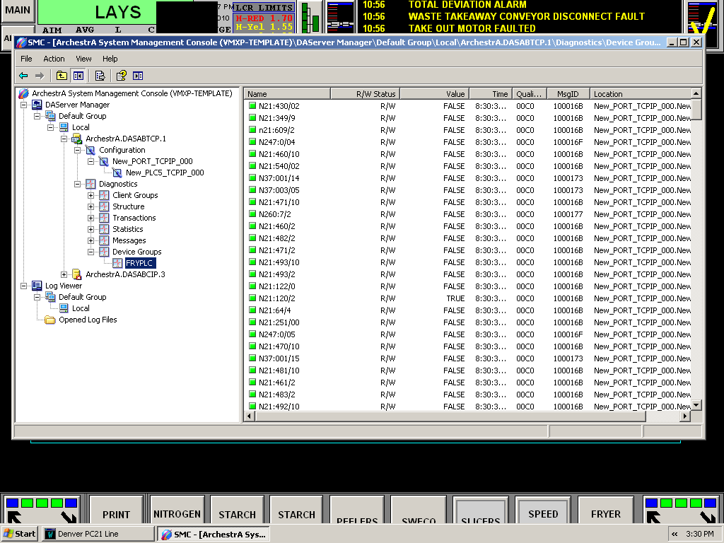

Figure : FRYPLC Device Group PLC Address.

1. Verify there is good communication (all boxes are GREEN) for all items within the Device Group.

## 10.16 LAB - Wonderware - Verifying Good Communication and the Diagnostics Component

Verifying Good Communication between the PLC and InTouch using the Diagnostics Component in the System Management Console. In this exercise, verify that the communication status is good between the PLC and InTouch. Use the DENVER_PC.RSP application in RSLogix 5 and Denver PC26 Conversion application in InTouch. Use IP Address 192.168.1.150 as the Host Name and FRYPLC as the Topic Name. The status of the Item Names should be solid GREEN when the DA Server is activated. All additional instructions will be provided by the instructor.

# LogixPro 500 PLC Simulator

LogixPro (The LearningPit) is an interactive educational tool used for understanding and acquiring common programming skills used in the PLC control of process equipment and systems. There are several *Student Exercises* on the CD, let’s take a quick look at a two of them,

The Menu bar consists of,

* File
* Edit
* Simulations
* Settings
* Comms
* Help

The Tool bar consists of shortcuts for items from the Menu bar. The Simulation window shows the simulation that is loaded for testing. The Instruction Panel contains all the instructions that can be added to the Workspace for the logic to work correctly during simulation exercises. See Figure 164.

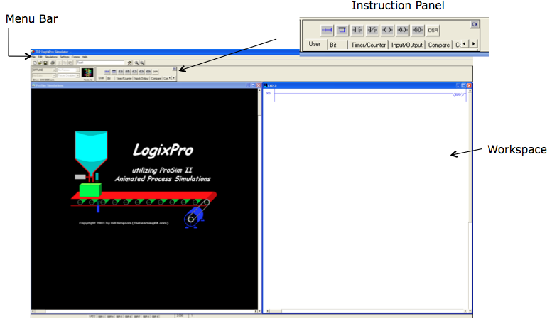

Figure LogixPro Software

## 11.1 LogixPro I/O Simulator

Follow the steps below to add a simple line of PLC logic. See Figure 165.

1. Select simulations from the Menu Bar and select IO simulator from the drop down menu.
2. Add logic to the Workspace to turn ON O:2/0 when I:1/0 is turned ON.
3. Click on the Show PLC control panel button.
4. Click on the Download button to download logic to PLC.
5. Click on the Run option to have the PLC in run mode.
6. Click the switch at I:1/0 to see light at O:2/0 turn on.

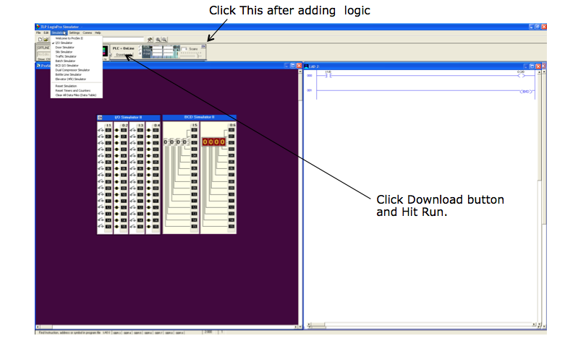

Figure 165 LogixPro I/O Simulator

## 11.2 LAB - LogixPro Garage Door

From the Menu bar, select “Simulations” then select “Door Simulator”. See Figure 166.

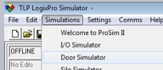

Figure Door Simulator

The instructions below are from the Student Exercises of the LogixPro CD.

### Exercise #1

In this exercise we want you to apply your knowledge of Relay Logic Instructions to design a program which will control the LogixPro Door Simulation. The Door System includes a Reversible Motor, a pair of Limit Switches and an Operator Control Panel, all connected to your PLC.

It is your responsibility to fully design, document, debug, and test your Program. Avoid the use of OTL or OTU latching instructions, and make a concerted effort to minimize the number of rungs employed.

Ensure that you have made effective use of both instruction and rung comments to clearly document your program. All I/O components referenced within your program should be clearly labeled, and rung comments should be employed to add additional clarity as required.

1. In this exercise the Open and Close pushbuttons will be used to control the movement of the door. Movement will not be maintained when either switch is released, and therefore the Stop switch is neither required nor used in this exercise. However, all other available Inputs and Outputs are employed in this exercise.
2. Pressing the Open Switch will cause the door to move upwards (open) if not already fully open. The opening operation will continue as long as the switch is held down. If the switch is released, or if limit switch LS1 opens, the door movement will halt immediately.
3. Pressing the Close Switch will cause the door to move down (close) if not already fully closed. The closing operation will continue as long as the switch is held down. If the switch is released, or if limit switch LS2 closes, the door movement will halt immediately.
4. If the Door is already fully opened, pressing the Open Switch will not energize the motor.
5. If the Door is already fully closed, pressing the Close Switch will not energize the motor.
6. Under no circumstance will both motor windings be energized at the same time.
7. The Open Lamp will be illuminated if the door is in the Fully Open position.
8. The Shut Lamp will be illuminated if the door is in the Fully Closed position.
9. Save the Logic as Door.rsl.

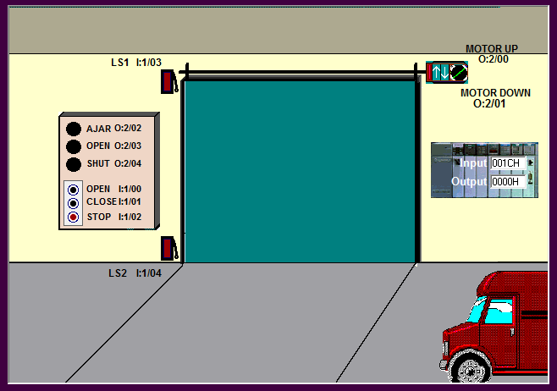

Figure 167 Garage Door Simulator

Continue with the other Student Exercises at your leisure.

# RSLogix 5000 and ControlLogix Processors



Figure ControlLogix

## 12.1 A Brief Tour of RSLogix 5000 (ControlLogix)

Reference Items in folder – “Section 12.1 To 12.4 and 14 To 15.6 - CLX Reference and Adding Devices” for examples and additional information

RSLogix 5000 has two basic areas to view when looking at a program: the project window, which shows the project “tree,” and the program file window, which opens when a program file shown in the project tree is double-clicked. These two areas are shown in Figure 169.

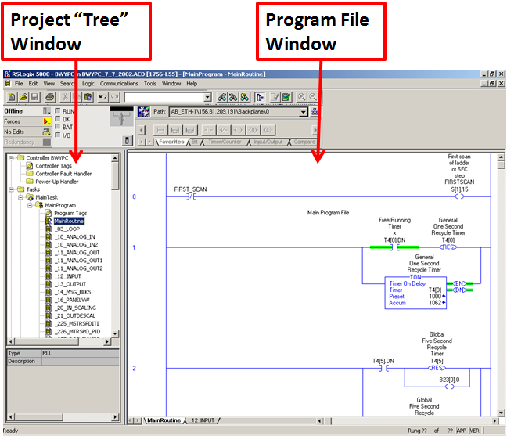

Figure : RSLogix 5000 Main Screen.

The top section of the RSLogix 5000 program contains the PLC status toolbars (Used to change PLC from Program Mode to Run Mode, for example), the search window, and the instruction palette. These are all commonly used features of RSLogix 5000. The instruction palette shows all of the available instructions in RSLogix 5000 in an easy-access format. The Address Find Tool can be used to search for a particular address in the PLC code (or can be used to find PID loops – by typing “PID,” among other things). The top toolbar area is shown in the figure below Figure 170.

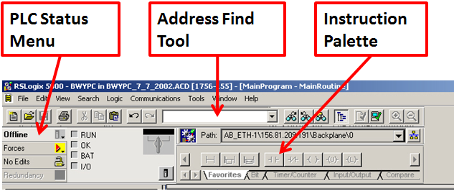

Figure : RSLogix 5000 Toolbar.

## 12.2 Creating a New Project in RSLogix 5000

Creating a new project in RSLogix 5000 is fairly simple and straightforward. Follow the steps in the list below to open a new project in RSLogix 5000:

1. Open RSLogix 5000 programming software, if it is not already open.
2. Select the “New” icon in the top toolbar (or go to the File menu and select “New”).
3. You will see the “New Controller” popup box appear, as shown in . Select the ControlLogix Controller type for this project.

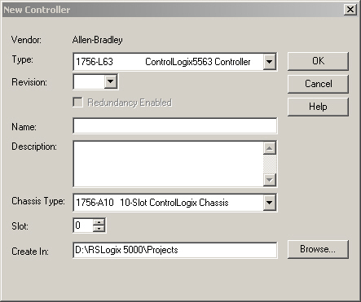

Figure : RSLogix 5000 New Controller Popup.

1. Select the firmware revision for the ControlLogix processor on which you will be loading this program.
2. Enter the processor name you will be using with the project (ex: DTC_Line2).
3. Select the chassis type in which the processor is installed.
4. Specify the slot number in the chassis in which the processor is installed.
5. Select the path where RSLogix 5000 will save this project.
6. Click OK when finished. RSLogix 5000 will then create the new project and display the new project window in the “project tree” area of the screen.

## LAB - RS Logix 5000 - Downloading / Uploading Programs to / from a Control Logix Processor

This lab will allow you to practice setting up communications between a computer and a ControlLogix processor. During this lab you will have the task of setting up the computer to communicate with the proper PLC, and then downloading a program to this PLC. Once the program has been downloaded, you will go online with the PLC. You will also practice uploading the program from the PLC to your computer.

### Downloading a Program to a Control Logix Processor

1. Open RSLogix 5000 on your computer, if it is not already open.
2. Open your program file on the computer.
3. Select “Communications” from the main toolbar and choose “Who Active” to view devices active on the network (see Figure 172).

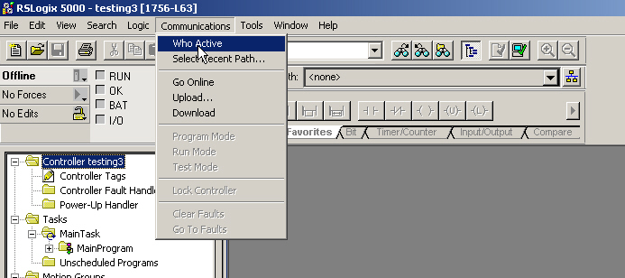

Figure : RSLogix 5000 Communications Menu.

1. Look at the Who Active popup to see what devices are currently online (as shown in Figure 173). Notice that this communications browser looks almost exactly the same as the browser in RSLinx, with the exception of the action buttons at the right of the popup screen and the lack of a selection window on the left side.

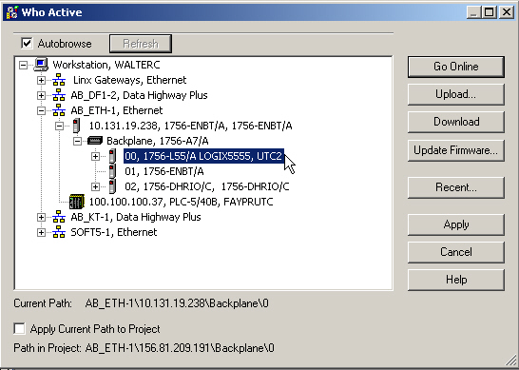

Figure : RSLogix 5000 Who Active Browser Window.

1. Select the PLC to which you want to download your program in the Who Active window. Notice that, unlike the PLC-5, the Control Logix processor shows up two levels below the IP Address of the Ethernet card. This is because the Ethernet card reports what cards are contained in its local rack, and the processor is one of these cards in the local rack.
2. Click on the “Download” button at the right-hand side of the screen to begin the process of downloading the program to the PLC. Keep in mind that the program you will be downloading is the program that you currently have open in RSLogix 5000.
3. When you click on the “Download” button, the popup screen shown in Figure 174 below will appear. Click “Download” to continue the download process.

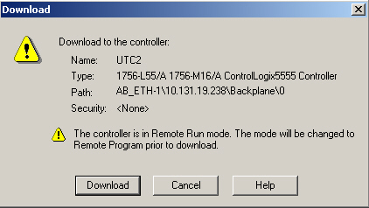

Figure : RSLogix 5000 Download Confirmation Window.

1. You will then see the download status box which shows the progress of the download to the PLC (shown in Figure 175).

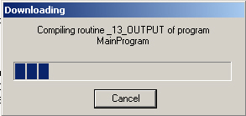

Figure : RSLogix 5000 Download Progress Window.

1. You will then see a popup screen that asks if you would like to switch the processor from PROGRAM mode back to RUN mode (shown in Figure 176). Click “Yes” to go online with the processor.

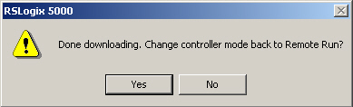

Figure : RSLogix 5 Online Mode Switch Window.

### Uploading a Program from a Control Logix Processor

1. Open RSLogix 5000 on your computer, if it is not already open.
2. Select “Communications” from the main toolbar and choose “Who Active” to view devices that are active on the network.
3. Select the PLC from which you want to upload the program in Who Active browser and click the “Upload…” button as shown in Figure 177 to start uploading the program from the PLC.

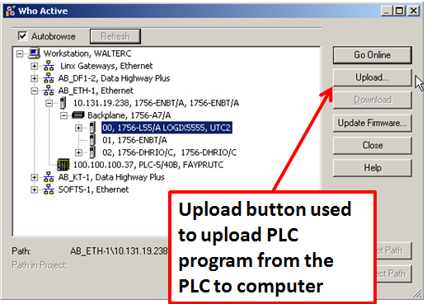

Figure : RSLogix 5000 Who Active Window Showing Upload Button.

1. You will then see the “Connected to Upload” window pictured in Figure 178. Click on the “Upload” button to continue uploading the program from the PLC.

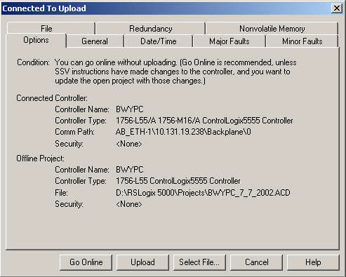

Figure : RSLogix 5000 Connected to Upload Window.

1. You will then see the Uploading status popup box as shown in Figure 179.

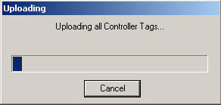

Figure : RSLogix 5000 Upload Status Popup Window.

## 12.4 Online Editing with RSLogix 5000

This part of the lab is included purely for familiarization with online programming tools. You will need to be able to identify what state your connection is in when connected to the Control Logix processor, and will need to know how to edit program rungs online. If you are online with the processor, you will be in either RUN mode, or in REMOTE PROGRAM mode. This makes a difference in what you can do and what steps you must go through to edit the PLC program. Figure 180 and **Figure 181** display some example screens showing the RUN and REMOTE PROGRAM modes:

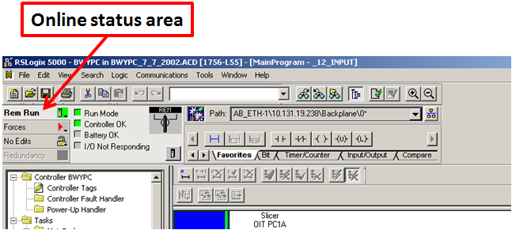

Figure : RSLogix 5000 in Online RUN Mode.

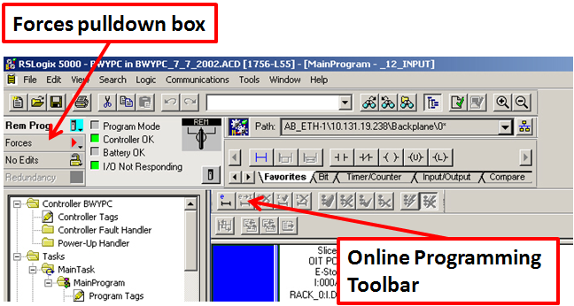

Figure : RSLogix 5000 in Online in REMOTE PROGRAM Mode.



### Online Editing in REMOTE PROGRAM Mode

To edit a rung in REMOTE PROGRAM mode, follow these steps:

1. Click on the left end (or margin) of the rung that you wish to edit. The end (or margin) should then show a series of vertical “i” characters, which shows that the rung is in the “edit” state. You will also see another rung below the original rung that has a series of vertical “r” characters, which shows that the rung is in the “run” state. RSLogix 5000 has basically made a copy of the rung that the PLC is executing (the “run” rung) for you to do your editing. This is shown in Figure 182.
2. When finished editing, click on the green check mark at the top of the program window.
3. To cancel an edit, click on the red X at the top of the program window.

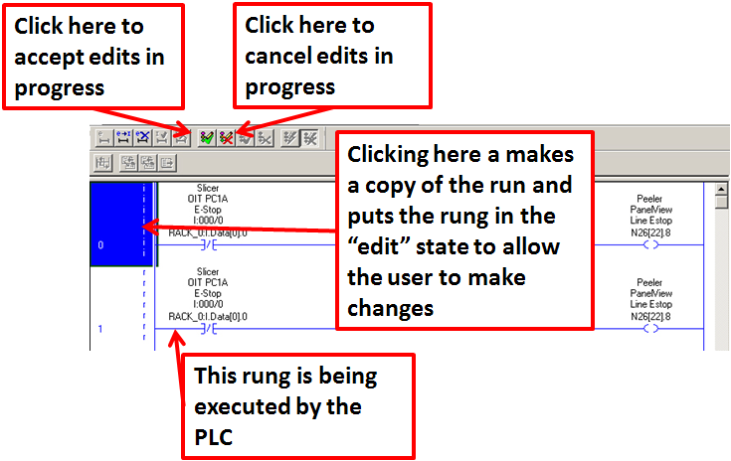

Figure : RSLogix 5 in Online in REMOTE PROGRAM Mode.

### Online Editing in RUN Mode

Reference Items in folder – “Section 12.1 To 12.4 and 14 To 15.6 - CLX Reference and Adding Devices” for examples and additional information

To edit a rung in RUN mode, follow these steps:

1. Click on the left end (or margin) of the rung that you wish to edit and proceed in REMOTE PROGRAM mode.
2. When finished editing, click on the green check mark at the top of the program window.
3. To cancel an edit, click on the red X at the top of the program window as pictured in .
4. Next you will see a lightning bolt shape in the toolbar. This is the “test edits” button. Use this to test the edits you have made – this will cause the PLC to execute the rung you have edited. If you want to cancel the edits once tested, simply press the other button with the lightning bolt shape (with the X in front of it), the “untest edits” button. This will cause the PLC to stop executing the edited rung as shown in Figure 184.
5. Once you have tested your edits and are satisfied with their stability while being executed, you are ready to assemble the edits. Press the “assemble edits” button (looks like a stack of paper) in the online toolbar. You have now completed the online edit process for this rung.

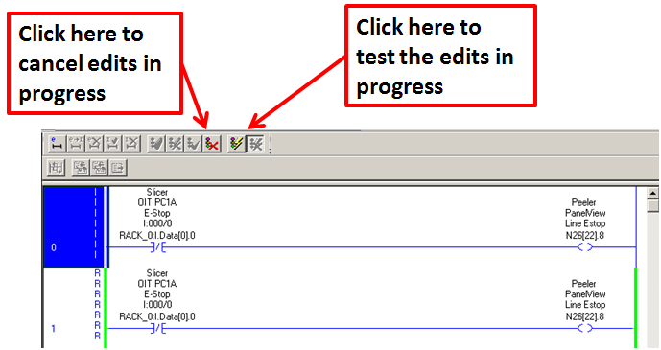

Figure : Testing Edits with RSLogix 5000 in Online in RUN Mode.

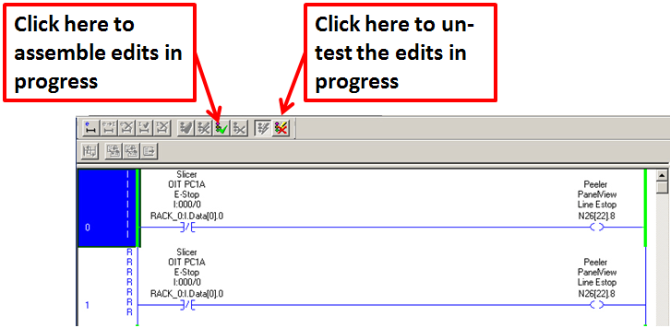

Figure : Assembling Edits with RSLogix 5000 in Online in RUN Mode.

# Sample PLC 5 Device Rungs Begin Intermediate

Reference Items in folder – “Section 5 To 9 and 12.5 To 13.4 - PLC5 Reference and Adding Devices” for examples and additional information

This customer sample details information with respect to control words for valves in addition to motors. Control and Status Words (CSW) or control words are used to keep the control actions of a device in a set of addresses contained in the same word.

Table 3 shows a customer’s standard for valve status and control.

Table : Customer Sample PLC-5 Standard Valves CSW.

|  |  |
| --- | --- |
| **Control and Status Word** | **Sub Element** |
| Position 1 Output Energized | 0 |
| Position 1 Input Confirmed | 1 |
| Position 1 Input Device Fault | 2 |
| Position 1 Manual Command | 3 |
| Position 1 Auto Command | 4 |
| Position 2 Output Energized | 5 |
| Position 2 Input Energized | 6 |
| Position 2 Input Device Fault | 7 |
| Position 2 Manual Command | 8 |
| Position 2 Auto Command | 9 |
| Position 3 Output Energized | 10 |
| Position 3 Input Confirmed | 11 |
| Position 3 Input Device Fault | 12 |
| Position 3 Manual Command | 13 |
| Position 3 Auto Command | 14 |
| Device Reset Fault | 15 |

When a CSW is assigned in the PLC an integer is used. For example, the word N26:153 is used to control a solenoid valve. The CSW for address N26:153 can be seen in Figure 185.

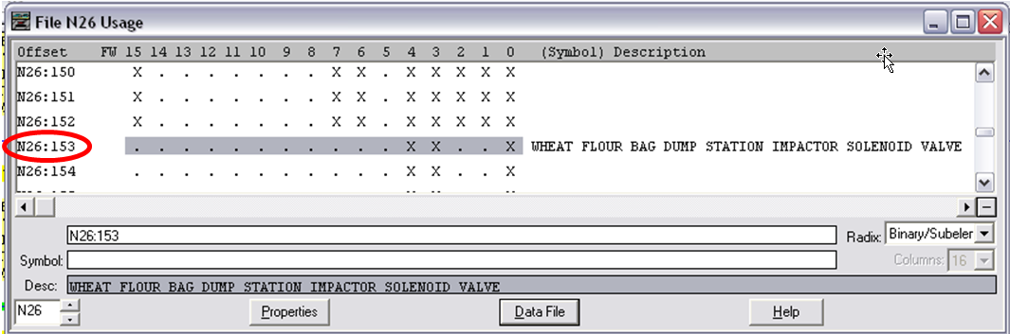

Figure : N26:153 CSW

An example AUTO/ MANUAL rung for a solenoid valve can be seen in Figure 186.

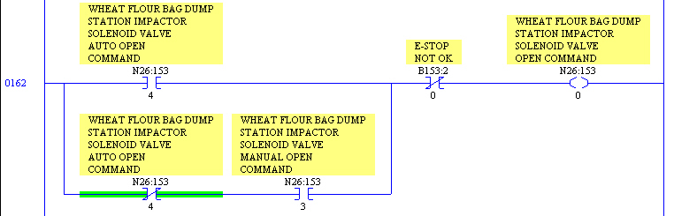

Figure : Valve AUTO/ MANUAL Rung

The first rung is the AUTO/ MANUAL control rung, which is operated from either the valve pop-up control screen in Wonderware (in the case of the manual bit) shown in Figure 187 or from the Auto system that controls the solenoid valve.

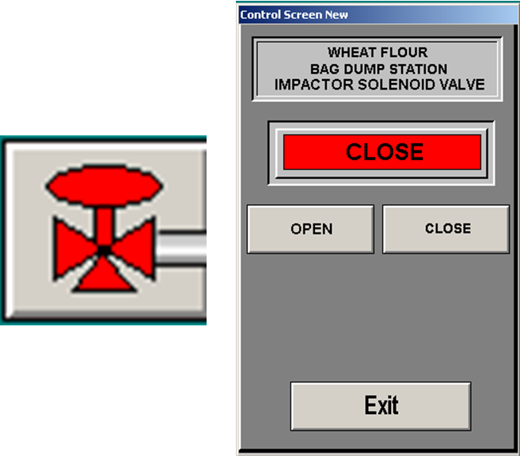

Figure : Solenoid Valve Wonderware Symbol and Control Pop-up.

The other control rung utilized for a valve is the AUTO/ MANUAL unlatch rung, where the auto command unlatches the manual command. This prevents the solenoid valve from opening or staying open in manual once the Auto command has been turned on. A screen shot of this rung is located in Figure 188.

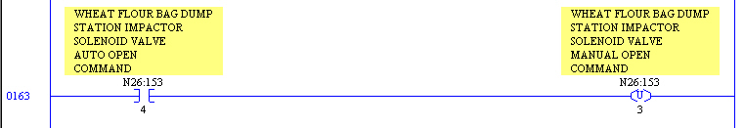

Figure : Valve AUTO Unlatch Rung.

## 13.1 Adding a new Valve to RSLogix 5 and Wonderware

1. Identify an available output (not used in PLC code and not wired at the terminal blocks) for use with the new Solenoid Valve.
2. To check usage of a particular Output in the PLC code, use the “Find” function in RSLogix 5 to look for the output.
3. Another way to check is to look at the output subroutine rungs as shown in Figure 189.

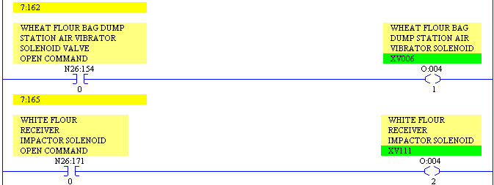

Figure : RSLogix 5 Output Subroutine Showing Output O: 004/0 is Available.

Also when viewing the data table, the view showing the bit and word usage for the data file can be changed. This can be done by clicking on the “Usage” button at the bottom of the data table popup screen as shown in

1. Figure 190. This changes the display of the data table from data to register usage. This tells the user (by way of an “X” character) which bits and words are being used in the program.

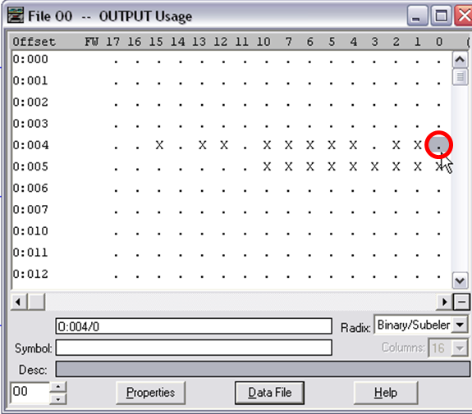

Figure : RSLogix 5 Output Data Table Showing Output O: 004/0 is not used (“.”).

1. To physically check usage of a particular Output at the terminal block, identify the output number and trace the wiring from the swing arm on the output card to the field terminal block. If wiring is not present on the field side of the terminal block, then the output is not wired to a field device.
2. Identify an available word in the N26 integer file to use with the new solenoid valve. This can be accomplished by looking at the data table for the N26 file and checking the word usage. Figure 191 shows the N26 data table in RSLogix 5. The default view when opening the data table is to show the data values contained in the file.

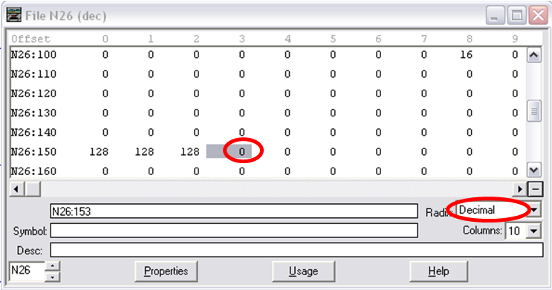

Figure : RSLogix 5 Data Table Showing Values.

1. Change the display to show the usage of the bits in the words. Keep in mind this displays only the bits or words utilized in an instruction in the PLC code. A bit or word may have a description or symbol assigned to it and may not be assigned to an instruction (hence it is not really being used in the program unless it is referenced by indirect addressing). An example of the data table showing bit usage is shown in Figure 192.

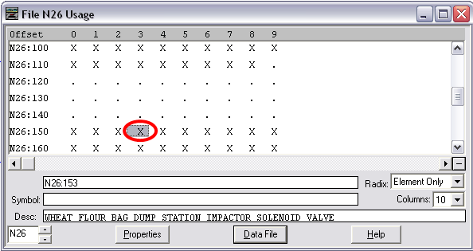

Figure : RSLogix 5 Data Table showing word level usage.

1. If the Radix setting is changed from “Element only” (word level) to “Binary/sub element” (bit level), the data table of the bits in these words is displayed. This is shown in Figure 193. Notice that in word N26:163 bits 0, 3, and 4 are used. This matches a customer’s standard for device control words and the number 0, 3 and 4 represent the AUTO, MANUAL and OPEN COMMAND bits in the control word. These are the bits used for this particular solenoid valve.

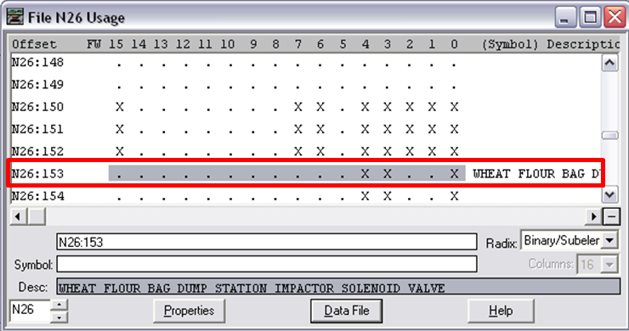

Figure : RSLogix 5 Data Table Showing Bit Level Usage.

1. Enter the AUTO/ MANUAL rung for the solenoid valve in the appropriate subroutine in RSLogix 5. This subroutine will usually appear in the area related to the part of the process line in interest. The motors/ devices subroutine will usually have a descriptive name identifying which part of the process line the subroutine uses (i.e. BPWhtFlrBgDmpImpctrCW could be the name assigned to the MTRS_VLVS subroutine – since RSLogix 5 only allows a ten character description for ladder files, the description is limited).

**\*\*Note: Be sure to include permissives that appear in other solenoid valve rungs, like E-stops or other conditions.**

1. Enter the AUTO/ MANUAL unlatch rung for the solenoid valve on the next rung following the AUTO/ MANUAL rung in the same subroutine.
2. Using the RUN COMMAND bit for the solenoid valve (Bit 0 in the solenoid control word), add a new rung in the OUTPUTS subroutine enabling the previously unused output in the PLC code. An example of this rung is pictured in Figure 194.

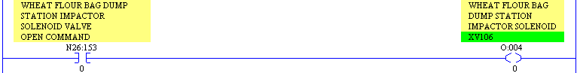

Figure : RSLogix 5 OUTPUT Subroutine Showing Output Rung.

1. Identify the auto system to which this valve should belong (if applicable) and add the appropriate auto system status bit to the appropriate device rungs.
2. Identify E-Stop permissives (and any other permissives) used for devices in the program and add these permissives to the appropriate device rungs.
3. Save the changes in RSLogix 5 and apply the changes to the controller.
4. In Wonderware, copy an existing solenoid valve icon and button and paste the copy in the appropriate position on the screen for the new solenoid valve as pictured in Figure 195. This can be accomplished by either using the CTRL-C (Copy) and CTRL-V (Paste) keyboard shortcuts or CTRL-D (Duplicate). Any of these commands can be accessed from the Edit toolbar.

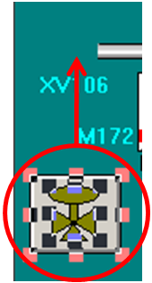

Figure : Copy and Paste Solenoid Valve.

1. Create a new tag name for each tag name used with the new solenoid valve by left clicking on the valve symbol with the mouse cursor. A new tag name will be used for the new solenoid valve. Standard tag names refer to the control word of the device so one tag has to created (ex: “BPWhtFlrBgDmpImpctrCW” could be the tag name for the Wheat Flour Bag Dump Station Impactor Valve Control Word and would refer to word N26:153), as shown in Figure 196.

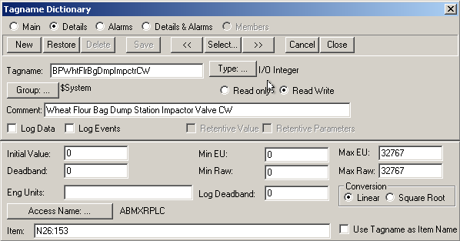

Figure : Creating a New Tag.

1. This new tag name refers to the control word used by the PLC program. This allows for the valve to be controlled by the operator at the OIT and to provide feedback to operator in regards to the state of the valve through the use of color coding and an analog script on the button. This animation script can be accessed in WindowMaker by selecting the valve symbol, pressing “Ctrl A” and clicking on the “Analog” button in the Fill Color section as pictured in Figure 197.

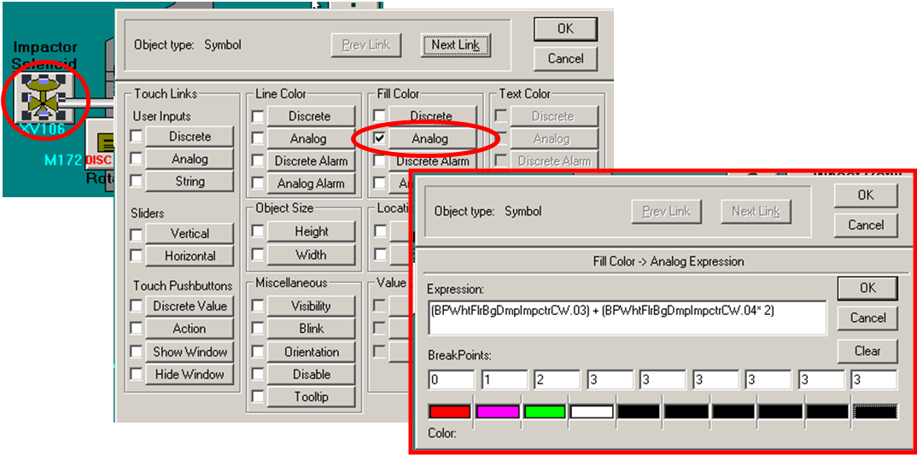

Figure : Solenoid Valve Analog Script.

1. The Analog Fill Color animation script uses the control word’s state in the PLC to display a color representing the valve’s position on the OIT. The standard solenoid valve expression looks like the one in Figure 198.

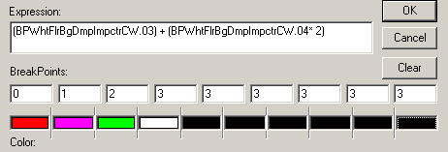

Figure : Analog Fill Color Animation Expression.

1. If bit three of the control word is a zero and bit four is a one, the result of the expression is two which corresponds with the color green (the auto color). When bit three is one and bit four is zero the result of the equation is one, the manual color as shown in Figure 199.

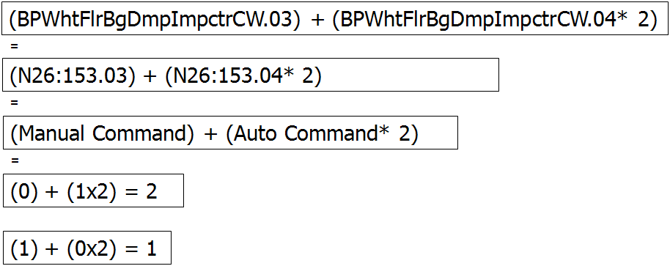

Figure : Solenoid Valve Analog Expression.

1. Double-click on the grey control button for the new solenoid valve. Select “Action” from the Animation links pop-up screen as pictured in .

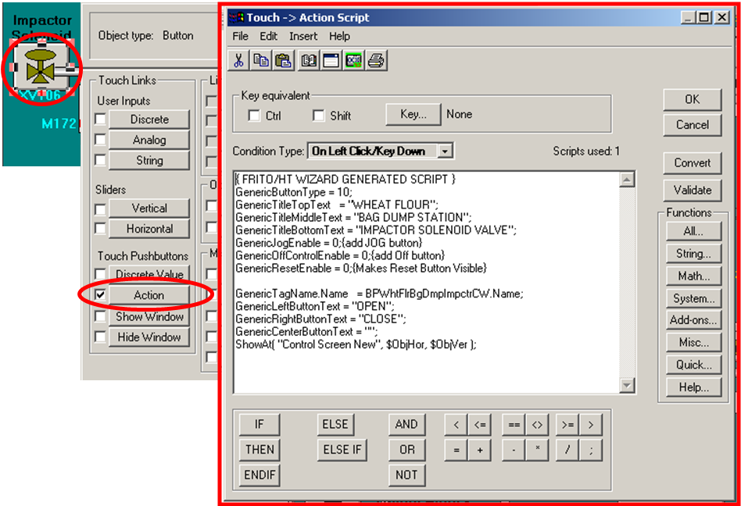

Figure : Solenoid Valve Wonderware Button Action Script.

1. Change the solenoid valve description in the “GenericTitleTopText” and “GenericTitleMiddleText” (and bottom text, if needed) to reflect the information for the new solenoid valve as pictured in Figure 201.

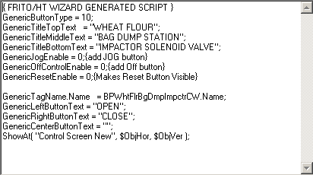

Figure : Solenoid Valve Action Script Text.

1. Save the changes to the Wonderware application.
2. ALT-Shift-1.

## 13.2 LAB - RSLogix 5 & Wonderware - Adding a New Solenoid Valve

Create a new project, develop new PLC code and WW icons to control a solenoid valve.

1. Create a new PLC5/40 Series E project.
2. Create a new Program File (LAD 3) and add your solenoid valve logic to this file.
3. Find and use an available Output
4. Create a new Wonderware application.
5. Add a new Window and icon to control your new valve
6. Create a “Popup Control” Window for indirect control of your valve.

## 13.3 Sample PLC 5 Motor Rungs

Motor control also utilizes CSW’s just as solenoid valves. shows the standard control word assignments for motors.

Table : Customer Standard Motor CSW.

|  |  |
| --- | --- |
| **Control and Status Word** | **Sub Element** |
| Forward Output Energized | 0 |
| Forward Auxiliary Input | 1 |
| Motor Forward Fault | 2 |
| Manual Forward Command | 3 |
| Auto Forward Command | 4 |
| Reverse Output Energized | 5 |
| Reverse Auxiliary Input | 6 |
| Motor Reverse Fault | 7 |
| Manual Reverse Command | 8 |
| Auto Reverse Command | 9 |
| Motor Disconnect Fault | 10 |
| Disconnect Closed Status | 11 |
| Spare | 12 |
| Motor Process Fault | 13 |
| Motor Faulted | 14 |
| Fault Reset | 15 |

For example, the word N26:105 is used to control a motor. The CSW for address N26:105 can be seen in Figure 202.

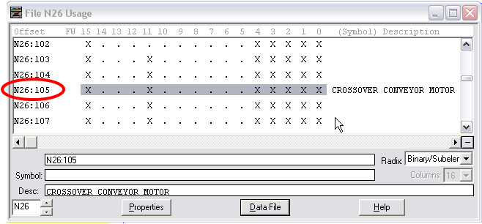

Figure : Motor Control Word.

The current standard for programming motor rungs is shown in several example rung screen shots throughout this section. Many of the features of these rungs are similar to past standard versions while others are different in some respects. Several different rungs are utilized to control motors in a standard Customer PLC code application. The RUN COMMAND bit rung is operated by the AUTO and MANUAL bits in the motor word. The AUTO and MANUAL bits are manipulated from the Wonderware application communicating with the PLC. The AUTO bit is operated indirectly from an Auto system button. The Auto system button is pressed on the Wonderware screen. If all the Auto system permissives are met, the auto bit for each motor controlled by that Auto system is enabled. An example of a button to start an AUTO system and its Control Pop-up can be seen in Figure 203. When the “AUTO” button on the Control Pop-up is pressed and the system’s permissives are met, all the motors for that system will begin to run.

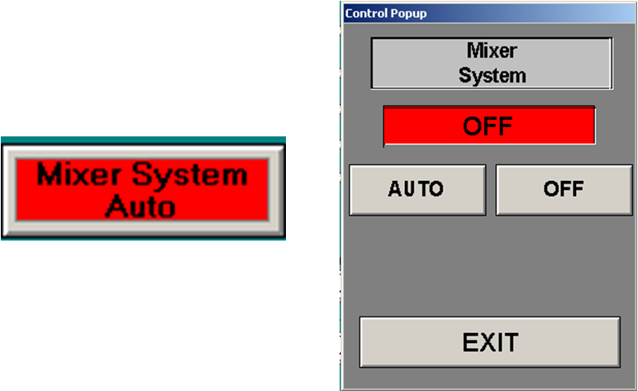

Figure : AUTO System Button and Control Pop-up.

The AUTO/ MANUAL rung is pictured in Figure 204.

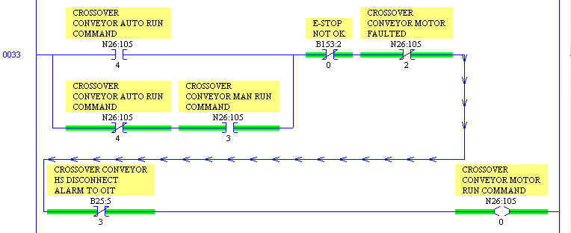

Figure : AUTO/ MANUAL Motor Control Rung.

The MANUAL bit is operated from the motor pop-up control screen in Wonderware after the symbol for the respective motor has been pressed on the OIT. The Wonderware motor symbol and Control Screen Pop-up can be viewed in Figure 205.

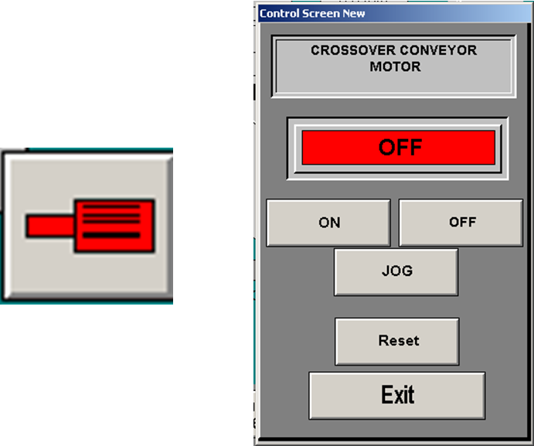

Figure : Wonderware Motor Symbol and Control Screen.

The motor fault rung is the next standard rung found in the standard motor control code. This rung uses several conditions to operate a fault timer for the motor. One of these conditions indicates the motor run command has been enabled. Another condition is that the auxiliary contact on the motor starter has NOT been enabled. There are several other conditions in this rung but the two mentioned are the key conditions. Based on these conditions, the timer may timeout and enable a motor fault alarm bit. This alarm bit is used in the Wonderware application to notify the line operator when the motor has faulted. The timer timeout will also enable a command to unlatch the manual run command for this motor. A standard motor fault rung is pictured in Figure 206.

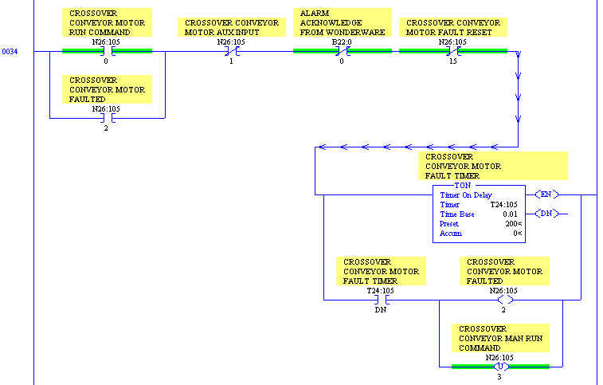

Figure : Motor Fault Rung.

The next standard rung pictured in Figure 207 is the AUTO/ MANUAL unlatch rung. The Auto system enables the auto bits in each of the motor words. Once these motor auto bits are enabled, the manual bit is unlatched in the motor word. This prevents the motor from being operated in manual once the auto bit has been turned on.

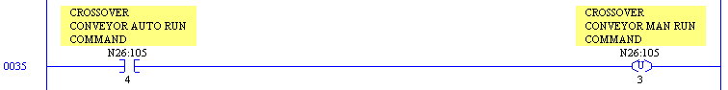

Figure : Motor AUTO / MANUAL Unlatch Rung.

The Hand Switch Disconnect rung displayed in Figure 208 is important when using local disconnects for the motors on a process line. The Hand Switch Disconnect rung keeps the operator from attempting to start the motor if the Hand Switch Disconnect alarm is on. This means the operator is notified of the problem (through the alarm) and must correct the problem before running the motor.



Figure : Motor Hand Switch Disconnect Rung.

When the motor Hand Switch Disconnect alarm has been activated the motor symbol will display a visual alarm banner similar to the one in Figure 209 to alert the operator if the Hand Switch Disconnect has been “opened” while running.



Figure : Hand Switch Disconnect Open Alarm Banner.

The motor fault reset rung is used to encourage a safer operating environment on the process line. This rung unlatches the fault reset bit for the motor until the motor is faulted as pictured in Figure 210.

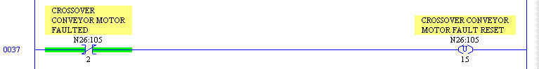

Figure : Motor Fault Reset Rung.

In order to reset the fault, the operator must open the motor pop-up screen for the faulted motor to press the reset button. The Reset button in Figure 211 on the standard motor pop-up screen in Wonderware applications operates in coordination with the fault timer rung to reset the motor. Once the reset button has been pressed, it is hidden on the Wonderware pop-up screen.

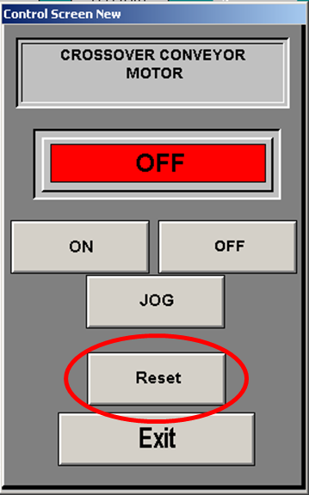

Figure : Wonderware Control Window Pop-up



### Adding a New Constant Speed Motor to RSLogix 5 / Wonderware

1. Identify an available output (not used in PLC code and not wired at the terminal blocks) for use with the new Motor (as was explained in the steps for a Solenoid Valve). This will be used for the run signal to the motor starter like the one in Figure 212.

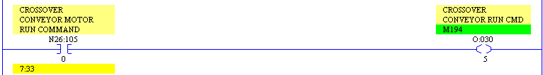

Figure : Motor Output Rung.

1. Identify two available inputs for use with the new Motor. One for the auxiliary input from the motor starter and one for the hand switch disconnect.
2. Identify an available word in the N26 integer file to use with the new motor (as was explained in the steps for a Solenoid Valve).
3. Enter the AUTO / MANUAL rung for the motor in the appropriate subroutine in RSLogix 5 (As shown in the examples earlier in this section). This subroutine will usually appear in the area related to the part of the process line in question.

**\*\*Note: Be sure to include permissives that appear in other motor rungs, like E-stops or other conditions.**

1. Enter the motor fault rung for the motor on the next rung immediately following the AUTO/ MANUAL rung. Be sure to set the timer preset value according to the plant’s standards (usually between 2 and 5 seconds).
2. Enter the AUTO/ MANUAL unlatch rung for the motor on the next rung following the motor fault rung in the same subroutine.
3. Enter the Hand Switch Disconnect rung for the motor on the next rung following the AUTO/ MANUAL unlatch rung in the same subroutine.
4. Enter the Motor Fault Reset rung for the motor on the next rung following the HS Disconnect rung in the same subroutine.
5. Using the RUN COMMAND bit for the motor (Bit 0 in the motor control word), add a new rung in the OUTPUTS subroutine that enables the previously unused output in the PLC code.
6. Using the Auxiliary Input bit for the motor (Bit 1 in the motor control word), add a new rung in the INPUTS subroutine that is enabled using the previously unused input in the PLC code. An example is displayed Figure 213.

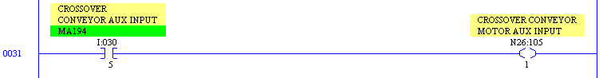

Figure : RSLogix 5 INPUT Subroutine Showing Input Rung.

1. Save the changes in RSLogix 5 and apply the changes to the controller.
2. In Wonderware, copy an existing motor icon and button and paste the copy in the appropriate position on the screen for the new motor as demonstrated in Figure 214.

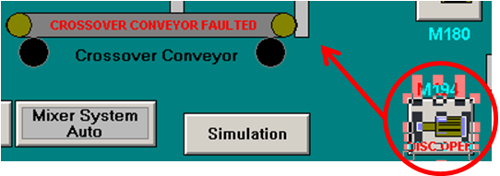

Figure : Copy and Paste Existing Motor Icon and Button

1. Create a new tag name the item name used with the motor copied in the previous step. The new tag name will be used for the new motor. These tags will typically refer to the Auto command and Manual command. Since the new standard uses a tag name that refers to the control word of the device, only one new tag name will have to be created (ex: CrossoverCnvyrCW could be the tag name for the Crossover Conveyor control word and would refer to word N26:105). To use this new tag name to refer to the bits in the control word (in the PLC code), the valve color script in Wonderware uses the “tag name.bit #” structure as shown in Figure 215. For example, to refer to the auto bit in N26:105, the usage in Wonderware would be: CrossoverConvCW.4. Since an existing functional button is being copied in Wonderware, there should not be changes the scripting for the button or icon.

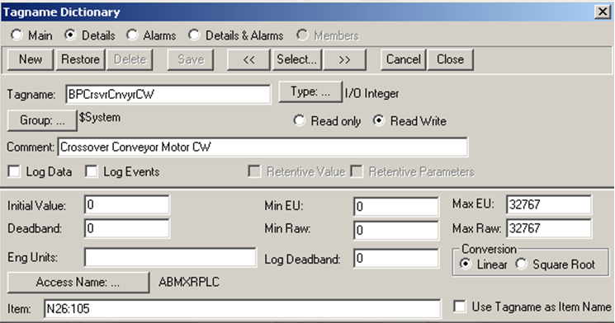

Figure : Creating Motor Tag in Wonderware.

**\*\*Note: Make sure the new tag names reference correct Access Name for the PLC associated with the motor or device being added.**

1. This new tag name refers to the control word used by the PLC program. This allows for the motor to be controlled by the operator at the OIT and to provide feedback to operator in regards to the state of the motor through the use of color coding and an analog script on the button. This animation script can be accessed in WindowMaker by selecting the motor symbol, pressing “Ctrl A” and clicking on the “Analog” button in the Fill Color section. The animation for the motor also includes a “Blink” script. It is used to indicate a faulted motor. Both of these scripts are displayed in Figure 216.

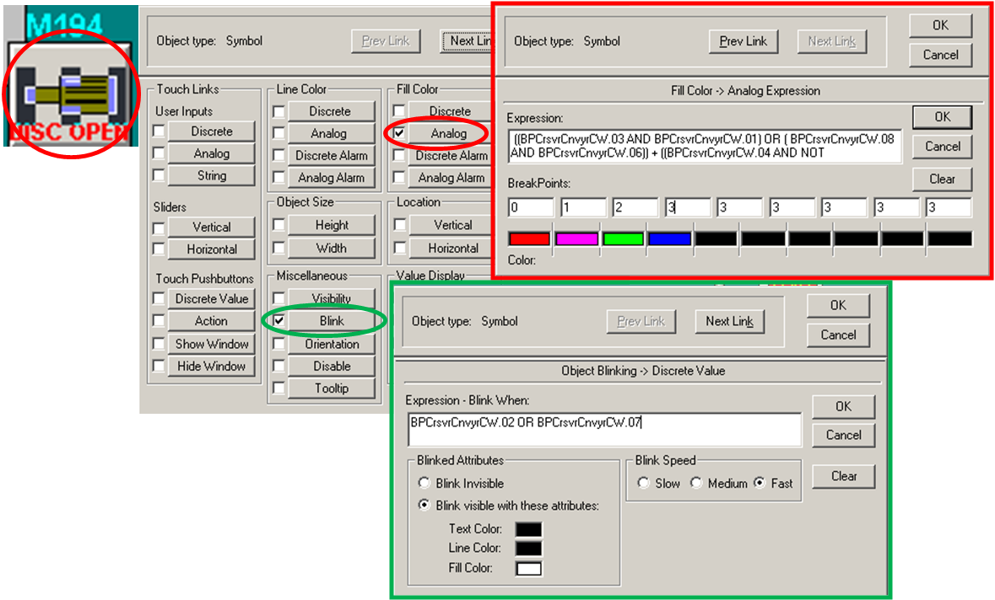

Figure : Analog and Blink Animation Scripts.

1. The “Analog” animation expression is explained in detail as shown in Figure 217.

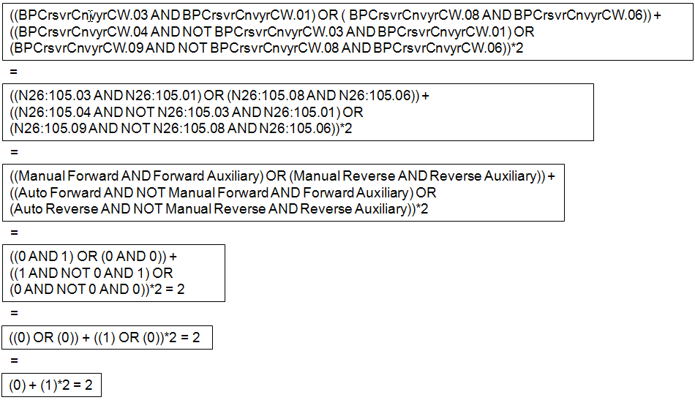

Figure : Analog Animation Expression.

Figure 218 explains the “Blink” expression.

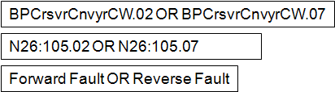

Figure : “Blink” Animation Expression.

2. Double-click on the control button for the new motor. Select “Action” from the Animation links pop-up screen as pictured in Figure 219.

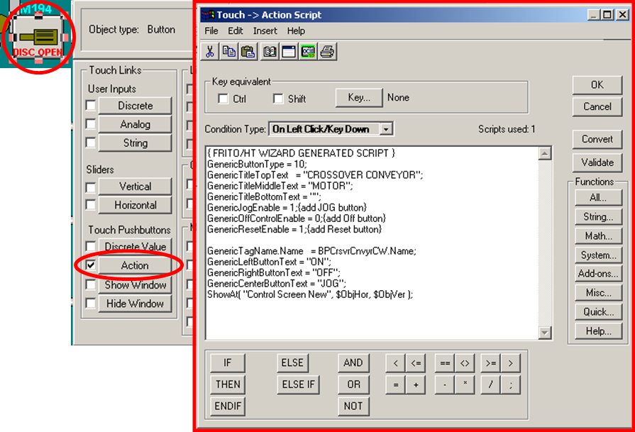

Figure : Motor Button Action Script.

3. Change the motor description in the “GenericTitleTopText” and “GenericTitleMiddleText” (and bottom text, if needed) to reflect the information for the new motor as pictured in Figure 220.

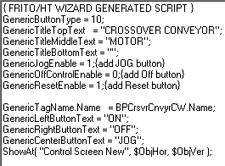

Figure : Action Script.

4. Save the changes to the Wonderware application.

5. Close Window Viewer on the OIT and re-open the Window Viewer application. This will allow Viewer to reflect the changes made to the Wonderware database.

## LAB - RSLogix 5 & Wonderware - Adding a New Motor

Develop new PLC code and WW icons to control a motor.

1. Use the existing project from the solenoid valve exercise.
2. Create a new Program File (LAD 4) and add your motor logic to this file.
3. Find and use available Inputs and Outputs.
4. Add a motor icon in WW to control your new motor.
5. Create a “Popup Control” Window for indirect control of your motor.

# Signal Filtering, Scaling and De-scaling Subroutines

Signal Filtering, Scaling and De-scaling subroutines are three tools for accomplishing fairly simple tasks. They are placed in subroutines and called from elsewhere in the program because they are used over and over for the same purposes. This makes them very useful.

## Signal Filtering Subroutine

The Signal Filtering subroutine is a useful tool to have when there is an inherent amount of noise in an incoming analog signal. The fact that noise is random adds a degree of variability to the input signal. This means the input signal will vary both upward and downward from an otherwise fairly steady value. These variations can make the signal appear somewhat erratic. The variations of the signal, usually occurring in short periods of time, can make control work difficult. For example when trying to control the flow rate of oil through a fryer, the flow rate from our flow meter controls the oil flow pump speed based on the input signal from a PID. If the input signal is rapidly changing in both upward and downward directions, tuning the PID to control the flow rate is going to be challenging. One possible solution would be to use the signal filtering subroutine to filter the input signal. This helps to slow down the changes in the input signal “seen” by the PID. The filtering limits the amount the input signal can change in a certain time period, thus slowing the effects of noise or other variable elements in the input signal.

Two types of filtering subroutines that are typically used in Customer applications are:

* The EWMA filter.
* The Low-Pass filter.

These both have the same effect on the input signal but use different equations to achieve this filtering action.

## Scaling and De-scaling Subroutines

The Scaling and De-scaling subroutines serve the purpose of changing numerical values from one format to another. Although a simple premise, it can be confusing when trying to follow what is happening in a PLC program through subroutines.

### Scaling Subroutine

The scaling subroutine takes an analog value from an analog input card in the card’s format (in the scale of 0 to 4095 for example) and changes the value to a scale like 0 to 400° F. The scaling subroutine provides the user with meaningful data from an input signal.

### De-scaling Subroutine

The de-scaling subroutine takes an analog value from the PLC code in scaled format (in the scale of 0 to 400° F) and changes the value to the card’s format. In this case the card is an analog output card having a scale of 0-4095 (for example). The de-scaling subroutine turns the scaled value into an analog value the analog output card can understand.

## Sample PLC 5 VFD Rungs

The following examples are from a customer’s standard VFD and analog output PLC rungs.

### Adding a New Motor/ VFD to RSLogix 5 and Wonderware

1. Follow all of the steps described in the previous section that describe how to add a new motor to RSLogix 5 and Wonderware.
2. Identify an unused channel on an analog output card in one of the PLC chassis on the process line. Record the Rack #, Group # and Slot # for the analog card to be used.
3. Go to the Block Transfer Write (BTW) instruction for the desired card (this instruction should be located in the ANALOG_OUT subroutine as shown in Figure 221).

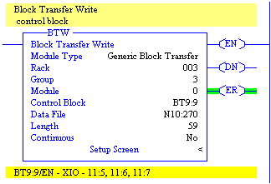

Figure : BTW Instruction.

1. Open the formatted screen that shows all of the card configuration information by double-clicking on the “Setup Screen” text at the bottom of the BTW instruction pictured in Figure 222.

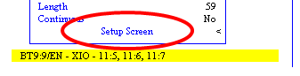

Figure : Setup Screen Link.

1. Find the Address listing that matches the channel number identified as unused (for example Channel 8). This should be a number in the format “NXX:XXX” (like N10:278 for example). See Figure 223.

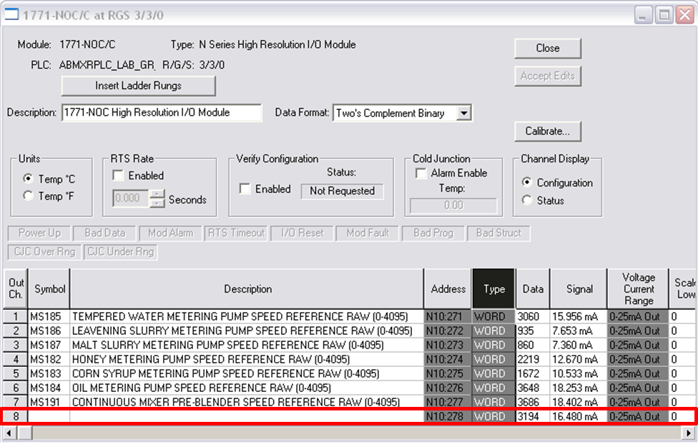

Figure : RSLogix 5 ANALOG_OUT Subroutine Showing Block Transfer BTW Instruction Setup Screen for a 1771-NOC Analog Output Card.

1. Enter a description and symbol information for the motor speed reference being added to this channel (in the figure above, this is shown as “MS190” and described as the “Pretzel Continuous Mixer Speed Reference Raw”). Also specify the Voltage / Current range (which should be the same on all channels on the card) and the scaling to be done on the card (which should match the other channels – usually 0 to 4095, but check the manual for the card if unsure or if it is a new card).
2. Add a JSR in the rung above the BTW instruction in the ANALOG_OUT subroutine that uses the proper sequential float address as an input parameter. Add the end of the float address as the second input parameter for the JSR. Use the NXX:XXX (like N10:278 in the example) address identified in the BTW instruction as the return parameter for the JSR. The example in , the next float number in the sequence is F29:16 and is used as the second input parameter (this second number is used for indirect addressing in our AO_SCALING subroutine – listed in the JSR as U:21 (subroutine # 21)).

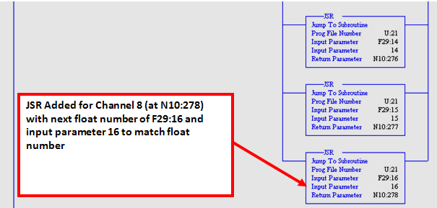

Figure : RSLogix 5 ANALOG_OUT Subroutine Showing Added JSR.

1. In Wonderware, copy a motor speed setpoint display and button from an existing motor and move the copied display and button to the appropriate position on the screen as shown in Figure 225.



Figure : Motor Speed Setpoint Display.

1. Create a new tag name for the speed setpoint display and use the new float address (F29:16 in our example) as the item name at which the tag points.

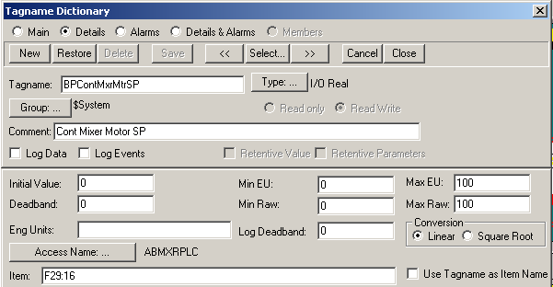

Figure : Speed Setpoint Display Tag.

### Jump to Subroutine Instructions

Jump to Subroutine (JSR) instructions are very useful when programming a PLC program. Here are the steps that occur when the JSR instruction is encountered in a ladder rung:

1. The JSR instruction is executed.
2. The input parameters for the JSR are passed to the subroutine that is specified (called) in the JSR instruction.
3. Execution control is passed to the called subroutine.
4. The ladder rungs in the called subroutine are executed. The last ladder rung passes an output parameter back to the calling JSR instruction.
5. The next rung/branch in the calling subroutine is executed.

Figure 227 shows how the ANALOG_OUT subroutine has executed a JSR instruction and is passing two parameters to the AO_SCALING subroutine. In this case the input parameters being passed are: the value in address F29:16 and the number “16.”

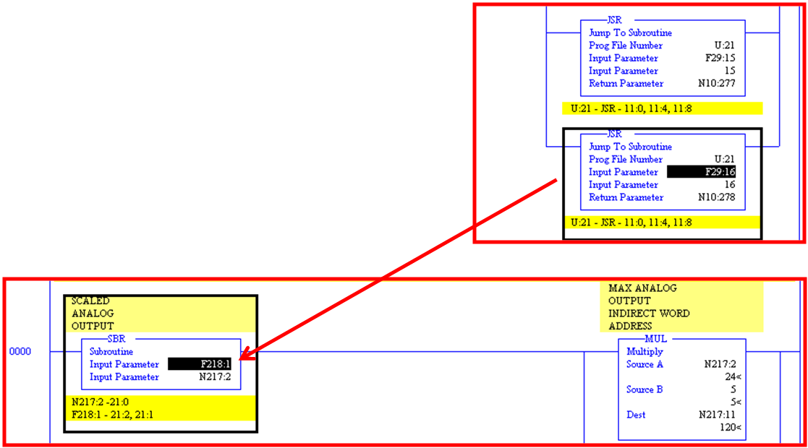

Figure : RSLogix 5 JSR Passing Parameters from ANALOG_OUT Subroutine to AO_SCALING Subroutine.

Figure 228 shows the last ladder rung in the AO_SCALING subroutine. This rung contains a RET instruction, which returns a value to the calling subroutine (which is the ANALOG_OUT subroutine in this case). This returning value is copied to the address specified in the JSR instruction as the Return Parameter.

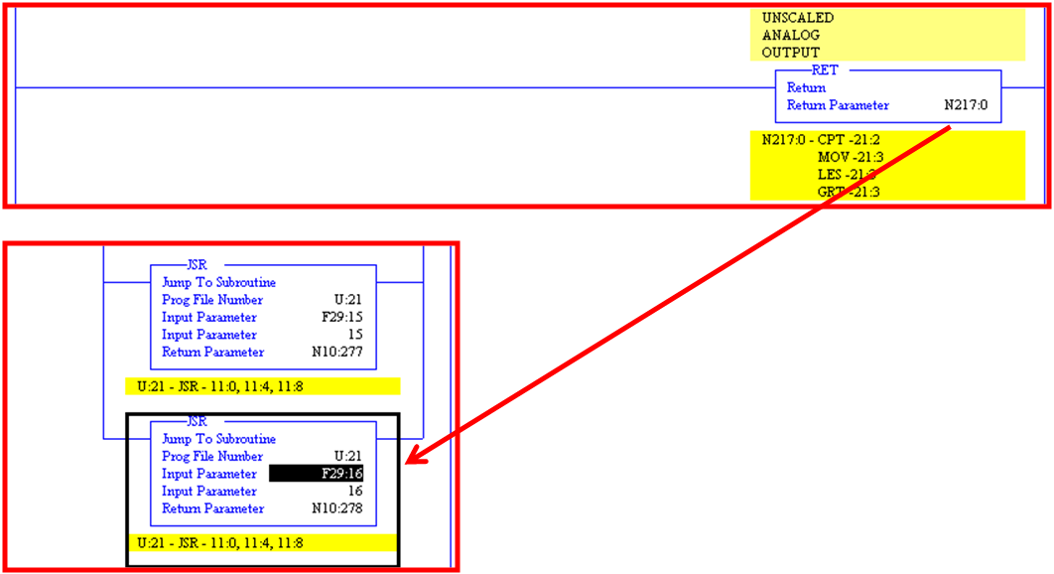

Figure : RSLogix 5 Returning Parameters from AO_SCALING Subroutine to JSR in ANALOG_OUT Subroutine.

### Analog Out Scaling Subroutine

The last section discussed how the values are passed to subroutines using JSR. This section will briefly discuss the Analog Out Scaling Subroutine. The purpose of the Analog Out Scaling Subroutine is to convert a real number (i.e. 0-100%) to a number the PLC can understand (i.e. 0-4095). This subroutine allows the operator to input a value such as a speed reference for a motor using the OIT which will be translated into a value the PLC can use to set the speed of the motor. After the value from the OIT has been scaled an analog output card in the PLC chassis will send the scaled setpoint to the VFD, which will set the speed of the motor.

As indicated in a current Customer standard, the Analog Out Scaling Subroutine is usually ladder file number twenty one. Two input parameters are passed to the subroutine. One is an address in the PLC and other parameter is a number that will be used with the calculations inside the subroutine. The two input parameters for this example can be seen in Figure 229.

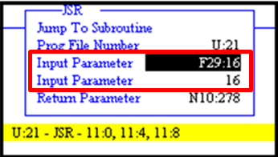

Figure : Subroutine Input Parameters.

In this example, the value of F29:16 coming from the OIT will be 50. The value the two input parameters are passed to input parameters of the subroutine as pictured in Figure 230.

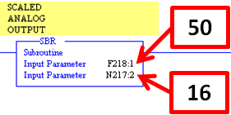

Figure : Incoming Subroutine Input Parameters.

The first rung of the subroutine takes the value of address N217:2 and sends it through a multiplication instruction and three addition instructions as pictured in Figure 231.

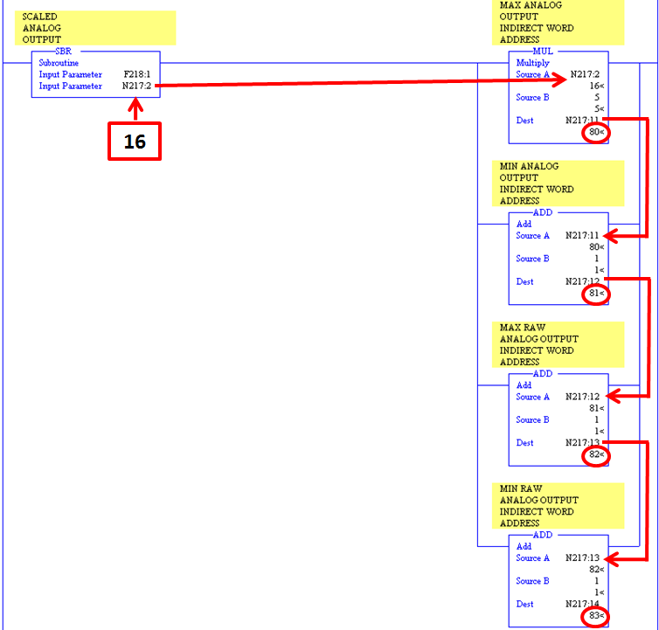

Figure : First Rung of the Analog Out Scaling Subroutine.

The next rung in the subroutine is a limit checking rung. It checks to make sure the incoming value F218:1 is not outside of its intended range. This rung also uses indirect addressing to check the limits. For example the address F210:[N217:12] is F210:81 because of the calculations that took place in the previous rung. A visual representation can be seen in Figure 232.

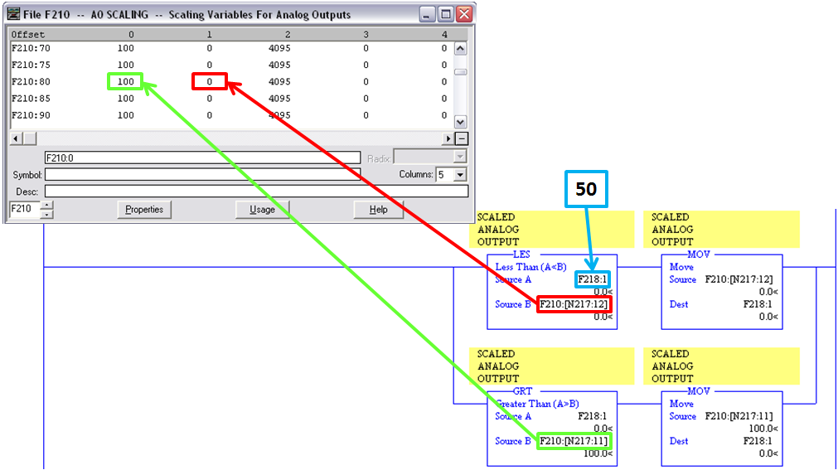

Figure : Analog Out Scaling Subroutine Limit Check.

The next rung performs a limit check on the second input parameter and a compute instruction scales the incoming value to the value used by the PLC’s analog output card. Figure 233 walks through the compute instruction.

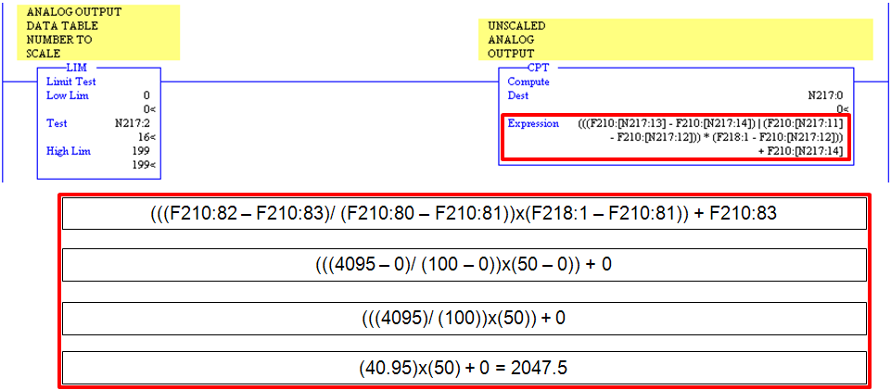

Figure : Scaling Compute Instruction.

The next rung performs another limit check. This time the subroutine is checking to make sure the newly scaled value is within the 0 to 4095 as pictured in Figure 234.

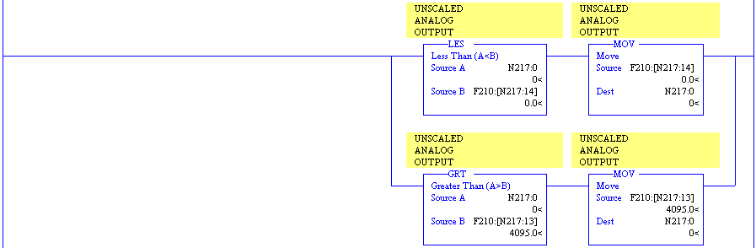

Figure : Newly Scaled Value Limit Check.

The last rung in the subroutine passes the scaled value back the return parameter is the JSR as shown in Figure 235.

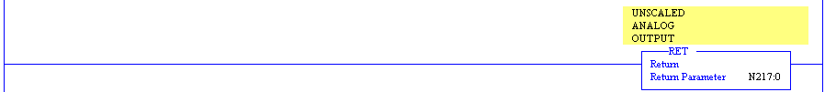

Figure : Return Parameter.

## LAB - RSLogix 5 & Wonderware - Adding VFD Speed Control

Reference Items in folder – “Section 5 To 9 and 12.5 To 13.4 - PLC5 Reference and Adding Devices” for examples and additional information

The following exercise adds VFD speed control to your existing motor exercise.

1. Add a 1771 OFE Analog Output card to Rack “0”, Group “1”, Slot “0” in the “IO Configuration”. Insert the Ladder Rungs for the BTR and BTW.
2. Add supporting PLC logic for “Engineering to Raw” Scaling conversion.
3. Scaling information below
   1. Raw = 0 – 4095
   2. Engineer = 0% – 100%
4. Add a setpoint entry on the WW screen near your existing motor.

# Rules for Crossing Versions of ControlLogix



With the increased use of ControlLogix processors in plants, there is a need to understand how these processors function and should be configured. One of the elements of configuration for these new controllers is the firmware. The firmware in each ControlLogix controller card can be updated via the Control FLASH software. This enables the user to download a new firmware version to the ControlLogix card using an Ethernet connection or a DH+ connection. Here is a list of rules that should be observed when considering updating the firmware in a ControlLogix controller:

1. When changing the firmware in the ControlLogix controller, ensure the software installed on PCs that must access the ControlLogix processor is the same version as the firmware in the processor. If the software version does not match the processor, the user may not be able to access the processor.
2. Ensure that the software being used is compatible with the firmware installed on the processor. If there are two versions of software installed on a PC, open an RSLogix 5000 project. The proper version of the RSLogix 5000 will be opened (according to the controller firmware version specified in the controller properties in the project).

## Using the Control FLASH Utility with ControlLogix Cards

Reference Items in folder – “Section 12.1 To 12.4 and 14 To 15.6 - CLX Reference and Adding Devices” for examples and additional information

When using the ControlLogix platform, there may be instances where the firmware will need to be updated on the ControlLogix cards. This is facilitated by the Control FLASH software from Rockwell Software. New firmware can be downloaded from the website at [www.ab.com/support](http://www.ab.com/support). The user will need to have a login to access the firmware updates. Once the firmware update has been downloaded, it must be unzipped. Installation of the firmware and Control FLASH utility is done by double-clicking on the “Setup” icon in the setup directory for the downloaded firmware update. The PC running the Control FLASH utility must have a network connection to the chassis where the card to be updated resides. By following the prompts on the Control FLASH utility, the user can select the firmware to be used and the card to which the firmware should be downloaded. The utility will give the user status on whether or not the download was successful.

**\*\*Note: When the firmware has been updated on a ControlLogix card, the card’s Major and Minor revision settings must be updated to reflect the new firmware information. This must be done in an offline version of the RSLogix 5000 software and downloaded to the processor that controls the updated card.**

## Troubleshooting Tools in RSLogix 5000

When using the ControlLogix platform, there are troubleshooting tools that can be used in RSLogix 5000 to determine the source of a problem. There are several locations in RSLogix 5000 where status information about faults and communication status/ faults can be found.

RSLogix 5000 shows the status of both major and minor faults in the controller information section of the project tree. Right-click on the Controller in the project tree and select “Properties” in the pop-up menu to open the controller properties screen. Major faults in the processor are shown in the Major Faults tab. The Major Faults tab is shown in Figure 236.

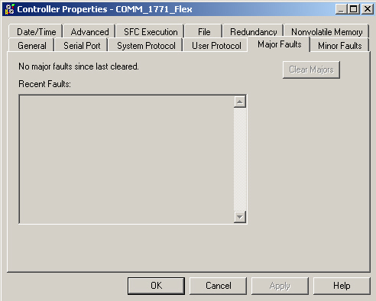

Figure : Major Fault Tab in Controller Properties Screen.

Minor faults in the processor are shown in the Minor Faults tab displayed in Figure 237. This also shows the status of the fault bits for powerup, I/O and other flags.

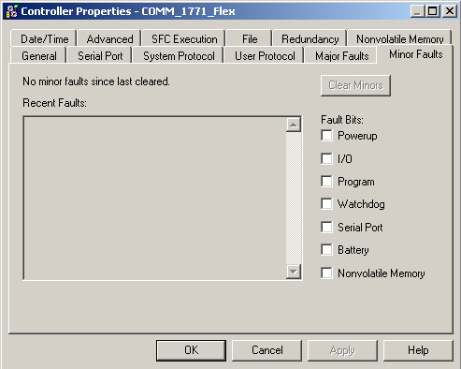

Figure : Minor Fault Tab in Controller Properties Screen.

## Sample ControlLogix Programming Standards

The customer sample programming standard details information with respect to the ControlLogix platform. In some respects, such as the subroutine numbering, these standards have carried over from the PLC5 standard. In other ways, the ControlLogix standard reflects the need for standardization of tag name usage and other issues that were not a factor in the PLC5 standard.

### User Defined Data Types

In RSLogix 5, the user was given predefined data types to use, such as N (Integer), B (Binary), and F (Float). RSLogix 5000 has a unique function with regard to data storage types. The user can actually create new data types to fit a particular application. These are called “User Defined Data Types.” The user can combine predefined types, such as INT (Integer), BOOL (Boolean, similar to Binary), and REAL (Float), to make a new structure. For example, the user can create a new data type called “Valvedata” and assign several BOOL sub elements (like “Autoopencmd” and “Manualopencmd”). This means the user can create a tag named “SV1001” for a new valve and select the tag type “Valvedata.” The new tag would have sub elements “SV1001.autoopencmd” and “SV1001.manualopencmd.” For every new tag created of this new data type, each new tag would have these sub elements assigned. This makes adding new devices easier and faster for the user.

In RSLogix 5000 the user is allowed to specify and create custom data types for custom applications. In applications that use the ControlLogix platform, these user defined data types are utilized for things like:

* Motor control structures.
* Valve control structures.
* Analog Input data.
* Analog Output data.

These data types can be imported into other RSLogix 5000 applications for use in other processers.

### Control Words

A customer sample standard valve control word is shown in Figure 238 on the following page. Notice the sub element numbers match the numbering used in the PLC-5 standard. This allows for some continuity for those familiar with the PLC-5 standard motor control word.

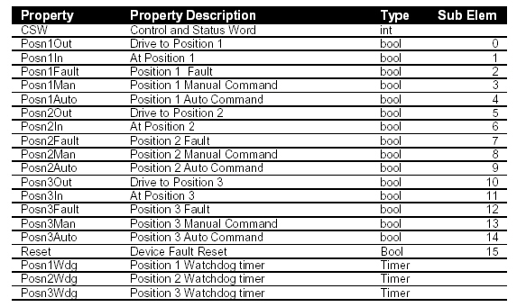

Figure : Customer Standard Valve Control Word for ControlLogix.

A customer’s standard motor control word is shown in Figure 239. The sub element numbers for valves also match the PLC-5 standard.

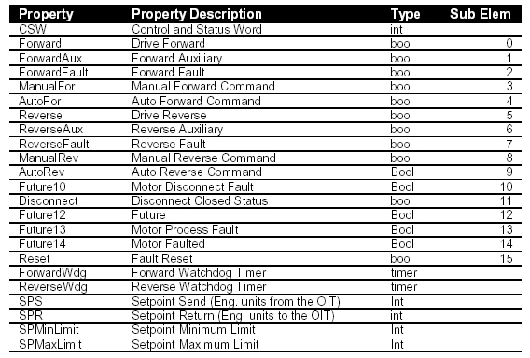

Figure : Customer Standard Motor Control Word for ControlLogix.Error! Bookmark not defined.

A customer standard control and status word for Analog Output data is shown in Figure 240. This includes the output value to send to the output card, as well as any scaling information.

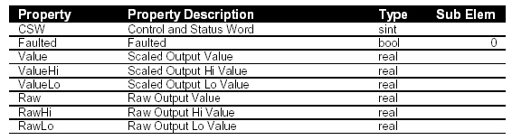

Figure : Customer Standard Analog Output Data for ControlLogix.

A customer’s standard control and status word for Analog Input data is shown in Figure 241. This shows input data from the module, as well as status information about the data being supplied.

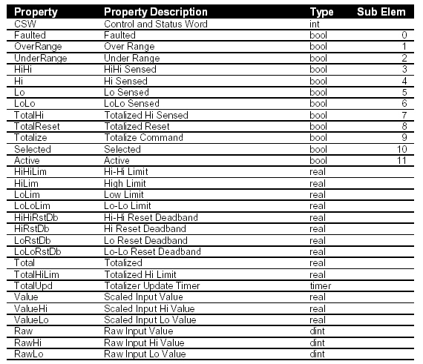

Figure : Customer Standard Analog Input Data for ControlLogix

# CLX Rungs and Adding Devices to RSLogix 5000 and Wonderware

Reference Items in folder – “Section 12.1 To 12.4 and 14 To 15.6 - CLX Reference and Adding Devices” for examples and additional information

Familiarity with the process of adding the appropriate code and screen changes is helpful when a valve or motor needs to be added on a process line. The controls specialist will need to know all of the changes needed to make the new device function properly. In order to understand how motor and device control rungs operate in ControlLogix code and Wonderware applications (and how to add new ones); it is beneficial to practice making additions to the ControlLogix code and Wonderware. This section will go through the steps to add a new Solenoid Valve, Motor and VFD in both RSLogix 5000 and Wonderware.

## Sample CLX Device Rungs

The following examples are from a customer’s standard PLC device rungs.

### Adding a New Valve to RSLogix 5000 and Wonderware

1. Identify an available output (not used in ControlLogix code and not wired at the terminal blocks) for use with the new Solenoid Valve.
   1. To check usage of a particular Output in the ControlLogix code, use the Cross Reference or “Find” function in RSLogix 5000 to look for the output as shown in Figure 242. If it does not show as used in the code this means the code is not trying to operate that output.

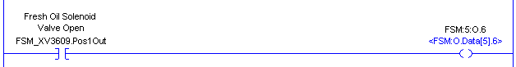

Figure : ControlLogix Output Rung.

* 1. To check usage of a particular Output at the terminal block, identify the output number and trace the wiring from the swing arm on the output card to the field terminal block. If wiring is not present on the field side of the terminal block, then the output is not wired to a field device.

1. Create a new tag to use with the new solenoid valve. This is done by looking at how other tags for solenoid valves are set up and following the existing convention. Use the “ValveData” User Defined Data type for this tag as pictured in Figure 243.

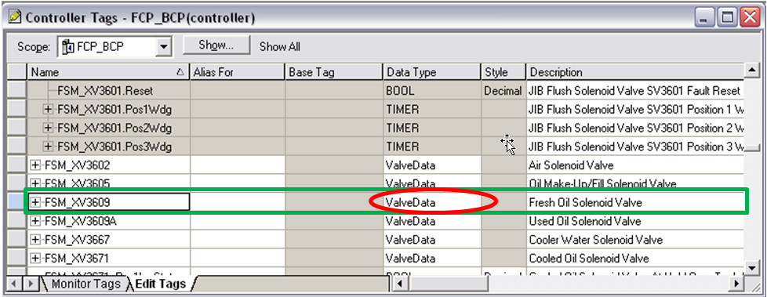

Figure : Creating New Controller Tags

1. Controller tags that use data types have sub elements of the tag for AUTO, MANUAL, and OPEN COMMAND bits in the software. These are the bits used for this particular solenoid valve. The standard for a solenoid valve tag in RSLogix 5000 is displayed in Figure 244. Notice the control bits are shown in the standard:
   1. AUTO = Posn1Auto.
   2. MANUAL = Posn1Man.
   3. OPEN COMMAND = Posn1Out.
2. The CSW control status word element of the main tag allows for easy to reference the tag in Wonderware as shown in Figure 244.



Figure : Customer ControlLogix Standard for Solenoid Valves.

1. Enter the AUTO/ MANUAL (Posn1Auto/ Posn1Man) rung for the solenoid valve in the appropriate subroutine in RSLogix 5000 like the one in Figure 245. This subroutine will usually appear in the area related to the part of the process line in question. The motors/ devices subroutine will usually have a name that describes which part of the process line the subroutine applies (i.e. CRNWASHMTR could be the name assigned to the Corn Wash Motors/ Devices subroutine).

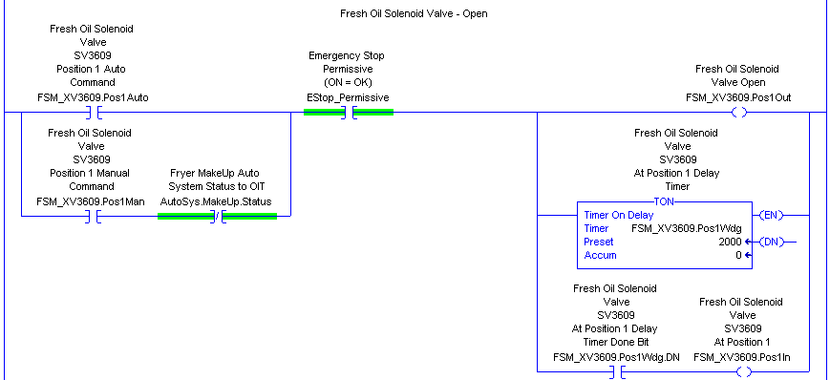

Figure : AUTO/ MANUAL Rung for Solenoid Valve in ControlLogix.

**\*\*\*\*Note: Be sure to include permissives that appear in other solenoid valve rungs, like E-stops or other conditions.**

1. Enter the AUTO/ MANUAL unlatch rung for the solenoid valve on the next rung following the AUTO/ MANUAL rung in the same subroutine as shown in Figure 246.

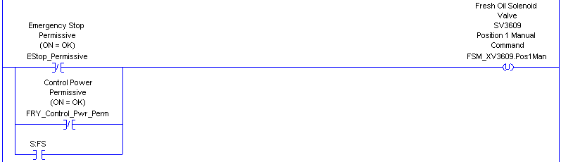

Figure : AUTO/ MANUAL Unlatch Rung for Solenoid Valve in ControlLogix.

1. Using the RUN COMMAND bit (Posn1Out) for the solenoid valve, add a new rung to the OUTPUTS subroutine enabling the previously unused output selected in the ControlLogix code. An example of this rung is shown in Figure 247.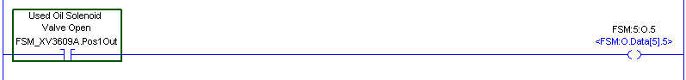

Figure : RSLogix 5000 OUTPUT Subroutine Showing Output Rung.

1. Save the changes in RSLogix 5000 and apply the changes to the controller.
2. In Wonderware, copy an existing solenoid valve icon and button and paste the copy in the appropriate position on the screen for the new solenoid valve as demonstrated in Figure 248. This can be accomplished by either using the CTRL-C (copy) and CTRL-V (paste) keyboard shortcuts or CTRL-D (Duplicate). These commands can be accessed from the Edit toolbar.

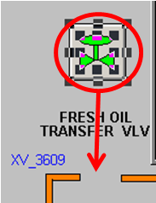

Figure : Copy and Paste Solenoid Valve in Wonderware.

1. Create a new tag name in Wonderware for each tag name used with the solenoid valve copied in the previous step. The new tag names will be used for the new solenoid valve. Since the standard uses a tag name that refers to the control word of the device, one new tag name will need to be created as shown in Figure 249. This new tag name to refer to the sub elements in the control word (in the ControlLogix code), the valve color script in Wonderware uses the “tag name.bit #” structure. For example, to refer to the auto bit in FSM_XV3609.CSW, the usage in Wonderware would be FSM_XV3609.4. Since a functional button in Wonderware is being copied, there should be very few changes to the scripting for the button or icon.

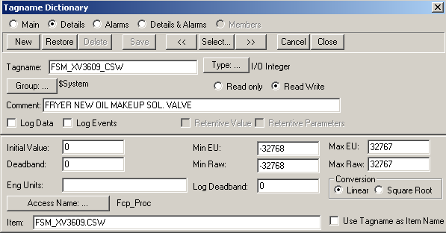

Figure : Creating a New Tagname in Wonderware for ControlLogix.

1. Double-click on the control button for the new solenoid valve. Select “Action” from the Animation links pop-up screen as shown in Figure 250.

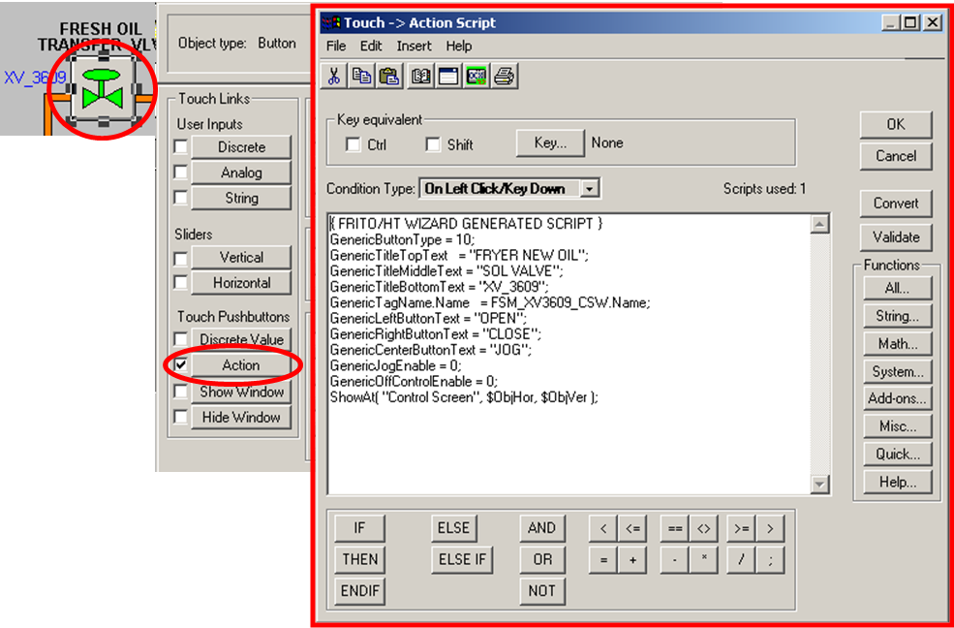

Figure : Solenoid Valve Action Script.

1. Change the solenoid valve description in the “GenericTitleTopText” and “GenericTitleMiddleText” (and bottom text, if needed) to reflect the information for the new solenoid valve as shown in Figure 251.

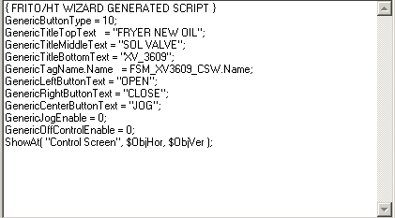

Figure : Solenoid Valve Button Action Script.

1. Save the changes to the Wonderware application.
2. Close Window Viewer on the OIT and re-open the Window Viewer application. This will allow Viewer to reflect the changes made to the Wonderware database.

## LAB - RSLogix 5000 & Wonderware - Adding a new Solenoid Valve.

This exercise will add a new valve to an application. Create a new CLX project, develop new CLX code and WW icons to control a solenoid valve.

1. Create a new CLX project. Select a 1756-L63 processor and use Rev. 19.
2. Create a Valve UDT and use in your logic
3. Install a 1756-OA16 output module to the local backplane. Use one of these outputs for your valve.
4. Create a new Program File (03_Vavles) and add your solenoid valve logic to this file.
5. Add a new Window and icon to control your new valve. (Use the same WW application you created for the PLC exercises.
6. Create a “Popup Control” Window for indirect control of your valve.

## Sample CLX Motor Rungs

The following examples are from a customer’s standard PLC motor rungs.

### Adding a New Constant Speed Motor to RSLogix 5000/ Wonderware

1. Identify an available output like the one in Figure 252 (not used in ControlLogix code and not wired at the terminal blocks) for use with the new motor (as was explained in the steps for a solenoid valve). This will be used for the run signal to the motor starter.

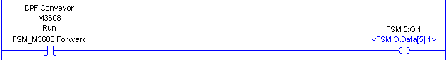

Figure : Motor Output Rung.

1. Identify an available input for use with the new motor such as the one in Figure 253. This will be used for the auxiliary contact coming back from the motor starter.

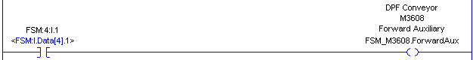

Figure : Motor Input Rung.

1. Create a new tag for the motor word to use with the new motor (as was explained in the steps for a solenoid valve). The tag standard for motors in RSLogix 5000 is shown in Figure 254.



Figure : Customer ControlLogix Standard for Motors.

1. Enter the motor fault rung for the motor like the one shown in Figure 255. Set the timer preset value according to the plant’s standards (usually between 2 and 5 seconds).

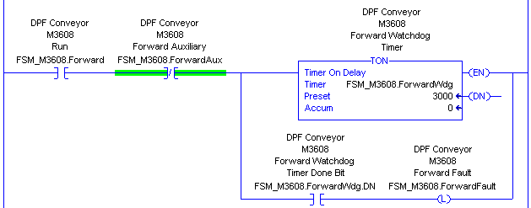

Figure : Standard Motor Fault Rung in RSLogix 5000.

1. Enter the AUTO/ MANUAL (AutoFor / ManualFor) rung for the motor in the appropriate subroutine in RSLogix 5000. This subroutine will usually appear in the area related to that specific part of the process line. An example of this rung can be seen in Figure 256.

**\*\*Note: Be sure to include permissives that appear in other motor rungs, like E-stops or other conditions.**

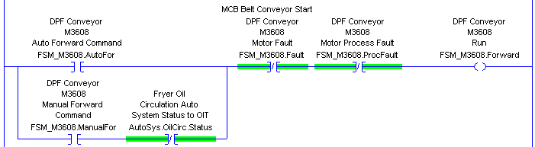

Figure : Standard AUTO/ MANUAL Rung in RSLogix 5000.

1. Enter the Motor Forward Command unlatch rung for the motor on the next rung following the motor fault rung in the same subroutine as shown in Figure 257.

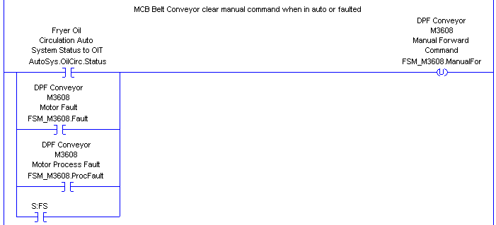

Figure : Motor Manual Unlatch Rung

1. Enter the Hand Switch Disconnect rung for the motor on the next rung following the Motor Forward Command unlatch rung in the same subroutine.
2. Enter the Motor Fault Reset rung for the motor on the next rung following the HS Disconnect rung in the same subroutine as pictured in Figure 258.



Figure : Motor Fault Reset Rung.

1. Using the RUN COMMAND bit for the motor (Forward in the motor control word), add a new rung in the OUTPUTS subroutine that enables the previously unused output selected in the ControlLogix code.
2. Save the changes in RSLogix 5000 and apply the changes to the controller.
3. In Wonderware, copy an existing motor icon and button and paste the copy in the appropriate position on the screen for the new motor as displayed Figure 259.

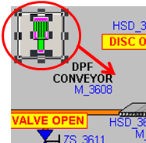

Figure : Copy and Paste Motor Icon.

1. Create a new tag name in Wonderware for each tag name used with the motor copied in the previous step as shown in Figure 260. The new tag name will be used for the new motor. Since the standard uses a tag name that refers to the control word of the device, only one new tag name will need to be created (ex: FSM_M3608 could be the tag name for the Fryer Drum Prefilter Conveyor control word and would refer to tag FSM_M3608.CSW). To use this new tag name to refer to the elements in the control word (in the ControlLogix code), the valve color script in Wonderware uses the “tag name.bit #” structure. For example, to refer to the auto element in FSM_M3608.CSW, the usage in Wonderware would be: FSM_M3608.4. Because an existing functional button is being coped in Wonderware, there should not be any changes to the scripting for the button or icon. The animation scripts will work the same as they did in the previous example.

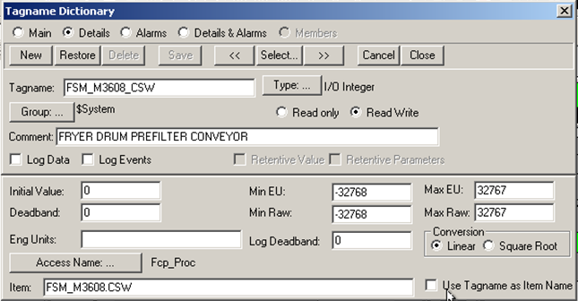

Figure : Motor Tag.

**\*\*Note: Make sure the new tag names reference the correct Access Name for the PLC associated with the motor or device being added.**

1. Double-click on the control button for the new motor. Select “Action” from the Animation links pop-up screen. Change the motor description in the “GenericTitleTopText” and “GenericTitleMiddleText” (and bottom text, if needed) to reflect the information for the new motor as pictured in Figure 261.

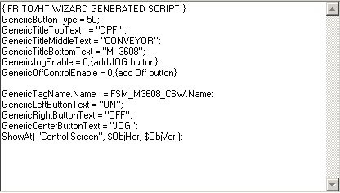

Figure : Motor Button Action Script.

1. Save the changes to the Wonderware application.
2. Close Window Viewer on the OIT and re-open the Window Viewer application. This will allow Viewer to reflect the changes made to the Wonderware database.

## 16.4 LAB - RSLogix 5000 & Wonderware - Adding a New Motor.

This exercise will add a new motor to the application. Develop new CLX code and WW icons to control a motor.

1. Use the existing CLX project from the solenoid valve exercise.
2. Create a Motor UDT to use in your logic
3. Install a 1756-IA16 input module to the local backplane. Use one of these inputs for the motor auxiliary and one for the motor disconnect.
4. Use an available output to start the motor
5. Create a new Program File (04_Motors) and add your motor logic to this file.
6. Add a motor icon in WW to control the new motor.
7. Create a “Popup Control” Window for indirect control of your motor.

## Sample CLX VFD Rungs

The following examples are from a customer’s standard PLC VFD and analog output rungs.

### Adding a new Motor/ VFD to RSLogix 5000 and Wonderware

1. Follow all of the steps described in the previous section that describe how to add a new motor to RSLogix 5000 and Wonderware.
2. Identify an unused channel on an analog output card. Record the Rack #, Group #, and Slot # for the analog card to be used.
3. Add a JSR in the ANALOG_OUT subroutine that uses the proper sequential float address as an input parameter. Use the same floating address as the first “Return Parameter” for the JSR. Use the address of the card rack, group and channel number in the JSR data tag as the second “Return Parameter” for the JSR as show in Figure 262.

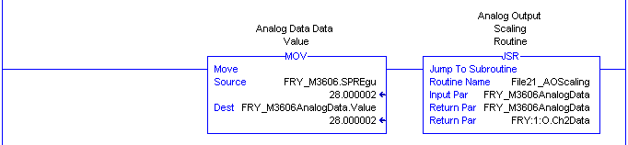

Figure : RSLogix 5000 ANALOG_OUT Subroutine Showing Added JSR.

1. The subroutine called in the JSR is the Analog Output Scaling. The “Return Parameter” of the JSR passes directly to the channel identified on the rack.
2. Enter a description for the motor speed reference being added to this channel in the description column for the tag name.
3. In Wonderware, copy a motor speed setpoint display and button from an existing motor and move the copied display and button to the appropriate position on the screen as displayed in Figure 263.

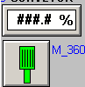

Figure : Speed Reference and Motor Display.

1. Highlight both the speed reference button and display as pictured in Figure 264.

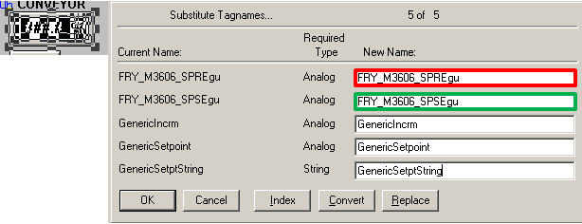

Figure : Speed Reference Tags.

1. Create a new tag name for the speed reference display (FRY_M3606.SPREgu) and the speed setpoint button (FRY_M3606.SPSEgu) as shown in Figure 265.

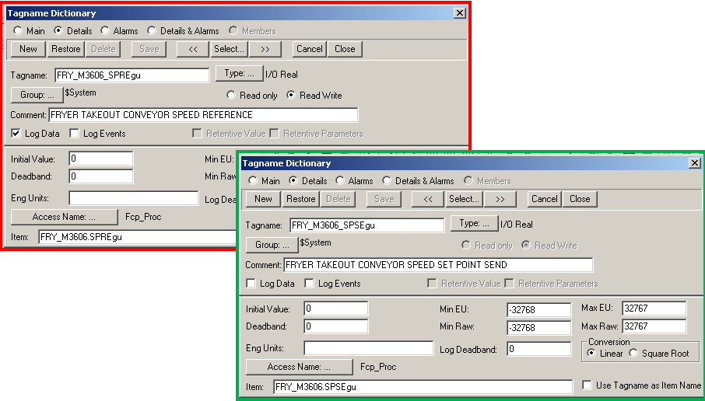

Figure : Speed Reference and Speed Setpoint Tags.

## 16.6 LAB - RSLogix 5000 & Wonderware - Adding a New VFD.

Reference Items in folder – “Section 12.1 To 12.4 and 14 To 15.6 - CLX Reference and Adding Devices” for examples and additional information

The following exercise adds VFD speed control to your existing motor exercise.

1. Install a 1756-OF4 Analog Output module in the local rack
2. Add supporting PLC logic (UDT, etc.)
3. Add a setpoint entry on the WW screen
4. Scaling information below
   1. Raw = 4,000 – 20,000
   2. Engineer = 0% – 100%

# PID Basics

PID stands for Proportional Integral Derivative. The PID is an instruction used as a reactionary controller.

Reference Items in folder – “Section 16 To 17 - PID's” for examples and additional information

## What a PID Does

A PID takes an input signal from a field device (like an oil flow meter’s flow rate) and increases or decreases the output signal to a related field device (like a pump motor that pumps oil through the flow meter) based on how that input signal (oil flow rate) compares to a predefined setpoint (oil lbs/hr).

An example of how a PID functions is shown in Figure 266. This figure is located in the RSLogix 5 help file on PID loops. It shows how the Setpoint and Process Variable are compared and how the error from that calculation is fed into the PID equation. The control output is then set controlling the valve.

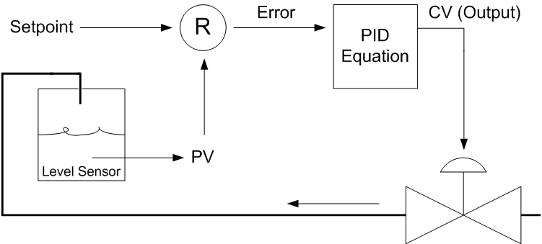

Figure : PID Functional Diagram.

### 17.1.1 PID Related Terms

Here are some terms that are related to the functionality of a PID loop. Some are directly related to how the PID operates, and some describe elements of the process that the PID is controlling.

1. **Upsets:** This term describes a step change (or large change) in a process to which a PID will react. Example: The oil flow being monitored on this process line increases suddenly because another process line has just shut down and is no longer drawing oil from the oil source.
2. **Error:** The difference in value between the Setpoint for a process and the PV (Process Variable).
3. **PID Tuning:** This term describes the adjustment of the three elements of a PID in order to attain the desired responsiveness of a PID loop to Upsets (changes) in a process.
4. **Setpoint:** This is the desired value for the part of the process that the PID is controlling. For example, if the PID is set up to control oil flow into a fryer, that flow rate may be 10 lbs/hr. This is the value to which the PID will attempt to control.
5. **Control Variable:** This is the output signal that is controlled by the PID. It is also simply called the Output of the PID, and is generally expressed in a range of 0 to 100 percent.
6. **Process Variable:** This is the input signal that the PID compares against the Setpoint in order to determine what action it must take to correct the error (difference) between the two values.
7. **Tieback:** This is the output signal that is fed back to be an input to the PID when the PID is switched from AUTO mode to MANUAL mode.
8. **Feed Forward:** This is a value used to compensate for a disturbance that cannot be directly compensated for by the PID. This value is based on the input of the PID, and the value is added to the output of the PID.

## 17.2 Elements of a PID and How They Relate



### Proportional Gain

Proportional Gain is the first term, or adjustment, used to tune a PID loop. It is also known simply as Gain and this is the most common reference for this adjustment. The mathematical symbol for Proportional Gain is Kc, which is worthy of noting at this point only because it is listed in the PID instruction in RSLogix 5. The Gain term in a PID defines how aggressively the loop will attempt to react when there is an error (difference) between the Setpoint and the Process Variable (Input value).

### Integral

The Integral is the second adjustment used to tune a PID loop and is generally utilized in conjunction with the Proportional Gain term. The Integral term is also known as Reset Time and is referred to in Minutes per Repeat (Minutes / Repeat). The mathematical symbol for the Integral term is Ti. The Integral in a PID controller is concerned with time, and relates the action of the controller with a measure of time. As David W. St. Clair states,

*“…the integral action causes the controller output to change at a RATE proportional to the error.”*[14]

In other words, the Integral can regulate how quickly or slowly the Gain is applied to the output signal. This allows the Gain to be applied in bigger or smaller slices of time, hence changing the responsiveness of the PID loop to upsets in the process that it is controlling.

### Derivative

The Derivative is the third adjustment used to tune a PID loop. The mathematical symbol for the Derivative term is Tds (also shown as Td). The Derivative term has the capability to increase the responsiveness of the PID control. It is, however, easy to use too much of this term and cause problems with PID control.

### 17.2.4 Direct Acting and Reverse Acting PIDs

The PID is given input signals, such as the Setpoint and the PV. Based on these input signals will set its CV (Output). There are two ways a PID can act upon the input information it is provided. It can either be a Direct Acting PID or a Reverse Acting PID.

### Direct Acting PID

A Direct Acting PID increases the CV (Output) when the PV is **LARGER** than the Setpoint value, using the E = PV – SP calculation for error. An example of this PID type would be to use a PID for an ambient cooling application to control a cooling blower.

### Reverse Acting PID

A Reverse Acting PID increases the CV (Output) when the PV is **SMALLER** than the Setpoint value, using the E = SP - PV calculation for error. An example of this PID type would be to use a PID to control oil heating in a fryer. PID’s are generally working with devices whose output value must be increased to meet a setpoint when the feedback from the field device (PV) is lower than the setpoint.

## The PID Instruction in RSLogix 5

The PID Instruction itself is much like any other instruction in RSLogix 5. It has certain parameters it needs in order to operate properly. Like other instructions, it gets some of the information it needs in order to operate from Wonderware. For example, if the PID is controlling a pump, the setpoint for the speed of the pump is most likely set on a screen in Wonderware. This means the operator on the process line must input a setpoint in the setpoint control in Wonderware in order for the PID to have this information sent to it. The PID can also be placed in different modes from Wonderware. If a button is assigned to the PID control word in Wonderware, then the PID can be toggled from AUTO to MANUAL mode from the OIT. An example of a PID instruction block is pictured in Figure 267.

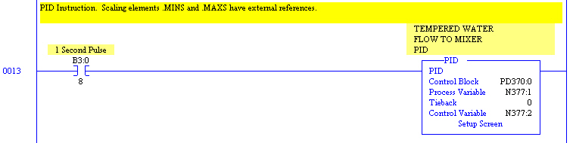

Figure : Standard PID Instruction in RSLogix 5.

To gain access to the PID instruction settings, double-click on the “Setup Screen” selection at the bottom of the PID instruction block. This opens the setup screen for the PID instruction. There are two parts to the setup screen, which are divided into tabs: The Status tab and the Configure tab.

### Status Tab for the PID Instruction

The Status Tab for the PID instruction allows the user to monitor the functionality of the PID instruction as it operates. It shows important information about the PID instruction and its input and output variables. It shows input variables like Setpoint, PV (Process Variable) and Tieback. It also shows the output of the PID instruction, also called the CV (Control Variable). The three elements used for PID tuning are shown (and can be changed) on the Status tab. These three adjustments are: Proportional Gain (Kc), Integral (Ti) shown as Reset Time on the status tab, and Derivative Rate (Td). An example of the Status Tab for a PID instruction is displayed in Figure 268.

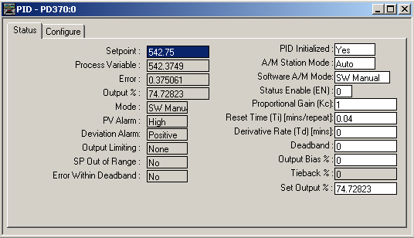

Figure : Status Tab in a PID Setup Screen.

### Configure Tab for the PID Instruction

The Configure Tab for the PID instruction allows the user access to the settings for the PID instruction. From the Configure Tab, the user can change everything about how the PID functions. These changes should only be made while the PID instruction block is in MANUAL mode, never when the PID is in AUTO mode.

**\*\*Note: Changes attempted while the PID is in AUTO mode can cause erratic behavior of the PID block and may even cause the PID block to “lock up” or stop responding.**

Some of the more important settings that the user can change on the Configure tab are:

* The control action of the PID (Direct Acting or Reverse Acting).
* Whether the PID is part of a cascaded loop.
* The input and output limits.
* The Engineering Units.

An example of a Configure tab for a PID is pictured in Figure 269.

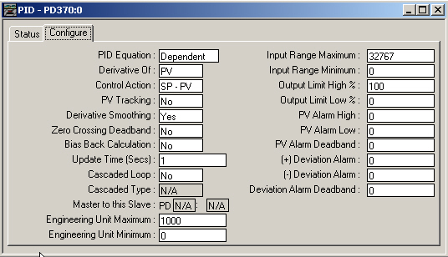

Figure : Configure Tab in a PID Setup Screen.

## PID Subprogram and Wonderware PID Faceplate

When adding a PID to a PLC program, the majority of the PLC code that relates to the PID is contained in a single PID subprogram (or subroutine). The only items that appear outside the PID subroutine that relate to the PID are:

* The Analog Input signal for the PV.
* The Analog Output signal for the CV.
* The status word for the PID (from Wonderware).

This third element is usually duplicated both outside and inside the PID subroutine. This allows the user to view the status of the PID from an area of the program relating to the portion of the process where the PID is used. For example, if the PID is used to control fryer oil circulation flow, one copy of the PID status word could appear in one of the Fryer subroutines in the PLC code.

### PID Subprogram

The PID subprogram will contain certain items pertaining to PID control, such as:

* The PID control word.
* Instructions that move input values (like setpoint and PV) into registers used in the PID subroutine.
* An instruction for PV de-scaling.
* The PID instruction.
* Instructions to move the output of the PID (CV) to the OIT display and to the Analog Output subroutine.

#### Moving External Values into the PID Subroutine

The external values that are moved into or used by the PID subroutine are:

* The Control Word.
* The Setpoint.
* The PV (Process Variable).

The rung that moves the PID control word status into the PID subroutine is displayed in . Notice the rung has certain permissives which must be met in addition to the AUTO / MANUAL bit from Wonderware to allow the PID to switch to AUTO mode.

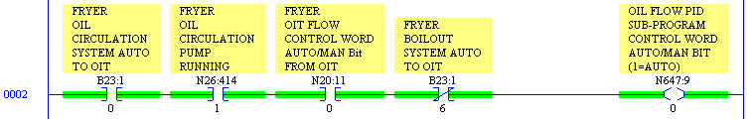

Figure : PID Control Word Moved into PID Subroutine.

The next item in the PID subroutine is the set of instructions that move related values into the registers (or addresses) used within the subroutine. These values are for things like the PID Setpoint. Part of the rung used for moving values into the PID subroutine is shown in Figure 271. The value contained in F27:260 in the figure is being moved into F648:10. The value in F27:260 comes directly from the setpoint control in Wonderware and is moved to F648:10. This F648 address is appropriate for local use in this subroutine, since this is subroutine number 64, and the Float’s default data file number is 8. This conforms to the customer’s standard for local addressing in a PLC5 subroutine.

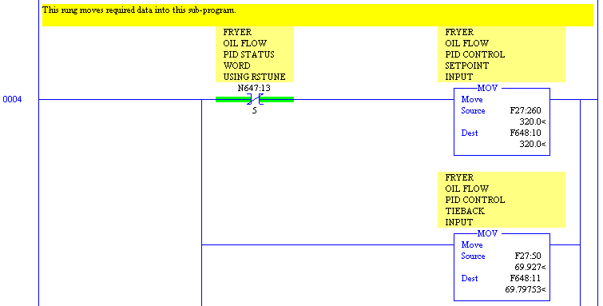

Figure : PID Setpoint Moved into PID Subroutine.

The PV for the PID is moved into the PID subroutine as part of the same rung where the Setpoint is moved. The “MOV” instruction moves the PV into the PID subroutine can be seen in Figure 272. It moves F28:41 into F648:12, which is a local register address for the PID subroutine. When a search for F28:41 is performed, the result indicates this address originates from a JSR in the ANALOG_IN subroutine. In other words, the value is coming directly from the Oil Flow meter’s analog signal in the field.

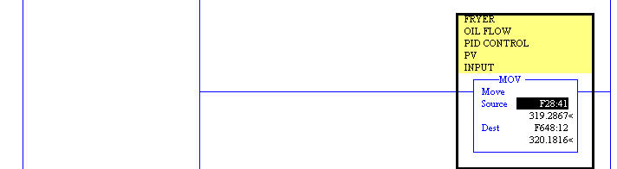

Figure : PID PV Input Moved into PID Subroutine.

#### Inside the PID Subroutine

After all of the external values are moved into local addresses, there are some additional rungs that perform other functions. Most of these are not of major concern and are generally easy to decipher by looking at them.

#### PID De-scaling

The PID De-scaling subroutine is the JSR instruction for PV de-scaling. It takes the PV input, Fryer Oil Flow, and changes the units from Engineering Units (lbs/hr in this case) to a Raw value (in a range like 0 to 4095 or 0 to 30480). The Raw format is the proper scale for input to the PID block. The scale is set in the PID block using the Input Range Maximum and Minimum fields on the Configure tab as pictured in Figure 273.

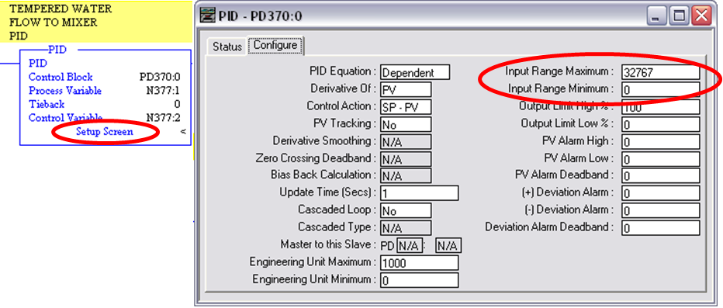

Figure : RSLogix 5 PID Configure Screen.

These values should match the values used for de-scaling. The de-scaling is done much the same way the scaling and de-scaling is done for analog inputs and outputs. The JSR feeds the value to be de-scaled to subroutine 25 (U:25), the PID_DESC subroutine, whose job it is to de-scale values for the PID subroutine. The other parameter fed to U:25 (PID_DESC) is the multiplier used to locate the proper de-scaling ranges. This multiplier configuration is just a method used to store all of the scaling / de-scaling ranges for Analog Inputs in one file. The file number used is typically F200 and the scaling ranges are found by taking the second input parameter (41 in this example) and multiplying it by 5. When 41 is multiplied by 5 the product is 205. 205 is used as the second half of the address for the scaling file: F200:205. This gives the location in the file where the related scaling/ de-scaling information is stored. An example of the PID De-scaling rung for the PV is displayed in Figure 274.

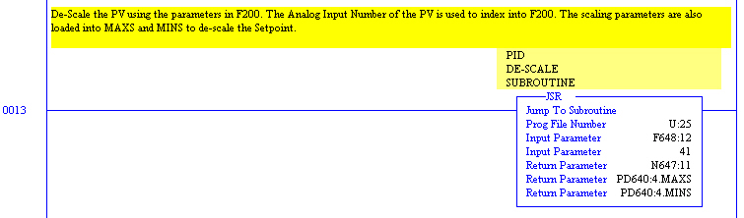

Figure : PV De-scaled for Input to the PID Instruction.

Once the de-scaling and some limit checking of the CV and Setpoint are complete, these “Return Parameters” are ready for the PID instruction itself.

#### The PID Control Block

The PID instruction executes every program scan, unless a timer bit is placed in the rung with it. It evaluates its inputs and sets its output. The PID instruction is displayed in Figure 275. Notice there is an entry for “Control Block” in the PID instruction parameters. This is where all of the information that the PID is using is stored. This includes flag bits about the status of the PID and includes values like the Setpoint, the Proportional Gain, the Integral, and the Derivative. This example is using element 4 of data file PD640. This data file also has information about other PID blocks (stored in other element numbers).



Figure : PID Instruction Block.

#### The PID Output

The output of the PID block is calculated by the PID and then moved from the OUT field in the PID control block to an address for display to the OIT. This move instruction is shown in Figure 276.

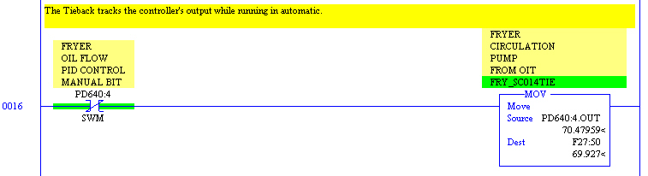

Figure : PID Output Moved to Address for OIT Display.

The output is also moved to an address for transfer to the ANALOG_OUT subroutine, which sends the signal (speed reference) to the Fryer Oil Circulation Pump. F29:50 is used in a JSR in the ANALOG_OUT subroutine to de-scale the Engineering Units output from the PID back to a Raw value for output by the card. An example of this rung is shown in Figure 277.

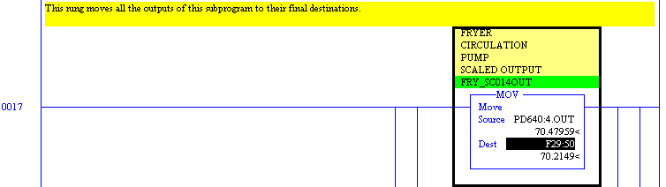

Figure : PID Output Moved to Address to go to the ANALOG_OUT Subroutine.

#### The PID Control Word

The PID Control Word has three main bits that are used to control the PID:

* Bit 0 – The Auto / Manual bit.
* Bit 3 – The On/ Off bit.
* Bit 5 – The “Use RSTune” bit.

By toggling these bits from Wonderware or within the PLC, allows user to control the PID’s functionality. The Auto/Manual bit is tied to the Auto/Manual button in Wonderware. The On/Off bit is usually used within the PLC and is tied to permissives allowing the PID to function. For example if a pump is not running, the PID will not be enabled. The “Use RSTune” bit is usually used in the PLC to interact with RSTune. This is useful when tuning the PID loop.

#### The PID Status Word

The PID status word uses four bits to show the status of the PID:

* Bit 0 – The Auto bit.
* Bit 1 – The Manual bit.
* Bit 3 – The Off bit.
* Bit 5 – RSTune bit.

These bits are manipulated by the control word. At the end of the PID subroutine, these bits are passed to the OIT.

### Typical Wonderware PID Faceplate

One helpful tool for checking on the correct functionality of a PID in a graphical sense is by looking at the PID screen in Wonderware. This screen shows the activity of:

* The Setpoint for the PID.
* The PV (Process Variable).
* The CV (Output of the PID).

Since it has both indicators for each of these values and a graph showing all three values, the PID screen can be very helpful during tuning and normal operation. An example of the PID faceplate (screen) is shown on the following page. As shown in the lower left corner, the PID screen has a toggle button to change the PID from AUTO mode to MANUAL mode. When in MANUAL mode, the operator can change the Tieback value of the PID using the control button at the bottom of the Output value indicator. When in AUTO mode, the operator can change only the Setpoint value, which is done using the control button at the bottom of the Setpoint value indicator. An example of a single PID Wonderware faceplate is pictured in .

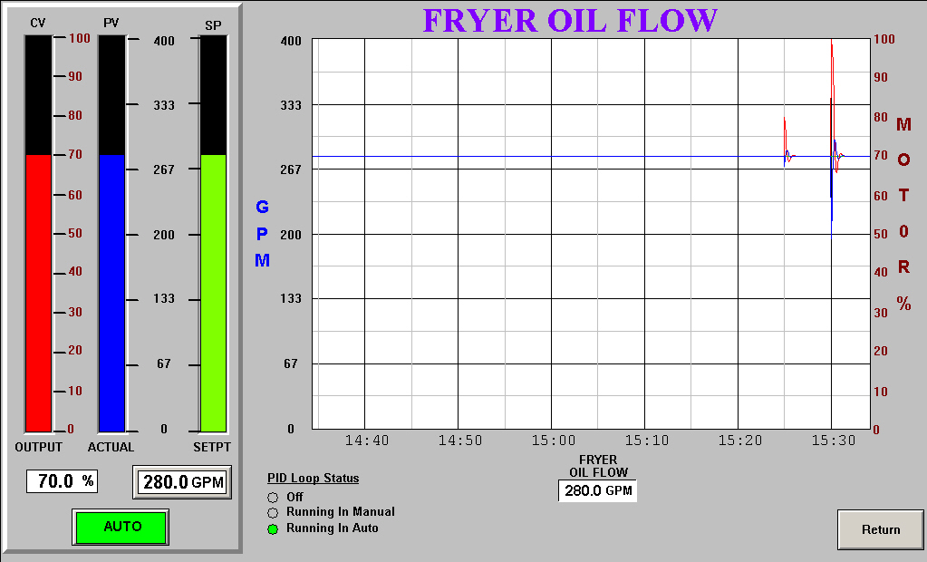

Figure : Fryer Oil Flow PID Wonderware Faceplate.

## Cascaded PID Structure

Cascaded PID’s provide for better control loops because it directly couples two PID loops together. The output of one PID becomes the Setpoint of the other. This means as the process changes, the effect that the change has on the first PID is passed on to the second PID as soon as it occurs. A Cascaded PID can be used when:

* There is a process in need of more precise control.
* There are two elements that must act together.

A typical PID is fairly simple in its inputs and output. Field inputs come in, are evaluated, and the output is set. A Cascaded PID is slightly more complex because two related PID loops work together. The Cascaded PID is similar in function to two separate PIDs, except that the CV (output) of the first, or master, PID becomes the Setpoint for the second, or slave, PID. For example, take a Fryer oil temperature control system using a Steam Heat Exchanger. The Fryer Oil Temperature PID is the master PID and the Steam Pressure PID is the slave PID. The Steam Pressure PID uses the CV (output) of the Fryer Oil Temperature PID as its setpoint. Normally the Fryer Oil Temperature PID will be tuned somewhat conservatively, while the Steam Pressure PID will be tuned somewhat more aggressively. This makes the Cascaded loop respond well to upsets in the process.

A block diagram showing how the cascaded PID functions is illustrated in Figure 279. Notice the CV (Output) of the top PID is sent to the Setpoint of the second PID.

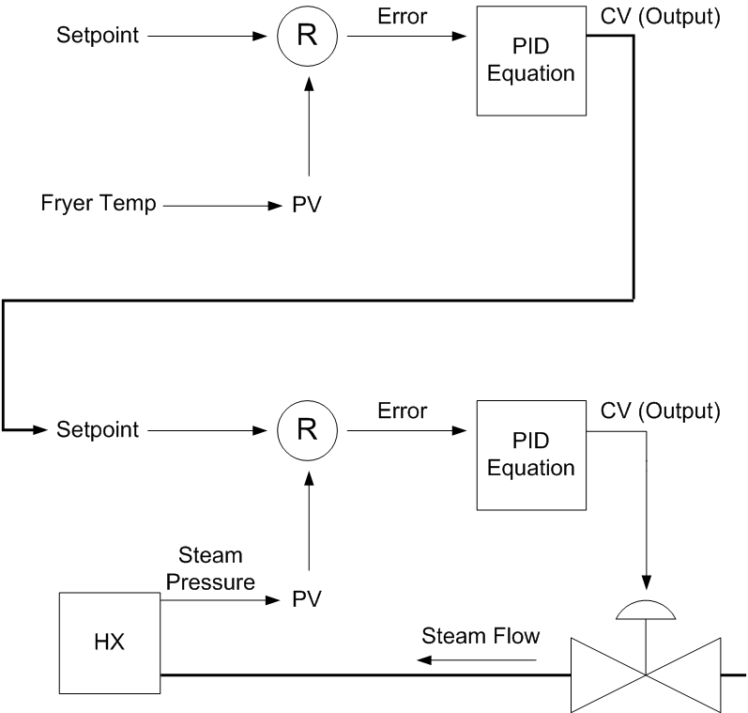

Figure : Cascaded PID Loop Block Diagram.

### Cascaded PID Subprogram and Wonderware PID Faceplates

The typical Cascaded PID subprogram combines the PID subprograms for the two PIDs into one larger subroutine. This makes monitoring the PIDs from the PLC code easier and also makes it easier to trace the code for both PIDs.

### Cascaded PID Subprogram

The Cascaded PID subprogram looks almost exactly like the single PID subprogram examined earlier in this manual, except for the fact it contains two PIDs. One of these PIDs (the Slave) does not have an external Setpoint from Wonderware being moved into the subprogram. It takes its Setpoint from the CV (output) of the Master PID. The Master PID operates almost exactly like a single PID does except it passes its CV to the Slave PID.

There are several settings that need to be changed in both the Master and Slave PIDs’ Configure tabs for the Cascaded loop to function properly. The Master PIDs’ Configure tab must have the Cascaded Loop selection set as “Yes,” and the Cascaded Type field set as “Master.” This is shown in Figure 280.

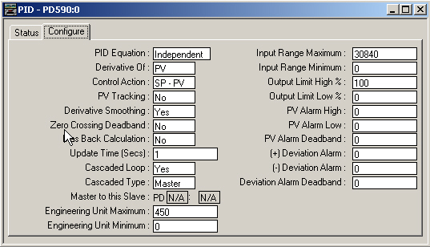

Figure : Fryer Oil Temperature PID – Master PID: Tin.

The Slave PIDs’ Configure tab must have the address of the Master PID placed in the “Master to this Slave” field. The Cascaded Loop selection must have “Yes” selected and the Cascaded Type field must be selected as “Slave.” This setup is shown in Figure 281.

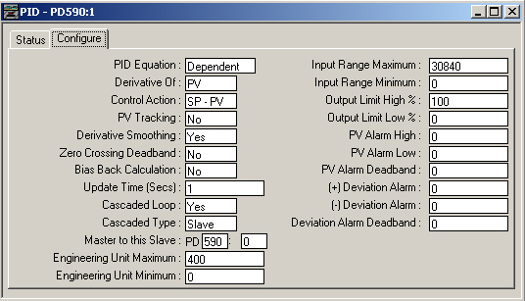

Figure : Fryer Oil Temperature PID – Slave PID: Steam Pressure.

### Cascaded PID Wonderware Faceplates

The single PID loop has a simple Wonderware screen to display the respective values and graphical activity of the PID loop. The Cascaded PID has at least two screens associated with it (maybe three screens). Both the Master PID and Slave PID have individual screens which show their respective values and graphical activity, much like the single PID loop. One noticeable difference is the Setpoint control button for the second (Slave) PID does not show up on the screen when the Cascaded loop is in AUTO mode. In fact, it may even be deleted from the screen. The reason is, in theory, this PIDs’ Setpoint should not be changed manually. When looking at the PID screens themselves, it is not obvious these two PIDs are related. The user may not be able to tell the two PIDs are linked (at least not by looking at the Wonderware screens). One way to clarify is to have another screen called the “Main PID Screen” which would show a small box to represent each PID. Between the two boxes is an arrow showing the relationship between the two. An example of a Master PID screen for a Cascaded loop is shown in Figure 282.

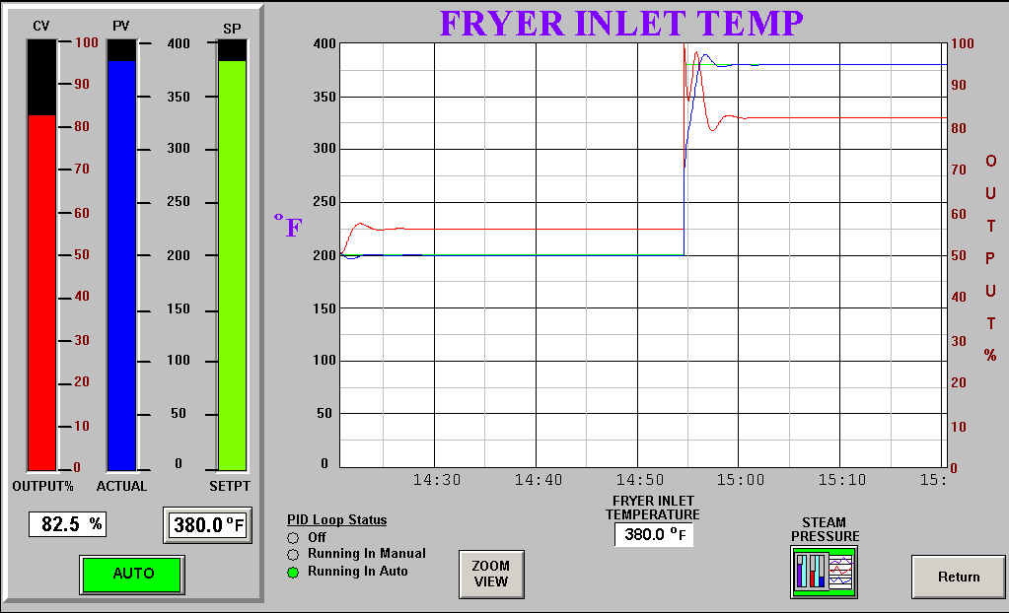

Figure : Fryer Oil Temperature Cascaded PID – Master PID WW Faceplate: Tin.

A screenshot of a Slave PID screen for a Cascaded loop can be seen in .

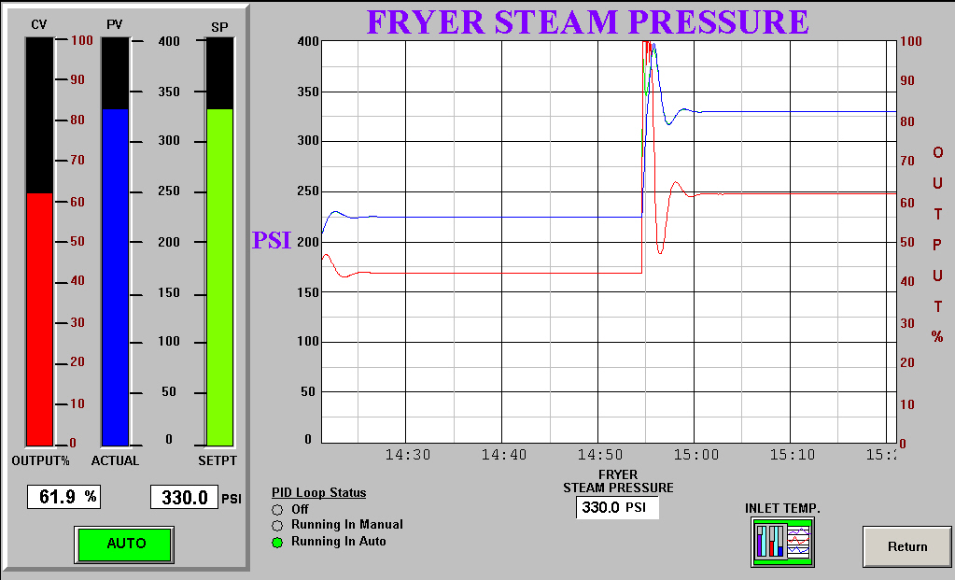

Figure : Fryer Oil Temperature Cascaded PID – Slave PID WW Faceplate: Steam Pressure.

An example of a main PID screen for a Cascaded loop is shown in Figure 284. By looking at the screen, the user can see there is a relationship between the two PID loops. The picture clearly shows the CV (Output) of the Tin PID is passed to the Setpoint of the Gas Flow PID.

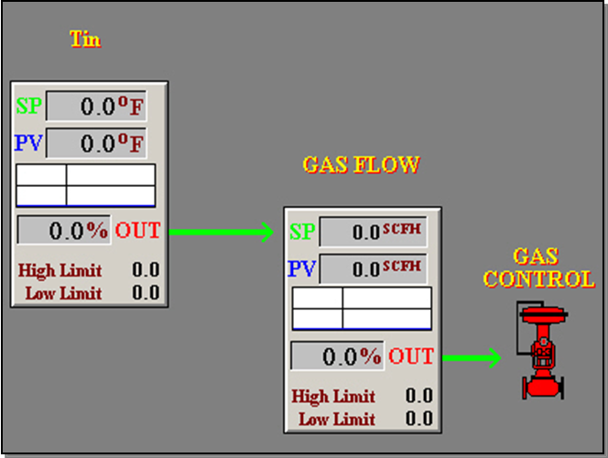

Figure : Main PID Screen Showing a Cascaded PID.

### 17.5.8 Adding a PID to a Program

If a motor with a VFD needs to be added on a process line, the familiarity with the process of adding the appropriate code and screen changes is helpful. This is especially true if the motor and VFD need to be controlled by a PID. The controls specialist will need to know all of the changes needed to make the new device function properly with the PID control. In order to understand how PID/ motor control rungs operate together in PLC code (and how to add new ones); it is beneficial to practice making additions to the PLC code.

1. **Ladder File for the PID Subroutine:**

Identify an unused file for use as the new PID subroutine ladder file. The file number will need to be close to related parts of the process line, if possible. If there are no file numbers available near the related part of the process line for this new device, then choose a higher number for the new PID subroutine.

1. **Creating the Ladder Rungs for the New PID Subroutine:**

Copy a working existing PID subroutine into the newly created PID subroutine. This will be used as a reference for the new PID.

1. **Analog Input for the PV:**

An Analog Input for the PIDs’ PV must be added in order to utilize the feedback of the field device with the PID. This should be done using the method described earlier in this manual. Record the F28:XX address used in the ANALOG_IN subroutine for this new Analog Input, since it will be used in the PID subroutine.

1. **Inputs for the PID:**

Identify available addresses for the Setpoint input value (not used in PLC code) for use with the new PID. Change the Setpoint addresses in the newly created PID subroutine to reflect these new addresses.

* 1. External Address: This value comes from the Wonderware screen. This is typically an F27:XX address, according to a customer’s addressing standard.
  2. Internal Address: This value is copied from the External Address and is used internal to the PID subroutine. It is typically an FXXX:XX address (such as F648:20 in PID subroutine 64).

Identify available addresses for the Tieback input value (not used in PLC code) for use with the new PID. Change the Tieback addresses in the newly created PID subroutine to reflect these new addresses.

1. External Address: This value comes from the Wonderware screen. This is typically an F27:XX address, according to a customer’s addressing standard. Change the Tieback input value in the newly created PID subroutine to reflect this new address.
2. Internal Address: This value is copied from the External Address and is used internal to the PID subroutine. It is typically an FXXX:XX address (such as F648:21 in PID subroutine 64).

Identify available addresses for the PV input value (not used in PLC code) for use with the new PID. Change the PV addresses in the newly created PID subroutine to reflect these new addresses.

* 1. External Address: This value is coming from the ANALOG_IN subroutine, and should have been identified in the “Analog Input for the PV” step. This is typically an F28:XX address, according to a customer’s addressing standard. Change the PV input value in the newly created PID subroutine to reflect this new address.
  2. Internal Address: This value is copied from the External Address and is used internal to the PID subroutine. It is typically an FXXX:XX address (such as F648:22 in PID subroutine 64).

Identify available addresses for the PID control word (not used in PLC code). Change the control word addresses in the newly created PID subroutine to reflect these new addresses.

1. External Address: This address will be used to control the status of the PID from Wonderware. This is typically an NXX:XX type address, according to a customer’s addressing standard.
2. Internal Address: This value is copied from the External Address and is used internal to the PID subroutine. It is an NXXX:XX address (such as N647:20 in PID subroutine 64).

Identify available addresses for the PID status word (not used in PLC code). Change the status word addresses in the newly created PID subroutine to reflect these new addresses. It is an NXXX:XX address (such as N647:23 in PID subroutine 64).

1. **Outputs for the PID:**

Identify an available address for the CV (PID Output) for use with the new PID. This value is sent to Wonderware for display and is also sent to the ANALOG_OUT subroutine for output to the new motor. This is an F29:XX address, according to a customer’s addressing standard. Change the CV address in the newly created PID subroutine to reflect this new address. Next, identify an available address for the Setpoint output value (not used in PLC code) for use with the new PID. This value is sent to Wonderware. This is an F28:XX address, according to a customer’s addressing standard. Change the Setpoint output value address in the newly created PID subroutine to reflect this new address. Next, identify an available address for the status word. This is N21:XX address.

1. **Analog Output for the CV:**

Identify an available channel on an Analog Output card attached to the PLC controlling the part of the process area in interest. Record the data address an unused channel on the Analog Output card. This should be incorporated into the JSR instruction to be used to de-scale the CV value. This JSR instruction must be added in the ANALOG_OUT subroutine before the BTW instruction for the correct Analog Output. This should be done using the same steps used when adding a VFD.

1. **Address for the PID Control Block:**

Identify an available address for the PID Control Block. This should be an element number in a data file of type “PD,” which means that the data file is meant for the storage of PID information. This is typically a PDXXX:XX address, according to a customer’s addressing standard. An example would be using PD640:2 as the PID control block address if the PID subroutine is located in subroutine number 64. Keep in mind there may be several PIDs using the same PD file number, but each are separated by element number (i.e. PD640:1, PD640:2, PD640:3). Be sure to use an element number that is not already assigned to another PID control block. This will result in problems with PID control in both PIDs. Change the existing PID control block address to the new address in our new PID subroutine. An example of where the PID control block address must be placed in the PID instruction is shown in Figure 285.

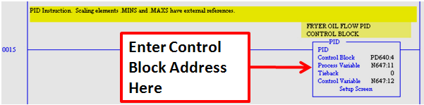

Figure : Control Block Address in the PID Instruction.

1. **Addresses for De-scaling the PV:**

Identify an available set of four addresses in the F200 data file for the de-scaling information for the PV. This data file is also used for Analog Input scaling information. In most cases, the same four consecutive addresses can be used for scaling the PV when it enters the PLC and for de-scaling when the PV is to be used in the PID subroutine. These four addresses contain the scaling range for the Analog card (like 0 to 30480) and the scaling range for the Engineering Units (like 0 to 400 degrees). Change the De-scaling JSR Instruction’s address reference in the newly created PID subroutine to reflect the new addressing.

1. **Setting Up the PID Instruction:**

Next input the proper information about the new PID in the PID instruction. This includes all of the settings covered earlier in the manual, such as the Control Action, whether or not it is a Cascaded PID and other settings described earlier in the PID section of this manual.

## 17.6 LAB - PID - Adding a PID to a Program

This lab will practice the steps demonstrated earlier in this unit to add a new PID to an existing program. The requirements for the lab are listed below:

1. Open the “PID Lab” file in RSLogix 5.
2. Add a new PID to this program called “Fryer Oil Flow” that will control a new motor with a VFD called “Fryer Oil Circulation Pump.” There will be a flow meter to provide the PV input value. Copy ladder file # 64 to use as a template for the new PID subroutine.
3. Use the following addresses to add the PID to the existing program:
   1. Setpoint Input
      1. External Address: F27:260 (Previously assigned to F27:270)
      2. Internal Address: F848:20 (Previously assigned to F648:20)
   2. Tieback
      1. External Address: F27:261 (Previously assigned to F27:271)
      2. Internal Address: F848:21 (Previously assigned to F648:21)
   3. PV
      1. External Address: F28:41 (Previously assigned to F28:40)
      2. Internal Address: F848:22 (Previously assigned to F648:22)
      3. Internal Address: N847:21 (Previously assigned to N647:21)
   4. PID Control Word
      1. External Address: N21:11 (Previously assigned to N21:12)
      2. Internal Address: N847:20 (Previously assigned to N647:20)
   5. PID Status Word
      1. Internal Address: N847:23 (Previously assigned to N647:23)
   6. PID Control Block
      1. Control Block Address: PD840:2 (Previously assigned to PD640:2)
      2. Control Feed Forward: F848:23 (Previously assigned to F648:23)
   7. Processed Feed Forward: F848:24 (Previously assigned to F648:24)
   8. CV Ramp Limit: F848:25 (Previously assigned to F648:25)
   9. PID De-scaling Addresses: F200:205 – 208 (Hint: Use 41 as second parameter for De-scaling JSR)
   10. CV
       1. Internal Address: F29:50 (Previously assigned to F29:250)
       2. Internal Address: N847:22 (Previously assigned to N647:22)
       3. Assign output N13:48 as the address output from JSR in Analog Out subroutine. This corresponds to Channel 2 on 1794-OF4I analog output card in Rack 14, Group 0, Slot 1
   11. Setpoint Output: Address to send to Wonderware: F28:260 (Previously assigned to F28:270)

Add a JSR in the MAIN subroutine that directs RSLogix 5 to the new PID subroutine.

## 17.7 The PID Instruction in RSLogix 5000

The PID Instruction itself is much like any other instruction in RSLogix 5000. It has certain parameters it needs in order to operate properly. Like other instructions, it gets some of the information it needs in order to operate from Wonderware. For example, if the PID is controlling a pump, the setpoint for the speed of the pump is most likely set on a screen in Wonderware. This means that the operator on the process line must input a setpoint in the setpoint control in Wonderware in order for the PID to have this information sent to it. The PID has another complicating factor: it can be placed in different modes from Wonderware. If a button is assigned to the PID control word in Wonderware, then the PID can be toggled from AUTO to MANUAL mode from the OIT. We will cover how this can be accomplished later in this section. An example of a PID instruction block is shown below.

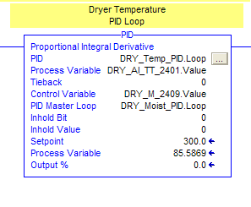

Figure . Standard PID instruction in RSLogix 5000.

To gain access to the PID instruction settings, double-click on the button at the top right-hand corner of the PID instruction block. This opens the set of tabs that contain the details for the PID instruction. There are five parts to the PID instruction, which are divided into tabs: The tuning tab, configuration tab, alarms tab, scaling tab, and the tag tab.

### 17.7.1 Tuning Tab for the PID Instruction in RSLogix 5000

The Tuning Tab for the PID instruction allows the user to monitor the functionality of the PID instruction as it operates. It shows important information about the PID instruction and its input and output variables. It shows input variables like Setpoint, PV (Process Variable), and Set Output (Tieback in PLC5). It also shows the Output of the PID instruction, also called the CV (Control Variable). The three elements used for PID tuning are shown (and can be changed) on the Tuning tab. These three adjustments are: Proportional Gain (Kc), Integral (Ti) shown as Reset Time on the tuning tab, and Derivative Rate (Td). The Tuning tab also shows whether or not the PID is in a manual mode (Manual or Software Manual). The Output Bias is also shown on the tuning tab. An example of the Tuning Tab for a PID instruction is shown below.

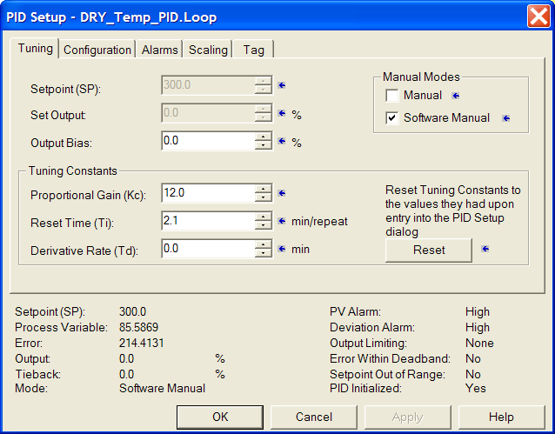

Figure . Tuning Tab in a PID setup screen in RSLogix 5000.

### 17.7.2 Configuration Tab for the PID Instruction in RSLogix 5000

The Configuration Tab for the PID instruction allows the user access to the settings for the PID instruction. From the Configuration Tab, the user can change almost everything about how the PID functions. These changes should only be made while the PID instruction block is in MANUAL mode, never when the PID is in AUTO mode.

*****Note: Changes attempted while the PID is in AUTO mode can cause erratic behavior of the PID block, and may even cause the PID block to “lock up” or stop responding.

Some of the more important settings that the user can change on the Configure tab are: the Control Action of the PID (Direct Acting or Reverse Acting), whether or not the PID is part of a cascaded loop, the loop update time, and the output limits. An example of a Configuration tab for a PID is shown in the figure below.

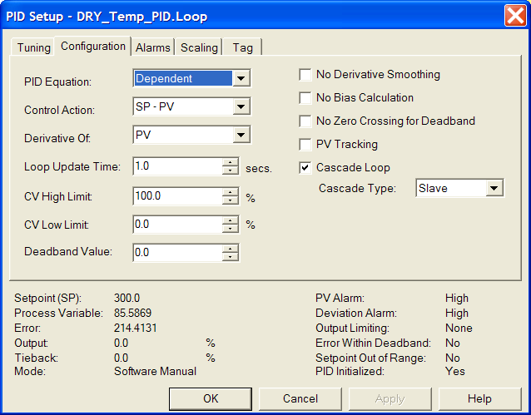

Figure . Configuration Tab in a PID setup screen in RSLogix 5000.

### 17.7.3 Alarms Tab for the PID Instruction in RSLogix 5000

The Alarms Tab for the PID instruction allows the user access to set alarms for the PID instruction. Alarms can be set for the PV limits and for other less used items. An example of a Configuration tab for a PID is shown in the figure below.

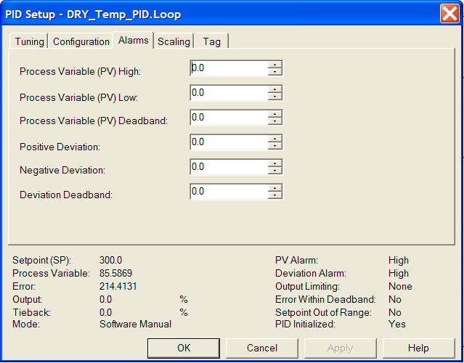

Figure . Alarms Tab in a PID setup screen in RSLogix 5000.

### 17.7.4 Scaling Tab for the PID Instruction in RSLogix 5000

The Scaling Tab for the PID instruction allows the user access to set the scaling for the PID instruction. The PV scale for both raw and engineering units can be set in this tab. The scale limits (in %) should be set for the output of the PID (CV). This is generally set to 0-100%. The Tieback range for the PID should also be set (this is generally not used). An example of a Configuration tab for a PID is shown in the figure below.

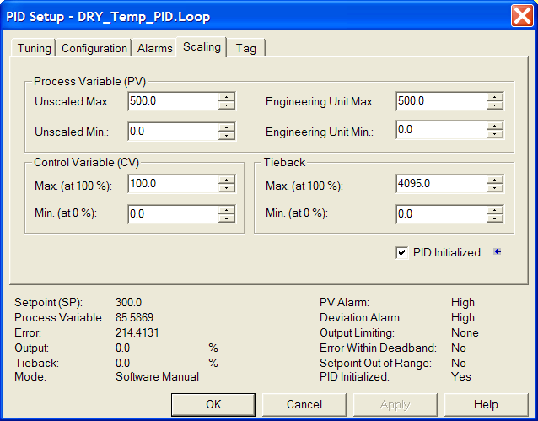

Figure . Scaling Tab in a PID setup screen in RSLogix 5000.

### 17.7.5 Tag Tab for the PID Instruction in RSLogix 5000

The Tag Tab for the PID instruction displays the PID tag for the PID instruction. This tag is created when setting up the PID instruction and contains all of the settings for the PID instruction. Once this is set up in the instruction block it should not be modified in the Tag tab. An example of a Configuration tab for a PID is shown in the figure on the following page.

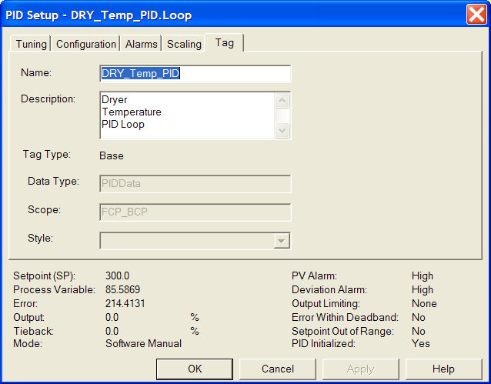

Figure . Tag Tab in a PID setup screen in RSLogix 5000.

## Typical PID Subprogram and Wonderware PID Faceplate

When adding a PID to a ControlLogix program, the majority of the PLC code that relates to the PID is contained in a single PID subprogram (or subroutine). The only items that appear outside the PID subroutine that relate to the PID are: the Analog Input signal for the PV, the Analog Output signal for the CV, and the status word for the PID (from Wonderware). This third element is usually duplicated both outside and inside the PID subroutine for PLC5. The status word is contained in the PID tag in RSLogix 5000.

### 17.8.1 Typical PID Subprogram in RSLogix 5000

The typical PID subprogram in RSLogix 5000 will contain certain items that pertain to PID control, such as: the PID tag, instructions that move status from tags in WW used in the PID subroutine, the PID instruction, and instructions to move the output of the PID (CV) to the OIT display.

#### Moving External Values into the PID Subroutine in RSLogix 5000

The external values that are moved into or used by the PID subroutine in RSLogix 5 are: the Control Word, the Setpoint, and the PV (Process Variable). In RSLogix 5000 all of these values are stored in the PID tag, rather than individual addresses. This means that they do not have an external address and an internal address with respect to the PID subroutine. They are all simply stored in the PID tag. The first of these sub elements used in the PID tag is the Off Request (OffReq). This turns on the Off Command (OffCmd). This rung is shown in the figure below.

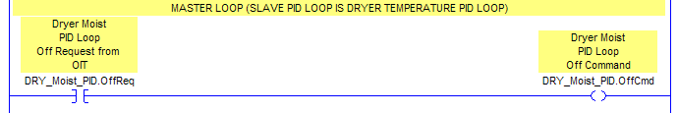

Figure . PID OffReq turns on the OffCmd in RSLogix 5000.

The Off Command is also used in conjunction with the Auto Command (.AutoCmd) and any other permissives for the PID to turn on the Permissive (.Permissive) sub element of the PID. This permissives rung is shown in the figure on the following page.

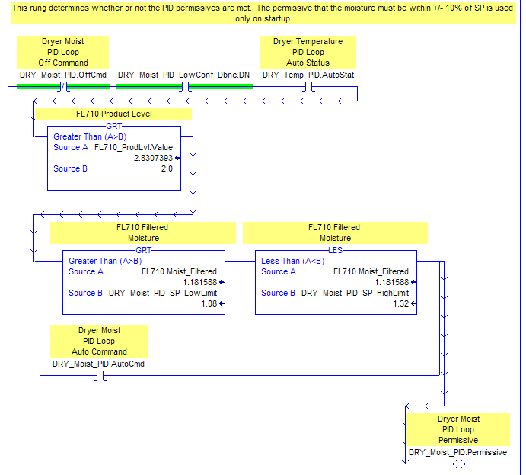

Figure . PID Off Command and Auto Command used to turn on the PID Permissive sub element.

The Auto Request (.Authored) and Permissive (.Permissive) sub elements are used to turn on the Auto Command (.AutoCmd). The Auto Request is sent from the Auto button in the WW application on the OIT. This is shown in the figure below.

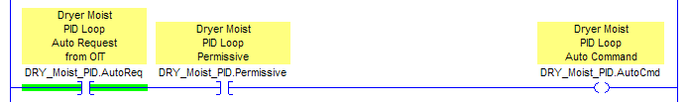

Figure . PID AutoReq and Permissive turning on the AutoCmd.

#### 17.8.2.1 Inside the PID Subroutine in RSLogix 5000

Once the information from the analog tags and WW application is transferred to the PID tag, these values and status elements are used inside the PID subroutine. Most of these are not of major concern, and are generally easy to decipher by looking at them.

##### PID Descaling – Not Needed in RSLogix 5000

The RSLogix 5 PID instruction block used for PLC5 required that we descale the PV before we passed the PV to the PID block. This is not necessary in RSLogix 5000. We can use the AnalogData type tag that we have defined for our PV to pass the PV value (in engineering units) to the PID instruction.

##### The PID Control Block in RSLogix 5000

The PID instruction executes every program scan, unless a timer bit is placed in the rung with it. It evaluates its inputs and sets its output. The PID instruction is shown in the figure below. Notice that there is an entry for “PID” in the PID instruction parameters. This is the tag of type “PIDData” where all of the information that the PID is using is stored. This includes flag bits about the status of the PID, and includes values like the Setpoint, the Proportional Gain, the Integral, and the Derivative. In this case, we are using DRY_Temp_PID.Loop. This reference to the “Loop” sub element is necessary in order for the PID to store internal values correctly. The PV is defined in the Process Variable field in the PID instruction. The CV is defined in the Control Variable field in the PID instruction. If the PID is a cascade (and is the slave loop in the cascade), then the PID Master Loop for this PID is defined in the PID Master Loop field in the PID instruction.



Figure . PID Instruction block in RSLogix 5000.

##### The PID Output in RSLogix 5000

The output of the PID block is calculated by the PID, and then moved from the OUT field in the PID control block to the Set Output sub element (.SetOutput) for display to the OIT. Remember that the output of the PID is sent to the proper Analog Output by defining the Control Variable in the PID Instruction block. This move instruction is shown in the figure below.

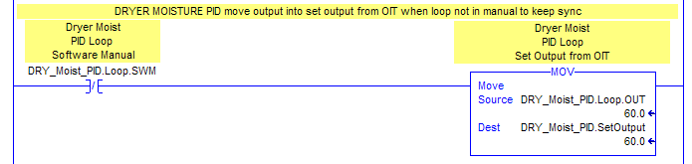

Figure . PID output moved to address for OIT display.

### 17.8.3 Typical Wonderware PID Faceplate for Use with RSLogix 5000

One helpful tool for checking on the correct functionality of a PID in a graphical sense is by looking at the PID screen in Wonderware. This screen shows the activity of the Setpoint for the PID, the PV (Process Variable), and the CV (Output of the PID). Since it has both indicators for each of these values and a graph showing all three values, the PID screen can be very helpful during tuning and normal operation. An example of the PID faceplate (screen) is shown on the following page. As you can see in the lower left corner, the PID screen has a toggle button to change the PID from AUTO mode to MANUAL mode. When in MANUAL mode, the operator can change the Tieback value of the PID using the control button at the bottom of the Output value indicator. When in AUTO mode, the operator can change only the Setpoint value, which is done using the control button at the bottom of the Setpoint value indicator. An example of a single PID Wonderware faceplate is shown in the figure below.



Figure . Fryer Oil Flow PID Wonderware Faceplate.

## Cascaded PID Structure

The first question we must ask is: Why use a Cascaded PID? The answer is simple: better control loops. The Cascaded PID gives us better control over a process because it directly couples two PID loops together. The output of one PID becomes the Setpoint of the other. This means that as the process changes, the effect that the change has on the first PID is passed on to the second PID as soon as it occurs.

The next question we must ask is: When do I use a Cascaded PID? The answer is twofold: when you have a process where you need more precise control, and when you have two elements that are involved with the control that must act together.

A Typical PID is fairly simple in its inputs and output. Field inputs come in, are evaluated, and the output is set. A Cascaded PID, as we have said, is slightly more complex in that it involves two related PID loops working together. The Cascaded PID is similar in function to two separate PIDs, except that the CV (output) of the first, or master, PID becomes the Setpoint for the second, or slave, PID. An example of this situation is in the case of a Fryer oil temperature control system that uses a Steam Heat Exchanger. The Fryer Oil Temperature PID is the master PID, and the Steam Pressure PID is the slave PID. The Steam Pressure PID uses the CV (output) of the Fryer Oil Temperature PID as its setpoint. Normally the Fryer Oil Temperature PID will be tuned somewhat conservatively, while the Steam Pressure PID will be tuned somewhat more aggressively. This makes the Cascaded loop respond well to upsets in the process.

A block diagram showing how the cascaded PID functions are shown in the figure below. Notice that the CV (Output) of the top PID is sent to the Setpoint of the second PID.



Figure . Cascaded PID Loop Block Diagram.

## 17.10 Typical Cascaded PID in RSLogix 5000 and WW PID Faceplates

The typical Cascaded PID subprogram in RSLogix 5000 combines the PID subprograms for the two PIDs into one larger subroutine. This makes monitoring the PIDs from the PLC code easier, and also makes it easier to trace the code for both PIDs.

### 17.10.1 Typical Cascaded PID Subprogram in RSLogix 5000

The Cascaded PID subprogram looks almost exactly like the single PID subprogram we examined earlier in this manual, except for the fact that it contains two PIDs. One of these PIDs (the Slave) does not have an external Setpoint from Wonderware being moved into the subprogram. It takes its Setpoint from the CV (output) of the Master PID. The Master PID operates almost exactly like a single PID does, with the exception that it passes its CV to the Slave PID.

#### 17.10.1.1 Cascaded PID Setup in RSLogix 5000

There are several settings that need to be changed in both the Master and Slave PIDs’ Configuration tabs in order for the Cascaded loop to function properly. The Master PIDs’ Configure tab must have the Cascaded Loop selection set as “Yes,” and the Cascaded Type field set as “Master.” This is shown in the figure on the following page.

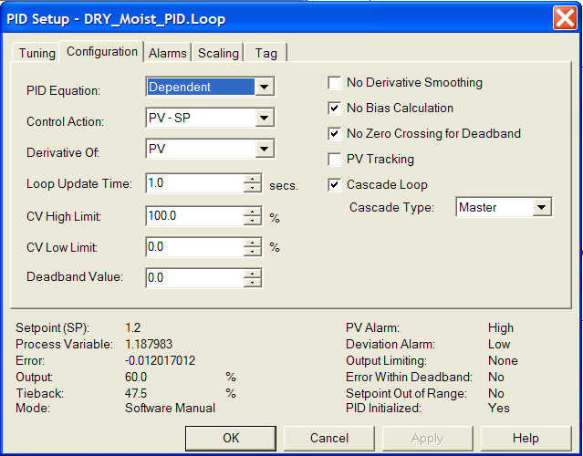

Figure . Dryer PID – Master PID: Dryer Moisture.

The Slave PIDs’ Configuration tab must have the address of the Master PID placed in the “PID Master Loop” field in the PID instruction. The Cascaded Loop selection must have “Yes” selected, and the Cascaded Type field must be selected as “Slave.” This setup is shown in the figure on the following page.



Figure . Dryer PID – Slave PID: Dryer Temperature.

### 17.10.2 Typical Cascaded PID Wonderware Faceplates for Use with RSLogix 5000

The single PID loop has a simple Wonderware screen to display the respective values and graphical activity of the PID loop. The Cascaded PID has at least two screens associated with it (maybe three screens). Both the Master PID and Slave PID have individual screens that show their respective values and graphical activity, much like the single PID loop. One noticeable difference is that the Setpoint control button for the second (Slave) PID does not show up on the screen when the Cascaded loop is in AUTO mode. In fact, it may even be deleted from the screen. The reason for this is that, in theory, this PIDs’ Setpoint should not be changed manually. When looking at the PID screens themselves, it is not obvious that these two PIDs are related. The user may not be able to tell that the two PIDs are linked (at least not by looking at the Wonderware screens). One way to clarify this is to have another screen that we could call the “Main PID Screen” which would show a small box to represent each PID. Between the two boxes is an arrow that shows the relationship between the two.

An example of a Master PID screen for a Cascaded loop is shown in the figure below.



Figure . Fryer Oil Temperature Cascaded PID – Master PID WW Faceplate: Tin.

An example of a Slave PID screen for a Cascaded loop is shown in the figure below.



Figure . Fryer Oil Temperature Cascaded PID – Slave PID WW Faceplate: Steam Pressure.

An example of a main PID screen for a Cascaded loop is shown in the figure below. Notice that by looking at the screen, the user can see that there is a relationship between the two PID loops. The picture clearly shows that the CV (Output) of the Tin PID is passed to the Setpoint of the Gas Flow PID.

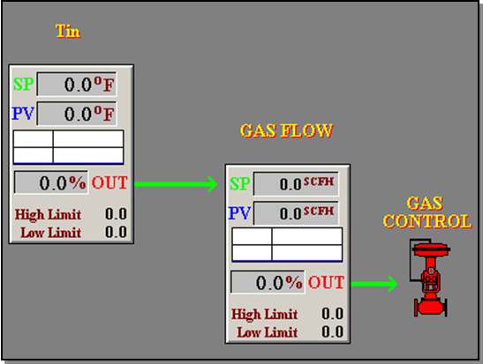

Figure . Main PID screen showing a Cascaded PID.

## Adding a PID Subprogram in RSLogix 5000

The PID subroutine in RSLogix 5000 contains the necessary logic to control a portion of a process that requires a PID. An example of this would be a burner on a Dryer for a Baked Cheetos line. We will now discuss the necessary steps to add a PID subroutine to an existing project in RSLogix 5000.

### 17.11.1 Steps to Add a PID Subroutine in RSLogix 5000

To add a PID subroutine to an existing RSLogix 5000 project, follow the steps below:

1. Identify an unused ladder file for PID subroutine. In most cases you will create a new ladder file for your new PID subroutine.
2. Copy an existing PID subroutine into new ladder file. Try to find a PID subroutine that has a similar application to the one that you will be controlling with the new PID.
3. Setup a new PID Control Block tag of tag type “PIDData.” Name it something specific to the new PID application. For example: If you are adding a new Seasoning Spray Bar to a seasoning area on TC Line #1, you could call your new PIDData type tag “TC1SeasSprayBarPID.”
4. Update the new PID program rungs with the new tags you created. Keep in mind that there may be changes you need to make to the permissives that allow the PID to enter auto mode.
5. Identify an available Analog Input for the PIDs’ PV (Process Variable – what we are looking at to compare to our setpoint).
6. Create a new tag for the PV’s Analog Input of tag type “AnalogData.”
7. Add a new JSR in the ANALOG_IN subroutine for the PID’s PV.
8. Identify an available Analog Output for the PIDs’ CV (Control Variable – what we are controlling with our PID).
9. Create a new tag for the CV’s Analog Output of tag type “AnalogData.”
10. Add a new JSR in the ANALOG_OUT subroutine for the PID’s CV.
11. Change the PID instruction settings to reflect the new application.

### 17.11.2 LAB - Add a PID in an existing RSLogix 5000 Project

In this exercise we want to add a PID subroutine in an existing RSLogix 5000 project.

Here are some details you will need:

1. The new PID subroutine will control Dryer temperature on a Cheetos line and will be a single stand-alone PID (Normally this is a Cascaded PID with Moisture, but for the lab we will simplify the application).
2. Use the project you created in the earlier lab and add a new subroutine to it – this will be for the BCP Line 1 Dryer Temperature and will have file # 107.
3. The name of the new PIDData tag for the PID Subroutine will be “BCP1DryTempPID.”
4. Use the existing Dryer temp PID as a template for the new PID subroutine (copy this PID subroutine and paste it to your new subroutine, changing the tags to your newly created PIDData tag where needed).
5. Create a new auto system to activate this PID called “AutoSysBCP2.DryerBnr” and use this auto system in your new PID subroutine.
6. Change the new PID settings for your new application.

# 18 RSTune Basics

RSTune is a Rockwell Software package that can be used in conjunction with an RSLogix 5 program to assist in tuning a PID loop.

Reference Items in folder – “Section 16 To 17 - PID's” for examples and additional information

## Starting RSTune

To open the RSTune program, go to Programs → Rockwell Software → RSTune → RSTune from the Start menu. This will bring up the Start screen, which is shown in . There will also be a window called “RSTune Tutorial” which will open when the application starts. This tutorial screen will walk through the steps to use RSTune.

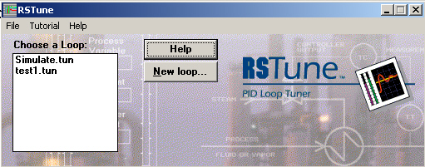

Figure : RSTune Start Screen.

To look at a simulated PID loop, select “Simulate.tun” from the list under the “Choose a Loop” title. This will bring up additional button selections, as pictured in Figure 305.

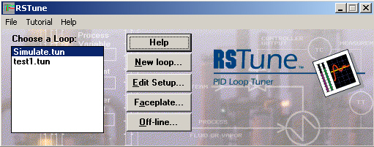

Figure : RSTune Start Screen with Added Buttons.

Press the “Faceplate” button to bring up the simulated PID loop example screen. This simulation acts much like a real PID loop, where the PV is constantly changing. From this screen the parameters can be changed for the PID loop by entering new values in the “NEW” column at the lower left of the screen. The setpoint and CV (Output) can be changed by double-clicking on them. The CV can only be changed if the loop is in Manual mode. The Faceplate screen is shown in Figure 306.

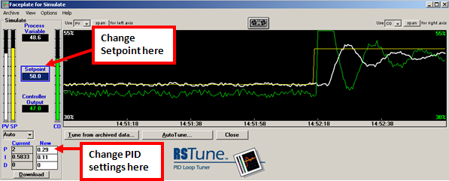

Figure : RSTune PID Tuning Screen.

RSTune is useful for the purpose of automatically tuning a PID loop.

## Using the AutoTune Feature in RSTune

The “AutoTune” feature in RSTune can be used to automatically tune a PID loop. RSTune will automatically tune the loop and the user will have to decide if the changes the software suggests will work well for the application. Use the following steps to utilize the AutoTune function in RSTune:

1. Press the “AutoTune” button on the Faceplate screen.
2. RSTune will prompt for the information it needs to tune the PID loop. Click through the appropriate buttons to complete the tuning process.
3. RSTune will show a prompt telling indicating it has saved the tuned loop specifications for when tuning is complete.

## A Simple Method for PID Tuning

In order to properly tune a PID loop, there are certain steps to follow to obtain satisfactory results. These steps will be outlined in this section and explain how to properly tune a PID loop. The steps below show the Ziegler and Nichols method taken from David W. St. Clair’s book on PID tuning.[15]

1. Turn the integral time to as high a number as possible (often called “off”). With digital controllers this is usually to set the integral time to zero, which is not zero time but a convention to indicate no integral action. Turn the derivative time (if used) to as small a number as possible (often called “off”).
2. Increase the gain in steps until the loop cycles (there is technique to this). It is a fundamental truth that any control loop will cycle if the controller gain is made high enough.
3. Observe the period of cycling, Pn, to be called the natural period. Note also the gain at which it cycled, Kcu, to be called the *ultimate* gain.
4. Set the controller settings to:
5. Kc = Kcu / 2 (aggressive).
6. Kc = Kcu / 4 (conservative).
7. Ti = 1.2 Pn. (Ti example – 15 sec =.25)
8. Td = Pn / 8.
9. Tf <= Pn / 8.

NOTE:

* 1. Kc = Controller Gain, % output / % input.
  2. Kcu = Controller Gain that produced the sustained cycle, % output / % input.
  3. Ti = Integral time, minutes.
  4. Td = Derivative time, minutes.
  5. Pn = Natural period, minutes.
  6. Tf = Filter time.

These steps are recommended for the proper tuning of a PID loop in a Closed-Loop application. This simply means there will be feedback illustrating the effect the tuning changes have on the process. The examination will be limited to Closed-Loop applications.

## User PID Tuning in RSTune Using a Simulation Loop

This section will have the user tune the PID from the RSTune Faceplate screen. This is done using the PID tuning controls at the lower left corner of the Faceplate screen. Open RSTune and select the Simulate.tun file. Click on the Faceplate button to open the faceplate for this application. In the lower left-hand corner of the screen, there is a set of boxes with the word PID next to them. There are two columns “Current” and “New” as highlighted in Figure 307.

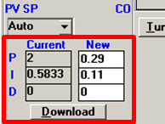

Figure : Current and New Columns is RSTune.

The “Current” column shows the current tuning settings being used by RSTune (previously set by the user). The “New” column is used to enter new tuning information. Simply type in the desired values into the correct row under the “New” column and press the “Download” button to download the new settings to RSTune. RSTune will prompt the user with an “Are you sure?” dialog box; click the “Yes” button. The setpoint value can also be changed to produce an upset in the process by double-clicking on the setpoint box and entering a value in the pop-up box as pictured in Figure 308.

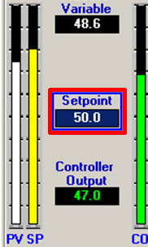

Figure : Setpoint in RSTune.

When attempting to tune with RSTune, RSTune must be in “Auto” mode. If RSTune is changed to “Manual” mode, then manual changes to the CV must be made to see the output change.

## Using RSTune with RSLogix 5

There are several tasks which have to be accomplished to use RSTune with RSLogix 5. First, a topic within RSLinx must be setup to allow RSTune and RSLogix 5 to communicate. RSLogix 5 must have the proper configuration within the PID subroutine being tuned. Also a tuning file in RSTune must be setup to use the new topic in RSLinx to communicate tuning changes with RSLogix 5. The remainder of this section will address the actions needed to use RSTune with RSLogix 5.

### 18.5.1 Setting Up a Topic in RSLinx

The Topic can be set up using the following steps:

1. Open the RSLinx software from Programs -> Rockwell Software -> RSLinx.

**\*\*Note: RSLinx Professional must be installed on the computer in order for RSTune to communicate with RSLogix 5.**

1. Select “Topic Configuration” from the DDE / OPC menu in RSLinx. Seen in Figure 309.

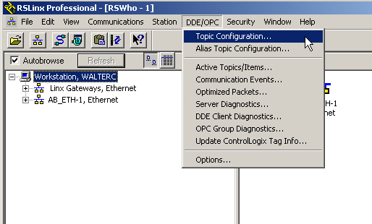

Figure : Topic Configuration in the DDE / OPC Menu in RSLinx.

1. The Topic List to the left in Figure 310 shows currently configured topics. To add a new topic, press the “New” button at the lower left of the screen. Type in a name for the new topic and press enter.

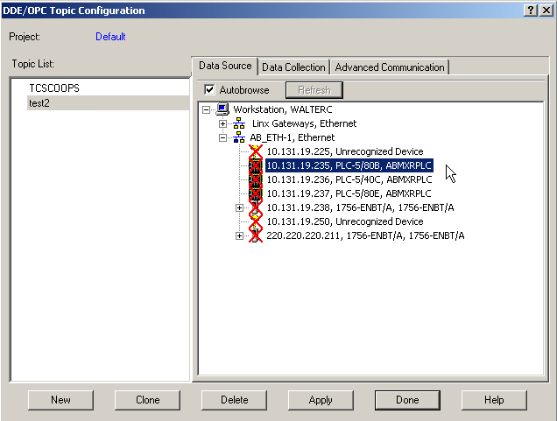

Figure : Topic Configuration in RSLinx.

1. Select the new topic name from the Topic List. Click on the appropriate driver in the Data Source tab and select the desired PLC.
2. The Topic must have settings defined in the Data Collection tab in order to communicate with the PLC. The typical data collection mode is “Polled Messages” with the default set at 1000 msecs (1 sec). This is shown in Figure 311.

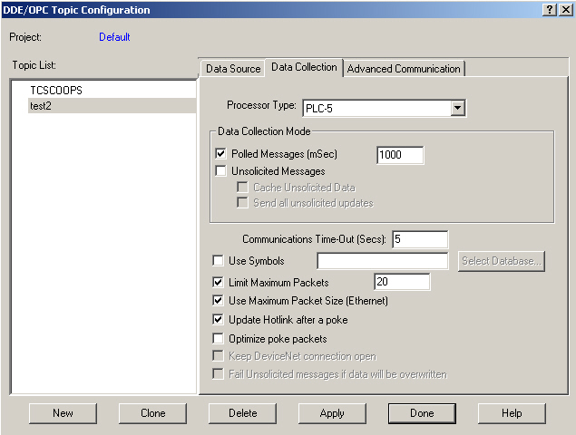

Figure : Topic Configuration Data Collection Tab in RSLinx.

1. The Advanced Communications tab should be set up to communicate with the appropriate communications driver (like A-B Ethernet). The station number can also be set. The addressing mode should be local, because RSLogix 5 is communicating with an instance that is running on a local machine (which is online with the processor). The Advanced Communications tab is pictured in Figure 312.

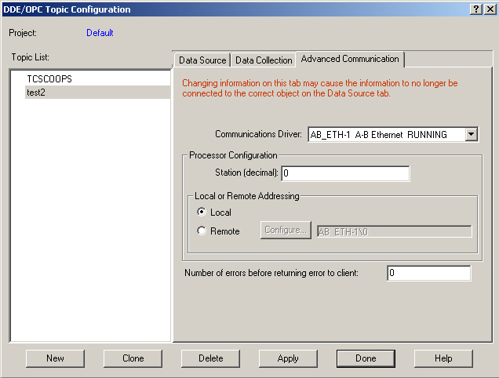

Figure : Topic Configuration Advanced Communication Tab in RSLinx.

### 15.5.2 Checking PID Configuration in RSLogix 5

There are several things to check in RSLogix 5 before RSTune is ready to tune a PID.

1. The first item to check in the configuration of the PID in RSLogix 5 is that the “Use RSTune” bit for the PID is “ON.” This bit may or may not be activated from a button in Wonderware. This bit enables setpoint changes to the PID from the RSTune faceplate.
2. Record the PD file and element where the information about the PID is stored in RSLogix 5. This information will be needed when setting up RSTune to interact with this PID.
3. Make sure RSLogix 5 is online with the PLC and the PLC is in run mode.
4. Ensure the permissives to allow the PID to run in automatic are met.

### 18.5.3 Setting Up a New Tuning File in RSTune

We must set up a new tuning file in RSTune to communicate with our new Topic created in RSLinx. In order to do so, use the following steps and the screenshot in Figure 313 as a reference.

1. From the main RSTune screen, press the “New Loop” button to create a new tuning file. The program will then prompt the user to enter a new file name for the new tuning file. Enter a new name and click on the “Save” button. This will bring up the setup screen for the new tuning file.
2. In the setup screen for the new tuning file, select the topic name (set up in RSLinx earlier) in the Topic Name field shown in the “RSLinx communication box” in RSTune.
3. Select the communication driver to be used by this topic (either DDE or OPC) from the Communicate Via box at the lower left side of the setup screen.
4. Select the Processor type that will be used in conjunction with RSTune from the Processor Type selection box at the right of the setup screen. Notice there are two types of PLC-5s under the Processor Type selection. Normally a PD file type is used in RSLogix 5 to store the PID information, so select the “PLC-5 PD file” as the processor type.
5. Enter the PID instruction’s address (the address location of the PID instruction in the RSLogix 5 program) in the PID Instruction Addresses box at the lower right side of the setup screen.

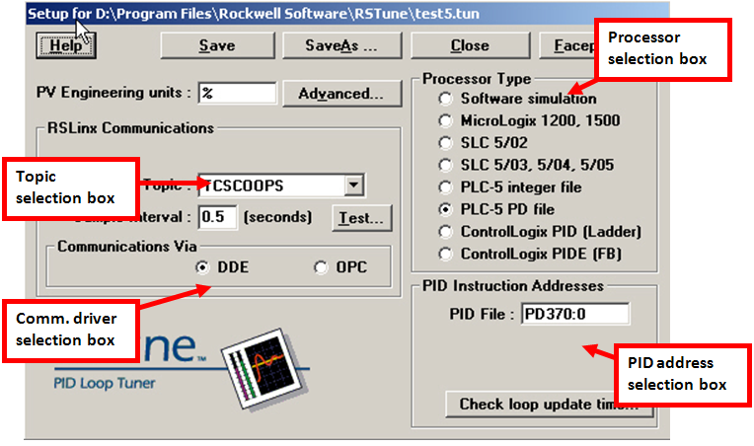

Figure : New Tuning File Setup Screen in RSTune.

1. Once the selections are completed, click the “Save” button to save the settings. The user may also choose to select “Save As” to save the setup as a different file name.
2. Press the “Faceplate” button at the top of the tuning file setup screen to open the Faceplate screen for the new tuning file.

### 18.5.4 User PID Tuning in RSTune Using a Real PID Loop

Earlier in the manual RSTune was used to practice tuning a PID using a simulation program. Now an actual process PID will be tuned using the setup with RSLinx and RSLogix5. Open the new tuning file “Oil_Flow” from the main RSTune screen using the “Faceplate” button. This will bring up the Faceplate screen showing the graph of the Setpoint, PV and CV for the PID. The PID should status box should show the PID is in Auto mode. Using the PID tuning controls at the lower left-hand side of the screen, begin tuning the PID using the steps described earlier in the manual for tuning a Closed-Loop PID. Observe the effects of the changes made to the PID parameters. Make setpoint changes to see how the PID reacts to these process upsets.

## 18.6 LAB - Tuning a Simulation PID Using RSTune

This lab will give the user practice in tuning a PID using RSTune.

1. Open RSTune and select the simulate PID
2. Replace the P & I & D values with “0”. (This will allow you to start with a zero loop)
3. Begin to tune your loop using the Ziegler and Nichols method. (Don’t forget to cause some upsets to see if your loop can recover).

# PLC-5 to PLC-5, SLC and ControlLogix Communications

Reference Items in folder – “Section 18 - PLC Messages” for examples and additional information

Communications between industrial controllers has many advantages. One such advantage to the user is the ability to send status information from one controller to another. This information passed from one controller to another could range from the level of a storage tank to state of the boiler that supplies all of the steam for heating on the process lines. This section will cover the specifics of how this communication, or messaging, is accomplished in different controllers.

## PLC-5 to PLC-5 Communications

Communications between two PLC-5 controllers is done using message instructions within one controller or the other. There are two types of messages that can be used between two PLC-5s:

* The PLC-5 Typed Write.
* The PLC-5 Typed Read.

These are, as the names imply, write and read message instructions. An example of a PLC5 MSG (Message) instruction in RSLogix 5 is pictured in .

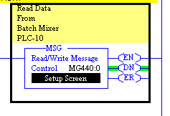

Figure : MSG Instruction for PLC-5 to PLC-5 Communication in RSLogix 5.

The MSG instruction requires a control block to be defined for the instruction. This is where all of the information about the MSG instruction will be stored. The MG file type is usually used for this purpose in RSLogix 5.

The MSG instruction can be configured by double-clicking on the Setup Screen button at the bottom of the instruction. This brings up the MSG instruction configuration screen for a PLC-5 Typed Read instruction seen in Figure 315.

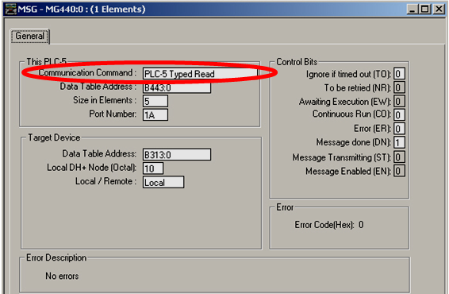

Figure : MSG Instruction Setup Screen for Typed Read.

A Typed Read instruction in the local PLC5- reads the information from the remote PLC-5 data address and writes the information to the specified data storage address in the local PLC-5. The Typed Write instruction takes information from the defined data storage location in the local PLC-5 and writes the information (sends a message) to the remote PLC-5. This specifies the data storage location in the remote PLC5 where the sent data will be written.

## 19.2 LAB - PLC-5 to PLC-5 Communications

This lab will practice setting up and testing message instructions to communicate between processors.

Part A: WRITE Instruction

Set up a message instruction in a local PLC-5 to write data to a remote PLC-5. Set up a data file on the local PLC and place some test data in the section of the data file to write with the WRITE instruction.

**LOCAL PLC5 SETTINGS FOR WRITE INSTRUCTION:**

Set up the local PLC5 with a MSG instruction with the following parameters:

1. Message Type: PLC-5 Typed Write.
2. Local PLC-5 Control Block address: MG140:0.
3. Local PLC-5 Data Table Address: N26:0.
4. Size in Elements: 1.
5. Port Number: 2 (for Ethernet).
6. Target Data Table Address: N20:0.
7. Ethernet address: use other PLC-5 IP Address.
8. Local / Remote: Local (does not pass through a bridge on the network).
9. Add a timer to trigger the write instruction.
10. Enter the number “54” in N26:0 in the data table.

Part B: READ Instruction

Now set up a message instruction in the local PLC-5 to read data from the remote PLC-5. Use the following parameters to set up the MSG instructions in the local PLC-5. Also set up a data file on the remote PLC and place some test data in the section of the data file to read with the READ instruction.

**LOCAL PLC5 SETTINGS FOR READ INSTRUCTION:**

Set up the local PLC-5 with a MSG instruction with the following parameters:

1. Message Type: PLC-5 Typed Read.
2. Local PLC-5 Control Block address: MG140:2.
3. Local PLC-5 Data Table Address: N26:1.
4. Size in Elements: 1.
5. Port Number: 2 (Ethernet).
6. Target Data Table Address: N20:1.
7. Ethernet Address: use other PLC-5 IP Address.
8. Local / Remote: Local (does not pass through a bridge on the network).

**REMOTE PLC5 SETTINGS FOR READ INSTRUCTION:**

Enter the number “22” in N20:1 in the data table in the Remote PLC5.

## 19.2.1 PLC-5 to SLC Communications

Communications between a PLC-5 controller and a SLC controller is done using message instructions within one controller or the other. There are two types of messages that can be used between a PLC5 and a SLC:

* The PLC-5 Typed Write to SLC.
* The PLC-5 Typed Read to SLC.

These function much the same way that the PLC-5 to PLC-5 MSG instructions did.

**\*\*Note: You must use the MG message control block when utilizing the PLC-5 to SLC MSG instruction in RSLogix 5. This is a requirement in RSLogix 5. You must also use the MG message block type when sending messages through any channel other than 1A.**

When using MSG instructions in the RSLogix500 (SLC) software, you should use an N message control block when using a SLC 5/04 or 5/05 processor. RSLogix 500 does not support the MG data file type for the either the SLC 5/04 or the 5/05 processor. The MSG instruction in RSLogix 500 is similar to the one used in RSLogix 5. An example of the MSG instruction for RSLogix 500 is displayed in Figure 316.

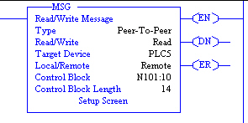

Figure : MSG Instruction Setup Screen for Typed Read.

The setup for the MSG instruction in RSLogix 500 is similar to one in RSLogix 5. There are two types of instructions to use for SLC to PLC-5 messaging:

* PLC-5 Read.
* PLC-5 Write.

Channel 1 for the SLC 5/04 processor is DH+ in RSLogix 500, while Channel 1 for the SLC 5/05 processor is Ethernet. The difference in nomenclature for RSLogix 500 is that Channel 1 is just “1” – there is no 1A or 1B. Keep this in mind when specifying the communication channel for the MSG instruction. An example of the setup screen for the MSG instruction in RSLogix 500 is shown in Figure 317.

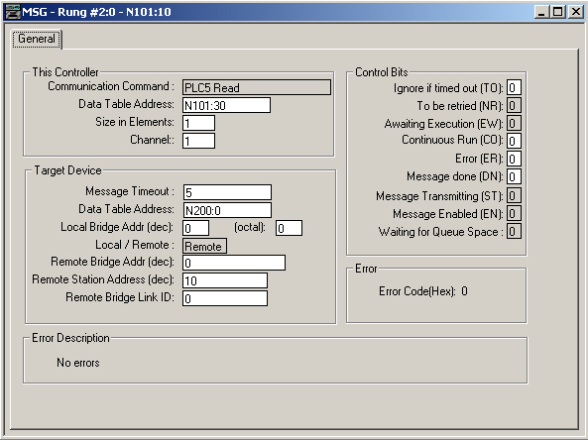

Figure : MSG Instruction Setup Screen for RSLogix 500 (SLC).

## 19.3 ControlLogix to PLC-5 Communications

Communications between a ControlLogix controller and a PLC-5 controller is done using message instructions in the ControlLogix controller. These messages operate basically the same as when messaging between PLC-5 controllers. One exception is the ControlLogix controller is using tag arrays to pass information to the PLC-5 and to read information from the PLC-5. These tags must resemble PLC-5 addresses or the PLC-5 will not recognize the addresses. An example of a ControlLogix MSG instruction is can be seen Figure 318.

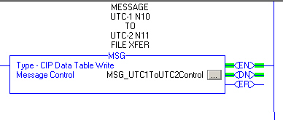

Figure : MSG Instruction for ControlLogix.

To configure the MSG instruction in RSLogix 5000, click on the button to the right-hand side of the MSG block. This will bring up the configuration tab shown in Figure 319. Notice this is a PLC-5 Typed Write that gets its data from a ControlLogix tag and writes to a PLC-5 address.

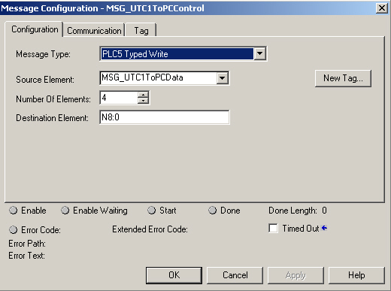

Figure : MSG Instruction Configuration Setup Screen for ControlLogix.

The Communication tab in the ControlLogix MSG instruction is used to set up the communications between the ControlLogix controller and the PLC-5 controller. A screenshot of the communications tab is in Figure 320. Notice in this case DH+ is being used for communication between the ControlLogix controller and the PLC-5. The local communication channel is specified, as is the destination node number.

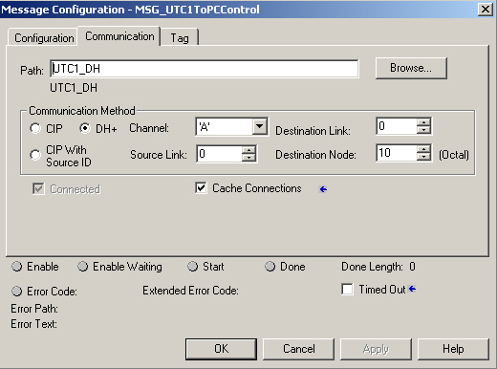

Figure : MSG Instruction Communications Setup Screen for ControlLogix.

The tag which the MSG instruction is retrieving the data to write to the remote PLC5 is defined in the Tag tab in the MSG instruction configuration. An example of this screen is shown in Figure 321.

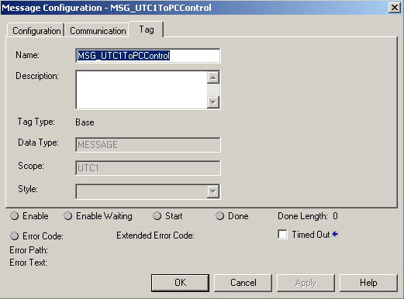

Figure : MSG Instruction Tag Setup Screen for ControlLogix.

## 19.4 LAB - CLX and PLC-5 Communications

This lab will practice setting up and testing message instructions to communicate between processors.

***Part A: WRITE Instruction***

Set up a message instruction in a local ControlLogix controller to write data to a remote PLC5. Use the following parameters to set up the MSG instructions in the local ControlLogix controller. Also set up a data file in the local ControlLogix controller and place some test data in the section of the data file to write with the WRITE instruction.

**LOCAL CONTROLLOGIX SETTINGS FOR WRITE INSTRUCTION:**

Set up the ControlLogix controller MSG instruction with the following parameters:

1. **Configuration Tab**
   1. Message Type: PLC-5 Typed Write.
   2. ControlLogix Control tag: MSG_CHEETOS_TO_CMUNLOAD_WRITE.
   3. Source Element: MSG_CHEETOS_TO_CMUNLOAD_WRITE_DATA.
   4. Number of Elements: 1.
   5. Destination Element: N257:04.
2. **Communication Tab**
   1. Path: ENET, 2, IP Address of PLC-5 (where ENET is name of your controller’s Ethernet card in IO CONFIGURATION, and the number “2” designates Ethernet communication).
   2. Communication Method: CIP.
3. **Tag Tab**

MSG_CHEETOS_TO_CMUNLOAD_WRITE.

Enter the number “65” in the MSG_CHEETOS_TO_CMUNLOAD_WRITE_DATA tag.

***Part B: READ Instruction***

Next, set up a message instruction in a local ControlLogix controller to read data from a remote PLC-5. Use the following parameters to set up the MSG instructions in the local ControlLogix controller. Also set up a data file in the remote PLC-5 and place some test data in the section of the data file to read the data with the READ instruction.

**LOCAL CONTROLLOGIX SETTINGS FOR READ INSTRUCTION:**

1. Set up the ControlLogix controller MSG instruction with the following parameters:

**Configuration Tab**

* 1. Message Type: PLC-5 Typed Read.
  2. ControlLogix Control tag: MSG_CHEETOS_FROM_CMUNLOAD_READ.
  3. Source Element: N257:01.
  4. Number of Elements: 1.
  5. Destination Element: MSG_CHEETOS_FROM_CMUNLOAD_READ_DATA.

**Communication Tab**

* 1. Path: ENET, 2, IP Address of PLC-5.
  2. Communication Method: CIP.

**Tag Tab**

MSG_CHEETOS_FROM_CMUNLOAD_READ.

Enter the number “58” in N302:50 in the remote PLC-5s’ data table.

Once you have set up both instructions in the local ControlLogix controller, place both controllers in RUN mode (ensuring that you have an Ethernet connection between them). The MSG instruction will execute one time. Check the data table in both the controllers to ensure that the data was transferred properly. Show this to the instructor.

# 20 Understanding First In First Out and Bit Shift Instructions

Reference Items in folder – “Section 19 - CLX FiFo and BSL” for examples and additional information

First In, First Out (FIFO) and Bit Shift (BS) instructions are both useful instructions in the PLC-5 for manipulating data. This first section will discuss FIFO instructions and their usage.

## FIFO Basics

**FIFO Definition**

When using a FIFO, the data is used in a First In, First Out sequence. The first element of data is placed in the storage area designated for the FIFO and is the first element of data to leave the storage area. Think of it as a buffer where data is stored in the order in which it was received. The first piece of data received is the first data to leave.

**Stack Definition**

The Stack is a set of memory locations the FIFO instructions use for data buffering (temporary storage). In basic terms, a stack is a set of consecutive memory locations used for data storage. How this set of memory is used is determined by the instruction type used (FIFO, LIFO – last in, first out).

**Stack Usage Example**

Using a FIFO means when it is time to use the stored data, the data is accessed beginning with the first piece saved.

A helpful visualization of this storage of data would be to stack pizza boxes as orders for pizzas are placed by customers, with the first box on the bottom and the last box stacked on top. When it is time to use the first pizza box, it will be pulled from the bottom of the stack. This will process will be repeated until box on the top of the stack of boxes can be accessed. While boxes are being pulled from the bottom of the stack, orders from customers are still coming in, placing new boxes on the top of the stack. This situation creates a continuous flow of boxes.

This concept can be applied to data storage. Placing a new piece of data on the stack is called “pushing” data onto the stack. Removing a piece of data at the time of usage is called “popping” data off of the stack.

### FIFO Instructions: FIFO Load and FIFO Unload

FIFO Instructions can be used to buffer data in the PLC. This is useful when there is a need to collect input data and use it at a future time in the process. This may be a matter of seconds or minutes. The FIFO provides a place to store data to keep the data in order from first received to last received data. The two FIFO instructions are:

* FIFO Load (FFL).
* FIFO Unload (FFU).

Each are used together to load and unload the “Stack.”

Here is a sequence of how the **FFL** instruction operates:

1. The values in the memory used by the FIFO are all shifted down by one position.
2. The FFL instruction copies a value from the Source location (like an FL710 moisture reading register).
3. The FFL instruction places this copy of data in the first position of the FIFO file (which was empty, since all values were shifted down one position).
4. Steps 1, 2, and 3 are repeated.

Here is a sequence of how the **FFU** instruction operates by taking the value from the designated address in the FIFO (defined by user when the FFU is set up) and copying it to a new location specified by the user.

### FIFO Application Example

A good example of FIFO usage would be to use the moisture reading from an FL710 unit on a process line to use as a guide to Auto abort when the reading of the product is out of range. In this example, the product takes ten seconds to travel from the FL710 head to where the moisture is read to the entrance of Abort gate location. This means the FL710 moisture readings need to be buffered by ten seconds to give the product time to reach the Abort gate. Once the product reaches the Abort gate, you will want to be able to recall the FL710 moisture reading (which is the reading for the product now entering the gate) to determine if the product coming in needs to be aborted or not. A FIFO can help resolve this issue. It provides a place to store the moisture readings until they are needed.

An example of a pair of FFL and FFU instructions can be seen in Figure 322. Notice the two instructions share the same FIFO, Control, Length and Position information. The timer .DN bit from T4:0 is used to trigger the rung every second. This means the FIFO will shift the stack and load the value from the source location every second. Also notice the .DN bit from the Control word is used to trigger the FFU. This will occur when the length and position pointers are equal. Once these are equal, the FFU will unload the value from the end of the FIFO buffer every second.

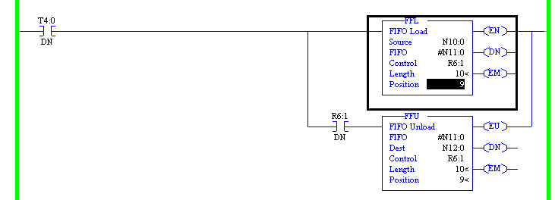

Figure : FFL and FFU Instructions.

## LAB - FIFO

This lab will practice setting up a FIFO using FFL and FFU instructions. The value received from the FIFO will determine the state of the Abort gate on the process line. This will allow the process line to abort product when it is out of specification. Follow the steps below to complete this exercise.

1. Create a project in RSLogix5 for the Auto Abort application.
2. Add rungs for an auto abort solenoid valve called “Moisture Auto Abort Valve.” Use N26:0 as the control word for the solenoid valve.
3. Create a new ladder rung for the FFL and FFU instructions (see example rung earlier in this section).
4. Make the FIFO address #N11:0.
5. Make the control address R6:1 for both instructions.
6. Make the FIFO ten elements in length.
7. Use N10:0 as the source address for the FFL.
8. Use N12:0 as the destination address for the FFU.
9. Use T4:0 for a free-running one-second timer that triggers the FIFO rung.
10. Add a test rung to test the FIFO value against set limits for aborting (example: the value needs to be less than 25 or the line will abort) if the value does not meet the test, then activate the abort solenoid valve (which opens our abort gate).

Enter sample data in the source address and test to see if it emerges from the other end of the FIFO and triggers the auto abort solenoid valve.

## Bit Shift Instructions: BSL and BSR

Bit Shift instructions allows for data to be manipulated at the bit level. The status of a device can be monitored and buffered with Bit Shift instructions. For the purpose of this example, say there is an abort bit that is turned on when the moisture reading from FL710 is out of range. The status of this abort bit can be used to determine when to open the abort gate. When the abort bit (discrete) gives a “Abort product” status (like a “1”) as an input to the PLC, this value can be buffered in a set of data registers using the Bit Shift instructions. Here is a sequence of how the **BSL** instruction operates:

1. The BSL shifts all bit values one position to the left.
2. The BSL instruction copies a value from the Bit Address (like a discrete proximity sensor) that serves as our data source.
3. The BSL instruction places this copy of data in the first position of the Binary file. This occurs when the rung on which the BSL is located goes true.
4. Steps 1, 2 and 3 continue until the buffer is filled.

## LAB - BSL

This lab will practice setting up a BSL instructions. Follow the steps below to complete this exercise.

1. Add the BSL to your existing FIFO logic you just created.
2. Find available addresses to use for your BSL instruction
3. When completed, change the value in your “Bit Address” from a “0” to a “1” and observe what happens in your “File Address” register.

The BSR instruction works basically the same way as the BSL, with the exception that the bits are shifted right in the file instead of left. An example of both the BSL and BSR instructions is shown in Figure 323.

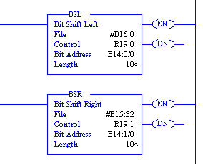

Figure : BSL and BSR Instruction

# I/O Networks (Inputs and Outputs)

Reference Items in folder – “Section 20 - NetWorx” for examples and additional information

I/O networks allow for communications to take place between PLC’s and remote Input / Output racks. There are many types of I/O networks available and in use today. This section will cover some different types of I/O networks.

## Configuring Remote I/O for ControlLogix

In some existing plants, there is a large installed base of 1771 series (PLC-5) I/O. The PLC-5 processors are being replaced with ControlLogix processors. While the processor can be replaced fairly easily (with respect to hardware), the large amount of installed I/O is not as easily replaced. As PLC-5 processors are replaced with the newer ControlLogix controllers, there is a need to understand how the ControlLogix platform should be configured to talk to the legacy I/O.

### Software Configuration for the DHRIO card in RSLogix 5000

The main difference in software configuration between the ControlLogix processor and the PLC-5 is the communications card must be added to the software in RSLogix 5000, while it was part of the default project in RSLogix 5. The reason is the communication tasks for ControlLogix were separated from the processor and placed in another card. The combination DH+ / RIO card is the card tasked with all of the communications between the local processor and remote nodes and Remote I/O. We will now discuss the steps for adding and configuring the communications card in RSLogix 5000.

1. In RSLogix 5000, select the I/O Configuration from the Project tree at the left-hand side of the screen.
2. Right-click on the I/O Configuration and select “New Module” from the pop-up list.
3. Select the 1756-DHRIO/C DHRIO card from the list of cards. This will bring up a Module Properties configuration screen, as shown in Figure 324.

**\*\*Note: When selecting a card from the list, be sure that the Major revision matches your hardware (the Major revision number is shown at the top of the list screen. This must match or the module will not work properly.**

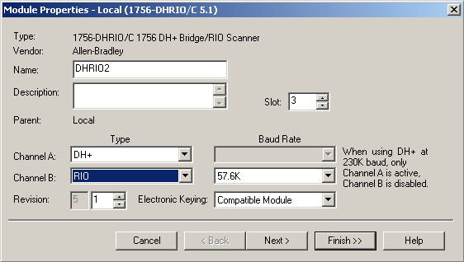

Figure : DHRIO card configuration in RSLogix 5000.

1. In the Module Properties screen, enter a unique name for the DHRIO card.
2. Select the Slot number in which the card is installed in the local chassis.
3. Select the channel type for both Channel A and Channel B. If either channel is selected for Remote I/O, then the BAUD rate should be selected on the screen. If DH+ is selected for either channel, the module dip switches must be set for the appropriate BAUD rate.
4. The Electronic Keying setting can be left at the default value (Compatible Module). This setting allows the card to compare information about the card that has been configured in software with the actual physical module to ensure compatibility. If the software is configured incorrectly, RSLogix 5000 will show an error.
5. There are other settings that can be changed by clicking the “Next” button, if desired. These settings can generally be left in their default states.
6. Press the “Finish” button to complete the card addition in RSLogix 5000.

### Hardware Configuration for the DHRIO card

The DHRIO card has several dials used to configure the card for different uses. There is one set of dials to set the type of usage for each channel (DH+, RIO) and there is another set to configure the address number for each channel (in the case that they are both used for DH+ -- these address switches do not apply when a channel is used for RIO). A figure showing the settings for the channel type is pictured in Figure 325. In order to set a channel for RIO, set the dial for that channel to “1.” This tells the card the channel is being used for Remote I/O.

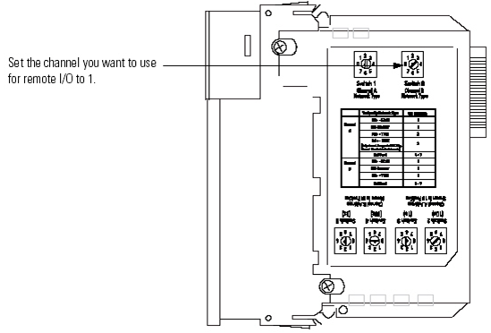

Figure : DHRIO dial configuration for channel type.[16]

### Configuring 1771 Series Remote I/O with ControlLogix

The most widely installed I/O series for Allen-Bradley is generally the 1771 Series. This is slowly being replaced by Flex I/O, but there are still many installations of 1771 I/O. RSLogix 5000 and ControlLogix can be configured to communicate with the 1771 series I/O, so the ControlLogix processor can directly take the place of a PLC5 in this case.

### Software Configuration for 1771 Remote ASB in RSLogix 5000

Now the communications card has been configured, the remote ASBs and I/O cards can be added. Use the following steps to add a remote 1771 ASB adapter:

1. Right-click on the DHRIO card in the IO Configuration section of the project tree in RSLogix 5000. Select 1771-ASB adapter card from the list of adapter modules. This will bring up the Module Properties screen, as seen in Figure 326.

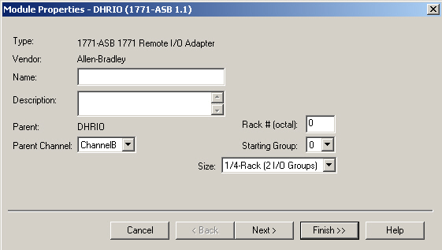

Figure : 1771-ASB card configuration in RSLogix 5000.

1. Enter a unique name for the ASB card in the “Name” box – this can be a name that describes the rack number and related equipment, if desired (like Fryer_Rack5).
2. Select the Parent channel as either Channel A or B, depending on which is configured for RIO. Be sure to follow the PLC5 standard of using Channel B for Remote I/O.
3. Enter the Rack number that will be assigned to the chassis where ASB will reside.
4. Enter the Starting Group # for this rack (usually zero).
5. Specify the size of the rack for the ASB configuration.
6. There are other settings that can be changed by clicking the “Next” button, if desired. These settings can usually be left in their default states.
7. Press the “Finish” button to complete the card addition in RSLogix 5000.

### Software Configuration for 1771 Remote I/O cards in RSLogix 5000

Once the 1771-ASB card has been added, IO cards can then be added under the 1771-ASB in the IO Configuration. This uses the same steps as above, with the exception of the Parent channel which is already set (by the ASB). The detailed steps to add a new IO card under the 1771-ASB are shown below.

1. Right-click on the 1771-ASB card in the IO Configuration section of the project tree in RSLogix 5000. Select RIO-MODULE card from the list of modules. This will bring up the Module Properties screen, shown in Figure 327.

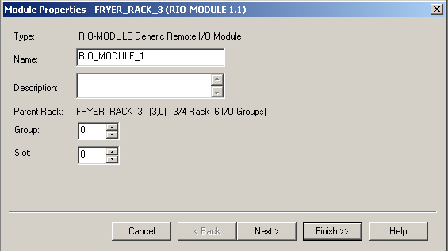

Figure : 1771-ASB card configuration in RSLogix 5000.

1. Enter a unique name for the RIO card in the “Name” box – this can be a name that describes the group number and slot number, if desired (like RIO_5_1).
2. Enter the Group number that will be assigned to the RIO card.
3. Enter the Slot number for this card.
4. There are other settings that can be changed by clicking the “Next” button, if desired. These settings can usually be left in their default states.
5. Press the “Finish” button to complete the card addition in RSLogix 5000.

### Hardware Configuration for the Remote I/O Adapter (1771-ASB)

The remote I/O adapter module serves as an interface between remote I/O modules in a remote chassis and the processor. There are two switch assemblies (S1 and S2) and one set of configuration jumpers that need to be set to properly configure the remote I/O adapter. The 1771-ASB module must be mounted in the leftmost slot of the chassis.

When connecting to a processor, module switch assembly S1 is used to set the first I/O group number and the I/O rack number. Module switch assembly S2 is used to set the Baud rate and Scan parameters (To scan all slots or all but the last four slots).

The diagram in Figure 328 shows the address switch assembly S1 is used to select the first I/O group number, the I/O rack number and whether the I/O scanner communicates with or without complimentary I/O. Address switch assembly S2 is used to select baud rate, whether the processor will scan all slots in the chassis or all but the last four slots in the chassis and the link response.



Figure : S1 and S2 Assembly switch locations.[17]

Table 5 shows how to set S1 to select the desired remote rack number.

Table : I/O rack selection for PLC5 family processors without complimentary I/O.5



The Module configuration plug is set in order to use 32-point I/O modules. Since 32-point cards are not normally used, the plugs should be set in the right position. Setting them in the right will allow use of 1771-IX or 1771-IY modules and any type of addressing method. A diagram of this plug is pictured in Figure 329.



Figure : Module configuration plug needs to be set in order to use 32-point I/O modules.[18]

Figure 330 shows how to set the chassis dip switches when using the remote adapter in the remote chassis.



Figure : 1771 I/O chassis switch assembly settings WHEN USING REMOTE ADAPTER (ASB) module in remote configuration.6

Use the configuration of the plug in the assembly shown in Figure 331 to identify the type of power supply being used with the remote chassis. Use the top setting for power supplies that slide into a slot in the chassis, and use the bottom setting for a power supply external to the chassis.



Figure : 1771 Series B I/O chassis power supply configuration plug settings. 6

## Configuring Flex I/O for ControlLogix

The most commonly installed I/O series for Allen-Bradley in new applications is generally the 1794 Flex I/O Series. RSLogix 5000 and ControlLogix can be configured to communicate with the 1794 series I/O, so the ControlLogix processor can directly take the place of a PLC-5 in this case.

### Software Configuration for 1794 Flex I/O ASB in RSLogix 5000

With the communications card properly configured, it is possible to begin adding the remote ASBs and I/O cards with which the communication card will be communicating. Use the following steps to add a remote 1794 Flex I/O ASB adapter:

1. Right-click on the DHRIO card in the IO Configuration section of the project tree in RSLogix 5000. Select 1794-ASB adapter card from the list of adapter modules. This will bring up the Module Properties screen, as was shown for the 1771 Series ASB.
2. Enter a unique name for the ASB module in the “Name” box – this can be a name that describes the rack number and related equipment, if desired (like Seasoning_Rack_4).
3. Select the Parent channel as either Channel A or B, depending on which is configured for RIO. Follow the PLC5 standard of using Channel B for Remote I/O.
4. Enter the Rack number that will be assigned to the ASB.
5. Enter the Starting Group # for this rack (usually zero).
6. Specify the size of the rack for the ASB configuration.
7. There are other settings that can be changed by clicking the “Next” button, if desired. These settings can generally be left in their default states.
8. Press the “Finish” button to complete the card addition in RSLogix 5000.

### Hardware Configuration for the Flex I/O Remote Adapter (1794-ASB)

The Flex I/O remote I/O adapter module consists of diagnostic indicators, reset push button, RIO wiring connections, 24 VDC power wiring connection and address/group switch assemblies. The Flex I/O RIO adapter is shown in Figure 332.



Figure : 1794-ASB RIO adapter.[19]

The RIO adapter has two 8-position switch assemblies which are set for starting I/O group, I/O rack number, hold inputs, last chassis, reply delay (always on), communication rate, processor restart lockout and hold last state (outputs).

The S1 dip switch set is used to set the starting I/O group and the I/O rack number. Detailed settings for the S1 switch are shown in Figure 333.



Figure : Flex IO adapter S1 dip switch settings.[20]

The S2 dip switch set is used to set hold the last state of outputs, set processor restart lockout, set the communications rate, set the replay delay, set last chassis and hold inputs. The table for the I/O Rack number is shown in Table 6 and Table 7.

Table : Flex IO adapter I/O Rack number settings.[21]

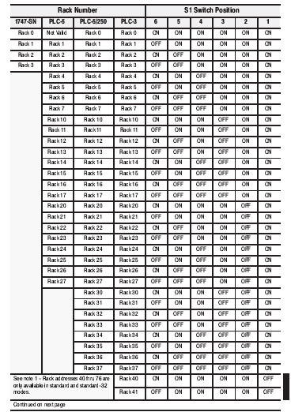

Table : Flex IO adapter I/O Rack number settings (cont.).xxi

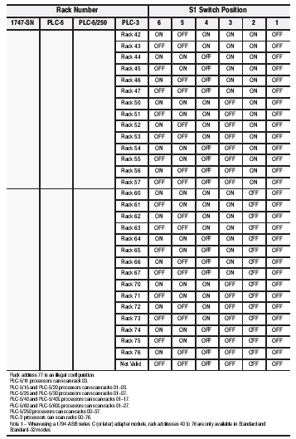

Detailed settings for the S2 switch are shown in Figure 334.



Figure : Flex IO adapter S2 settings.9

## LAB- ControlLogix Configuring 1771 and Flex I/O Remote ASBs

This lab will practice setting up the 1771 and Flex I/O Remote ASB cards for use with the ControlLogix processor. Follow the steps below to complete this lab exercise.

1. Open CTLX_RIO_LAB project in RSLogix 5000 and set up the project for the ControlLogix controller being used for the lab (5555-Rev15, 5561-Rev16 or 5563-Rev17).
2. Add the 1756-DHRIO card in the IO Configuration section of the RSLogix 5000 project tree. Set Channel A for DH+, and set Channel B for RIO (Remote I/O).
3. Add the 1771-ASB card under the DHRIO card. Set the rack number as listed on the board by the instructor.
4. Add the 1794-ASB Flex I/O ASB module under the DHRIO card. Set the rack number as listed on the board by the instructor.
5. Ensure the hardware settings for the DHRIO card according to the manual for the module.
6. Ensure the dip switch settings for the chassis and 1771-ASB module.
7. Ensure the dip switch settings for the 1794-ASB Flex IO module.
8. Connect the 1771-ASB and the 1794-ASB in a daisy-chain configuration to the DHRIO card in the main processor chassis.
9. Download the newly created project in RSLogix 5000 to the ControlLogix controller and switch the controller to run mode.
10. Check the status of the DHRIO module and the two ASB modules. Once you have verified that all three modules are running and working properly, you will be finished with this exercise. Show the results to your instructor.

## DeviceNet Network Structure

DeviceNet is an Allen-Bradley network technology that allows communication between field devices and a DeviceNet scanner card in a PLC chassis. Some examples of field devices that can communicate via DeviceNet are:

* VFDs.
* Proximity switches.
* Bar code scanners.

The DeviceNet network allows the PLC (or ControlLogix controller) to communicate with these devices and retrieve data from these devices. In some ways it is similar to the Remote I/O network used in many plants. One exception is that all of the information is sent back and forth on one set of media, whether flat cable, thick or thin cable. The remote DeviceNet nodes can be either drive faceplates or remote ADN modules for communication to drives or I/O chassis.

DeviceNet has a trunk line/ drop line network configuration. The trunk is terminated on each end by a terminating resistor to reduce reflections (errors) on the network. The DeviceNet network may sometimes look like a combination between different network topologies when using the Armorlok connection points. These allow for multiple drops from a single box. All this block is really doing for the network is to extend the trunk line to accommodate several devices being connected in a certain area. An example of how the DeviceNet topology can be set up is shown in Figure 335.

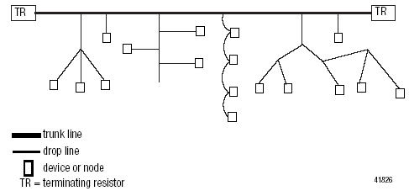

Figure : Example of basic DeviceNet network topology.[22]

Figure 336 shows a more detailed view of how the devices in the network fit together. The trunk line can be extended by the DevicePort taps that are located on the trunk line. These allow devices in the same area to be connected to the trunk line that have short drop line lengths.

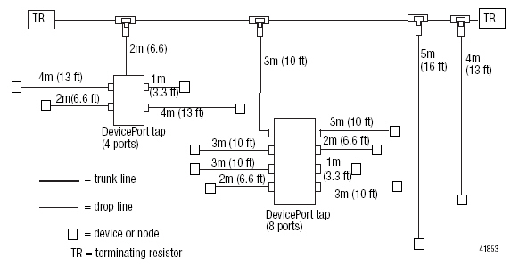

Figure : Example of Detailed DeviceNet Network Topology.xxii

### DeviceNet Network Cabling

DeviceNet has specifications for cabling length limits, as documented in the DeviceNet Cable System manual. DeviceNet has limits on the trunk line length, similar to DH+ except that the DeviceNet data rates are much higher. The cabling limits for the trunk line are shown in the Table 8.

Table : DeviceNet Network Trunk Line lengths.xxii

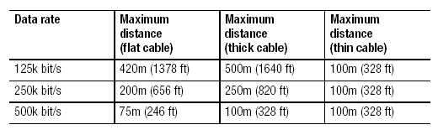

Coupled with the trunk line limits for each data rate, DeviceNet also specifies limits on the length of the drop lines attached to the trunk line. DeviceNet drop line cabling limits are shown in Figure 337. These are the cumulative drop line lengths for each data rate.

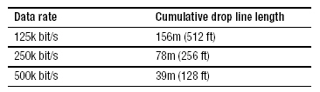

Figure : DeviceNet network cumulative drop line lengths.xxii

The DeviceNet network has two cabling types for use in the network. The round cabling and flat cabling wiring connection assignments are shown in the Table 9. Notice that both the power and signal wires are carried in the same cable, eliminating the need for separate power cabling to each device location.

Table : DeviceNet Wiring Color Code for Round and Flat Cabling. xxii

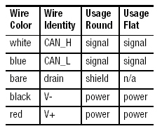

An example of a ten pin DeviceNet field type connector is shown in Figure 338. This shows the proper wire color code scheme for DeviceNet connections. Notice this connector has a terminating resistor attached between the Blue and White wires. This is the proper connection for a terminating resistor, which would be connected at the end of the trunk line.

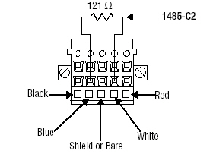

Figure : Ten pin connector for DeviceNet network with terminating resistor.xxii

An example of a five pin DeviceNet field type connector is shown in Figure 339. This shows the proper wire color code scheme for DeviceNet connections.

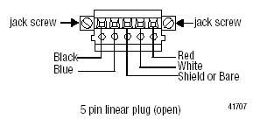

Figure : Five pin connector for DeviceNet network.xxii

### DeviceNet Network Basics for PLC-5

The PLC5 platform has a scanner card solution for connecting to a DeviceNet network. This solution uses the 1771-SDN DeviceNet scanner card for the PLC5 to talk to DeviceNet.

### Configuring the 1771-SDN DeviceNet Scanner

The DeviceNet scanner card for PLC5 allows the processor to communicate with available DeviceNet device nodes on the DeviceNet network. This means the processor can utilize these devices and receive status information from the devices. This section will now discuss how to set up the DeviceNet scanner card in RSLogix 5.

1. Configure the DeviceNet driver for the 1770-KFD adapter in RSLinx, as shown in Figure 340.

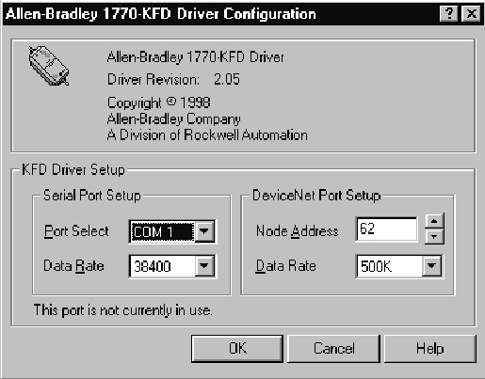

Figure : 1770-KFD device driver for DeviceNet network.

1. Open the project that will be configured to communicate with DeviceNet in RSLogix5.
2. To add programming for the new module, set up the BTR and BTW instructions to read and write data to and from the DeviceNet scanner card. Record the data table information in order to set up the devices on the DeviceNet network.
3. Set the data rate switches on the left hand side of the 1771-SDN module to the correct data rate. These switches are shown in Figure 341.

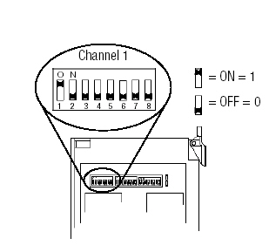

Figure : Data Rate switches on the 1771-SDN module.[23]

1. Set the chassis addressing switches on the left hand side of the 1771-SDN module to the correct setting. These are shown in Figure 342.

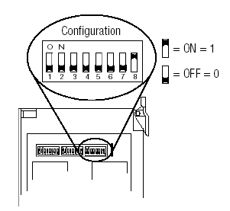

Figure : Chassis Addressing switches on the 1771-SDN module.xxiii

1. Install the 1771-SDN module in the PLC5 chassis.
2. Wire the communication channel for the DeviceNet network according to the DeviceNet wiring scheme. The correct wiring for the 1771-SDN module is shown in Figure 343.

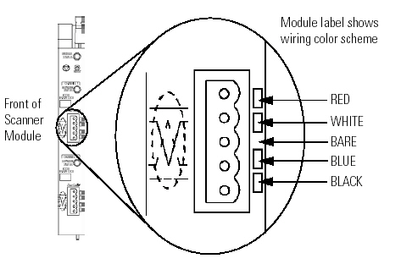

Figure : Channel wiring on the 1771-SDN module.xxiii

### DeviceNet Network Basics for ControlLogix

The ControlLogix platform has several possible solutions for connecting to a DeviceNet network. A solution in this case is to use the 1756-DNB DeviceNet scanner card for ControlLogix.

### Configuring the 1756-DNB DeviceNet Scanner in RSLogix 5000

The DeviceNet scanner card for ControlLogix allows the ControlLogix processor to communicate with available DeviceNet device nodes on the DeviceNet network. This means the ControlLogix processor can utilize these devices and receive status information from the devices. This section will now discuss how to set up the DeviceNet scanner card in RSLogix 5000.

1. Open the project that will be configured to communicate with DeviceNet in RSLogix 5000.
2. Right-click on IO Configuration to add a new module.
3. Select the part number for the module from the list of ControlLogix cards (1756-DNB). Select the Major Revision number when selecting the cards’ part number from the list (This number can be found on the label on the side of the card). This will bring up the Module Properties screen, as shown in Figure 344.

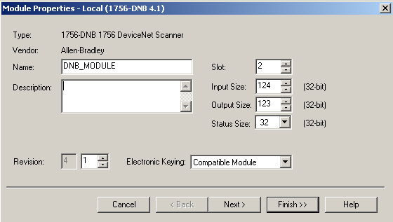

Figure : Module Properties screen for 1756-DNB DeviceNet Scanner card.

1. Enter a name, the minor revision number, the slot number, the input size, output size, status size and electronic keying selections in the Module properties screen.
2. Click on the “Next” button to proceed to the next step in the installation.
3. Set the packet interval in the next screen, if desired. Click on the “Next” button.
4. The next screen shows the file information for the DeviceNet file (created in RSNetworx) which contains the DeviceNet network configuration. Click on the “Browse” button to locate this file. If this file has not already been created, then it must be created before the card configuration will function properly.
5. Once the DeviceNet file has been selected, click on the “Next” button twice and click on the “Finish” button to complete the addition of the card.

When the card has been added, the local tag arrays will be created for use with the DeviceNet card. These will show up in the format:

* Local:X:I for inputs.
* Local:X:O for outputs.
* Local:X:S for status (where X represent the slot number in which the card is installed).

These tags are used to display input information from devices on the DeviceNet network, and allow the user to set output states for devices using ladder logic. They also show status information with regard to the DeviceNet card itself in the Status tag array. The detailed setup for these arrays is actually done in the RSNetworx software package. See the RSNetWorx section of this manual for further setup information.

### RSNetWorx for DeviceNet Overview

RSNetWorx is a software package that allows the user to configure DeviceNet networks for use with SLC, PLC5, and ControlLogix processors. The software enables the user to configure devices on the network and provide configuration information to the DeviceNet scanner card. The main screen for RSNetWorx is pictured in Figure 345. On the left hand side is a list of devices that can be added to the device graph at the right hand side of the screen. Any device that is configured on the network will appear in the graph screen if the device is working properly.

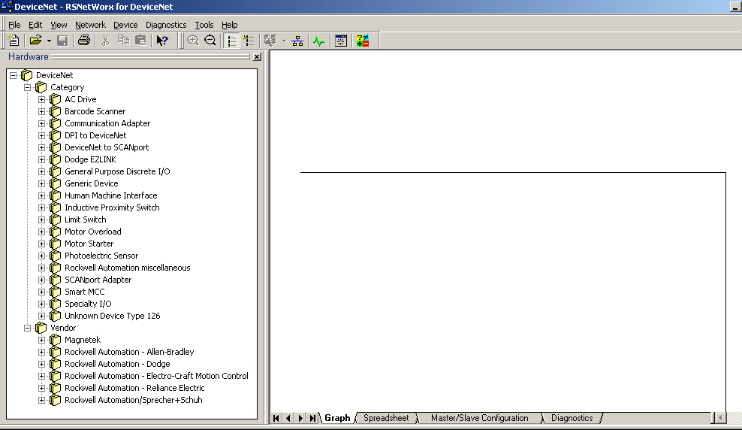

Figure : RSNetWorx Main Screen

### Configuring Devices on the Network with RSNetWorx

To begin configuration of the DeviceNet network, follow the steps listed below.

1. Click on the “Online” button in the main toolbar. This button is shown in Figure 346. Clicking on the “Online” button will bring up the “Browse for Network” screen.

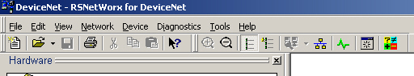

Figure : RSNetWorx Main Toolbar showing Online button.

1. Browse to the DeviceNet scanner card in this screen. Look below the scanner card in the hierarchy to find the DeviceNet network. Click on the “Ok” button to accept the network selection. The Browse for Network screen is pictured Figure 347.

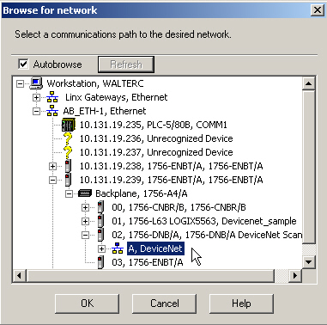

Figure : RSNetWorx Main Toolbar showing Online button.

1. Once the “Ok” button has been clicked on the “Browse for Network” screen, RSNetWorx will pop up a screen informing the user an upload or download must be performed before the network can be browsed. This screen is shown in the Figure 348.

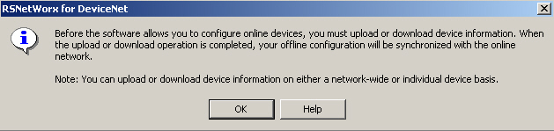

Figure : RSNetWorx Upload / Download prompt.

1. Once the “Ok” button has been clicked on the Upload / Download prompt screen, a “Browsing network” screen will appear and will show the status of the network browse. This screen will tell the user when a device has been found at an address on the network as seen is Figure 349. The user can either cancel the browse after the highest known address number with a device has been passed, or can let RSNetWorx browse the entire network (the browse goes in order from smallest address to largest address). The graph at the right hand side of the screen will then display all of the devices found on the network.

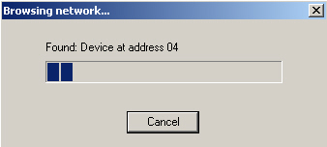

Figure : RSNetWorx Browsing network screen.

### Configuring the DeviceNet Scanner card in RSNetWorx

To begin configuration of the DeviceNet scanner card in RSNetWorx, follow the steps listed below.

1. Double-click on the DeviceNet scanner card icon in the graph screen to bring up the card configuration screen. This will open the “General” tab for the DeviceNet card. This is shown in Figure 350. This shows the name for the card, information about the card and the currently assigned address on the DeviceNet network.

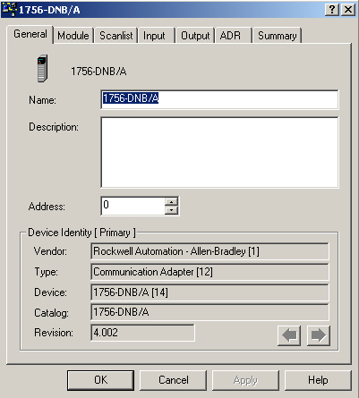

Figure : DeviceNet scanner card configuration in RSNetWorx.

1. Click on the “Scan list” tab to modify the scan list for the DeviceNet scanner module. The scan list is where devices need to be added in order for the scanner to communicate with them. The scan list tab is pictured in Figure 351. Devices found on the network will appear in the “Available Devices” box and can be moved to the Scan list box using the right arrow. The “Automap on Add” selection will set aside a block of addresses in the data array for each device as the devices are added to the scan list. This will be discussed in the next step.

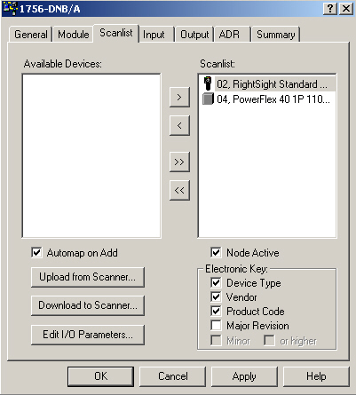

Figure : DeviceNet scanner card scan list configuration in RSNetWorx.

1. When devices are added to the scan list, the DeviceNet scanner must make assignments in the data array for the scanner to pass the device information to and from the ControlLogix processor (the data array is the one that is created in the Controller tags in RSLogix 5000 when the DeviceNet scanner is added in the IO Configuration). The mapping, as it is called, can be viewed in RSNetWorx in the “Input” and “Output” tabs in the DeviceNet scanner configuration. The “Input” tab is shown in Figure 352. Notice that the Power Flex drive at address 04 is assigned to the 1:I:Data[1] address in the RSLogix 5000 tag array, which can be found in the Local tag addresses in RSLogix 5000 (like Local:1:I.Data in the tag database).

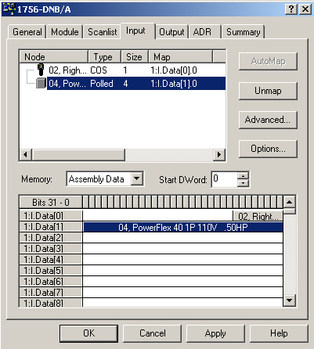

Figure : DeviceNet scanner card input mapping in RSNetWorx.

These assignments can be manually configured by clicking the “Unmap” button and changing the “Start DWord” selection to the desired starting data word. Press the “Automap” button again and the device will be remapped using the starting data word selected as the beginning location. The locations where these devices are mapped is important, since these are the locations at which the ControlLogix controller will be either monitoring (inputs) or controlling (outputs) using these tag addresses.

## LAB - DeviceNet Configure a DeviceNet Scanner

### Adding a 1756-DNB DeviceNet Scanner card to RSLogix 5000

Complete this exercise by following the steps listed below:

1. Open the “Brock_DNet_Demo_Lab” project in RSLogix 5000.
2. Configure the project for the 5555 (Rev 15) or 5561 (Rev 16) or 5563 (Rev 17) ControlLogix controller installed in the DeviceNet demo unit.
3. Add the 1756-DNB DeviceNet scanner module under the IO Configuration in slot two of RSLogix 5000.

### Creating a DeviceNet network in RSNetWorx

Complete this exercise by following the steps listed below:

1. Download to the specific PLC assigned by the instructor.
2. Go online with the DeviceNet network listed under the DeviceNet scanner card (located in the DeviceNet demo chassis).
3. Have RSNetWorx browse the network to find the Flex Module and the Power Flex drive.
4. Add these devices to the scanlist (found in the DeviceNet scanner configuration – access this by double-clicking on the DeviceNet scanner icon in the graph screen).
5. Identify the locations to which RSNetworx has automatically mapped the I/O for these devices in the “Input” and “Output” tabs.

### Verifying Communications with devices in RSLogix 5000

Complete this exercise by following the steps listed below:

1. Look at the data tags for the DeviceNet scanner card in RSLogix 5000.
2. Based on the input and output locations defined in RSNetWorx for each device, verify that the data is changing when the photo eye is first covered, then uncovered.
3. Verify that the data is changing when the drive is operated from the drive keypad.

## ControlNet Network I/O (Coax)

The ControlNet network is an open, state-of-the-art control network that meets the demands of real-time, high-throughput applications. The ControlNet network uses the proven Common Industrial Protocol (CIP) to combine the functionality of an I/O network and a peer-to-peer network providing high-speed performance for both functions.

The ControlNet network gives deterministic, repeatable transfers of all mission-critical control data in addition to supporting transfers of non-time-critical data. I/O updates and controller-to-controller interlocking always take precedence over program uploads and downloads and messaging. Some of the features offered are listed below.

* Programming, processor-to processor interlocking and I/O control on the same link without impacting time-critical I/O.
* Media options to fit your application needs including copper, fiber, fiber ring, media redundancy and intrinsically-safe.
* Improves I/O performance and controller-to-controller interlocking with high-speed data throughput.
* Supports a maximum of 99 nodes, with no minimum distance between nodes.
* Simple and flexible installation options available.
* Access the network from any node for PLC processor programming and troubleshooting.
* Improved network efficiency with Multicast of inputs and peer-to-peer data.
* Deterministic, repeatable transfers of data to/from digital and analog I/O.
* Producer/ Consumer services configure devices, control and collect information over a single network[24].
* Figure 353 shows a ControlNet card installed in a Control Logix rack and various types of ControlNet splitters.

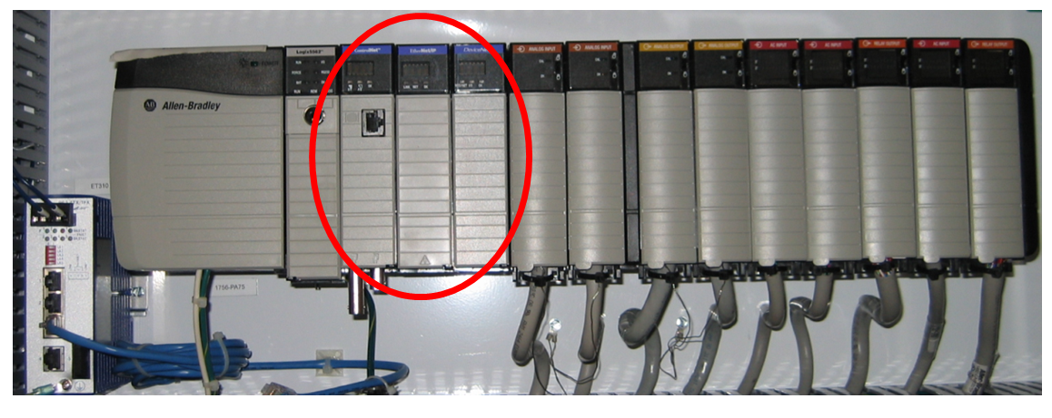

Figure : ControlNet Card.

Figure 354 shows a ControlNet option card installed on a PowerFlex 40 VFD.

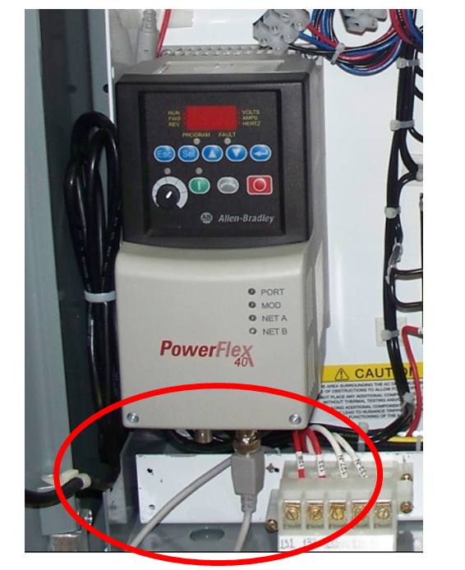

Figure : ControlNet on PowerFlex40.

### ControlNet Basics

ControlNet is an Allen-Bradley network technology that allows communication between remote chassis and a ControlNet scanner card in a ControlLogix chassis. These remote chassis that communicate with the scanner card generally use ControlNet Flex I/O adapters. The ControlNet network allows the ControlLogix controller to communicate with these remote chassis via the ControlNet scanner card and retrieve data from the I/O cards attached to the remote adapters. In some ways it is similar to the Remote I/O network used in many plants. One difference is that the media used is coaxial cable, rather than blue hose. There are other differences which will be covered in this section.

### ControlNet Network Structure

ControlNet has a Trunk line/Drop line configuration. The trunk is terminated on each end by a terminating resistor to reduce reflections (errors) on the network. An example of how the ControlNet topology can be set up is shown in the figure below. The “T” shown in the figure is the truck connection device where the drop line is connected to the main trunk for each node. The “N” represents a node on the network, and the circles at each end represent the terminating resistors.

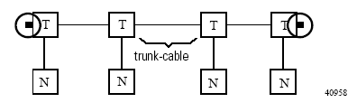

Figure .Example of basic ControlNet network topology.[25]

The figure below shows a more detailed view of how the network is connected together. The trunk line can be extended by using a repeater box to connect segments of the trunk line. A bridging device can also be used.

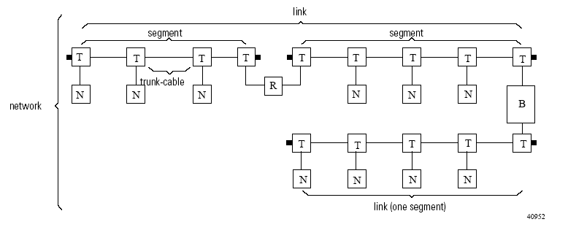

Figure . Example of detailed ControlNet network topology.3

### ControlNet Network Cabling

ControlNet has specifications for cabling length limits, as documented in the ControlNet Coax Media Planning and Installation Guide. The formula for determining the trunk length using standard RG-6 coaxial cable for your network is as follows:

**Maximum Allowable Segment Length =** 1000m (3280 ft) – 16.3m (53.4 ft) x (# of taps – 2)

This formula can be found in the ControlNet Coax Media Planning and Installation Guide.3 The formula will change if you use high-flex cable. See the guide for more details.

An example of two ControlNet field type connectors is shown in the figure below. This figure shows the T-tap and Y-tap connectors. T-tap connectors are generally used at the end of the trunk, while Y-taps are generally used at drops that occur inside control panels (for individual ControlNet remote adapters). On the T-tap the coax is connected on each side with the drop cable attached on the bottom. On the Y-tap the coax is connected on the top with the drop cable attached on the bottom.

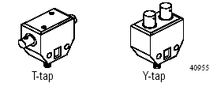

Figure . Ten pin connector for DeviceNet network with terminating resistor.3

### ControlNet Network Terms

We will now discuss ControlNet network terms that are commonly used when describing features of the ControlNet network.

1. NUT – Network Update Time
2. Time interval used to update network on a regular basis
3. Includes scheduled, unscheduled, and maintenance messages
4. An example of NUT is shown in the figure on the following page

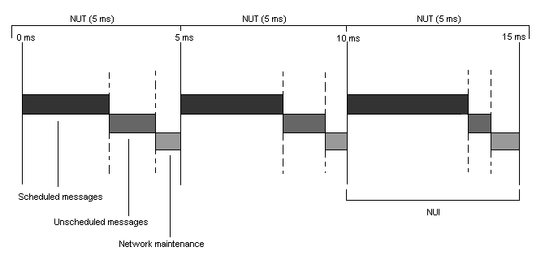

Figure . Network Update Time shown graphically.

1. Scheduled Connection
2. Each scheduled I/O node has a guaranteed predetermined time during the scheduled portion of the NUT to transmit data
3. Unscheduled Connection
4. A scheduled I/O node can transmit data during the unscheduled portion of the NUT
5. This transmission time goes in order of node # and repeats until the unscheduled portion of the NUT expires
6. RPI – Requested Packet Interval
   1. How often you want packets from a node to be transmitted during the scheduled portion of the NUT on the ControlNet network
   2. Set this for ControlNet scanner card and ControlNet communication adapter modules
7. Keeper
8. Stores Scheduled maximum address #, Unscheduled maximum address #, NUT, media configuration, and scanner signatures
9. Scanner Signatures
10. A hexadecimal value stored by the active keeper, the scanner card, and the RSNetworx configuration file
11. Used to determine whether or not online and offline network configurations are the same
12. If the three signatures do not all match then scanner cannot open scheduled connections
13. Resolved by Uploading or Downloading the network configuration file to/from the scanner card
14. Viewable under the Network toolbar by selecting “Scanner Signature Status”

### ControlNet and ControlLogix

The ControlLogix platform has several possible solutions for connecting to a ControlNet network. The solution we will concentrate on in this case is to use the 1756-CNB ControlNet scanner card for ControlLogix.

ControlNet I/O in a ControlLogix application can be configured in many ways. In the application below there are two ControlNet network cards installed in the local rack. One is used for VFD communication. The other ControlNet card is used for I/O communications to the flex racks as shown in Figure 359.

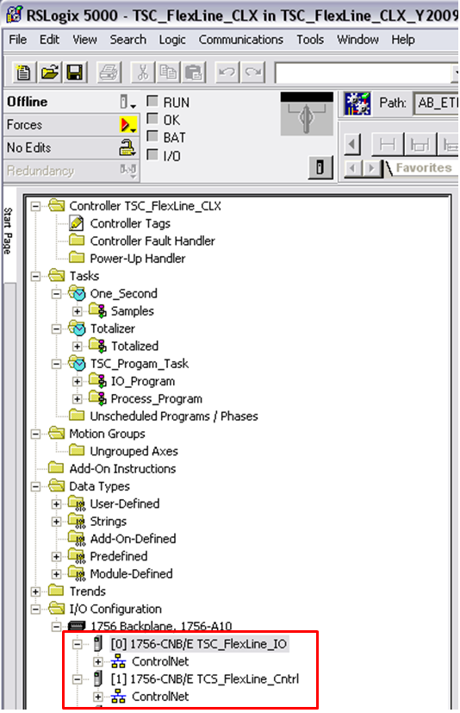

Figure : ControlNet I/O.

To view all the configured I/O on the ControlNet network, select the ControlNet “+”. Figure 360 shows the expanded ControlNet I/O network.

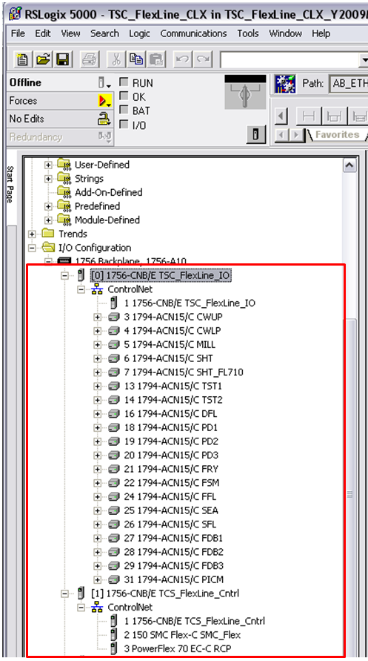

Figure : Expanded ControlNet I/O.

Right clicking on the 1756-CNB/E TCS_Flexline_IO module and selecting Properties will show the following information about the module as pictured in Figure 361.

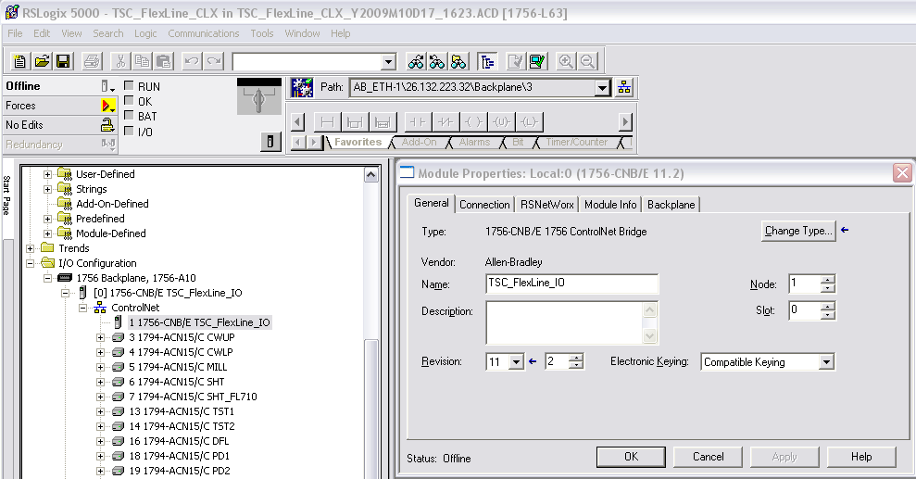

Figure : 1756-CNB/E TCS_Flexline_IO Module Properties.

Right clicking on the 1794-ACN15/c CWUP Flex module and selecting Properties will show the following information about the module as shown in Figure 362.

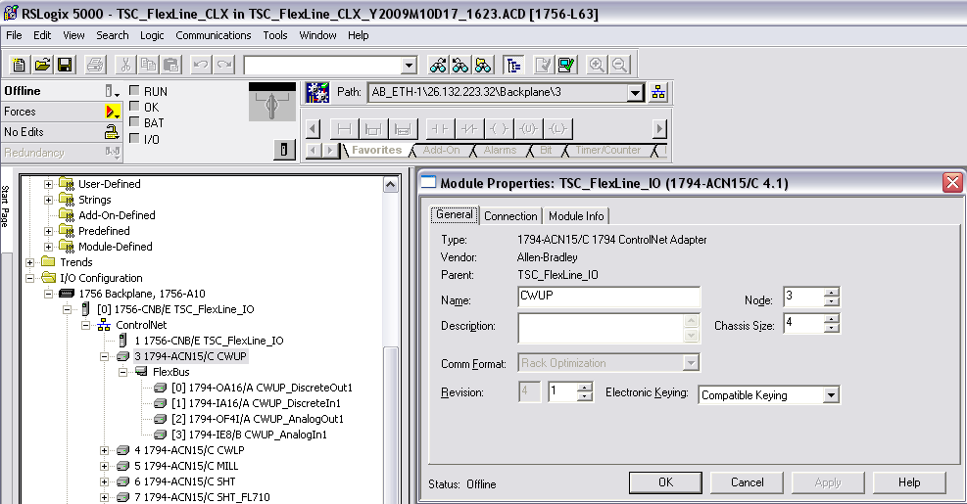

Figure : 1794-ACN15/c CWUP Flex Module Properties.

### Configure a 1756-CNB ControlNet Scanner in CLX 5000

The ControlNet scanner card for ControlLogix allows the ControlLogix processor to communicate with available ControlNet nodes on the ControlNet network. This means that the ControlLogix processor can utilize the I/O attached to these nodes, and receive status information from the I/O attached to these nodes. We will now discuss how to set up the ControlNet scanner card in RSLogix 5000.

1. Open the project that will be configured to communicate with ControlNet in RSLogix 5000.
2. Right-click on IO Configuration to add a new module.
3. Select the part number for the module from the list of ControlLogix cards (1756-CNB/A (or /B or /D depending on the card revision you have)). You must also select the Major Revision number when selecting the cards’ part number from the list (You can find this number on the label on the side of the card). This will bring up the Module Properties screen, as shown in the figure on the following page.

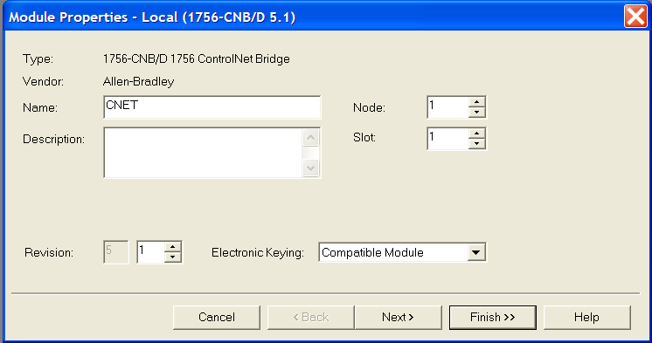

Figure . Module Properties screen for 1756-CNB/D ControlNet Scanner card.

1. Enter a name, the minor revision number, the slot number, the node number, and electronic keying selections in the Module properties screen. The ControlNet scanner card must be assigned a node number so that it appears on the network.
2. Click on the “Next” button to proceed to the next step in the installation.
3. The packet interval in the next screen is not available to set offline. Click on the “Next” button.
4. The next screen shows the file information for the ControlNet file (created in RSNetworx) which contains the ControlNet network configuration. Click on the “Browse” button to locate this file. If this file has not already been created, then it must be created before the card configuration will function properly. You can still finish the setup of the card without setting up this file.
5. Once the ControlNet file has been selected (or left blank to be configured later), click on the “Next” button twice and click on the “Finish” button to complete the addition of the card.

Once the card has been added in RSLogix 5000, we can then begin adding the ControlNet adapter modules that will serve as remote nodes on the ControlNet network. These nodes will communicate with the ControlNet scanner card in our local chassis.

### Hardware Configure a 1756-CNB ControlNet Scanner

The ControlNet scanner card for ControlLogix allows the ControlLogix processor to communicate with available ControlNet nodes on the ControlNet network. The scanner card has a digital display on the front that gives the user information about the status of the communications channels. It also has Channel Status indicators for each comm. channel. The scanner card is shown in the figure below.

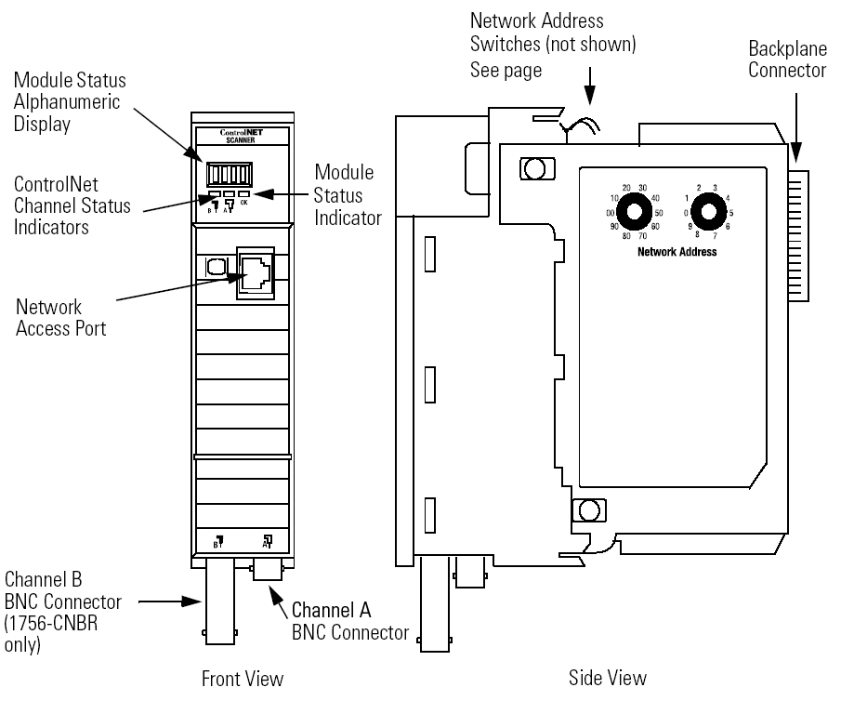

Figure . Module Comm lights for 1756-CNB ControlNet Scanner card.[26]

We will now discuss how to set up the ControlNet scanner card hardware.

1. Use the Network Address switches on the top of the module to set the network node number for the scanner card. This is typically set to a value of “1.” Valid selections are 1 to 99.

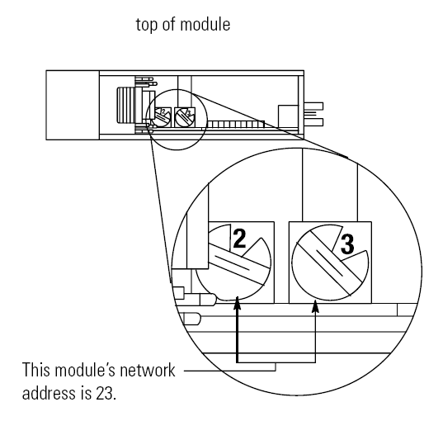

Figure . Module network address switches for 1756-CNB ControlNet Scanner card.4

### Configure a 1794-ACN15 Flex I/O ControlNet Module

We will now discuss how to set up ControlNet adapter modules in RSLogix 5000. We will use the 1794-ACN15 adapter module to communicate with the ControlNet scanner card.

1. Open the project that will be configured to communicate with ControlNet in RSLogix 5000.
2. Right-click on the ControlNet scanner card in the IO Configuration to add a new module. By selecting the ControlNet module and right clicking to add a new module, we are telling RSLogix 5000 that the new card will be associated with the ControlNet scanner card for communications.
3. Select the part number for the module from the list of ControlLogix cards (1794-ACN15 –this is the Flex I/O ControlNet adapter module). You must also select the Major Revision number when selecting the cards’ part number from the list (You can find this number on the label on the side of the card). This will bring up the Module Properties screen, as shown in the figure below.

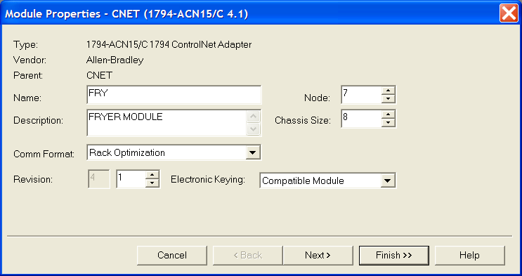

Figure . Module Properties screen for 1794-ACN15/C ControlNet Scanner card.

1. Enter a name, the minor revision number, the comm. format (default is rack optimization), the node number on the ControlNet network (this is set on the front of the module), the chassis size, and electronic keying selections in the Module properties screen.

*****NOTE: For ControlNet adapter modules the name given should correspond to the Unit Op assigned to that particular I/O chassis. In the example picture above, Node 7 is the Fryer Module and is named “FRY” since the Unit Op assigned for the Fryer Module is “FRY.”

1. Click on the “Next” button to proceed to the next step in the installation.
2. Set the packet interval in the next screen, if desired. The RPI (Requested Packet Interval must be greater than or equal to the NUT (Network Update Time) to be valid. Typically the RPI for an adapter is set higher than the Network Update Time. Click on the “Next” button.
3. Click on the “Finish” button to complete the addition of the card.

### Configuration a 1794-ACN15 Flex I/O ControlNet Adapter

The ControlNet Flex I/O adapter module for ControlLogix allows the ControlNet scanner card to communicate with I/O in the modules connected to the Flex I/O module. The Flex I/O adapter module has status lights for each comm. channel and an overall status light. These are shown in the figure below. We will now discuss how to set up the Flex I/O ControlNet adapter module hardware.

1. Set the ControlNet network node address using the “+” and “-” buttons above and below the numeric readout on the front of the ACN15 module.

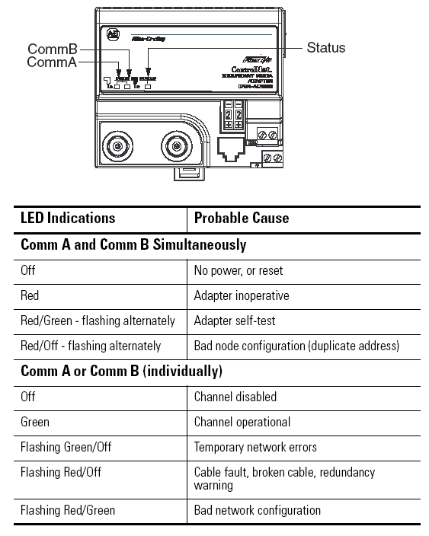

Figure . Module Comm lights for 1794-ACN15/C Flex I/O ControlNet Adapter Module.[27]

1. Once the network has been connected and the software configuration for the network has been updated, you can use the status LED (as well as the Comm lights) to determine the state of each ACN15 module. These LED indications are shown in the figure below.

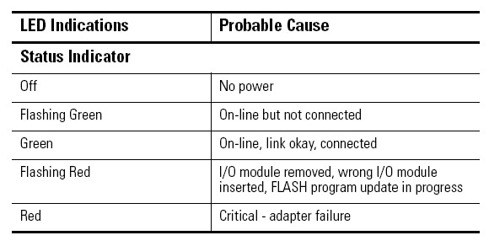

Figure . Module Comm lights for 1794-ACN15/C Flex I/O ControlNet Adapter Module.5

### Configure a 1794 Flex I/O Discrete Module

We will now discuss how to set up 1794 Flex I/O discrete modules with ControlNet in RSLogix 5000. Typically we will use the 1794-ACN15 Flex I/O adapter module to communicate with the ControlNet scanner card. The Flex I/O discrete modules are connected to the Flex I/O adapter module. We will use the 1794-IA16 discrete input card for this step-through.

1. Open the project that will be configured to communicate with ControlNet in RSLogix 5000.
2. Right-click on the Flex I/O ControlNet adapter module (1794-ACN15) in the I/O Configuration to add a new module. By selecting the ControlNet module and right clicking to add a new module, we are telling RSLogix 5000 that the new card will be associated with the ControlNet scanner card for communications.
3. Select the part number for the new discrete module from the list of ControlLogix cards (1794-IA16 for example). You must also select the Major Revision number when selecting the cards’ part number from the list (This is “1” for Flex I/O modules). This will bring up the Module Properties screen, as shown in the figure on the following page.

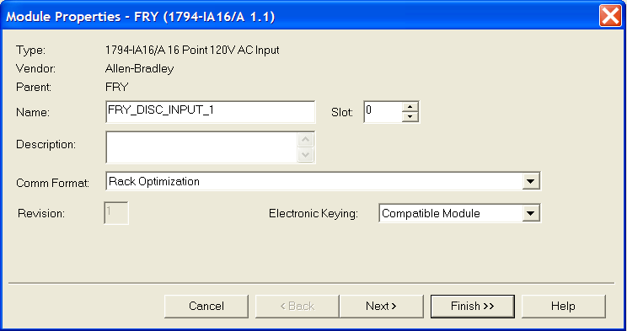

Figure . Module Properties screen for 1794-IA16/A Discrete Input card using ControlNet.

1. Enter a name, the comm. format (default is rack optimization), the slot number in the Flex I/O rack, and electronic keying selections in the Module properties screen.
2. Click on the “Next” button twice to proceed to the next step in the installation.
3. The input delay time can be changed in this screen, but it is not recommended.
4. Click on the “Finish” button to complete the addition of the card.

When the card has been added, remote tag arrays will be created for use with the Flex I/O discrete card. These will show up in the format: FRY:X:I for inputs, FRY:X:O for outputs, and FRY:X:C for configuration (where FRY is the Unit Op name we used for the 1794-ACN15 adapter module and X represents the slot number to which the discrete card is assigned). These tags are used to display input information from I/O on the ControlNet network, and allow the user to set output states for devices using ladder logic.

**Example:** FRY:0:I.0 would be the first input point on the 1794-IA16 card in slot 0 of the Fryer Module rack.

### Configure a 1794 Flex I/O Analog Module

We will now discuss how to set up 1794 Flex I/O analog modules with ControlNet in RSLogix 5000. Typically we will use the 1794-ACN15 Flex I/O adapter module to communicate with the ControlNet scanner card. The Flex I/O discrete modules are connected to the Flex I/O adapter module. We will use the 1794-OE4/B analog output card for this step-through.

1. Open the project that will be configured to communicate with ControlNet in RSLogix 5000.
2. Right-click on the Flex I/O ControlNet adapter module (1794-ACN15) in the I/O Configuration to add a new module. By selecting the ControlNet module and right clicking to add a new module, we are telling RSLogix 5000 that the new card will be associated with the ControlNet scanner card for communications.
3. Select the part number for the new discrete module from the list of ControlLogix cards (1794-OE4/B for example). You must also select the Major Revision number when selecting the cards’ part number from the list (This is “1” for Flex I/O modules). This will bring up the Module Properties screen, as shown in the figure on the following page.

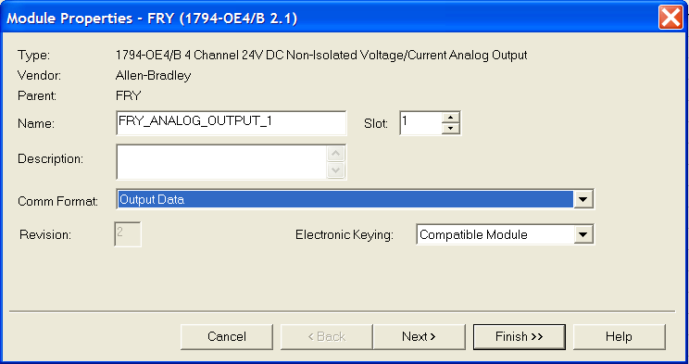

Figure . Module Properties screen for 1794-OE4/B Analog Output card using ControlNet.

1. Enter a name, the comm. format (default is Output Data), the slot number in the Flex I/O rack, and electronic keying selections in the Module properties screen.
2. Click on the “Next” button to proceed to the next step in the installation.
3. Select the Requested Packet Interval time, if desired.
4. Click on the “Next” button twice to proceed to the next step in the installation.
5. Set the Communications Fault mode and Program Mode states for the output card in this screen. Outputs are usually set to zero in both of these cases.
6. Click on the “Next” button to proceed to the next step in the installation.
7. Set the voltage/current range for all four of the channels on the card (Typically we use 4-20mA).
8. Click on the “Finish” button to complete the addition of the card.

When the card has been added, remote tag arrays will be created for use with the Flex I/O analog card. These will show up in the format: FRY:X:I for card status, FRY:X:O for analog output values, and FRY:X:C for configuration (where FRY is the Unit Op name we used for the 1794-ACN15 adapter module and X represents the slot number to which the discrete card is assigned). These tags are used to display input information from I/O on the ControlNet network, and allow the user to set output states for devices using ladder logic.

**Example:** FRY:1:O.Ch0Data would be the first analog output channel on the 1794-OE4/B card in slot 1 of the Fryer Module rack.

### RSNetWorx for ControlNet Overview

As mentioned previously in the DeviceNet section of this document, RSNetWorx allows the user to configure networks for use with SLC, PLC5, and ControlLogix processors. The same software, with the ControlNet drives loaded, enables the user to configure devices on the ControlNet network, and provides configuration information about the ControlNet Network. The figure below shows the configuration of the ControlNet I/O Network. RSNetWorx is a software package that allows the user to configure ControlNet networks for use with PLC5 and ControlLogix processors. The software enables the user to configure the remote nodes on the network, and provide configuration information to the ControlNet scanner card. The main screen for RSNetWorx is shown in the figure below. On the left hand side is a list of remote adapter devices that can be added to the node graph at the right hand side of the screen. Any node that is configured on the network will appear in the graph screen and will indicate if the device at that node number is working properly using a (+).

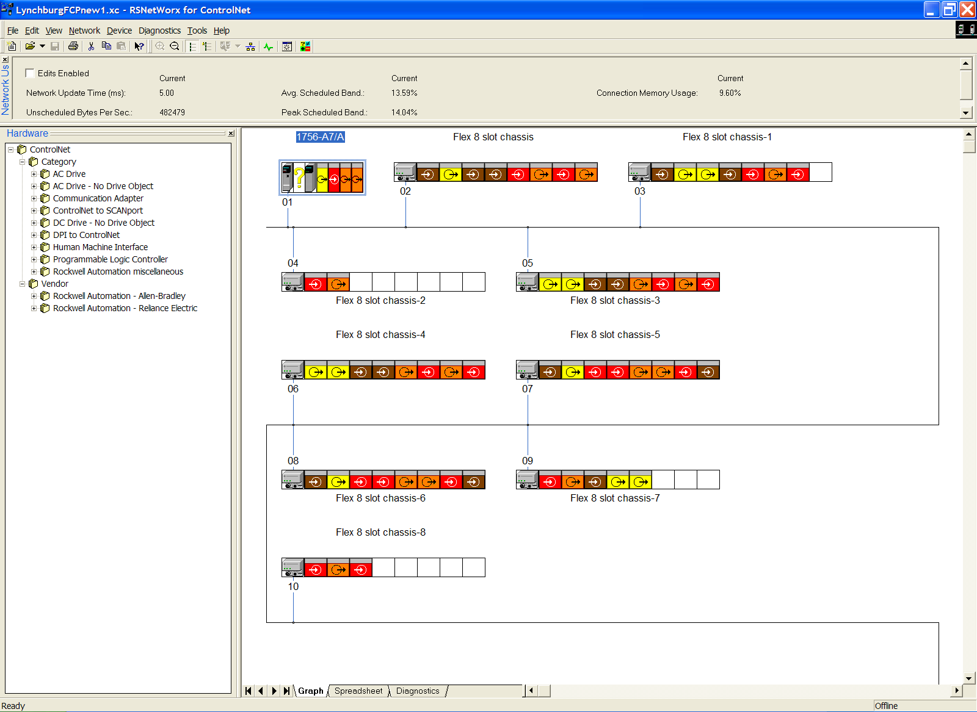

Figure . RSNetWorx Main Screen

#### Configure / Schedule the Network with RSNetWorx in Offline Mode

To begin configuration of the ControlNet network in Offline mode, follow the steps listed below.

1. Open the Properties box for the 1756-CNB ControlNet scanner module.
2. Select the RSNetWorx tab.
3. Type in a name for the ControlNet (.xc) file. This is where the ControlNet configuration information will be stored.
4. Select the “Schedule the ControlNet network” selection.

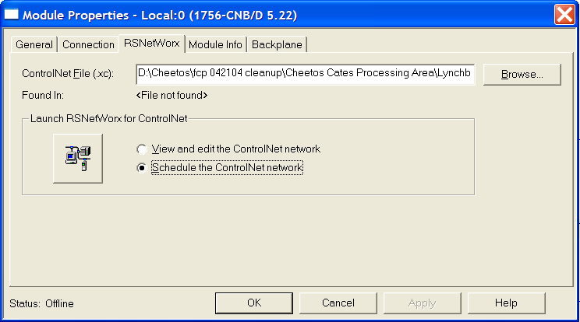

Figure . RSNetWorx tab in the 1756-CNB ControlNet scanner card properties.

1. Click on the Launch RSNetWorx for ControlNet button at the left-hand side of the module properties box. This will open RSNetWorx for ControlNet. RSNetWorx will create the schedule for the ControlNet network.
2. RSNetWorx will prompt you to “Optimize and Rewrite schedule for all connections.” Click “OK” to accept.
3. Click on the “Edits Enabled” checkbox in the left-hand corner of the RSNetWorx screen.
4. Access the network properties in the Network toolbar and set these values to proper settings.
5. Set the Max Scheduled Address (should match the highest node number to transmit scheduled messages).
6. Set the Max Unscheduled Address.
7. Set the Media Redundancy (should be “A only” for 1756-CNB).
8. Enter the name of the network.
9. Save the project in RSNetworx.
10. Save the project in RSLogix 5000.

#### Configure / Schedule the Network with RSNetWorx in Online Mode

To begin configuration of the ControlNet network in Online mode, follow the steps listed below.

1. Create a new ControlNet network project in RSNetworx by clicking on the “New” button in the upper left-hand corner of the screen.
2. Click on the “Online” button in the main toolbar. This button is shown in the figure below. Clicking on the “Online” button will bring up the “Browse for Network” screen.

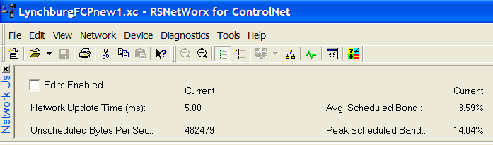

Figure . RSNetWorx Main Toolbar showing Online button.

1. Browse to the ControlNet scanner card in the “Browse for Network” screen. Look below the scanner card in the hierarchy to find the ControlNet network. Click on the “Ok” button to accept the network selection. The Browse for Network screen is shown in the figure on the following page.

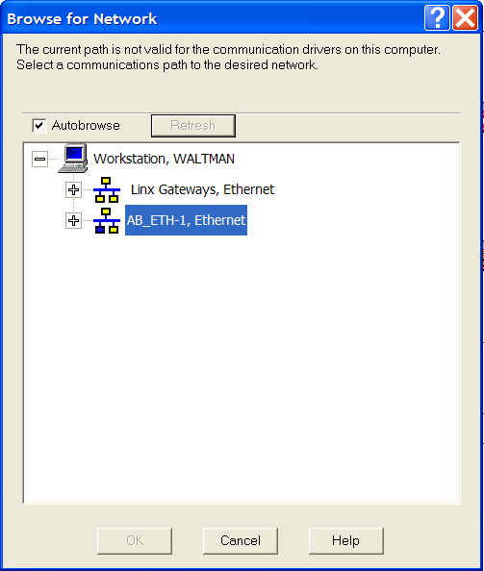

Figure . RSNetWorx Browse for Network screen.

1. Have RSNetWorx browse the network to find the devices on the ControlNet network. (Set the network to Single Browse Pass).
2. Check the “Edits Enabled” checkbox in RSNetworx to enable RSNetworx to schedule the network devices available on the network.
3. Access the network properties in the Network toolbar and set these values to proper settings.
   1. Set the Max Scheduled Address (should match the highest node number to transmit scheduled messages).
   2. Set the Max Unscheduled Address.
   3. Set the Media Redundancy (should be “A only” for 1756-CNB).
   4. Enter the name of the network.
4. Save the project in RSNetworx.
5. Save the project in RSLogix 5000.

## LAB - Adding a New Device to an Existing ControlNet Network with RSNetWorx

When adding a new device to an existing ControlNet network, we must have RSNetWorx reschedule the ControlNet network. RSNetWorx will then add the new device to the network schedule so that the ControlLogix processor can communicate with this device.

To add a new device to an existing ControlNet network, follow the steps listed below.

1. Open RSNetWorx and open the existing network’s configuration file.
2. Click on the “Online” button in the main toolbar.
3. Check the “Edits Enabled” checkbox in RSNetworx to enable RSNetworx to schedule the network devices available on the network.
4. Save the project in RSNetworx. This will save the new schedule and activate the ControlNet network.
5. Save the project in RSLogix 5000 while online with the ControlLogix processor.

## LAB - ControlNet

Wiring, Configuring & Adding a ControlNet network to a ControlNet Scanner using ControlLogix

### Exercise #1: Wiring a ControlNet Network

Connect the ControlNet scanner card to the Flex I/O ControlNet adapter module and terminate the trunk at each end.

### Exercise #2: Configure a ControlNet Network

Add a 1756-CNB ControlNet Scanner card, 1794-ACN15 Flex IO ControlNet Adapter card and I/O cards in RSLogix 5000

Complete this exercise by following the steps listed below:

1. Open a new project in RSLogix 5000
2. Configure the project for a ControlLogix controller (Instructor will provide details).
3. Add the 1756-CNB ControlNet scanner module under the IO Configuration in RSLogix 5000 (check the card for the exact part number and major/minor revision numbers).
4. Use the following information to complete the card addition:
5. Card Name: CNET
6. Node Number: 1
7. Slot Number: ? (Instructor will provide details)
8. Add the 1794-ACN15 Flex I/O ControlNet adapter module under the ControlNet scanner card in RSLogix 5000 (check the card for the exact part number and major/minor revision numbers).
9. Use the following information to complete the card addition:
10. Card Name: SEA (for Seasoning Unit Op)
11. Node Number: 2
12. Chassis Size: 2 (ensure that there are two I/O cards or change this number to reflect how full the Flex I/O rack is)

### Exercise #3: Schedule a ControlNet Network Offliine

Create and Schedule a ControlNet network in RSNetWorx in Offline Mode Complete this exercise by following the steps listed below:

1. Open the properties screen on the 1756-CNB ControlNet scanner card.
2. Select the RSNetWorx tab.
3. Create a new name for the ControlNet configuration file. Name it “TCLine1_network.”
4. Have RSNetworx schedule the network.
5. Save the project in RSNetWorx.
6. Save the project in RSLogix 5000.

### Exercise #4: Schedule a ControlNet Network Onliine

Creating and Scheduling a ControlNet network in RSNetWorx in Online Mode Complete this exercise by following the steps listed below:

1. Open a new project in RSNetWorx.
2. Go online with the ControlNet network.
3. Have RSNetWorx schedule the network.
4. Access the network properties in the Network toolbar and set these values to proper settings.
5. Set the NUT to 5msecs.
6. Set the Max Scheduled address to the last node number.
7. Set the Max Unscheduled address to 99.
8. Set the Media Redundancy to “A Only.”
9. Set the network name to “TCLine1.”
10. Save the project in RSNetworx.
11. Save the project in RSLogix 5000.
12. Verify communications with the ControlNet Network.

### Exercise #5: Add a node to an existing ControlNet network in RSNetWorx

Complete this exercise by following the steps listed below:

1. Set the network address for the new 1794-ACN15 ControlNet node to 3 (since this is an unused network node number on the existing network).
2. Connect the new node to the ControlNet network using the ControlNet cabling and BNC connectors.
3. Open RSNetWorx and open the existing network’s configuration file (the one you used in the previous exercises).
4. Click on the “Online” button in the main toolbar.
5. Check the “Edits Enabled” checkbox in RSNetworx to enable RSNetworx to schedule the network devices available on the network.
6. Save the project in RSNetworx. This will save the new schedule and activate the ControlNet network.
7. Save the project in RSLogix 5000 while online with the ControlLogix processor.

## Ethernet Network

Ethernet IP is becoming a popular option for I/O. All traditional Ethernet options for star, tree, switch ring, and other high-availability topologies. Many automation devices include two physical Ethernet ports and follow the ODVA DLR (Device Level Ring) standard to support linear and ring topologies, without the need for external Ethernet switches

* 100 m between devices for copper twisted-pair wiring Formula for Maximum Length of trunk
* Fiber cabling permits longer distances (design dependent)

### EtherNet Network I/O (Cat 5)

Deployment of Ethernet on the plant floor and across the enterprise, combined with increasing business pressures, has encouraged network convergence as well as organizational and cultural convergence of IT and manufacturing organizations. Ethernet, in particular, has delivered significant benefits for manufacturers. EtherNet/IP, which is unmodified Ethernet, allows the user to effectively manage real-time control and information flow throughout the manufacturing and IT enterprise. EtherNet/IP (using the Common Industrial Protocol) allows networks, including motion and safety, to communicate seamlessly on the factory floor along with other common sets of IT capabilities like voice, video, and data.[28] Figure 375 shows a flex I/O module using EtherNet I/O communication.

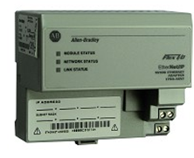

Figure : Flex I/O with Ethernet I/O Communication.

### EtherNet and ControlLogix

Typically when using EtherNet I/O in a Control Logix application, two Ethernet network cards are installed in the local rack as pictured in Figure 377. One is used for programming, monitoring and trending data from the processor on the Controls Network. The other Ethernet card is strictly I/O communications such as remote racks, VFD’s etc.

### BooTP for Ethernet Devices

New Devices with no configured IP address have BooTP enabled so that you can use the BooTP/DHCP server to assign a IP address for your network.

Once you assign a IP address disable BooTP.

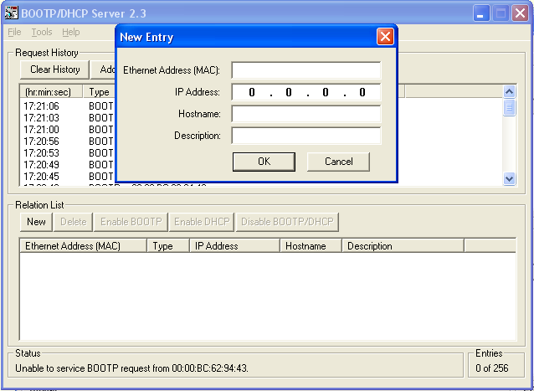

Figure . BooTP for Ethernet Flex Adaptor

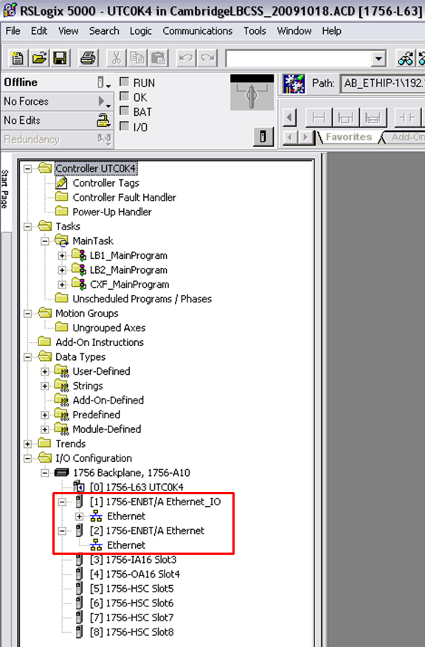

Figure : EtherNet I/O in a Control Logix Application.

To view all the configured I/O on the EtherNet I/O network, select the EtherNet “+”. Figure 378 shows the expanded EtherNet I/O network.

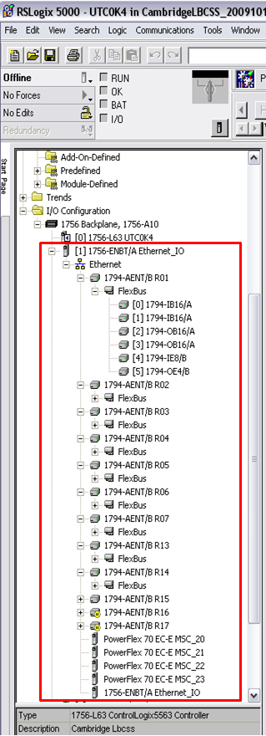

Figure : Expanded EtherNet I/O Network.

Right clicking on the 1756-ENBT/A Ethernet _IO module and selecting Properties will show the following information about the module as demonstrated in Figure 379.

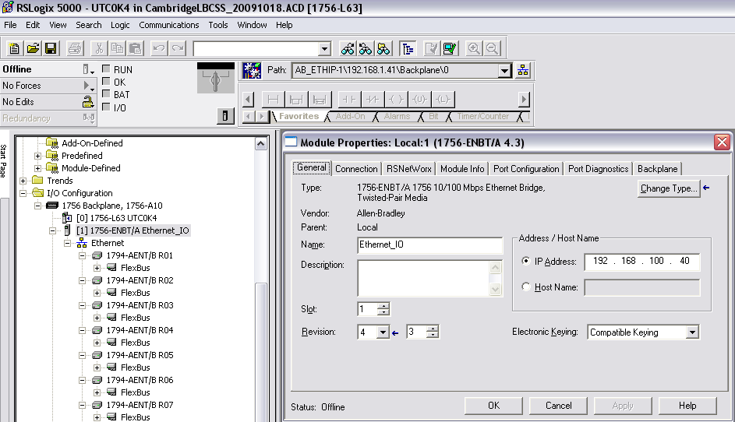

Figure : 1756-ENBT/A Ethernet _IO Module Properties.

Right clicking on the 1794-AENT/B R01 Flex module and selecting Properties will show the following information about the module as pictured in Figure 380.

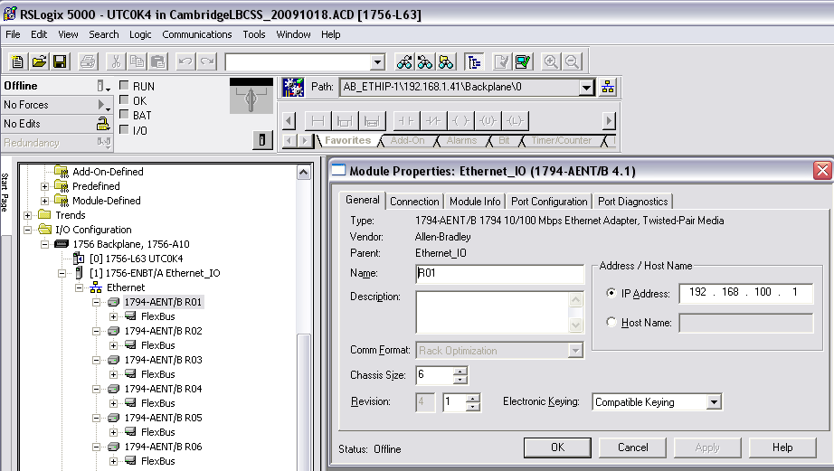

Figure : 1794-AENT/B R01 Flex Module Properties.

### RSNetWorx for EtherNet Overview

RSNetWorx, with the EtherNet drives loaded, enables the user to configure and provides information about the EtherNet network. Figure 381 shows the configuration of the EtherNet I/O Network.

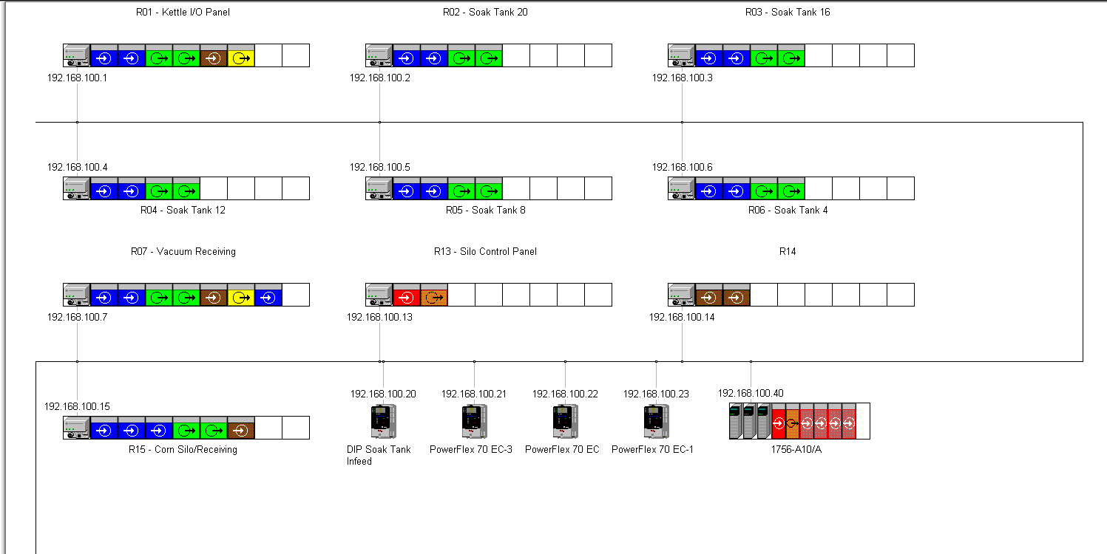

Figure : RSNetWorx Main Screen

## LAB - Ethernet I/O

1. Create a 1756-ENBT/B Ethernet Communication card for I/O in RSLogix 5000
2. Add a 1794-AENT Flex IO Ethernet adapter card in RSLogix 5000
3. Add any 4 I/O modules to the Flex I/O rack.

# Panelview and FactoryTalk View Studio

Reference Items in folder – “Section 21 - FT View Studio and Panelview” for examples and additional information

Let’s take a look at the Panelviews (AB HMI). This training is dedicated to the identification and understanding of FactoryTalk View software. After studying the information contained in this section and practicing the steps contained in the laboratory exercises, you should be able to:

* Identify the basic components of Panelview
* Understand the programming software for FactoryTalk View Studio

**PanelViewPlus HMI Terminals**

Once an application is created in FactoryTalk View Studio, a run-time file has to be created, transferred and downloaded into an HMI Terminal. The HMIs are known as PanelView Plus Terminals and they give operators the ability to monitor and control applications. The PanelView Plus family of products provides a broad range of rugged terminals that offer:

* Premier integration with Integrated Architecture
* Real-time monitoring of a terminal's displays from a web browser
* Common development software, FactoryTalk View Studio.
* Scalable 4- to 15-inch displays with touch screen, keypad, or both for input
* Options for sizing memory to requirements of application

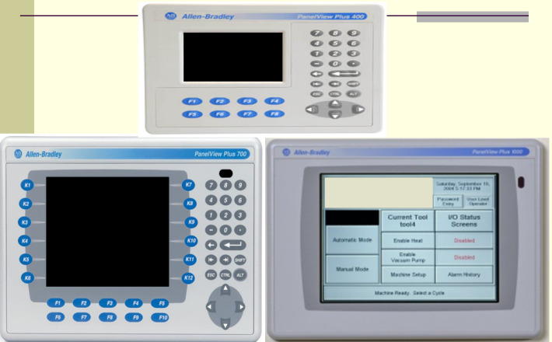

Figure . FactoryTalk Panelview Plus

**PanelView and FactoryTalk View Studio Basics**

FactoryTalk View Studio is a program that allows users to design applications that can be used as a Human Machine Interface (HMI) for AB PanelViews, and control different assets of a manufacturing operation to receive feedback.

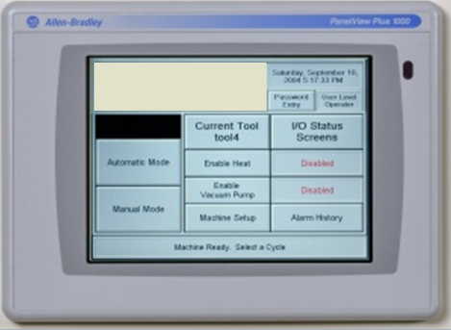

Figure . Allen Bradley PanelView HMI

To open FactoryTalk View Studio, left click on the FactoryTalk View Studio icon.



Figure . FactoryTalk View Studio Icon

## FactoryTalk View Studio

Once the application is open you can begin exploring the main window. The main window consists of,

* Title Bar
* Menu Bar
* Tool Bar
* Explorer Window
* Workspace
* Diagnostics List
* Status Bar

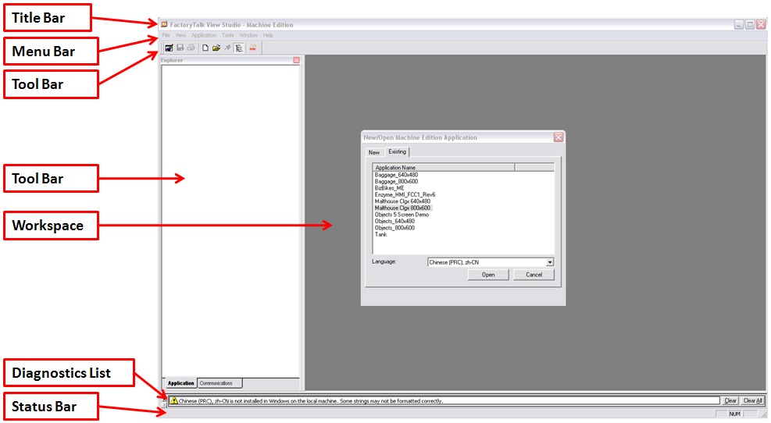

Figure . FactoryTalk Main Window

### Menu Bar

The Menu Bar contains the following items for the active window:

* File
* View
* Application
* Tools
* Window
* Help



Figure . FactoryTalk Menu Bar

### Tool Bar

The Tool Bar allows for quick access to menu bar items. Placing the cursor over the icon will allow for a description of the icon to “pop-up” on the screen.

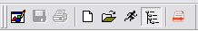

Figure . FactoryTalkTool Bar

### Explorer Window

The Explorer Window contains two tabs:

**Application tab** — Contains the tools used for editing and creating an application, as well as, a System folder used for setting up FactoryTalk security.

**Communications tab**— Contains the communications tree for communications with the development computer.

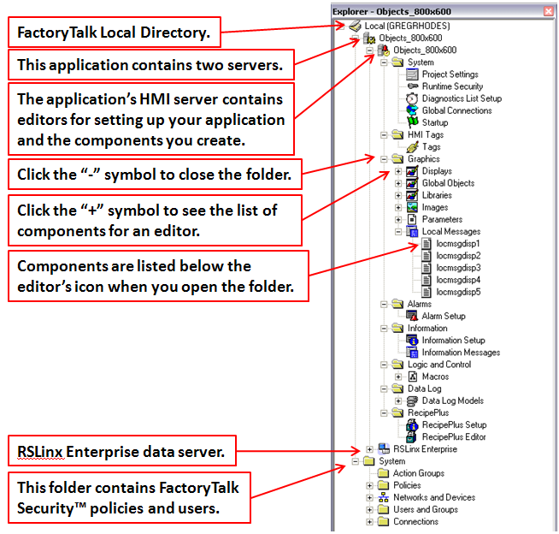

Figure . FactoryTalk Explorer Window

### The Workspace

The Workspace is the blank area of the FactoryTalk View Studio Window. Icons can be dragged from the Explorer window to the Workspace to open editors and components.

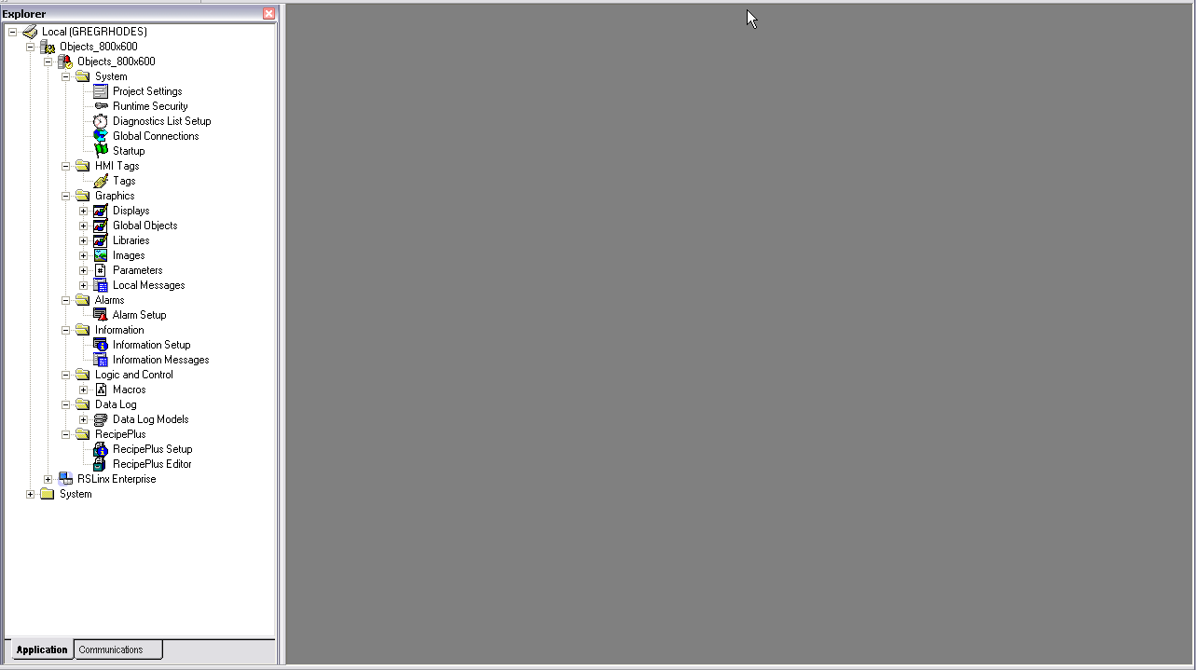

Figure . FactoryTalk Workspace

### Diagnostics List

The Diagnostics List shows messages about system activities. The user can specify the types of messages displayed, move the list, resize it and clear the messages.



Figure . FactoryTalk Diagnostics List

### Status Bar

The Status Bar displays information about the active window, selected tool or menu item depending on where the mouse pointer is. Example: If the user selects an object in the Graphics editor, the status displays information about the selected object.

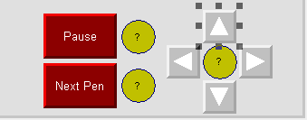

Figure . FactoryTalk Status Bar

### Workbook Tabs

Displays information about the active window, selected tool or menu item depending on where the mouse pointer is. Example: If the user selects an object in the Graphics editor, the status displays information about the selected object.

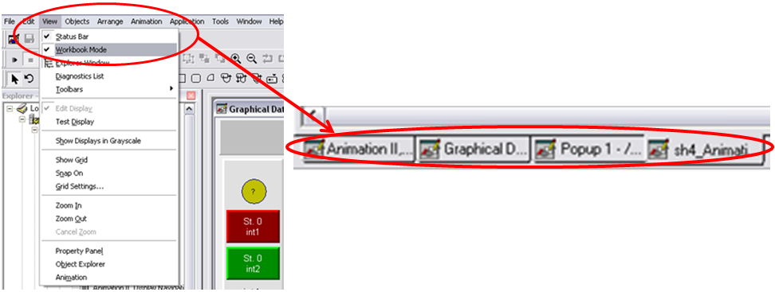

Figure . FactoryTalk Workbook Tabs

### Project Settings

Project settings determine the general appearance of your run-time project, such as the size of the project window and whether a title bar appears on the project window. To open the Project Settings editor, in the Explorer window's System folder, double-click the Project Settings icon.

There are two tabs associated with the Project Settings pop-up window: **General** and **Runtime**. In the General tab of the Project settings editor, specify the size of the project window and the application type, that is, whether or not the application is a Compact Machine Edition application. In the Runtime tab of the Project Settings editor, specify the window elements that are displayed at run time (such as title bar and minimize button).

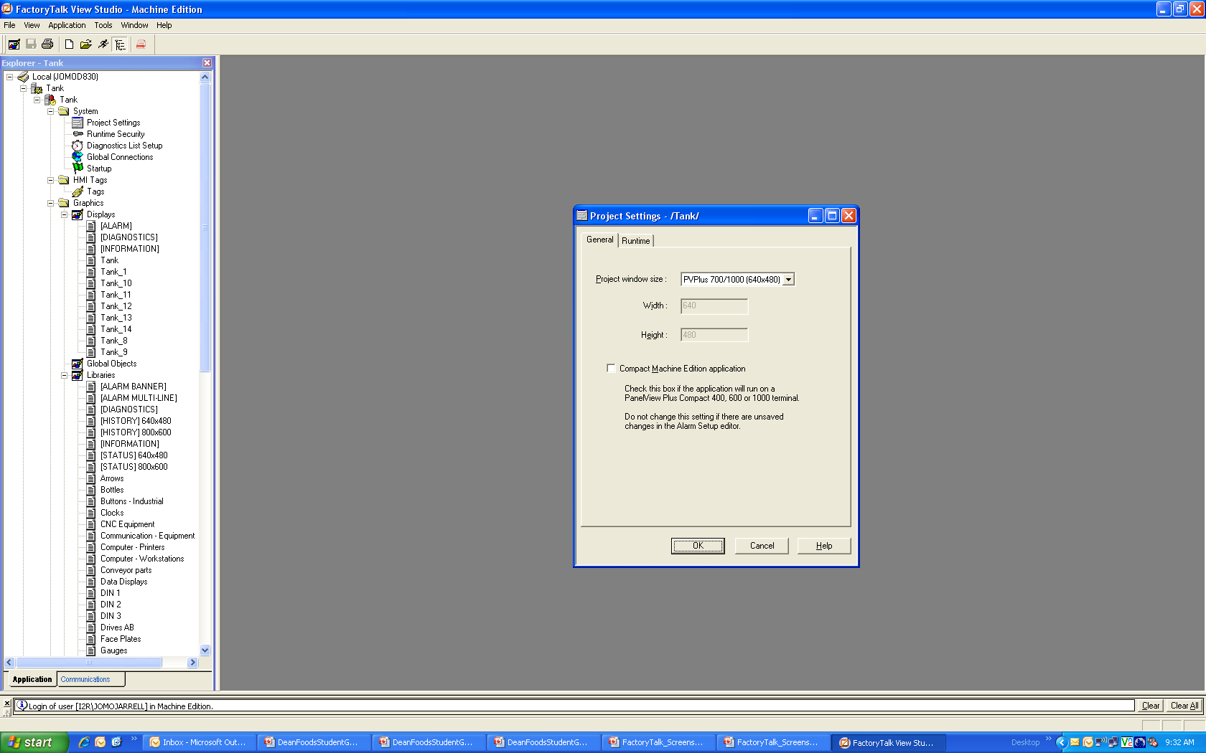

Figure . FactoryTalk Project Settings

### Runtime Security

Security provides a way to restrict access to certain parts of the system. You can limit the users who have access to the system by setting up user accounts and passwords. You can also limit users to specific graphic displays. If you don’t set up security, anyone can use the system without logging on, and view all the graphic displays.

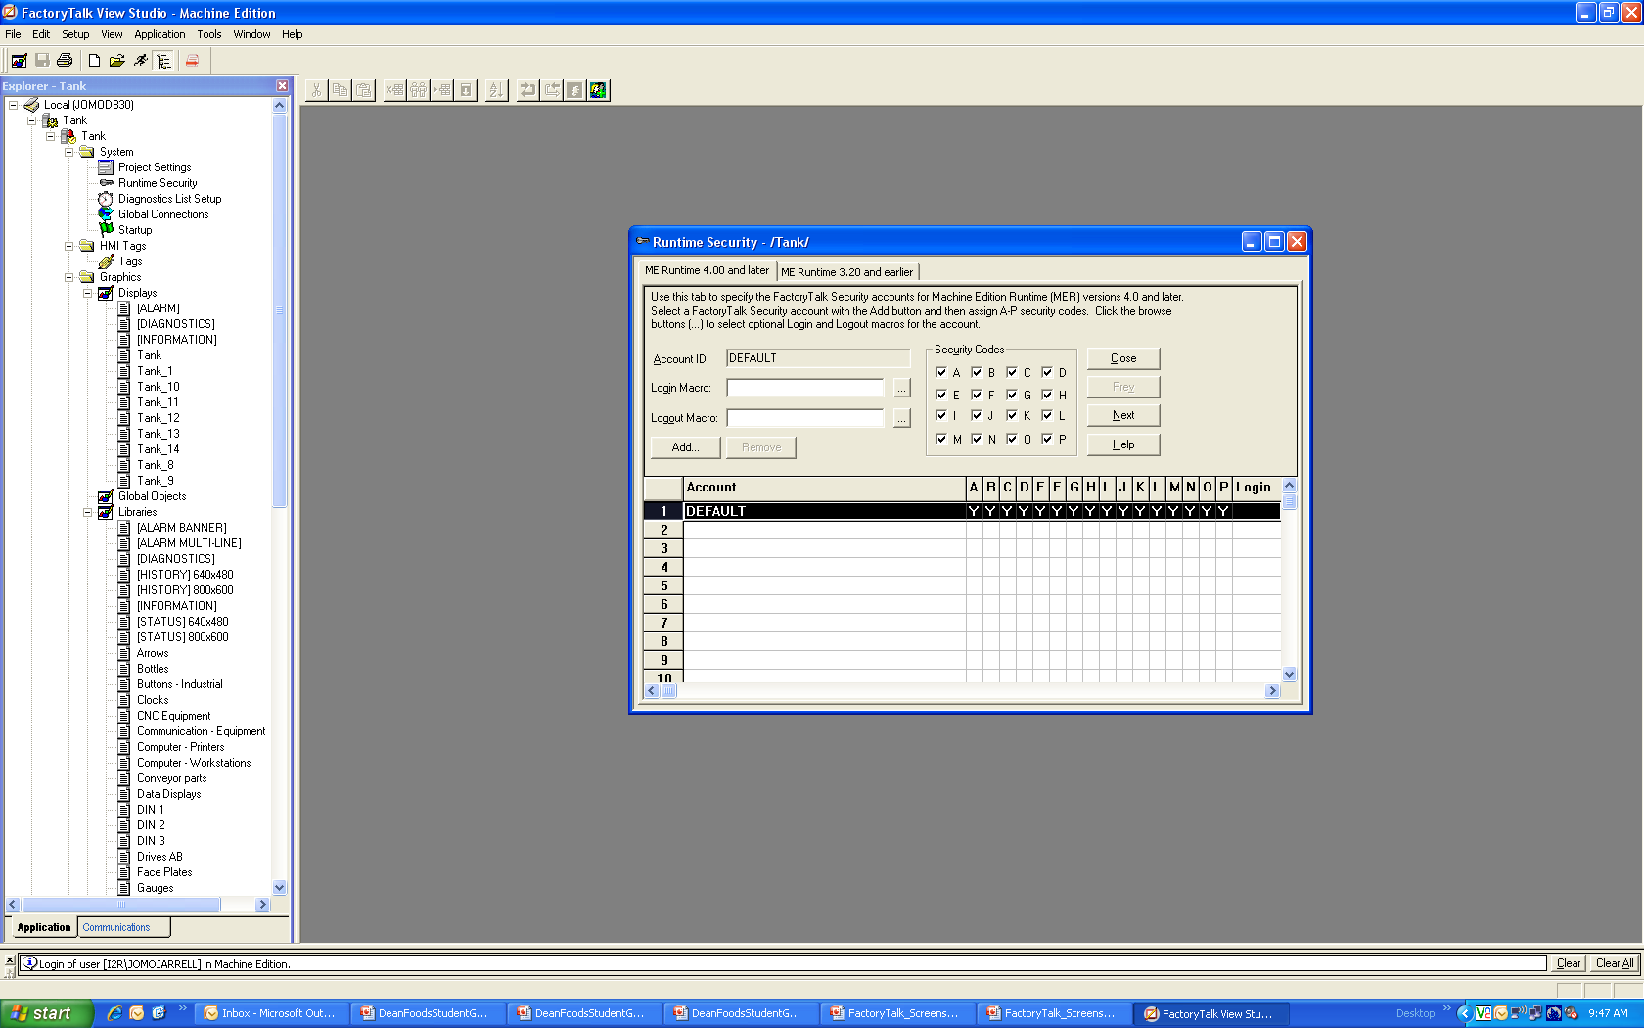

Figure . FactoryTalk Runtime Security

### Diagnostics List Setup

In the Diagnostics List Setup editor, set up when to print messages at run time, the graphic display to use and when to open it, and the maximum number of messages to store.

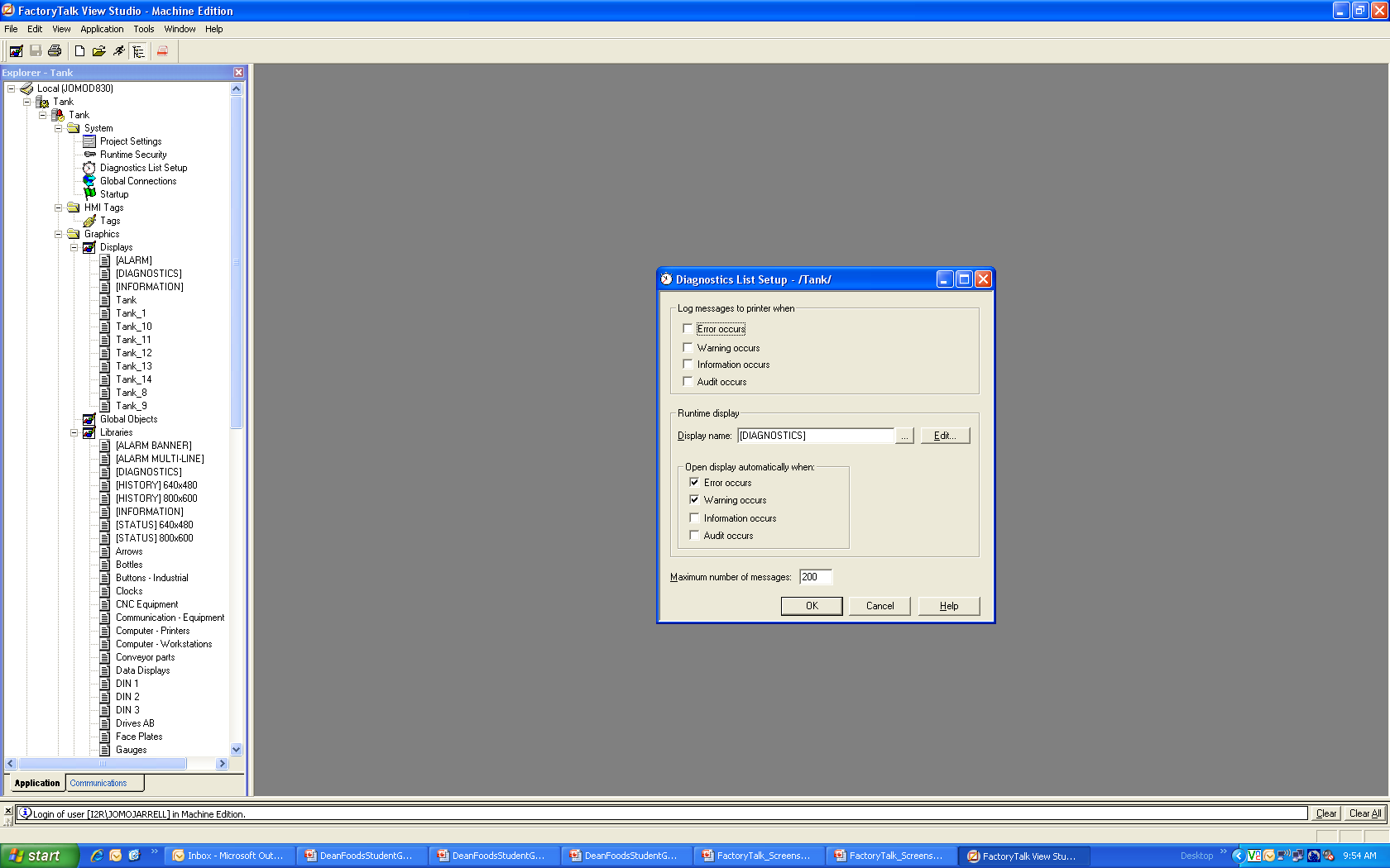

Figure . FactoryTalk Diagnostics List Setup

### Global Connections

Global connections provide run-time functions that apply to your entire project.

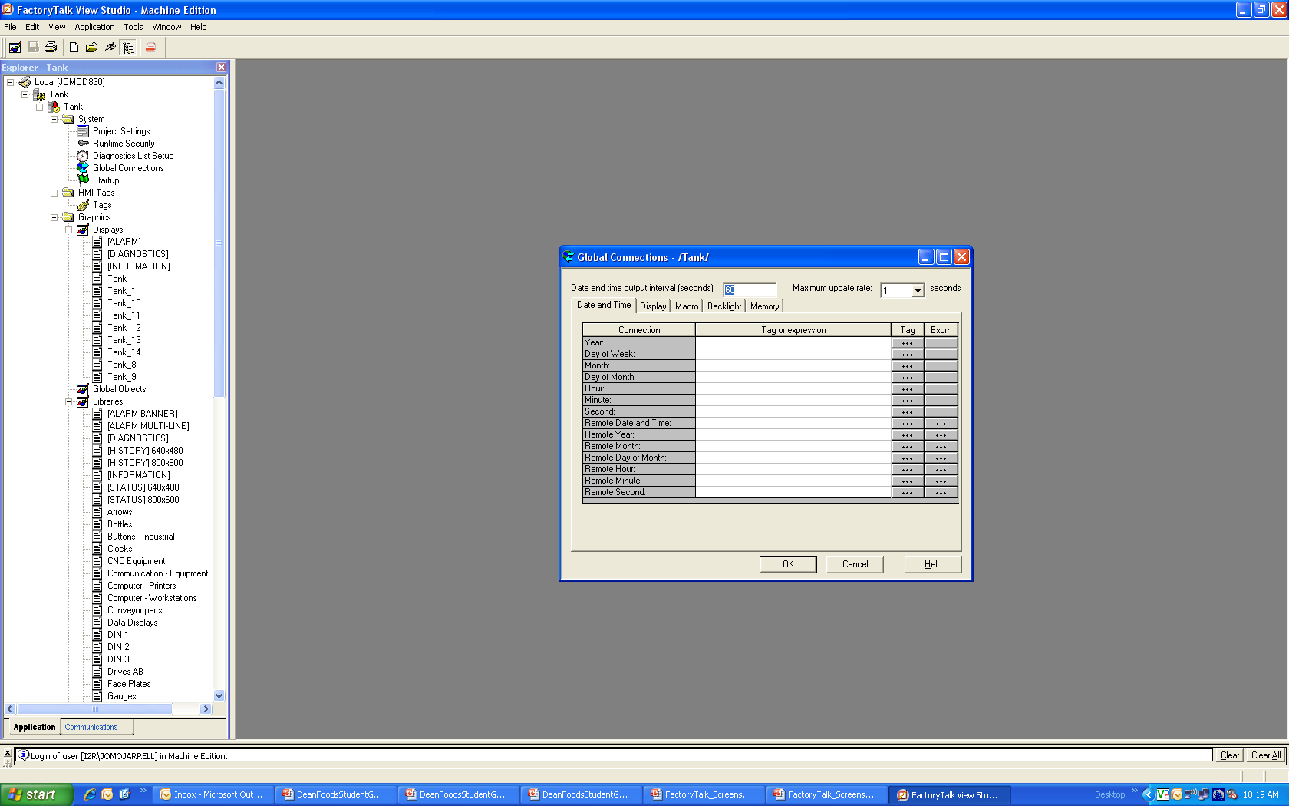

Figure . FactoryTalk Global Connections

### Startup Editor

The Startup editor is used to specify which project components to start at run time.

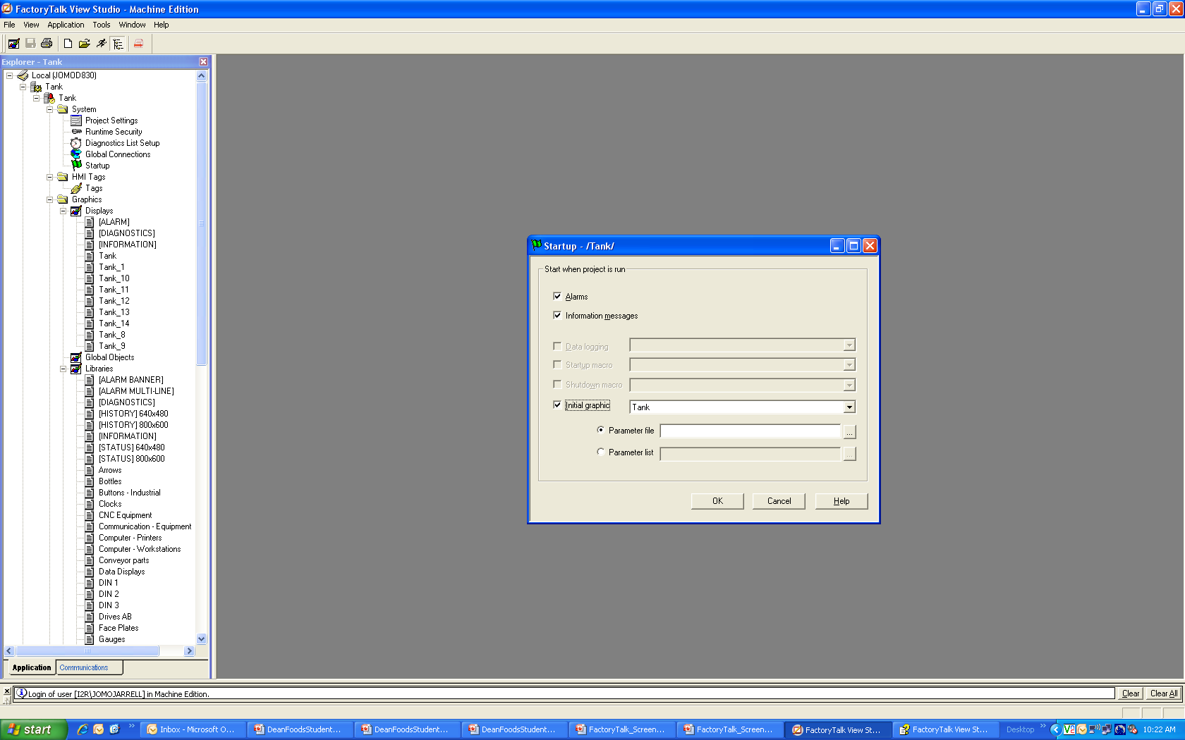

Figure . FactoryTalk Startup Editor

### Tags

To add new tags, double-click on Tags in the Explorer window, enter the desired tagname, select the tag type (Digital, Analog, or String), enter a description, select the data source type, and the address. NOTE: Tank_HMI is a shortcut used in RS View to point to tags directly inside of the PLC.

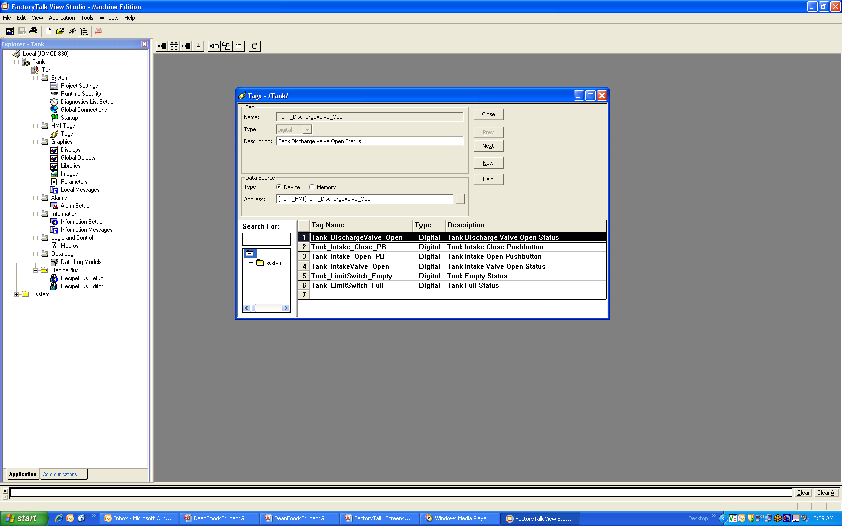

Figure . FactoryTalk Tags

### Alarm Setup

In the Alarm Setup editor, specify the tags or expressions to monitor, the conditions that trigger alarms, the alarm messages, the pop-up alarm display (if any), and what to do when an alarm occurs. To set up alarms:

* In the Explorer window, open the Alarms folder.
* Double-click the Alarm Setup icon to open the editor.
* Set up alarms in the Triggers, Messages, and Advanced tabs.
* Click OK to save your changes and close the editor.

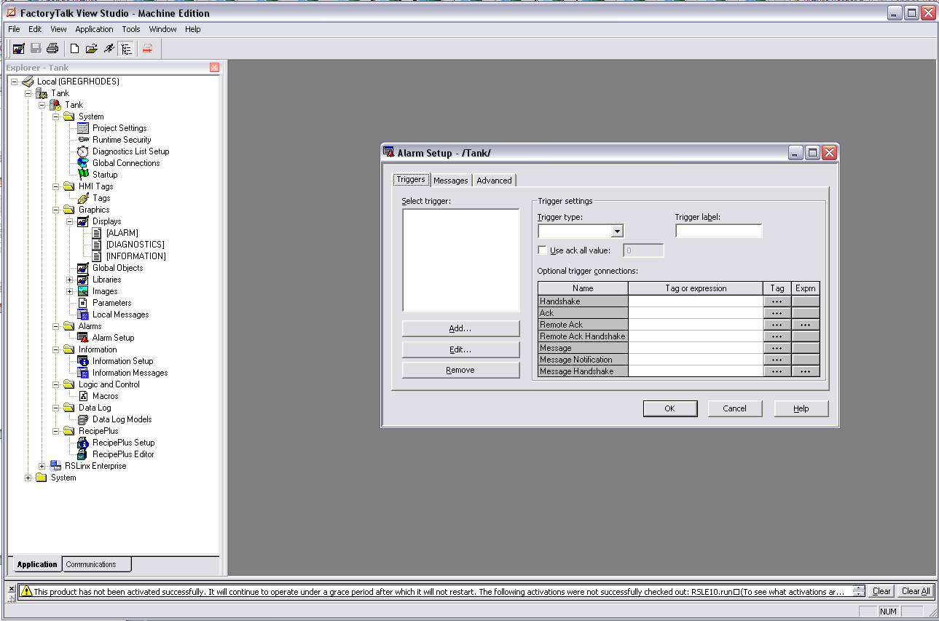

Figure . FactoryTalk Alarm Setup

### Information Setup

Use information messages to give the operator messages about the process, prompts or instructions, and information about the current states.

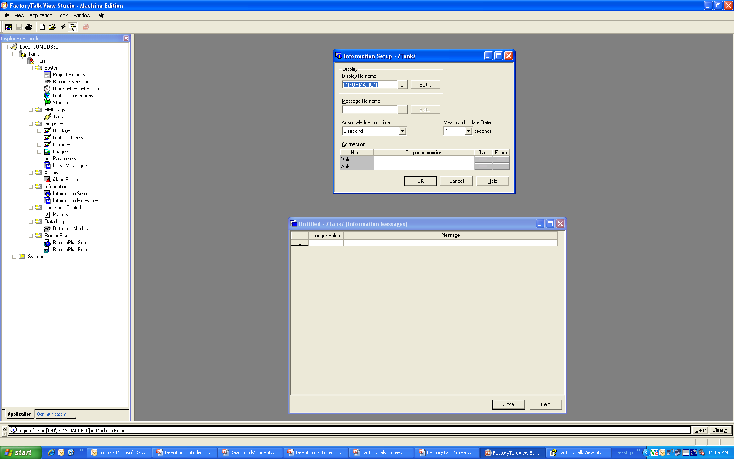

Figure . FactoryTalk Information Setup

### Logic and Control (Macros)

A macro is a list of tag assignments stored in a text file. Use macros to assign initial values to tags. You can use macros in these editors:

* **Startup** - assign project startup and shutdown macros.
* **Graphics** - assign startup and shutdown macros to graphic displays in the Display Settings dialog box of this editor.
* **Runtime Security** - assign login and logout macros to users.
* **Global connections** - assign macros to up to five global connections. Macros are run when an expression result or tag value changes.

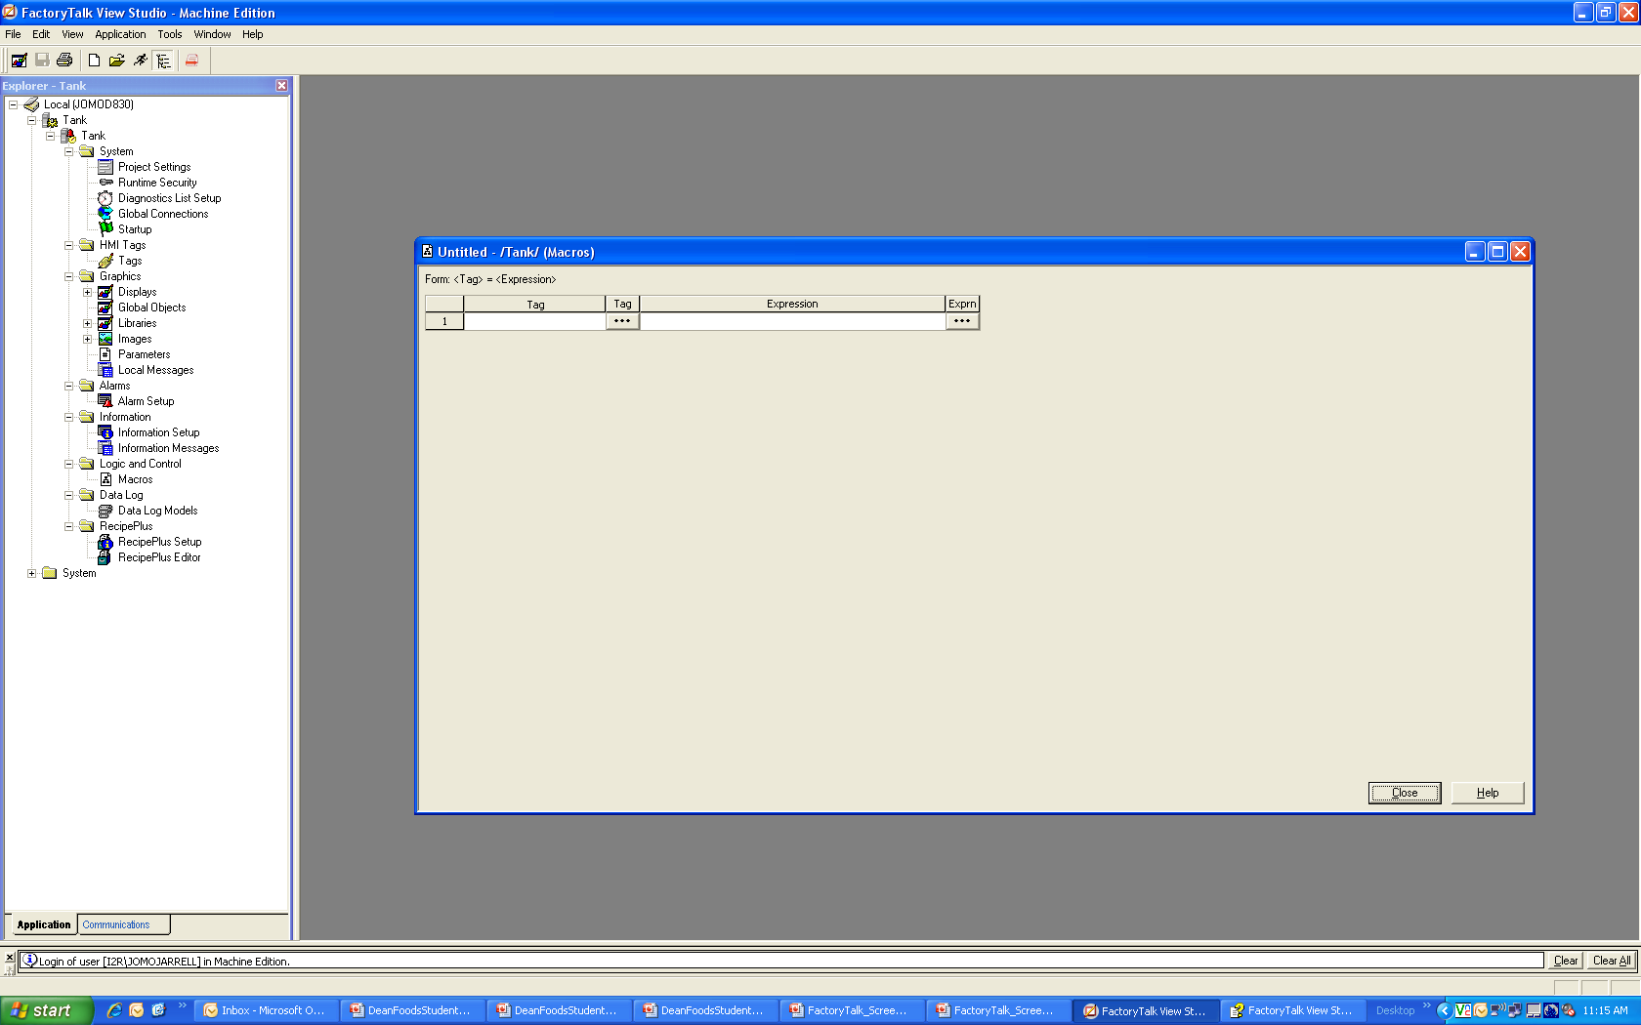

Figure . FactoryTalk Logic and Control

### Data Log Models

Use data logging to set up a data log model that specifies how many log values to store, the conditions that trigger data logging, and which tags to monitor. The data log tag can be used to display trend over time.

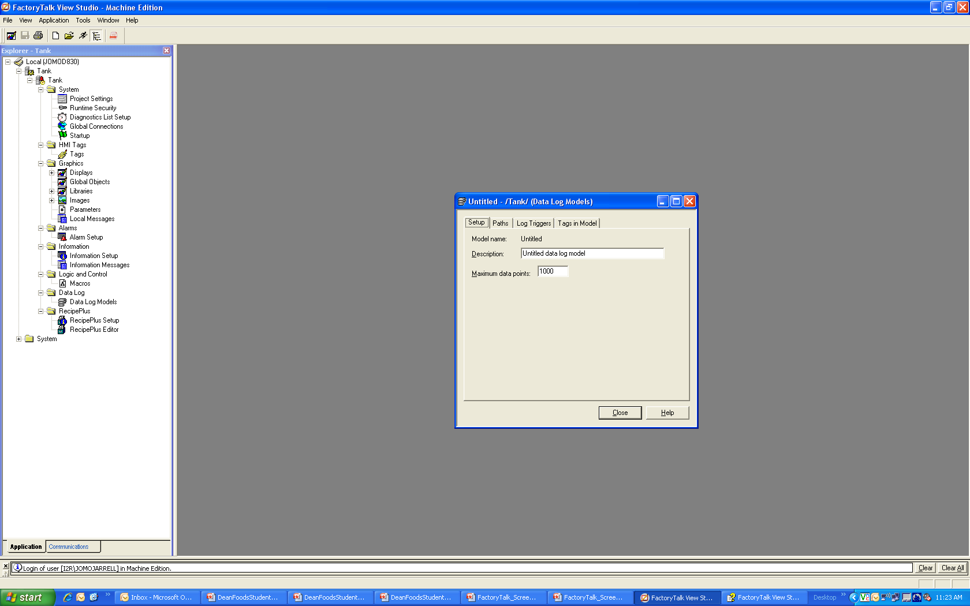

Figure . FactoryTalk Data Log Models

### Recipe Plus

The basic purpose of a recipe system is to allow the user to write a set of values to a set of tags in a single operation. RecipePlus consists of the following parts:

* **RecipePlus Setup** — used to specify whether recipe files will be a part of the HMI project or not, and where the files will be stored for retrieval at run time.
* **RecipePlus editor** — used to create and edit the recipe files by specifying the ingredients of the recipe, the data sets and tag sets the recipe will use, and the recipe units. You can also use the editor to compare one recipe file to another, or data sets and tag sets within a single recipe file, and determine where they are different.

### Display Objects for Recipe

* **RecipePlus table object** — used to display, modify, and save the contents of a recipe at run time. The table also shows the differences between the recipe data values and the values in the tags associated with the recipe.
* **RecipePlus button object** — used to initiate recipe operations at run time.
* **RecipePlus selector object** — used to select from a list of recipes available to the operator at run time.

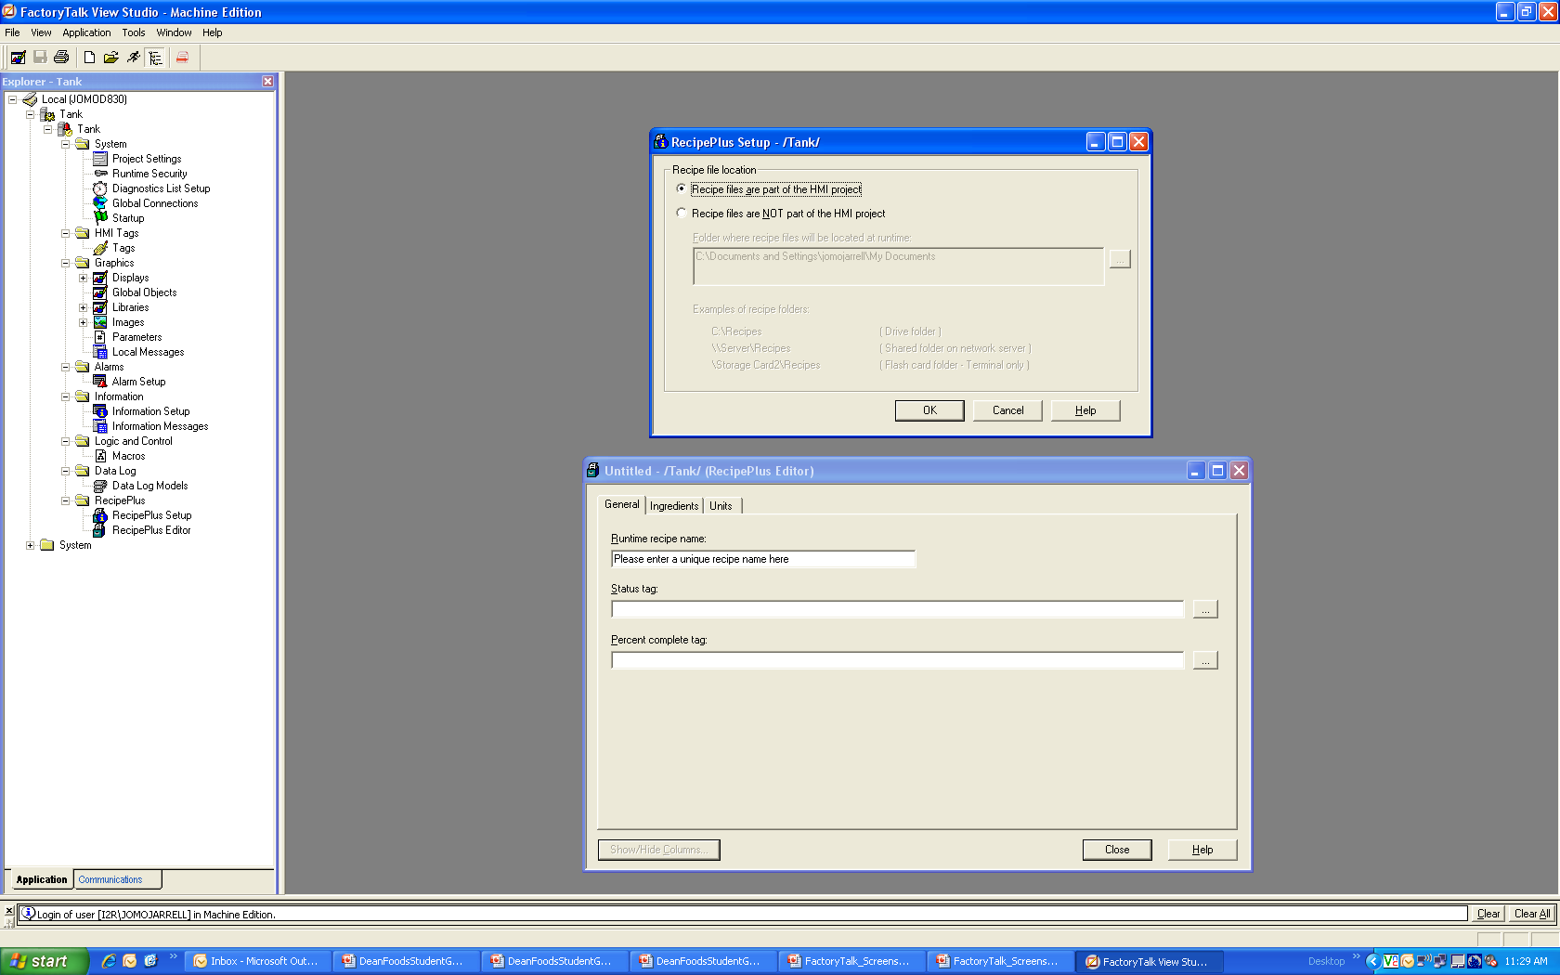

Figure . FactoryTalk Recipe Plus

### Communications

FactoryTalk View Studio is an OPC client (OLE for Process Control, where OLE is an acronym for Object Linking and Embedding). The default OPC server installed with FactoryTalk View Studio is RSLinx Enterprise. Most OPC servers are capable of communicating with a variety of devices over a variety of networks using a variety of protocols.

To communicate with programmable controllers, you need to:

* Specify an RSLinx Enterprise for your application
* Configure a device shortcut, that is, a path between the data server and each controller you want to use as a data source.
* Add device tags to the tag database for your application, or use direct references to objects in the graphic displays.

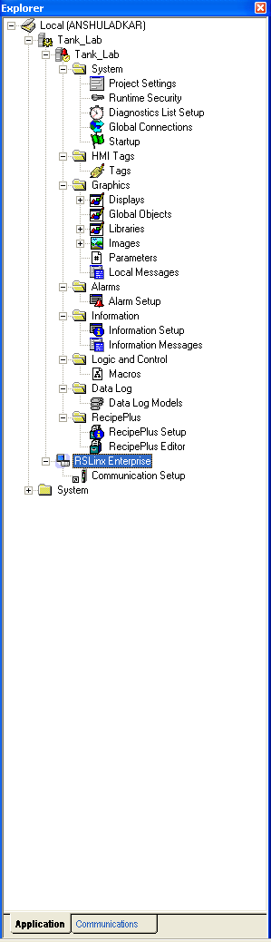

Figure . FactoryTalk Communication

## LAB - FactoryTalk View

In this section, we will discuss how to create a new application of a tank, add devices from the library, add objects from the menu bar, add tags, add animation to devices, and configure properties of objects and devices.

We will create an application which has all the above graphics and assign all the tags for an Emulate PLC.

Outputs:  
Intake Valve: ____________________________  
Discharge Valve:__________________________

Inputs:  
PB Intake Open: __________________________  
PB Intake Close: __________________________  
Full LSH: _________________________________  
Empty LSL: _______________________________

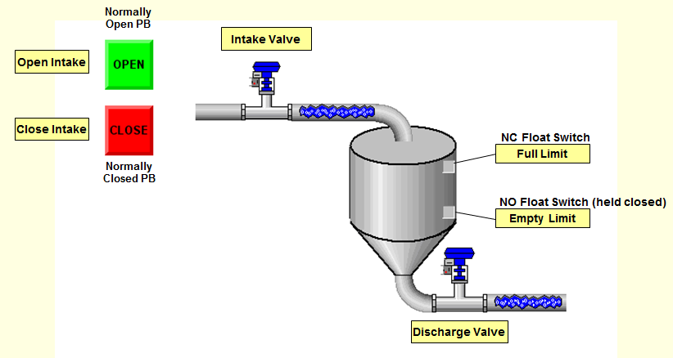

Figure . Tank Lab

### Creating an Application

* Left click on FactoryTalk View Studio.
* When creating a new application select the “New” tab in the “New/Open Machine Edition Application” window.
* Input the desired name of the application in the “Application name” field.
* Add description if desired.
* Select language from language drop down.
* Click on “Create” button.

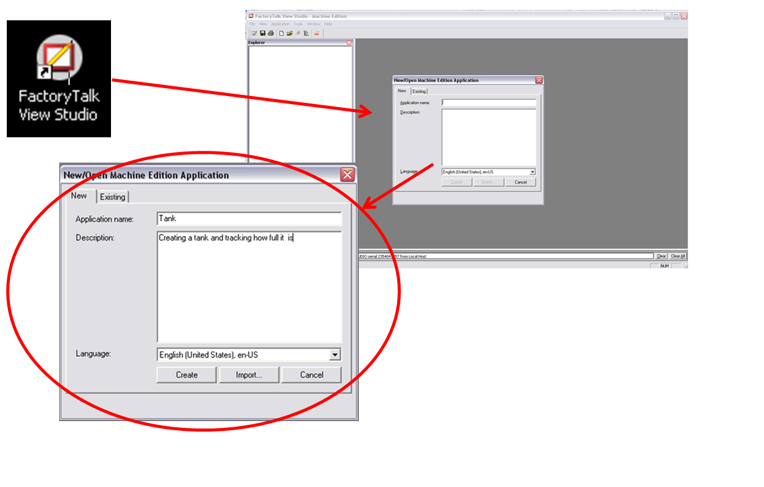 Figure . Creating an Application

* Create a new graphics window by scrolling down to the Graphics folder and right clicking on “Display”.
* Click the left click the new option.

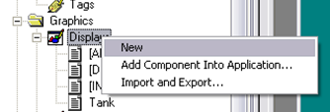

Figure . New Display

* In the Explorer window, expand the Libraries menu.
* Scroll down to the library named “Tank”.
* Select the desired tank, left click on the tank, drag it to the graphics window and position it where desired.

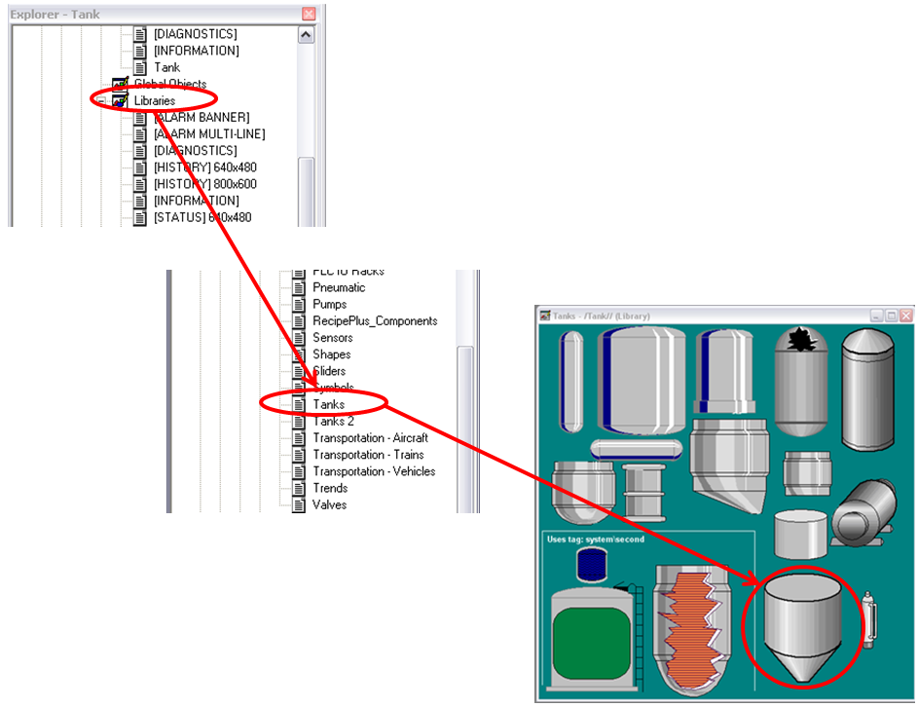

Figure . Add New Tank

Next, we want to add a pipe on the intake side of the tank. Follow the steps listed below to add a pipe to the tank:

* In the Explorer window, expand the Libraries menu.
* Scroll down to the library named “Pipes 3”.
* Select the desired pipe, left click on the pipe, drag it to the graphics window and position it where desired.

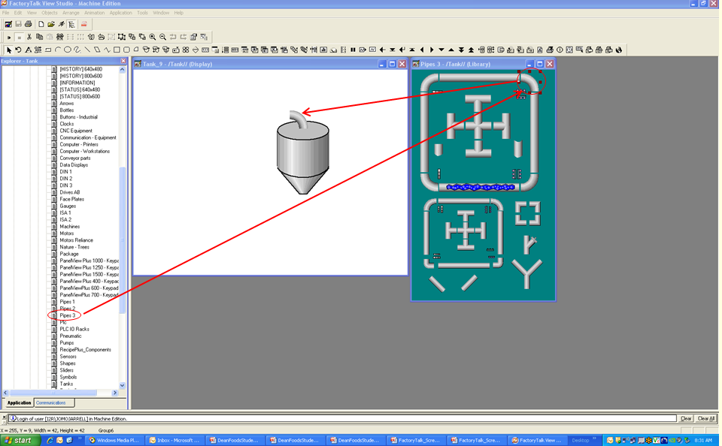

Figure . Add New Pipe

Attach an additional pipe that displays the ingredients on the intake side of the tank. Repeat the steps listed above to add a pipe to the tank.

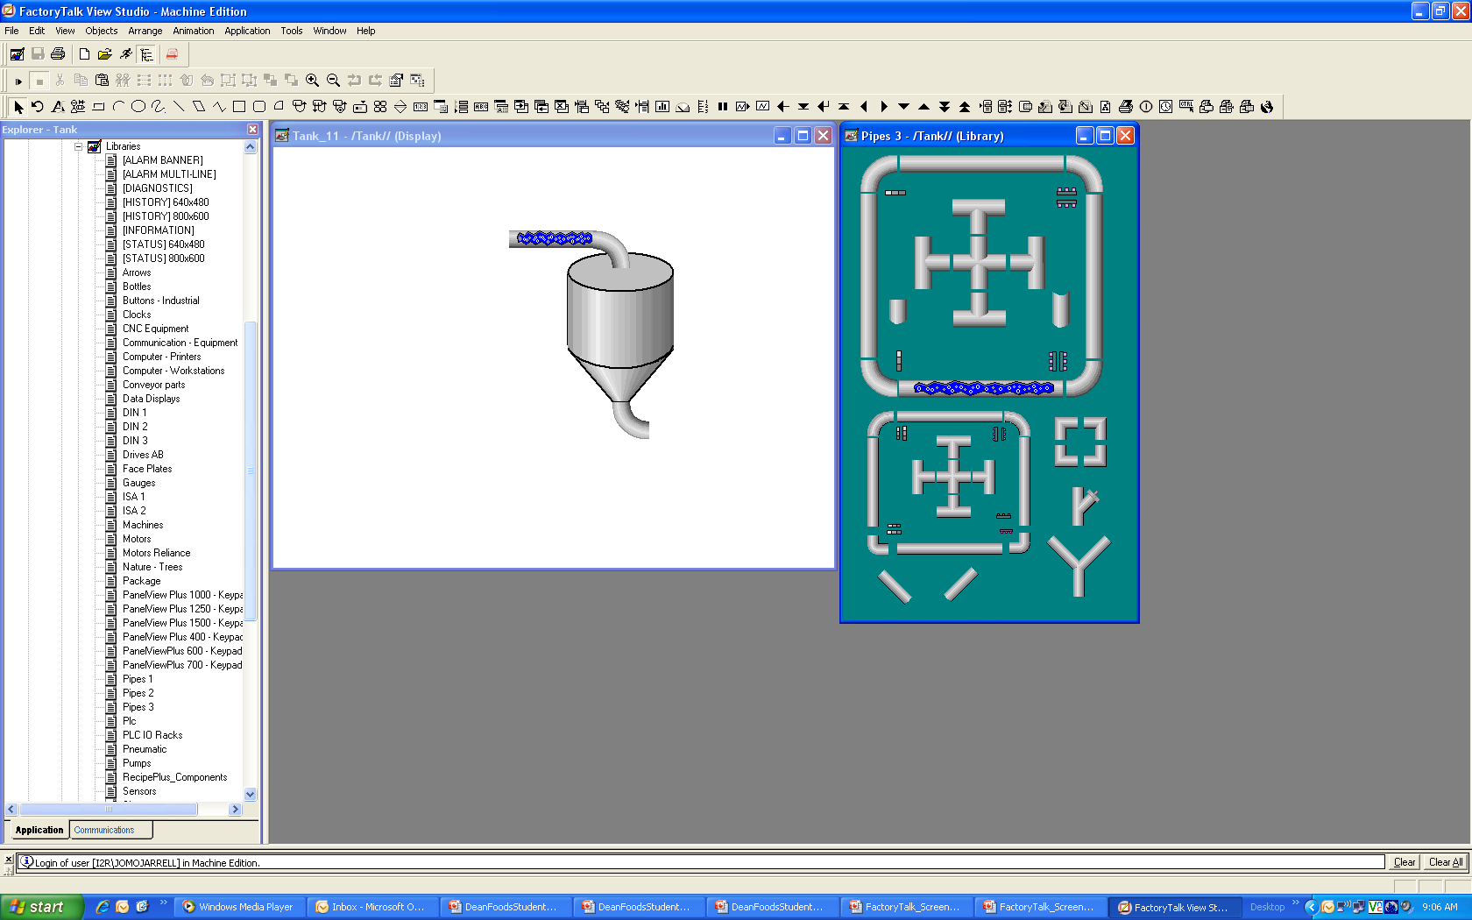

Figure . Add New Pipe with Animation

To add a valve to the tank, follow the steps listed below to add a pipe to the tank:

* In the Explorer window, expand the Libraries menu.
* Scroll down to the library named “Valves”.
* Select the desired valve, left click on the valve, drag it to the graphics window and position it where desired.

Add more pipe before the intake valve.

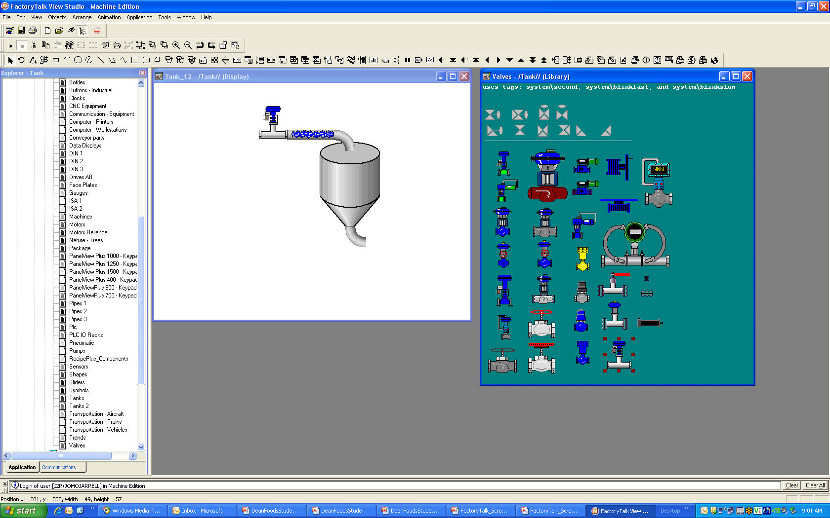

Figure . Add Intake Valve

* Add the Discharge side of the tank similar to the intake with valve and pipes
* Add a Limit Switch Full Indicator to the tank. From the Explorer Window, click on Libraries, Shapes, and select the first square under Recessed.
* Add a Limit Switch Empty indicator to tank

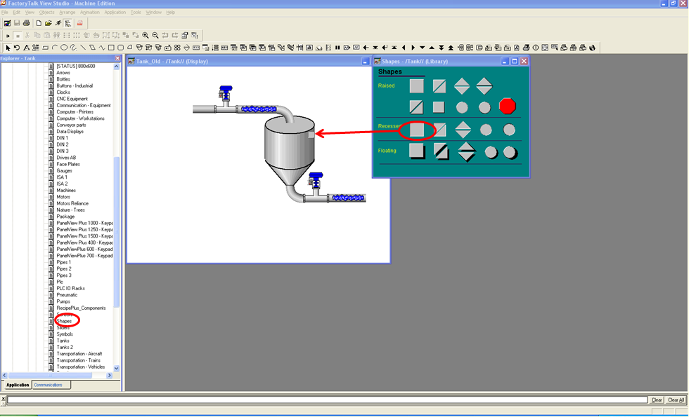

Figure . Add Full Limit Switch

To add new tags, double-click on Tags in the Explorer window, enter the desired tagname, select the tag type (Digital, Analog, or String), enter a description, select the data source type, and the address. NOTE: Tank_HMI is a shortcut used in RS View to directly point to tags inside of the PLC.

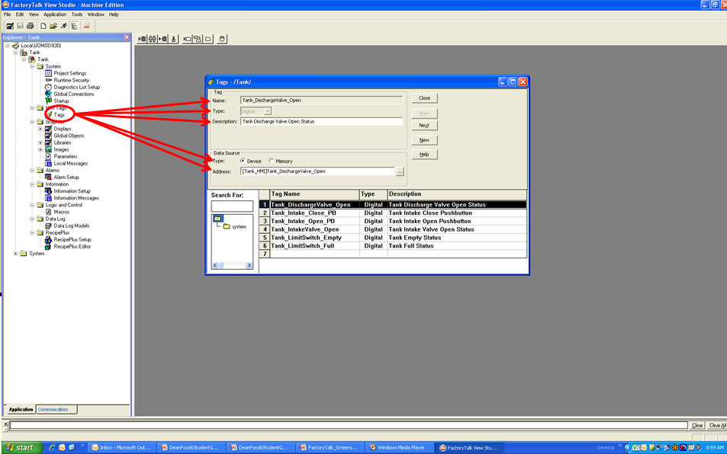

Figure . Add New Tags

To add animation to an object, right-click on the object, select animation, then select the attribute that you would like to animate. In this case, we will use color to indicate whether the tank is full or empty.

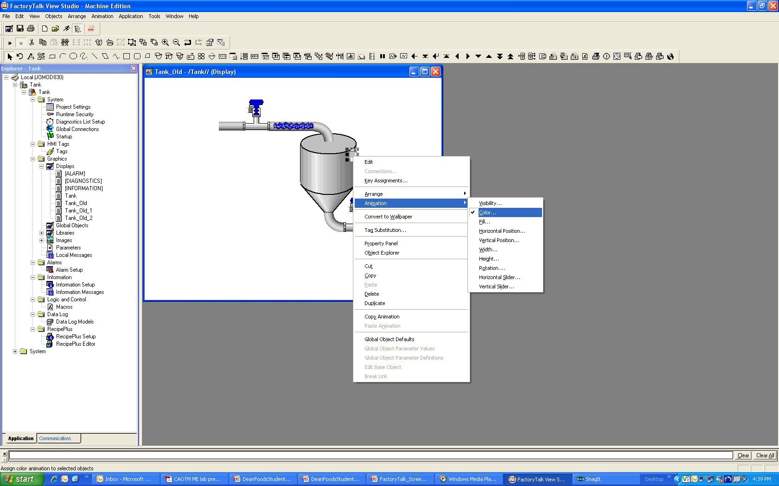

Figure . Add Animation to Limit Switch

Before changing the foreground and background colors, you must first select the appropriate tag.

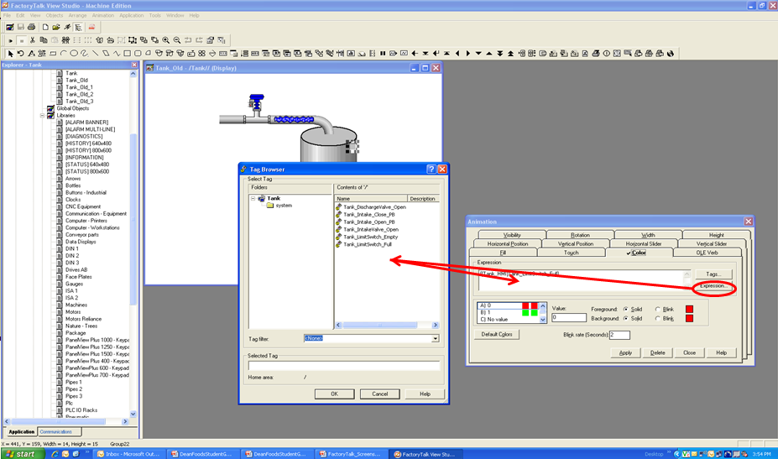

Figure . Add Tags to Limit Switch

Next, change the foreground color to red to represent when the tank is empty.

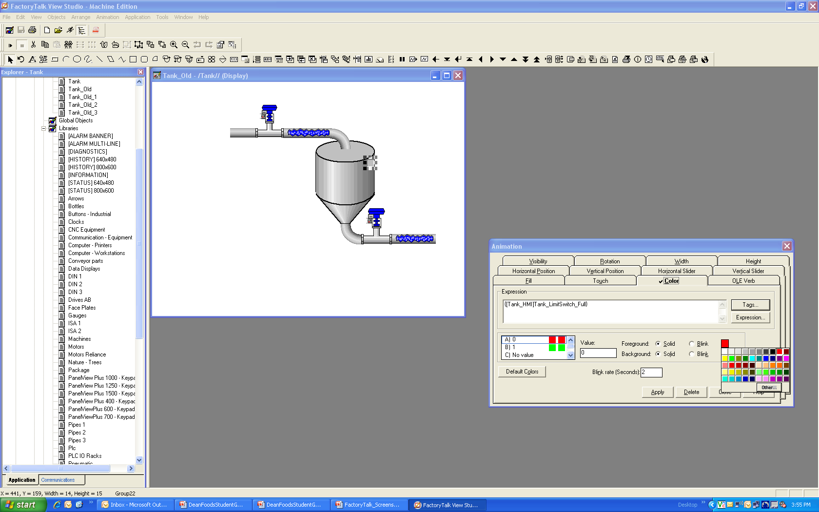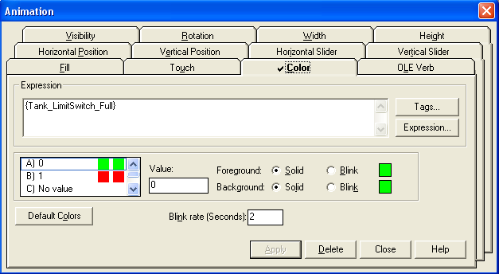

Figure . Add Color to Limit Switch

* Add a Limit Switch Empty Indicator to the tank just as above.
* Add an Open Momentary Pushbutton. From the Menu Bar, select Objects, Push Button, Momentary.

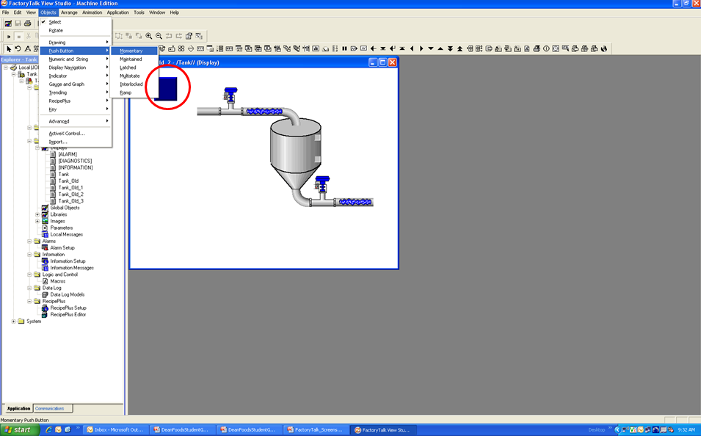

Figure . Add Momentary Push Button

Right-click and select Properties.

There are four tabs under the Momentary Push Button Properties: General, States, Common, and Connections. Under the General Tab, you have the ability to change the appearance, settings, and touch margins of the button. You can also add audio by selecting the check box under Other.

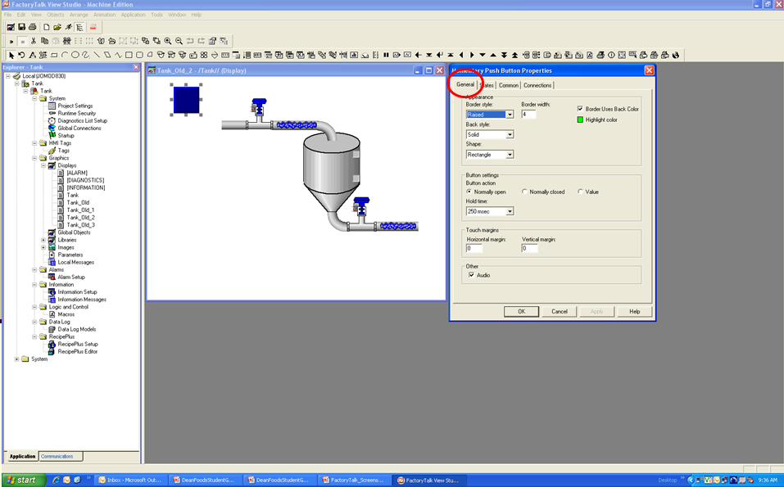

Figure . Properties of Momentary Push Button

The States tab allows the user to change the button’s color, pattern style, as well as enter caption, change the font, font size, alignment, and caption back style. You may also change the button’s image if desired. NOTE: In most cases, the user does not change the image settings.

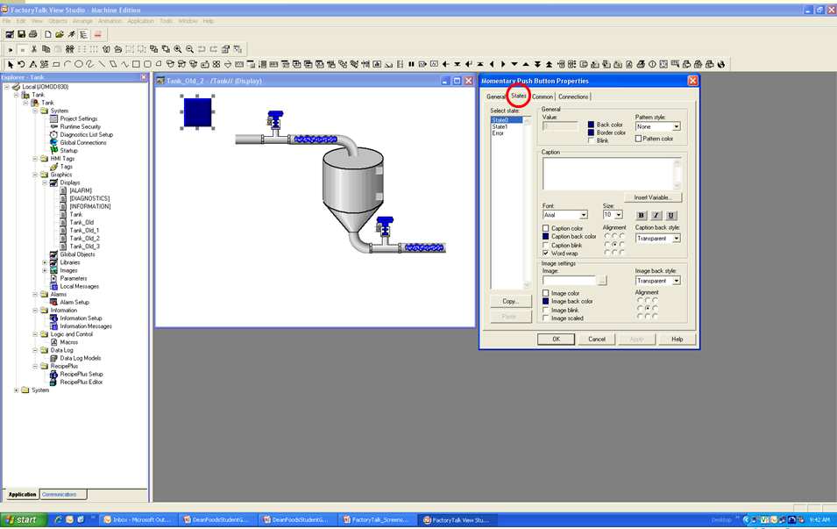

Figure . States Tab of Momentary Push Button

Change the button’s State 0 attributes as shown below. Click apply, then OK to accept the changes.

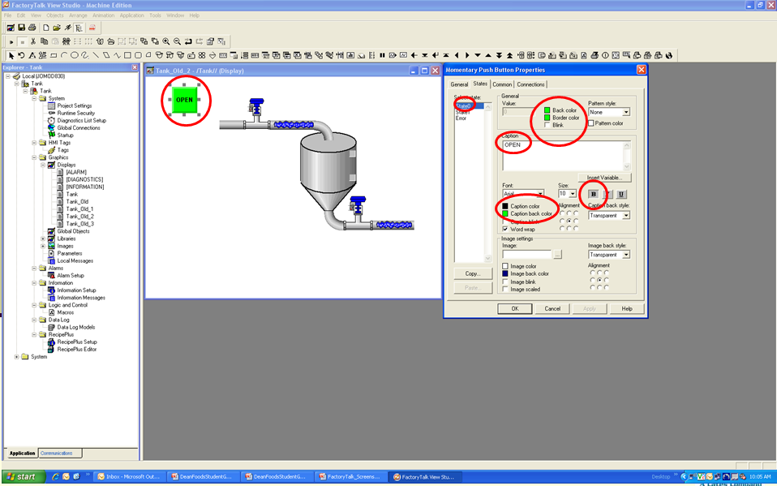

Figure . State 0 of Momentary Push Button

Change the button’s State 1 attributes as well. Click apply, then OK to accept the changes.

By selecting the Common tab, the user can change the button’s size and position on the screen.

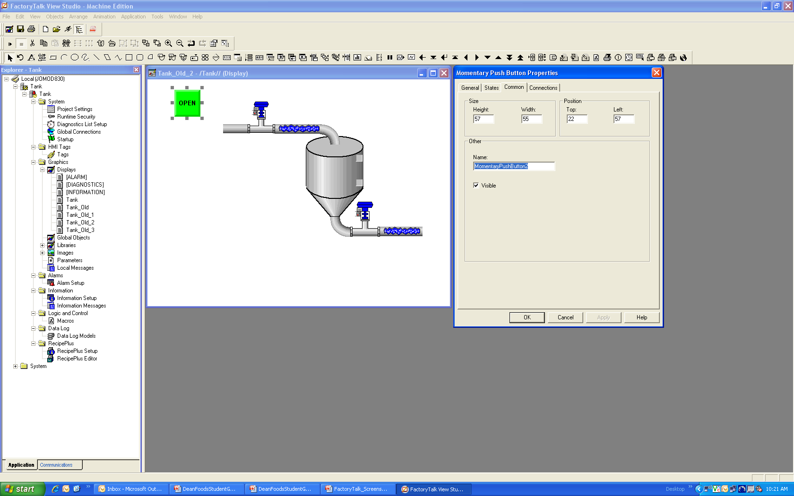

Figure . Common Tab of Momentary Push Button

Click on the Connections tab to add tags to the button. Under the Tag column, press the button with the three plus symbols (+++) to open the Tag Browser and select the appropriate tag. NOTE: You have to manually type in the shortcut [Tank_HMI] if you are pointing directly to the PLC tag otherwise you can keep it the same.

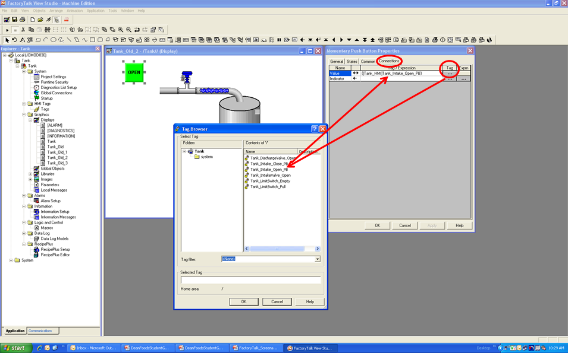

Figure . Connections Tab of Momentary Push Button

* Add a Close Momentary Pushbutton just like Open Momentary Pushbutton.
* Add color animation to the Intake Valve.

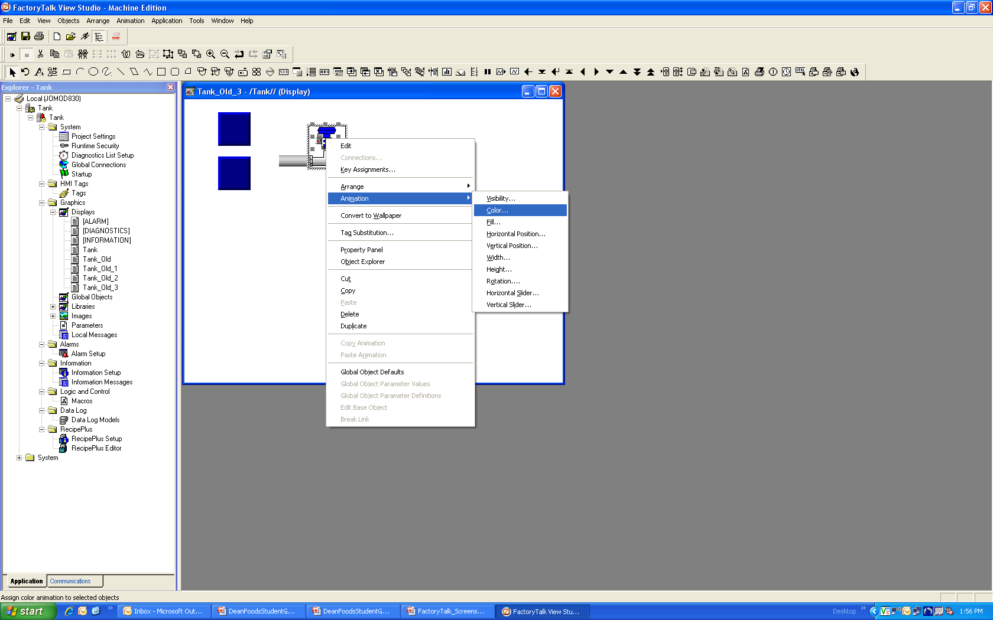

Figure . Add Animation to Intake Valve

Choose the appropriate tag from the Tag Browser and double-click on it.

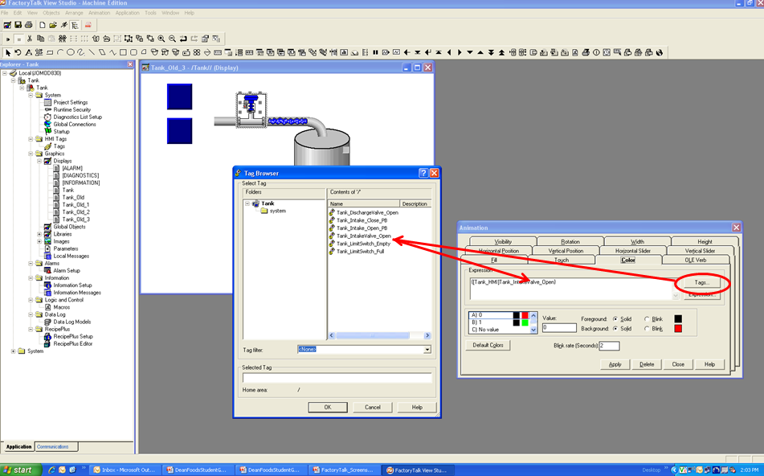

Figure . Add Tag for Animation

Change the foreground color from black to red to represent when the valve is closed (Value of A=0). Click on the color box to the right to change the color box on the left then hit apply.

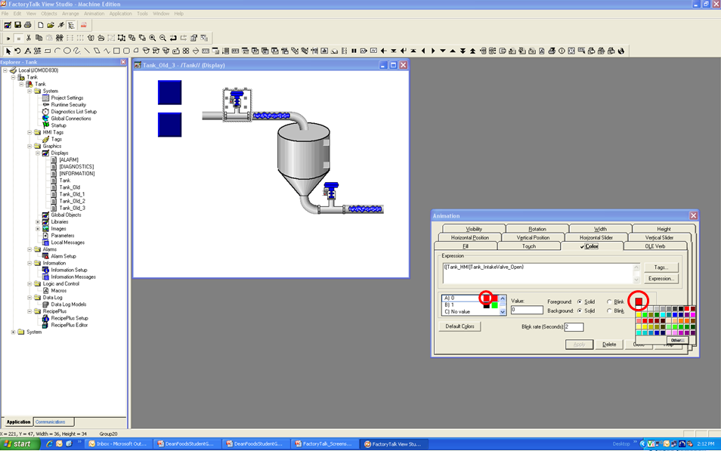

Figure . Changing Color when Value 0

Change the foreground color from black to green to represent when the valve is open (Value of B=1). Click on the color box to the right to change the color box on the left then hit apply.

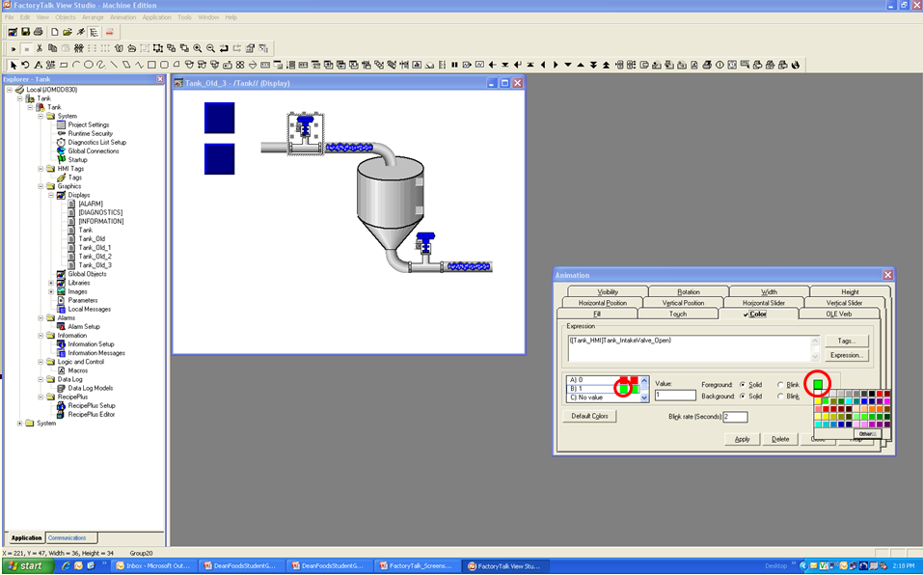

Figure . Changing Color When value 1

* Add color animation to the Discharge Valve.
* Add visibility to the water shown inside of the pipe on the intake side. Right-click on the water, then select animation and point to visibility.

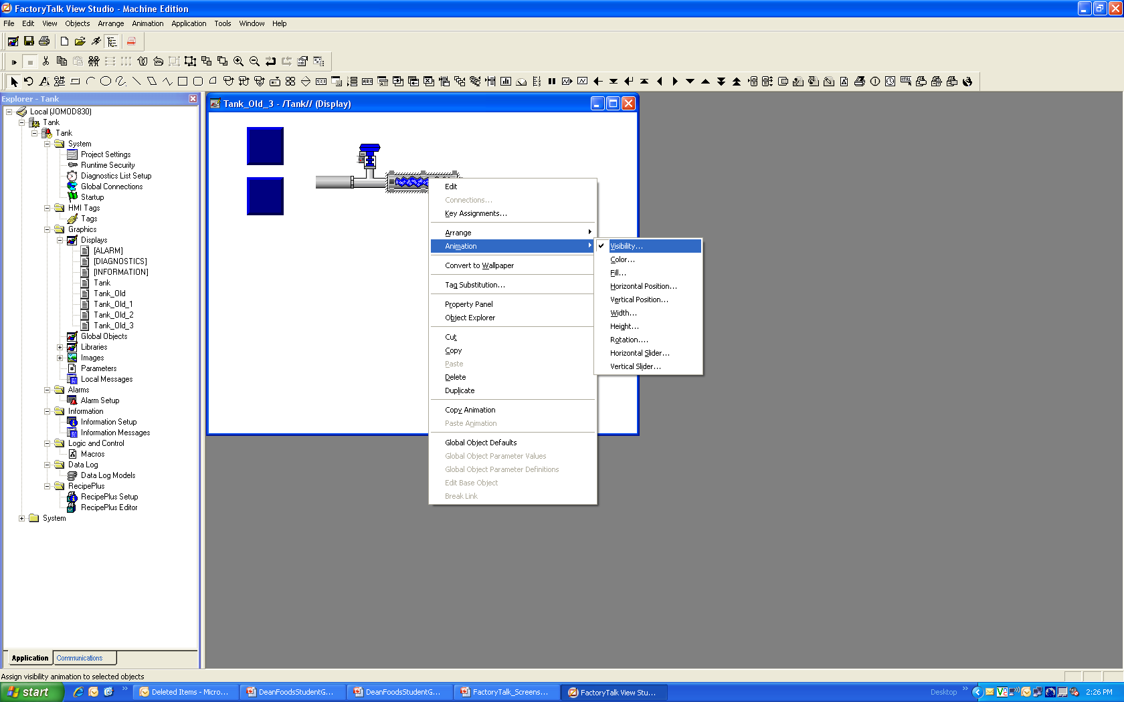

Figure . Adding Visibility to Pipe

First, select the appropriate tag from the Tag Browser and its true visibility state. In this case, we will set the water to be visible on true (the value of Tank_IntakeValve_Open = 1). Click on apply and close the pop-up window.

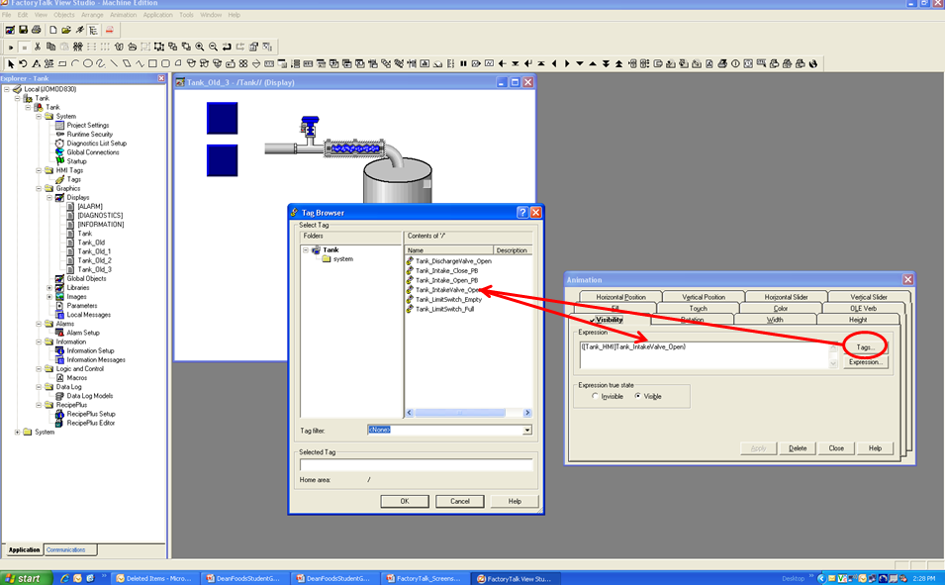

Figure . Adding Tag

* Add visibility to the water shown inside of the pipe on the discharge side.

### Adding Communication

To create a new configuration for communication between the PLC and FactoryTalk View Studio:

* In the Explorer Window under RSLinx Enterprise, double-click on Communication Setup.
* Next, click on Create a new configuration in the RSLinx Enterprise Configuration Wizard.
* Click on Finish.

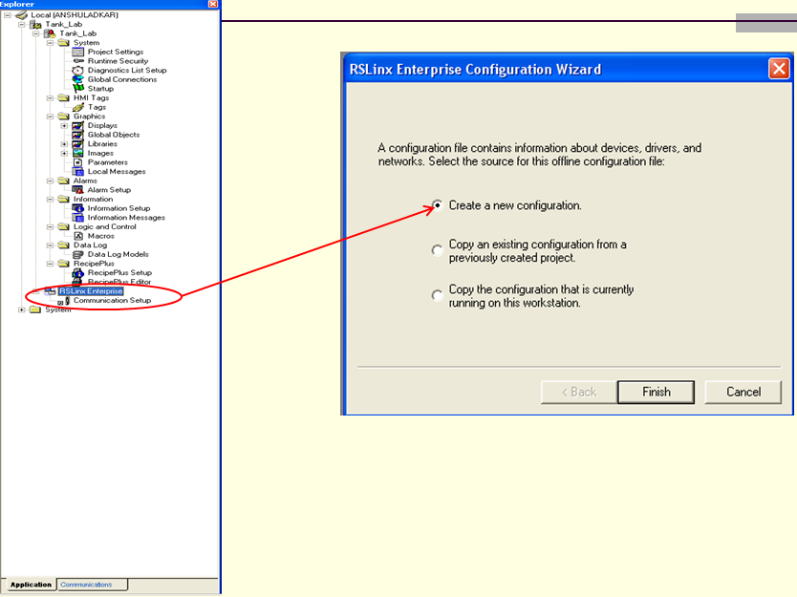

Figure . Adding Communication Configuration

This pop-up window will appear after clicking Finish on the previous window. On the left-hand side of the window, you may add device shortcuts, which points to tags directly inside of the PLC. On the right-hand side of the window, there are two tabs: Design (Local) and Runtime (Target).

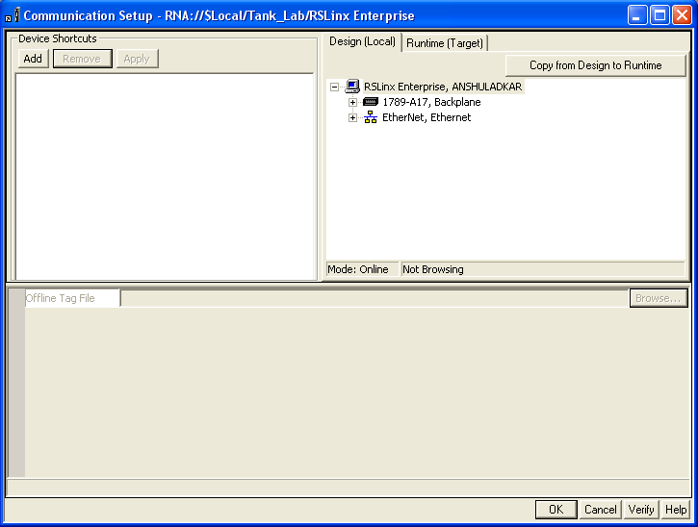

Figure . Properties Adding Device Shortcut

To add a Device Shortcut,

* Type in the desired name of the shortcut. <Tank_HMI>
* Click Apply, then Add.
* Click on Copy from Design to Runtime.
* Click on OK.

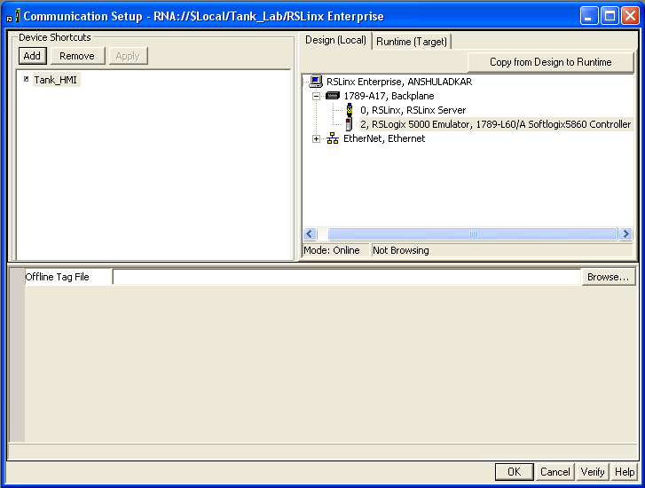

Figure . Assigning PLC to Device Shortcut

## LAB – FT View Studio

Complete the follow exercises.

#### Exercise #1

After completing this exercise you will be able to create/modify ladder logic using bit level instructions.

**Task**

Create the following rung logic:

1. Energize (Open/ON) the Intake_Valve when an operator pushes (closes) a Normally Open momentary pushbutton and remains open after the operator releases the button. When the operator pushes (opens) a Normally Closed pushbutton the Intake_valve closes.
2. When the tank is full, energize (Open/ON) the Discharge_Valve when the Normally Closed float switch Full_LS opens and remains open until the tank is empty, Normally Open float switch Empty_LS opens.

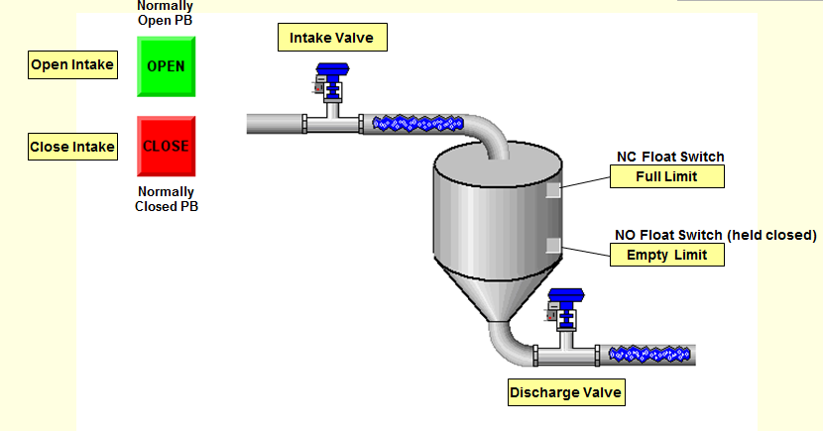

Figure . Exercise 2A

#### Exercise #2

**Task**

Assign tags to the following devices:  
Discharge Valve #2:__________________________

Create the following rung logic:

Add another discharge valve and modify the program to alternate valves open every time the tank is filled.

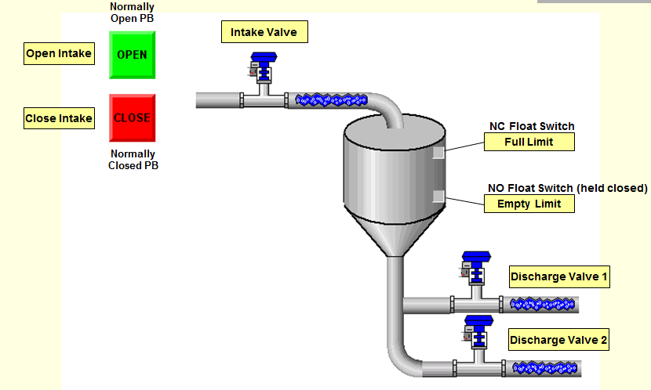

Figure . Exercise 2B

### Users and Groups

For FactoryTalkView Studio, if the application is being opened in the Laptop or Computer for the first time, we need to add new users to it. Click on the System Folder in the explorer window and open it. There is Users and Groups folder in it, open that. If you open the Users folder it will list all the users in your FactoryTalk View Studio. (Note: If you already have engineer, admin and operator users you don’t have to add them, please skip this step). Right click on users and click on New.

It brings up a popup where you have to enter new user name and password. The new user names and corresponding passwords of the same are listed below. (These are examples and not specific to all applications)

**User Name Password**

* engineer engineer
* admin admin
* operator operator

Once you add these users to FactoryTalk View studio you don’t have to do this for any other Ingredient Skid application.

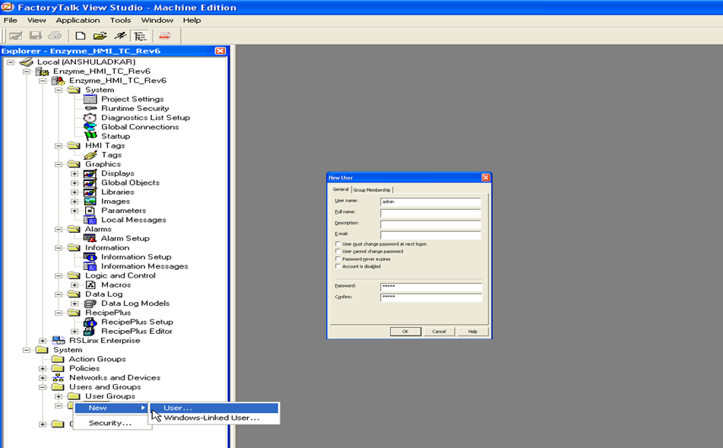

Figure . FactoryTalk View Users

#### Runtime Security

Double click on Runtime Security under your project tree; the user accounts under it will have some cluttered numbers and alphabets in it as shown in picture below.

(Note: If you have engineer, admin and operator setup here as well please skip this step).

You have to remove all these user accounts except Default, by selecting them and then clicking on Remove.

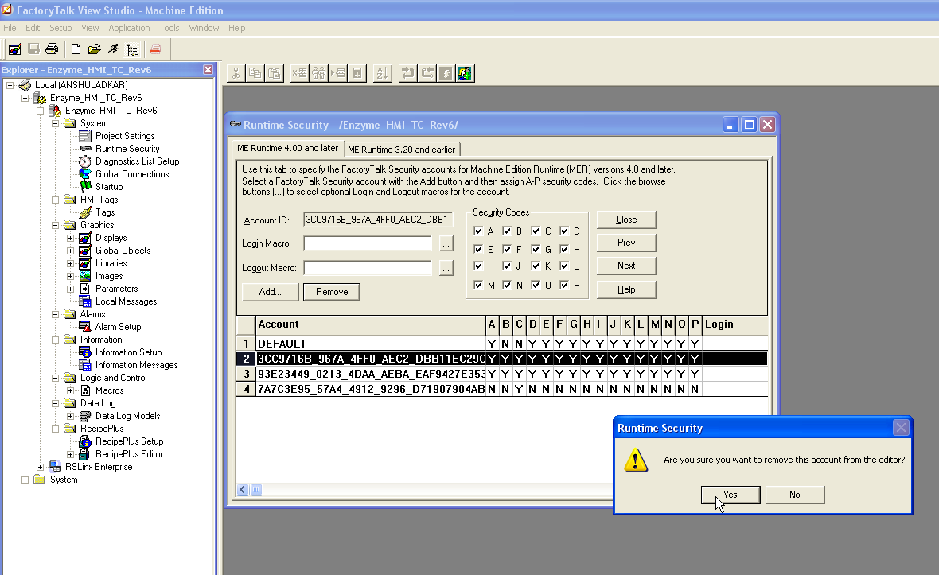

Figure . Runtime Security when application opened for first time

#### Users

After removing the three accounts we need to add three new users to Runtime Security by clicking on Add button. It will bring up a new popup, select the Users only button and add admin and click ok. Do the same steps for engineer and operator. Once you add the user they will show in the Runtime Security Dialog Box. Here is a screen shot.

Once you add all three Users, select operator and unclick all the security codes except C and hit accept.

All the User account details are as below:

**User Name Password Security Codes**

* engineer engineer All
* admin admin All
* operator operator C

All applications in the plant need to have these users; so add these Users in Runtime Security when opening the application for the first time. This completes security needed for application.

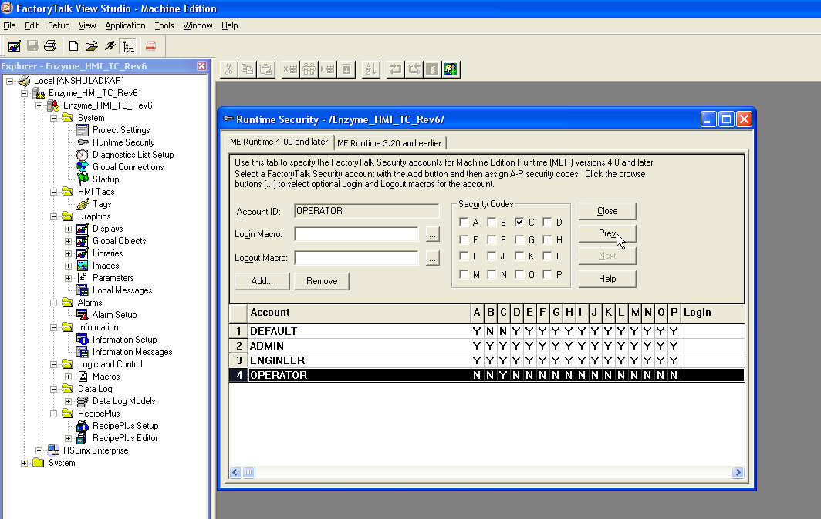

Figure . Runtime Security After adding users

### RecipePlus

To add a new recipe to the application open RecipePlus folder in the project tree and open the RecipePlus editor. The recipe can be found in this, in the screenshot my recipe is TC, if you double click on TC and it brings up the RecipePlus editor dialog box. It has three tabs General, Ingredients and Units. Click on Units, it will list all the recipes in the application. Here is a screenshot of my example.

As you see I have some extra recipes ZUnit06 onwards, so I can now double click on it and it will bring a new popup where you can change ZUnit06 to the recipe name you want.

If you don’t have extra recipes like I have the click on insert and it will bring up the same dialog box. Enter the new recipe name in the unit name and select a Data set different from the one that have already been used and Tag set remains the same for all recipes.

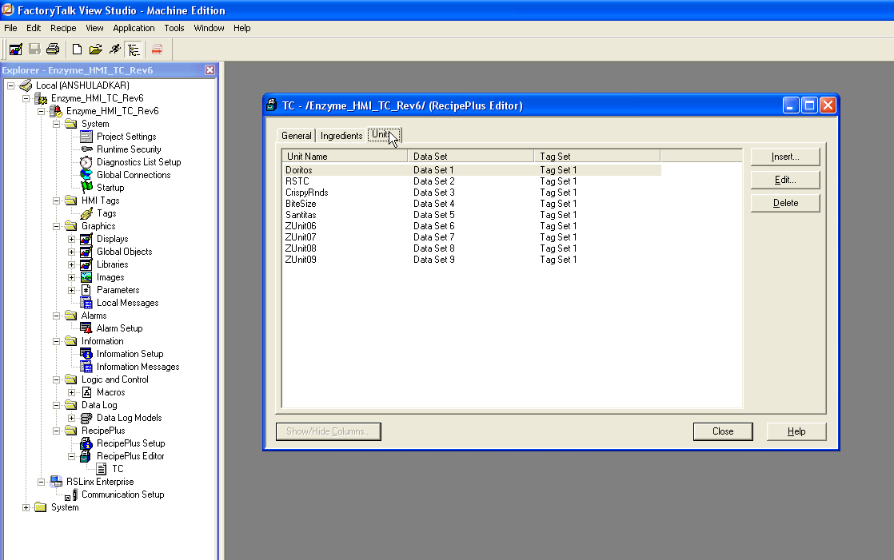

Figure . RecipePlus Units Tab

Now click on the Ingredients tab, you will see all the Recipe parameters here along with columns of Data Sets. The Data Set basically represents a column for the Recipe in the Recipe manager. So in my example I had Data Set 6 for my NewRecipe, so I will start changing all the parameters under that.

Row 6 in the Ingredients in the Recipe Number, so it should match the recipe number you have in the Process Line for the new recipe. Save the recipe. This completes new recipe setup in Recipe Manager.

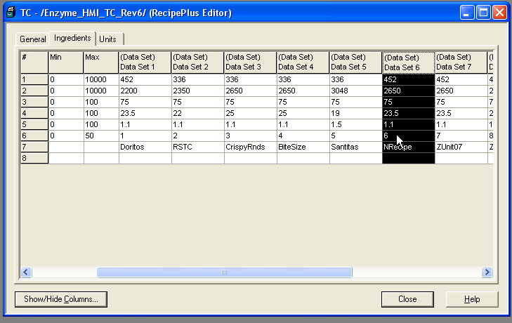

Figure . RecipePlus Ingredients Tab

## Communication Setup

Before you create a new runtime file and download the new recipe to the panelview, you have to make sure the communication shortcut is pointing to the right PLC. So open the RSlinx enterprise in your project tree and double click on communication setup. It should have an Ingredient_HMI shortcut under device shortcuts, and if you click on it, the PLC with the IP address that the shortcut is talking to will be displayed under Design and Runtime tabs.

If it does not point to right PLC IP address then click on the right PLC IP address and then also click on the Copy from Design to Runtime button on the right hand corner. Click on Ok button after that. This completes the communication setup.

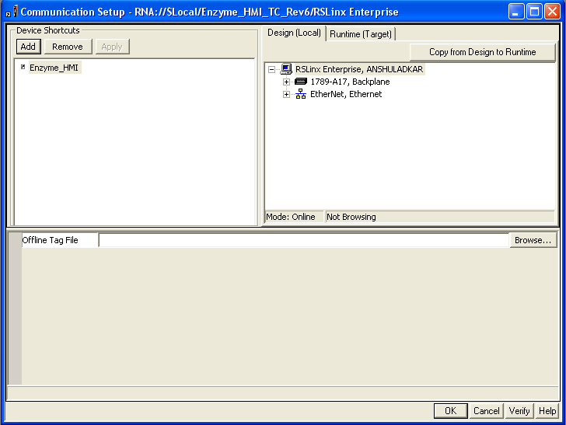

Figure . Communication Setup

## Runtime file:

Now we need to create a runtime file for the new application, if you click on application in the menu bar and select create runtime application, a new popup appears where you can enter filename and select the type of file. Enter the same file name that you have for the line and select Runtime 4.0 Application from the dropdown menu and click save.

The .mer file created should be in the following folder, it is the default folder created for FactoryTalkView,

C:\Documents and Settings\All Users\Documents\RSView Enterprise\ME\Runtime

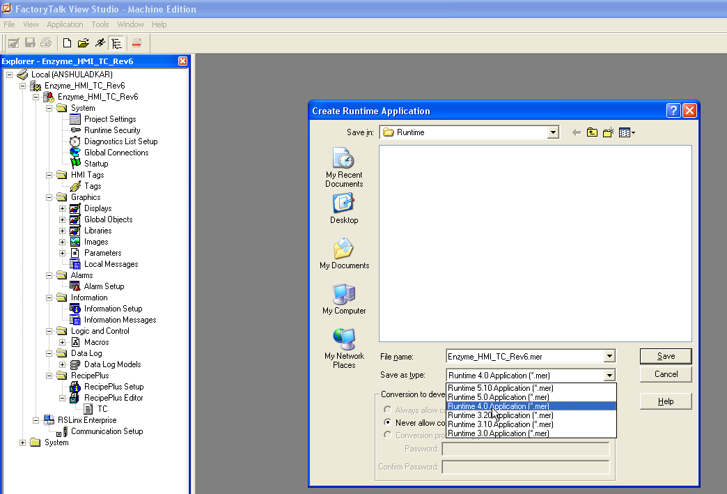

Figure . Create Runtime File 4.0 version

## Transfer Utility:

Now we need to download the file to panelview. Make sure that before you download you backup the existing .mer file on a computer.

You can download the file by going to Tools in the menu bar and then click on Transfer utility. It brings up a popup where you can select the file you want to download along with other properties. Select the .mer file just created in the Source file and also click on Run application at start-up and Replace communications selections. Here is a screen shot.

Now select the IP address of the panelview you want to download to under Ethernet in RSLinx enterprise and click download.

Another way to download to the panelview is to copy the .mer file on a stick and take it to the panelview and paste it.

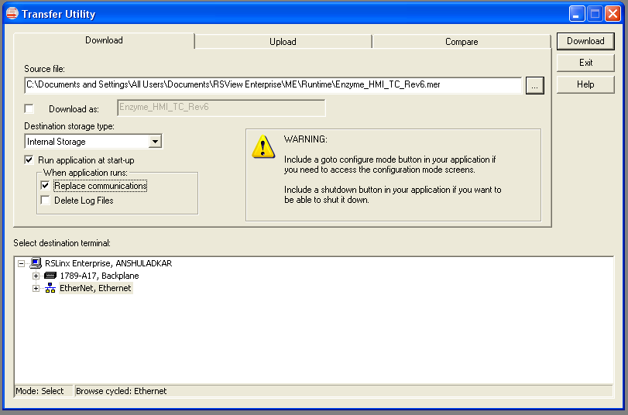

Figure . Transfer Utility

# Appendix

## MicroLogix



Figure . MicroLogix PLC

There are five levels of Controllers available, providing a wide variety of features to suit most applications.

* Micrologix 1000
* Micrologix 1100
* Micrologix 1200
* Micrologix 1400
* Micrologix 1500

### 1000 Controllers

1761 MicroLogix 1000 Controllers are the most compact of the MicroLogix family. This controller fits a wide variety of applications up to 32 I/O points, while using a fraction of the space of a full-size controller. It contains embedded analog I/O, providing compact and cost-effective analog performance.

### 1100 Controllers

1763 MicroLogix 1100 Controllers add embedded Ethernet/IP, on-line editing and an LCD to the MicroLogix family. The built-in LCD shows controller status, I/O status and simple operator messages. With 2 analog inputs, 10 digital inputs and 6 digital outputs, the MicroLogix 1100 controller can handle a wide variety of tasks.

### 1200 Controllers

1762 MicroLogix 1200 Controllers are small enough to fit in tight spaces and powerful enough to accommodate a broad range of applications. The controller is available in 24-point and 40-point versions. You can expand the I/O count using rackless I/O modules. You can build larger control systems, achieve greater application flexibility, and expand your system at a lower cost and with reduced parts inventory. A field-upgradeable flash operating system keeps you be up-to-date with the latest features.

### 1400 Controllers

1766 MicroLogix 1400 Controllers build upon critical MicroLogix 1100 features: EtherNet/IP, on-line editing and a built-in LCD. These controllers feature a higher I/O count, faster high-speed counter, pulse train output, enhanced network capabilities and backlight on the LCD. Controllers without embedded analog I/O points provide 32 digital I/O points, while analog versions offer 32 digital I/O points and 6 analog I/O points. You can expand all versions with up to seven 1762 expansion I/O modules.

### 1500 Controllers

1764 MicroLogix 1500 Controllers are the most expandable members of the MicroLogix family. Building upon the critical features of the MicroLogix 1200 controllers, this controller fits many applications that traditionally called for larger, more expensive controllers. With a processor, base unit with power supply and embedded I/O, this controller packs the best features of a modular system into a low-cost, small footprint.

### Expansion I/O Modules

1762 MicroLogix™ Expansion I/O modules extend the capabilities of the MicroLogix 1100, 1200, and 1400 controllers by maximizing flexibility of the I/O count and type. The modular, rackless design enhances cost savings and reduces replacement parts inventory. Modules can be either DIN rail or panel mounted.

### Compact I/O Modules

1769 Compact I/O modules can be used as local and distributed I/O for a CompactLogix or MicroLogix 1500 controller. Select from a variety of digital, analog, and specialty modules. The 16- and 32-point modules provide high-density I/O in a small package. A built-in removable terminal block provides connections to I/O sensors and actuators. You can route the I/O wiring from beneath the module to the I/O terminals.

### Communication Interfaces

1761 Communication Interfaces and 1769 DeviceNet Scanner Module support your MicroLogix controller systems with a variety of features. Any DH-485 compatible device that has an RS-232 port can access any other DH-485 network with these products. Connect to Ethernet networks and upload programs, download programs, communicate between controllers and leverage web server functionality. Program and monitor your MicroLogix system over the DeviceNet network. Upload, download, and monitor programs through the DeviceNet scanner.

Shares common RSLogix 500 programming software and RSLogix Micro programming software, providing an instruction set that is common to the MicroLogix and SLC 500 controller families. See Figure 7 below.

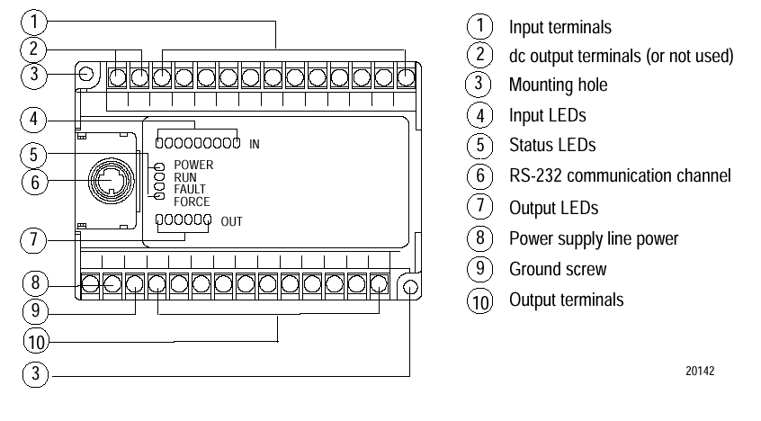

Figure MicroLogix Detail

## CompactLogix

Compactlogix are small and offer a variety of communication platforms and I/O card selection. See Figure 8 below.



Figure . AB Compactlogix PAC

### Controllers

1768 and 1769 CompactLogix controllers integrate easily with other controllers. These controllers use the same RSLogix5000 programming software that other members of the Logix controller family use, so you can easily duplicate and scale existing programs to run on the CompactLogix platforms. With a user memory ranging from 512 KB to 3 MB, CompactLogix controllers offer integrated serial, EtherNet/IP or ControlNet channels, modular DeviceNet communications and local I/O capacity that can range from 3 to 30 I/O modules. Use the 1768-L4xS controllers for your safety applications.

### Communication Modules

1768 and 1769 CompactLogix communication modules help you configure your system to exchange information between operating systems and a range of devices and platforms. You can select a CompactLogix controller with built-in communication ports, or select a coordinating communications module for the networks that meet your needs.

### Compact I/O Modules

1769 Compact I/O modules can be used as local and distributed I/O for a CompactLogix or MicroLogix 1500 controller. Select from a variety of digital, analog and specialty modules. The 16- and 32-point modules provide high-density I/O in a small package. A built-in removable terminal block provides connections to I/O sensors and actuators. I/O wiring can be routed from beneath the module to the I/O terminals.

### Motion Modules

CompactLogix 1768-L4x controllers support integrated motion through the 1768 SERCOS interface modules. Depending on the controller you select, the SERCOS interface module supports either four or eight axes, two or four feedback axes and six virtual axes. You can communicate with a variety of servo drives over a DeviceNet network or an RS-232 serial network.

### Power Supplies

1768 CompactLogix Power Supplies and 1769 Compact I/O Expansion Power Supplies help keep your system running smoothly. Select power supplies based on the controller and the number of additional I/O banks you're using. If you are using a 1769-L23x controller, you do not need a separate power supply because the controller package includes an integrated power supply.

Use RSLogix 5000 programming software to design and configure your CompactLogix system.

1. Enhanced and Ethernet PLC-5 Programmable Controllers: User Manual. Publication 1785-6.5.12, page 23-2, Allen-Bradley, Nov, 1998.
2. Enhanced and Ethernet PLC-5 Programmable Controllers: User Manual. Publication 1785-6.5.12, page 1-5, Allen-Bradley, Nov, 1998.
3. Universal I/O Chassis: Installation Instruction Manual. Publication 1771-IN075A-EN-P, page 13, Allen-Bradley, March, 2002.
4. Enhanced and Ethernet PLC-5 Programmable Controllers: User Manual. Publication 1785-6.5.12, page 23-4, Allen-Bradley, Nov, 1998.
5. Remote I/O Adapter Module: User Manual. Publication 1771-UM001A-US-P, p. 2-7, Allen-Bradley, Feb. 2000.
6. Remote I/O Adapter Module: User Manual. Publication 1771-UM001A-US-P, p. 2-2, 2-11, 2-12, Allen-Bradley, Feb. 2000.
7. Remote I/O Adapter Module: User Manual. Publication 1794-UM009B-EN-P, p. 1-3, Allen-Bradley, Mar. 2002
8. Remote I/O Adapter Module: User Manual. Publication 1794-6.5.3, p. 2-8, Allen-Bradley, May, 1996.
9. Enhanced and Ethernet PLC-5 Programmable Controllers: User Manual. Publication 1785-6.5.12, page 1-11, Allen-Bradley, Nov. 1998.
10. 1785 PLC-5 Family Programmable Controllers
11. Remote I/O Adapter Module: User Manual. Publication 1771-UM001A-US-P, p. 3-3, Allen-Bradley, Feb. 2000.
12. Remote I/O Adapter Module: User Manual. Publication 1771-UM001A-US-P, p. 3-2, Allen-Bradley, Feb. 2000.
13. RSLinx Technical Data, Doc ID LINX-TD001C-EN-P, p. 2, Rockwell Software, 2002.
14. St. Clair, David W. “Controller Tuning and Control Loop Performance, Second Edition,” p. 8, Straight-Line Control Company, Inc, 1993.
15. St. Clair, David W. “Controller Tuning and Control Loop Performance, Second Edition,” p. 17, Straight-Line Control Company, Inc, 1993.
16. ControlLogix Data Highway Plus-Remote I/O Communication Interface Module: User Manual. Publication 1756-UM514B-EN-P, p. 2-7, Allen-Bradley, Feb. 2003.
17. Remote I/O Adapter Module: User Manual. Publication 1771-UM001A-US-P, p. 2-7, Allen-Bradley, Feb. 2000.
18. Remote I/O Adapter Module: User Manual. Publication 1771-UM001A-US-P, p. 2-2, 2-11, 2-12, Allen-Bradley, Feb. 2000.
19. Remote I/O Adapter Module: User Manual. Publication 1794-UM009B-EN-P, p. 1-3, Allen-Bradley, Mar. 2002
20. Remote I/O Adapter Module: User Manual. Publication 1794-6.5.3, p. 2-8, Allen-Bradley, May, 1996.
21. Remote I/O Adapter Module: User Manual. Publication 1794-6.5.3, pp. 2-13, 2-14, Allen-Bradley, May, 1996.
22. DeviceNet Cabling System: Planning and Installation Manual, Publication DN-6.7.2, p. 1-2, 1-3, 1-4, 1-5, 1-7, Rockwell Automation, May 1999.
23. PLC5 DeviceNet Scanner Module: 1771-SDN, Publication 1771-UM118C-EN-P, p. 3-8, 3-10, Rockwell Automation, June 2003.
24. http://www.ab.com/networks/controlnet/
25. ControlNet Coax Media Planning and Installation Guide, Publication CNET-IN002A-EN-P, pp. 1-1,1-4, 2-6, Rockwell Automation, December 2001.
26. ControlLogix ControlNet Bridge, Publication 1756-IN571B-EN-P, pp. 9,10, Rockwell Automation, April 2001.
27. Flex I/O ControlNet Adapter Modules, Publication 1794-IN101B-EN-P, pp. 3,4, Rockwell Automation, June 2004.
28. http://www.ab.com/networks/ethernet/